Millennium Ecosystem Assessment Synthesis Report
Draft 9: 1 March 2005

Note to reader: This is the unedited penultimate draft of the MA General Synthesis Report. The contents of this draft may change before its final release on March 30. The material in this draft should not be quoted or cited. Information from this draft should be checked against the final draft that will be posted at http://www.MAweb.org on March 30, 2005.

A Report of the Millennium Ecosystem Assessment

Core Writing Team: Walter V. Reid, Harold A. Mooney, Angela Cropper, Doris Capistrano, Stephen R. Carpenter, Kanchan Chopra, Partha Dasgupta, Thomas Dietz, Anantha Kumar Duraiappah, Roger Kasperson, Rik Leemans, Robert M. May, Tony (A.J.) McMichael, Prabhu Pingali, Rashid Hassan, Cristián Samper, Robert Scholes, Zhao Shidong, Robert T. Watson, A.H. Zakri, Neville J. Ash, Elena Bennett, Pushpam Kumar, Marcus J. Lee, Ciara Raudsepp-Hearne, Jillian Thonell, and Monika B. Zurek
Extended Writing Team: MA Coordinating Lead Authors, Lead Authors, Contributing Authors, and Sub-Global Coordinators
Review Editors: José Sarukhán and Anne Whyte (co-chairs) and MA Board of Review Editors
Millennium Ecosystem Assessment Board
The MA Board represents the users of the findings of the MA process.

Co-chairs
Robert T. Watson, World Bank
A.H. Zakri, United Nations University

Institutional Representatives
Salvatore Arico, United Nations Educational, Scientific and Cultural Organization
Peter Bridgewater, Ramsar Convention on Wetlands
Hama Arba Diallo, United Nations Convention to Combat Desertification
Adel El-Beltagy, Consultative Group on International Agricultural Research
Max Finlayson, Ramsar Convention on Wetlands
Colin Galbraith, Convention on Migratory Species
Erika Harms, United Nations Foundation
Robert Hepworth, Convention on Migratory Species
Kerstin Leitner, World Health Organization
Alfred Oteng-Yeboah, Convention on Biological Diversity
Cristian Prip, Convention on Biological Diversity
Mario Ramos, Global Environment Facility
Thomas Rosswall, International Council for Science
Achim Steiner, IUCN–The World Conservation Union
Halldor Thorgeirsson, United Nations Framework Convention on Climate Change
Klaus Töpfer, United Nations Environment Programme
Jeff Tschirley, Food and Agricultural Organization of the United Nations
Alvaro Umaña, United Nations Development Programme
Ricardo Valentini, United Nations Convention to Combat Desertification
Hamdallah Zedan, Convention on Biological Diversity

At-large Members

Fernando Almeida
Phoebe Barnard
Gordana Beltram
Delmar Blasco
Antony Burgmans
Esther Camac
Angela Cropper
Partha Dasgupta
José Maria Figueres
Fred Fortier
Mohamed H.A. Hassan
Jonathan Lash
Wangari Maathai
Paul Maro
Harold Mooney
Marina Motovilova
M.K. Prasad
Walter V. Reid
Henry Schacht
Peter Johan Schei
Ismail Serageldin
David Suzuki
M.S. Swaminathan
José Galízia Tundisi
Axel Wenblad
Xu Guanhua
Muhammad Yunus

Millennium Ecosystem Assessment Panel
Harold A. Mooney (co-chair), Stanford University, United States
Angela Cropper (co-chair), Cropper Foundation, Trinidad and Tobago
Doris Capistrano, Center for International Forestry Research, Indonesia
Stephen R. Carpenter, University of Wisconsin, United States
Kanchan Chopra, Institute of Economic Growth, India
Partha Dasgupta, University of Cambridge, United Kingdom
Rik Leemans, Wageningen University, Netherlands
Robert M. May, University of Oxford, United Kingdom
Prabhu Pingali, Food and Agriculture Organization of the United Nations, Italy
Rashid Hassan, University of Pretoria, South Africa
Cristián Samper, Smithsonian National Museum of Natural History, United States
Robert Scholes, Council for Scientific and Industrial Research, South Africa
Zhao Shidong, Chinese Academy of Sciences, China
Editorial Board Chairs:
José Sarukhán, Universidad Nacional Autónoma de México, Mexico
Anne Whyte, Mestor Associates Ltd., Canada

MA Director
Walter V. Reid

Millennium Ecosystem Assessment Secretariat Support Organizations
The United Nations Environment Programme coordinates the Millennium Ecosystem Assessment Secretariat, which is based at the following partner institutions:
Food and Agricultural Organization of the United Nations, Italy
Institute of Economic Growth, India
International Maize and Wheat Improvement Center, Mexico (until 2004)
Meridian Institute, United States
National Institute of Public Health and the Environment, Netherlands (until mid-2004)
Scientific Committee on Problems of the Environment, France
UNEP-World Conservation Monitoring Centre, United Kingdom
University of Pretoria, South Africa
University of Wisconsin, United States
World Resources Institute, United States
WorldFish Center, Malaysia

Table of Contents
Foreword 5
Preface 8
Reader’s Guide 13

Summary for Decision-makers 13
Finding 1: Ecosystem Change in Last 50 Years 16
Finding 2: Gains and Losses from Ecosystem Change 17
Finding 3: Ecosystem Prospects for Next 50 Years 24
Finding 4: Reversing Ecosystem Degradation ……..27

Key Questions in the Millennium Ecosystem Assessment
1. How have ecosystems changed? 49
2. How have ecosystem services and their use changed? 63
3. How have ecosystem changes affected human well-being and poverty alleviation? 76
4. What are the most critical factors causing ecosystem changes? 93
5. How might ecosystems and their services change in the future under various plausible scenarios? 100
6. What can be learned about the consequences of ecosystem change for human well-being at sub-global scales? 116
7. What is known about time scales, inertia, and the risk of non-linear changes in ecosystems? 122
8. What options exist to sustainably manage ecosystems? 128
9. What are the most important uncertainties hindering decision-making concerning ecosystems? 142
Appendix A. Ecosystem Service Reports 145
Appendix B. Effectiveness of Assessed Responses 172
Appendix C. Authors and Review Editors 180
Appendix D. Abbreviations and Acronyms 182
Appendix E. Assessment Report Tables of Contents 185

Foreword
The Millennium Ecosystem Assessment was called for by United Nations Secretary-General Kofi Annan in 2000 in his report to the UN General Assembly, We the Peoples: The Role of the United Nations in the 21st Century. Governments subsequently supported the establishment of the assessment through decisions taken by three international conventions, and the MA was initiated in 2001. The MA was conducted under the auspices of the United Nations, with the secretariat coordinated by the United Nations Environment Programme, and it was governed by a multistakeholder board involving international institutions and representatives of governments, business, NGOs, and indigenous peoples. The objective of the MA was to assess the consequences of ecosystem change for human well-being and to establish the scientific basis for actions needed to enhance the conservation and sustainable use of ecosystems and their contributions to human well-being.
This report presents a synthesis and integration of the findings of the four MA Working Groups (Condition and Trends, Scenarios, Responses, and Sub-Global Assessments). It does not, however, provide a comprehensive summary of each Working Group report, and readers are encouraged to also review the findings of these separately. This synthesis is organized around the core questions originally posed to the assessment: How have ecosystems and their services changed? What has caused these changes? How have these changes affected human well-being? How might ecosystems change in the future and what are the implications for human well-being? And what options exist to enhance the conservation of ecosystems and their contribution to human well-being?
This assessment would not have been possible without the extraordinary commitment of the approximately 1,360 experts worldwide who contributed their knowledge, creativity, time, and enthusiasm to this process. We would like to express our gratitude to the members of the MA Assessment Panel, Coordinating Lead Authors, Lead Authors, Contributing Authors, Board of Review Editors, and Expert Reviewers who contributed to this process, and we wish to acknowledge the in-kind support of their institutions, which enabled their participation. (The list of reviewers is available at www.MAweb.org.)
We would like to thank the host organizations of the MA Technical Support Units—WorldFish Center (Malaysia); UNEP-World Conservation Monitoring Centre (United Kingdom); Institute of Economic Growth (India); National Institute of Public Health and the Environment (Netherlands); University of Pretoria (South Africa), U.N. Food and Agriculture Organization; World Resources Institute, Meridian Institute, and Center for Limnology of the University of Wisconsin (all in the United States); Scientific Committee on Problems of the Environment (France); and International Maize and Wheat Improvement Center (Mexico)—for the support they provided to the process.
We thank the MA secretariat staff, interns, and volunteers, the administrative staff of the host organizations, and colleagues in other organizations who were instrumental in facilitating the process: Isabelle Alegre, Adlai Amor, Neville Ash, Elena Bennett, Hyacinth Billings, Emmanuelle Bournay, Herbert Caudill, Chan Wai Leng, Lina Cimarrusti, Emily Cooper, Dalène du Plessis, John Ehrmann, Keisha-Maria Garcia, Habiba Gitay, Helen Gray, Lori Han, Sherry Heileman, Toshie Honda, Francisco Ingouville, Christine Jalleh, Humphrey Kagunda, Nicole Khi, Brygida Kubiak, Pushpam Kumar, Marcus Lee, Liz Levitt, Belinda Lim, Nicolas Lucas, Christian Marx, Mampiti Matete, Tasha Merican, Stephanie Moore, John Mukoza, Arivudai Nambi, Laurie Neville, Rosemarie Philips, Veronique Plocq Fichelet, Maggie Powell, Meenakshi Rathore, Ciara Raudsepp-Hearne, Carolina Katz Reid, Walter Reid, Liana Reilly, Philippe Rekacewicz, Carol Rosen, Mariana Sanchez Abregu, Anne Schram, Tang Siang Nee, Henk Simons, Linda Starke, Sara Suriani, Darrell Taylor, Valerie Thompson, Jillian Thonell, Tutti Tischler, Elsie Velez Whited, Elizabeth Wilson, Mark Zimsky, and Monika Zurek.
We thank the members of the MA Board for the guidance and oversight they provided to this process. In addition to the current Board members (listed earlier), the contributions of past members of the MA Board were instrumental in shaping the MA focus and process and these individuals include Philbert Brown, Gisbert Glaser, He Changchui, Richard Helmer, Yolanda Kakabadse, Yoriko Kawaguchi, Ann Kern, Roberto Lenton, Hubert Markl, Arnulf Müller-Helbrecht, Corinne Lepage, Alfred Oteng-Yeboah, Seema Paul, Susan Pineda Mercado, Jan Plesnik, Peter Raven, Cristián Samper, Ola Smith, Dennis Tirpak, and Meryl Williams. We wish to also thank the members of the Exploratory Steering Committee that designed the MA project in 1999–2000. This group included a number of the current and past Board members, as well as Edward Ayensu, Mark Collins, Andrew Dearing, Louise Fresco, Madhav Gadgil, Habiba Gitay, Zuzana Guziova, Calestous Juma, John Krebs, Jane Lubchenco, Jeffrey McNeely, Ndegwa Ndiang'ui, Janos Pasztor, Prabhu L. Pingali, Per Pinstrup-Andersen, and José Sarukhán. And we would like to acknowledge the support and guidance provided by the secretariats and the scientific and technical bodies of the Convention on Biological Diversity, the Ramsar Convention on Wetlands, the Convention to Combat Desertification, and the Convention on Migratory Species, which have helped to define the focus of the MA and of this report.
We also want to acknowledge the support of a large number of nongovernmental organizations and networks around the world that have assisted in outreach efforts: Professional Council of Environmental Analysts of Argentina, Probioandes (Peru), Peruvian Society of Environmental Law, Foro Ecológico (Peru), Institute for Biodiversity Conservation and Research–Academy of Sciences of Bolivia, Forest Institute of the State of São Paulo, WWF-Brazil, Fundación Natura (Ecuador), University of Chile, Resources and Research for Sustainable Development (Chile), Asociación Ixacavaa (Costa Rica), Terra Nuova (Nicaragua), Indonesian Biodiversity Foundation, University of the Philippines, The Nature Conservancy (United States), WWF-US, The Regional Environmental Centre for Central Asia, Alexandria University, Suez Canal University, European Union of Science Journalists’ Associations, Arab Media Forum on Environment and Development, Stockholm University, Charles University (Czech Republic), European Environmental Agency, EIS-Africa (Burkina Faso), Permanent Inter-States Committee for Drought Control in the Sahel, Regional Center AGRHYMET (Niger), IUCN Regional Offices for West Africa and South America, IUCN office in Uzbekistan, World Assembly of Youth, International Alliance of Indigenous Peoples of the Tropical Forests, Global Development Learning Network, World Business Council for Sustainable Development, Argentine Business Council for Sustainable Development, and Brazilian Business Council on Sustainable Development.
We are extremely grateful to the donors that provided major financial support for the MA and the MA Sub-global Assessments: Global Environment Facility; United Nations Foundation; David and Lucile Packard Foundation; World Bank; Consultative Group on International Agricultural Research; United Nations Environment Programme; Government of China; Government of Norway; Kingdom of Saudi Arabia; Swedish International Biodiversity Programme. We also thank other organizations that provided financial support: Asia Pacific Network for Global Change Research; Association of Caribbean States; British High Commission, Trinidad & Tobago; Caixa Geral de Depósitos, Portugal; Canadian International Development Agency; Christensen Fund; Cropper Foundation, Environmental Management Authority of Trinidad and Tobago; Ford Foundation; Government of India; International Council for Science; International Development Research Centre; Island Resources Foundation; Japan Ministry of Environment; Laguna Lake Development Authority; Philippine Department of Environment and Natural Resources; Rockefeller Foundation; U.N. Educational, Scientific and Cultural Organization; UNEP Division of Early Warning and Assessment; United Kingdom Department for Environment, Food and Rural Affairs; United States National Aeronautic and Space Administration; and, Universidade de Coimbra, Portugal. Generous in-kind support has been provided by many other institutions (a full list is available at www.MAweb.org). The work to establish and design the MA was supported by grants from The Avina Group, The David and Lucile Packard Foundation, Global Environment Facility, Government of Norway, Swedish International Development Cooperation Authority, Summit Foundation, UNDP, UNEP, the United Nations Foundation, United States Agency for International Development, Wallace Global Fund, and World Bank.

Finally, we would particularly like to thank Angela Cropper and Harold Mooney, the co-chairs of the MA Assessment Panel, and José Sarukhán and Anne Whyte, the co-chairs of the MA Review Board, for their skillful leadership of the assessment and review processes.

Dr. Robert T. Watson
MA Board Co-Chair
Chief Scientist, The World Bank

Dr. A.H. Zakri
MA Board Co-Chair
Director, Institute for Advanced Studies, United Nations University

Dr. Klaus Töpfer
Executive Director, United Nations Environment Programme
Director General, United Nations Office in Nairobi

Preface
The Millennium Ecosystem Assessment was carried out between 2001 and 2005 to assess the consequences of ecosystem change for human well-being and to establish the scientific basis for actions needed to enhance the conservation and sustainable use of ecosystems and their contributions to human well-being. The MA responds to government requests for information received through four international conventions—the Convention on Biological Diversity, the United Nations Convention to Combat Desertification, the Ramsar Convention on Wetlands, and the Convention on Migratory Species—and is designed to also meet needs of other stakeholders, including the business community, the health sector, nongovernmental organizations, and indigenous peoples.
The assessment focuses on the linkages between ecosystems and human well-being and, in particular, on “ecosystem services.” An ecosystem is a dynamic complex of plant, animal, and microorganism communities and the nonliving environment interacting as a functional unit. The MA deals with the full range of ecosystems—from those relatively undisturbed, such as natural forests, to landscapes with mixed patterns of human use, to ecosystems intensively managed and modified by humans, such as agricultural land and urban areas. Ecosystem services are the benefits people obtain from ecosystems. These include provisioning services such as food, water, timber, and fiber; regulating services that affect climate, floods, disease, wastes, and water quality; cultural services that provide recreational, aesthetic, and spiritual benefits; and supporting services such as soil formation, photosynthesis, and nutrient cycling. (See Figure A.) The human species, while buffered against environmental changes by culture and technology, is ultimately fully dependent on the flow of ecosystem services.
The MA examines how changes in ecosystem services influence human well-being. Human well-being is assumed to have multiple constituents, including the basic material for a good life, such as secure and adequate livelihoods, enough food at all times, shelter, clothing, and access to goods; health, including feeling well and having a healthy physical environment, such as clean air and access to clean water; good social relations, including social cohesion, mutual respect, and the ability to help others and provide for children; security, including secure access to natural and other resources, personal safety, and security from natural and human-made disasters; and freedom of choice and action, including the opportunity to achieve what an individual values doing and being. Freedom of choice and action is influenced by other constituents of well-being (as well as by other factors, notably education) and is also a precondition for achieving other components of well-being, particularly with respect to equity and fairness.
The conceptual framework for the MA assumes that people are integral parts of ecosystems and that a dynamic interaction exists between them and other parts of ecosystems, with the changing human condition driving, both directly and indirectly, changes in ecosystems and thereby causing changes in human well-being. (See Figure B.) At the same time, social, economic, and cultural factors unrelated to ecosystems alter the human condition, and many natural forces influence ecosystems. Although the MA emphasizes the linkages between ecosystems and human well-being, it recognizes that the actions people take that influence ecosystems result not just from concern about human well-being but also from considerations of the intrinsic value of species and ecosystems. Intrinsic value is the value of something in and for itself, irrespective of its utility for someone else.
The Millennium Ecosystem Assessment synthesizes information from the scientific literature and relevant peer-reviewed datasets and models. It incorporates knowledge held by the private sector, practitioners, local communities, and indigenous peoples. The MA did not aim to generate new primary knowledge, but instead sought to add value to existing information by collating, evaluating, summarizing, interpreting, and communicating it in a useful form. Assessments like this one apply the judgment of experts to existing knowledge to provide scientifically credible answers to policy-relevant questions. The focus on policy-relevant questions and the explicit use of expert judgment distinguish this type of assessment from a scientific review.
Five overarching questions, along with more detailed lists of user needs developed through discussions with stakeholders or provided by governments through international conventions, guided the issues that were assessed:
- What are the current condition and trends of ecosystems and human well-being?
- What are the plausible future changes in ecosystems and their ecosystem services and the consequent changes in human well-being?
- What can be done to enhance well-being and conserve ecosystems? What are the strengths and weaknesses of response options that can be considered to realize or avoid specific futures?
- What are the key uncertainties that hinder effective decision-making concerning ecosystems?
- What tools and methodologies developed and used in the MA can strengthen capacity to assess ecosystems, the services they provide, their impacts on human well-being, and the strengths and weaknesses of response options?
The MA was conducted as a multiscale assessment, with interlinked assessments undertaken at local, watershed, national, regional, and global scales. A global ecosystem assessment cannot easily meet the needs of decision-makers at national and sub-national scales because the management of any particular ecosystem must be tailored to the particular characteristics of that ecosystem and to the demands placed on it. However, an assessment focused only on a particular ecosystem or particular nation is insufficient because some processes are global and because local goods, services, matter, and energy are often transferred across regions. Each of the component assessments was guided by the MA conceptual framework and benefited from the presence of assessments undertaken at larger and smaller scales. The sub-global assessments were not intended to serve as representative samples of all ecosystems; rather, they were to meet the needs of decision-makers at the scales at which they were undertaken.
The work of the MA was conducted through four working groups, each of which prepared a report of its findings. At the global scale, the Condition and Trends Working Group assessed the state of knowledge on ecosystems, drivers of ecosystem change, ecosystem services, and associated human well-being around the year 2000. The assessment aimed to be comprehensive with regard to ecosystem services, but its coverage is not exhaustive. The Scenarios Working Group considered the possible evolution of ecosystem services during the twenty-first century by developing four global scenarios exploring plausible future changes in drivers, ecosystems, ecosystem services, and human well-being. The Responses Working Group examined the strengths and weaknesses of various response options that have been used to manage ecosystem services and identified promising opportunities for improving human well-being while conserving ecosystems. The report of the Sub-global Working Group contains a synthesis of the key findings of the MA sub-global assessments. The first product of the MA—Ecosystems and Human Well-being: A Framework for Assessment, published in 2003—outlined the focus, conceptual basis, and methods used in the MA.
Approximately 1,360 experts from 95 countries were involved as authors of the assessment reports, as participants in the sub-global assessments, or as members of the Board of Review Editors. (See Appendix C for the list of authors and review editors.) The latter group, which involved 85 experts, oversaw the scientific review of the MA reports by governments and experts and ensured that all review comments were appropriately addressed by the authors. All MA findings underwent two rounds of expert and governmental review. Review comments were received from approximately 850 individuals (of which roughly 250 were submitted by authors of other chapters in the MA), although in a number of cases (particularly in the case of governments and MA-affiliated scientific organizations), people submitted collated comments that had been prepared by a number of reviewers in their governments or institutions.
The MA was guided by a Board that included representatives of five international conventions, five U.N. agencies, international scientific organizations, and leaders from the private sector, nongovernmental organizations, and indigenous groups. A 13-member Assessment Panel of leading social and natural scientists oversaw the technical work of the assessment, supported by a secretariat with offices in Europe, North America, South America, Asia, and Africa and coordinated by the United Nations Environment Programme.
The MA is intended to be used:
- to identify priorities for action;
- as a benchmark for future assessments;
- as a framework and source of tools for assessment, planning, and management;
- to gain foresight concerning the consequences of decisions affecting ecosystems;
- to identify response options to achieve human development and sustainability goals;
- to help build individual and institutional capacity to undertake integrated ecosystem assessments and act on the findings; and
- to guide future research.
Because of the broad scope of the MA and the complexity of the interactions between social and natural systems, it proved to be difficult to provide definitive information for some of the issues addressed in the MA. Relatively few ecosystem services have been the focus of research and monitoring and, as a consequence, research findings and data are often inadequate for a detailed global assessment. Moreover, the data and information that are available are generally related to either the characteristics of the ecological system or the characteristics of the social system, not to the all-important interactions between these systems. Finally, the scientific and assessment tools and models available to undertake a cross-scale integrated assessment and to project future changes in ecosystem services are only now being developed. Despite these challenges, the MA was able to provide considerable information relevant to most of the focal questions. And by identifying gaps in data and information that prevent policy-relevant questions from being answered, the assessment can help to guide research and monitoring that may allow those questions to be answered in future assessments.
Figure A. Linkages between Ecosystem Services and Human Well-being. This figure depicts the strength of linkages between categories of ecosystem services and components of human well-being that are commonly encountered, and includes indications of the extent to which it is possible for socioeconomic factors to mediate the linkage. (For example, if it is possible to purchase a substitute for a degraded ecosystem service, then there is a high potential for mediation.) The strength of the linkages and the potential for mediation differ in different ecosystems and regions. In addition to the influence of ecosystem services on human well-being depicted here, other factors—including other environmental factors as well as economic, social, technological, and cultural factors—influence human well-being, and ecosystems are in turn affected by changes in human well-being. (See Figure B.)
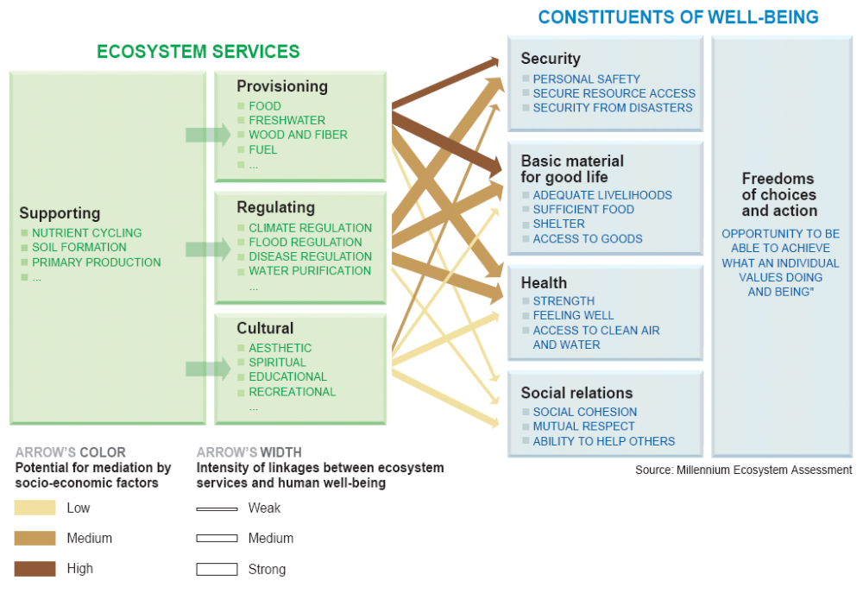
Figure B. Framework of interactions between biodiversity, ecosystem services, human well-being, and drivers of change. Changes in drivers that indirectly affect biodiversity, such as population, technology, and lifestyle (lower left corner of figure), can lead to changes in drivers directly affecting biodiversity, such as the catch of fish or the application of fertilizers (lower right corner). These result in changes to ecosystems and the services they provide (center), thereby affecting human well-being. These interactions can take place at more than one scale and can cross scales. For example, an international demand for timber may lead to a regional loss of forest cover, which increases flood magnitude along a local stretch of a river. Similarly, the interactions can take place across different time scales. Different strategies and interventions can be applied at many points in this framework to enhance human well-being and conserve ecosystems.
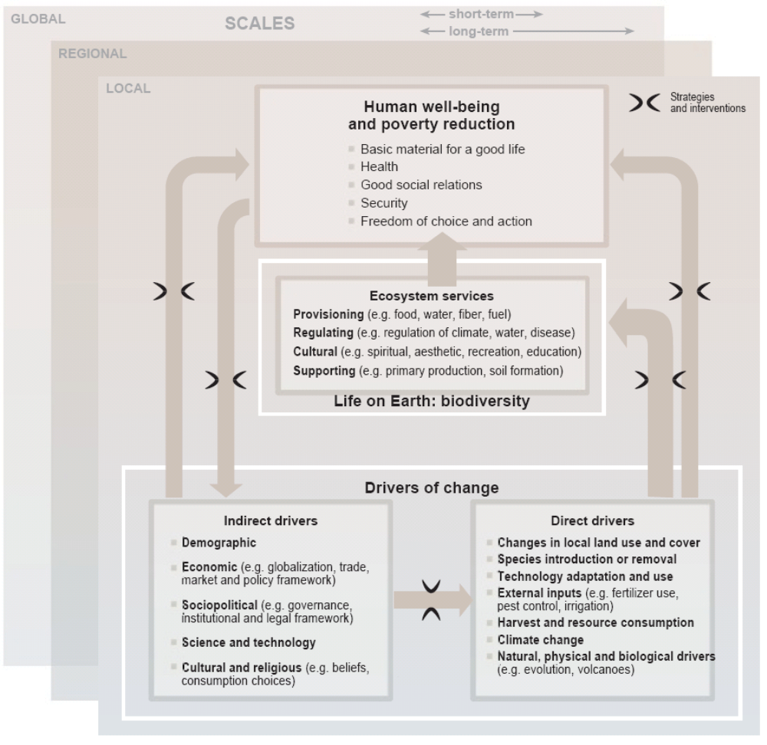

Reader’s Guide
This report presents a synthesis and integration of the findings of the four MA Working Groups along with more detailed findings for selected ecosystem services concerning condition and trends and scenarios (see Appendix A) and response options (see Appendix B). Five additional synthesis reports were prepared for ease of use by specific audiences: CBD (biodiversity), UNCCD (desertification), Ramsar Convention (wetlands), business, and the health sector. Each MA sub-global assessment will also produce additional reports to meet the needs of its own audience. The full technical assessment reports of the four MA Working Groups will be published in mid-2005 by Island Press. All printed materials of the assessment, along with core data and a glossary of terminology used in the technical reports, will be available on the Internet at www.MAweb.org. Appendix D lists the acronyms and abbreviations used in this report.
References that appear in parentheses in the body of this synthesis report are to the underlying chapters in the full technical assessment reports of each Working Group. (A list of the assessment report chapters is provided in Appendix E.) Bracketed references within the Summary for Decision-makers are to the chapters of this full synthesis report, where additional information on each topic can be found.
In this report, the following words have been used where appropriate to indicate judgmental estimates of certainty, based on the collective judgment of the authors, using the observational evidence, modeling results, and theory that they have examined: very certain (98% or greater probability), high certainty (85–98% probability), medium certainty (65–85% probability), low certainty (52–65% probability), and very uncertain (50–52% probability). In other instances, a qualitative scale to gauge the level of scientific understanding is used: well established, established but incomplete, competing explanations, and speculative. Each time these terms are used they appear in italics.
Throughout this report, dollar signs indicate U.S. dollars and tons means metric tons.

[Note: For ease of editing, figures referenced in the SDM are not currently repeated in the body of the document. In the next draft, the figures will appear both in the relevant chapter and in the SDM. The graphics in the SDM are penultimate drafts. Graphics in the body of the document are first drafts.]

Summary for Decision-makers
Everyone in the world depends completely on Earth’s ecosystems and the services they provide, such as food, water, disease management, climate regulation, spiritual fulfillment, and aesthetic enjoyment. Over the past 50 years, humans have changed these ecosystems more rapidly and extensively than in any comparable period of time in human history, largely to meet rapidly growing demands for food, fresh water, timber, fiber, and fuel. This transformation of the planet has contributed to substantial net gains in human well-being and economic development. But all regions and groups of people have not benefited from this process—in fact, many have been harmed. Moreover, the full costs associated with these gains are only now becoming apparent.
Three major problems associated with our management of the world’s ecosystems are already causing significant harm to people and will substantially diminish the long-term benefits we obtain from ecosystems:
- First, approximately 60% (15 out of 24) of the ecosystem services examined during the Millennium Ecosystem Assessment are being degraded or used unsustainably, including fresh water, capture fisheries, air and water purification, and the regulation of regional and local climate, natural hazards, and pests. The full costs of the loss and degradation of these ecosystem services are difficult to measure, but the available evidence indicates that they are substantial and growing. Many ecosystem services have been degraded as a consequence of actions taken to increase the supply of other services, such as food. These trade-offs often shift the costs of degradation from one group of people to another or defer costs to future generations.
- Second, there is established but incomplete evidence that changes being made in ecosystems are increasing the likelihood of nonlinear (that is, stepped) and potentially abrupt changes in ecosystems that have important consequences for human well-being. Examples of such changes include disease emergence, abrupt alterations in water quality, the creation of “dead zones” in coastal waters, the collapse of fisheries, and shifts in regional climate.
Four Main Findings
Over the past 50 years, humans have changed ecosystems more rapidly and extensively than in any comparable period of time in human history, largely to meet rapidly growing demands for food, fresh water, timber, fiber and fuel. This has resulted in a substantial and largely irreversible loss in the diversity of life on Earth.
The changes that have been made to ecosystems have contributed to substantial net gains in human well-being and economic development, but these gains have been achieved at growing costs in the form of the degradation of many ecosystem services, increased risks of nonlinear changes, and the exacerbation of poverty for some groups of people. These problems will substantially diminish the benefits that future generations obtain from ecosystems.
The degradation of ecosystem services could grow significantly worse during the first half of this century and is a barrier to achieving the Millennium Development Goals.
The challenge of reversing the degradation of ecosystems while meeting increasing demands for their services can be met under some scenarios involving significant policy and institutional changes, but these changes are large and not currently under way. Many options exist to conserve or enhance specific ecosystem services in ways that reduce negative trade-offs or that provide positive synergies with other ecosystem services.

- Third, the degradation of ecosystem services is harming many of the world’s poorest people, which is contributing to growing inequities and disparities across groups of people and is sometimes the principal factor causing poverty. This is not to say that ecosystem changes such as increased food production have not also helped to lift hundreds of millions of people out of poverty, but these changes have harmed many other individuals and communities, and their plight has been largely overlooked. In some regions, such as sub-Saharan Africa, the condition and management of ecosystem services is a dominant factor influencing prospects for reducing poverty.
The ongoing degradation of ecosystem services is a significant barrier to achieving the Millennium Development Goals agreed to by the international community in September 2000. And the harmful consequences of this degradation could grow significantly worse n the next 50 years. Already, the regions facing the greatest challenges in achieving the MDGs coincide with those facing significant problems of ecosystem degradation: sub-Saharan Africa, Central Asia, and parts of South and Southeast Asia, as well as some regions in Latin America. The consumption of ecosystem services, which is already unsustainable in many cases, will continue to grow as a consequence of a likely three- to sixfold increase in global GDP by 2050 even while global population growth is expected to slow and level off in mid-century. Most of the important direct drivers of ecosystem change are unlikely to diminish in the first half of the century and two drivers—climate change and excessive nutrient loading—will become more severe. Any progress achieved in addressing the MDGs of poverty and hunger eradication, improved health, and environmental protection is unlikely to be sustained if most of the ecosystem services on which humanity relies continue to be degraded.
There is no simple fix to these problems since they arise from the interaction of many recognized challenges, including climate change, biodiversity loss, and land degradation, each of which is complex to address in its own right. Nevertheless, there is tremendous scope for action that could lessen the severity of these problems in the coming decades. Indeed, three of four detailed scenarios examined by the MA show that significant changes in policy can mitigate many of the negative consequences of growing pressures on ecosystems. But the changes required are substantial and are not currently under way.
An effective set of responses to ensure the sustainable management of ecosystems requires changes in institutions and governance, economic policies and incentives, social and behavior factors, technology, and knowledge. Actions such as the integration of ecosystem management goals in other sectors, increased transparency and accountability of government and private-sector performance in ecosystem management, elimination of perverse subsidies, greater use of economic instruments and market-based approaches, empowerment of groups dependent on ecosystem services or affected by their degradation, promotion of technologies enabling increased crop yields without harmful environmental impacts, ecosystem restoration, and the incorporation of nonmarket values of ecosystems in management decisions all could substantially lessen the severity of these problems in the next several decades.
The remainder of this Summary for Decision-makers presents the four major findings of the Millennium Ecosystem Assessment on the problems to be addressed and the actions needed to enhance the conservation and sustainable use of ecosystems.
Finding #1: Over the past 50 years, humans have changed ecosystems more rapidly and extensively than in any comparable period of time in human history, largely to meet rapidly growing demands for food, fresh water, timber, fiber and fuel. This has resulted in a substantial and largely irreversible loss in the diversity of life on Earth.
The structure and functioning of the world’s ecosystems changed more rapidly in the second half of the twentieth century than at any time in human history. [1]
- More land was converted to cropland since 1945 than in the eighteenth and nineteenth centuries combined. Cultivated systems (areas where at least 30% of the landscape is in croplands, shifting cultivation, confined livestock production, or freshwater aquaculture) now cover one quarter of Earth’s terrestrial surface. (See Figure 1.) Areas of rapid change in forest land cover and land degradation are shown in Figure 2.
- Approximately one quarter of the world’s coral reefs were badly degraded or destroyed in the last several decades of the twentieth century, and approximately 35% of mangrove area has been lost in this time (in countries for which sufficient data exist, which encompass about half of the area of mangroves).
- The amount of water impounded behind dams quadrupled since 1960, and three to six times as much water is held in reservoirs as in natural rivers. Water withdrawals from rivers and lakes doubled since 1960; most water use (70% worldwide) is for agriculture.
- Since 1960, flows of reactive (biologically available) nitrogen in terrestrial ecosystems have doubled, and flows of phosphorus have tripled. More than half of all the synthetic nitrogen fertilizer, which was first manufactured in 1913, ever used on the planet has been used since 1985.
- Since 1750, the atmospheric concentration of carbon dioxide has increased by about 32% (from about 280 to 376 parts per million in 2003), primarily due to the combustion of fossil fuels and land use changes. Approximately 60% of that increase (60 parts per million) has taken place since 1959.

Humans are fundamentally, and to a significant extent irreversibly, changing the diversity of life on Earth, and most of these changes represent a loss of biodiversity. [1]
- More than two thirds of the area of 2 of the world’s 14 major terrestrial biomes (temperate grasslands and Mediterranean forests) and more than half of the area of four other biomes (tropical dry forests, temperate broadleaf forests, tropical grassland, and flooded grasslands) had been converted by 1990, primarily to agriculture. (See Figure 3.)
- Across a range of taxonomic groups, either the population size or range or both of the majority of species is currently declining.
- The distribution of species on Earth is becoming more homogenous; in other words, the set of species in any one region of the world are becoming more similar to other regions primarily as a result of the massive movement of species associated with increased travel and shipping.
- The number of species on the planet is declining. Over the past few hundred years, humans have increased the species extinction rate by between 50 and 1,000 times over background rates typical over the planet’s history. (See Figure 4.) Some 10–30% of mammal, bird, and amphibian species are currently threatened with extinction.
- Genetic diversity has declined globally, particularly among cultivated species.
Most changes to ecosystems have been made to meet a dramatic growth in the demand for food, water, timber, fiber, and fuel. [2] Some ecosystem changes have been the inadvertent result of activities unrelated to the use of ecosystem services, such as the construction of roads, ports, and cities and the discharge of pollutants. But most ecosystem changes were the direct or indirect result of changes made to meet growing demands for ecosystem services, and in particular growing demands for food, water, timber, fiber, and fuel (fuelwood and hydropower). Between 1960 and 2000, the demand for ecosystem services grew significantly as world population doubled to 6 billion people and the global economy increased more than sixfold. To meet this demand, food production increased by roughly two-and-a-half times, water use doubled, wood harvests for pulp and paper production tripled, installed hydropower capacity doubled, and timber production increased by more than half.
The growing demand for these ecosystem services was met both by consuming an increasing fraction of the available supply (for example, diverting more water for irrigation or capturing more fish from the sea) and by raising the production of some services, such as crops and livestock. The latter has been accomplished through the use of new technologies (such as new crop varieties, fertilization, and irrigation) as well as through increasing the area managed for the services in the case of crop and livestock production and aquaculture.
Finding #2: The changes that have been made to ecosystems have contributed to substantial net gains in human well-being and economic development, but these gains have been achieved at growing costs in the form of the degradation of many ecosystem services, increased risks of nonlinear changes, and the exacerbation of poverty for some groups of people. These problems will substantially diminish the benefits that future generations obtain from ecosystems.
In the aggregate, and for most countries, changes made to the world’s ecosystems in recent decades have provided substantial benefits for human well-being and national development. [3] Many of the most significant changes to ecosystems have been essential to meet growing needs for food and water; these changes have helped reduce the proportion of malnourished people and improved human health. Agriculture, including fisheries, and forestry have been the mainstay of strategies for the development of countries for centuries, providing revenues that have enabled investments in industrialization and poverty alleviation. Although the value of food production in 2000 was only about 3% of global gross domestic product, the agricultural labor force accounts for approximately 22% of the world’s population, half the world’s total labor force, and 24% of GDP in countries with a per capita GNP less than $765 (the low-income developing countries, as defined by the World Bank).
These gains have been achieved, however, at growing costs in the form of the degradation of many ecosystem services, increased risks of large nonlinear changes in ecosystems, and the exacerbation of poverty for some people and a contribution to growing inequities and disparities across groups of people.
Degradation and Unsustainable Use of Ecosystem Services
Approximately 60% (15 out of 24) of the ecosystem services evaluated in this assessment (including 70% of regulating and cultural services) are being degraded or used unsustainably. [2] (See Table 1.) Ecosystem services that have been degraded over the past 50 years include capture fisheries, water supply, waste treatment and detoxification, water purification, natural hazard protection, regulation of air quality, regulation of regional and local climate, regulation of erosion, spiritual fulfillment, and aesthetic enjoyment. The use of two ecosystem services—capture fisheries and fresh water—is now well beyond levels that can be sustained even at current demands, much less future ones. At least one quarter of important commercial fish stocks are overharvested (high certainty). (See Figures 5, 6, and 7.) From 5% to possibly 25% of global freshwater use exceeds long-term accessible supplies and is now met either through engineered water transfers or overdraft of groundwater supplies (low to medium certainty). Some 15–35% of irrigation withdrawals exceed supply rates and are therefore unsustainable (low to medium certainty). While 15 services have been degraded, only 4 have been enhanced in the past 50 years, three of which involve food production: crops, livestock, and aquaculture. Terrestrial ecosystems were on average a net source of CO₂ emissions during the nineteenth and early twentieth centuries, but became a net sink around the middle of the last century, and thus in the last 50 years the role of ecosystems in regulating global climate through carbon sequestration has also been enhanced.
Actions to increase one ecosystem service often cause the degradation of other services. [2, 6] For example, because actions to increase food production typically involve increased use of water and fertilizers or expansion of the area of cultivated land, these same actions often degrade other ecosystem services, including reducing the availability of water for other uses, degrading water quality, reducing biodiversity, and decreasing forest cover (which in turn may lead to the loss of forest products and the release of greenhouse gasses). Similarly, the conversion of forest to agriculture can significantly change the frequency and magnitude of floods, although the nature of this impact depends on the characteristics of the local ecosystem and the type of land cover change.
The degradation of ecosystem services often causes significant harm to human well-being. [3, 6] The information available to assess the consequences of changes in ecosystem services for human well-being is relatively limited. Many ecosystem services have not been monitored, and it is also difficult to estimate the influence of changes in ecosystem services relative to other social, cultural, and economic factors that also affect human well-being. Nevertheless, the following types of evidence indicate that the harmful effects of the degradation of ecosystem services on livelihoods, health, and local and national economies are substantial.
- Most resource management decisions are most strongly influenced by ecosystem services entering markets; as a result, the nonmarketed benefits are often lost or degraded. These nonmarketed benefits are often high and sometimes more valuable than the marketed ones. For example, one of the most comprehensive studies to date, which examined the marketed and nonmarketed economic values associated with forests in eight Mediterranean countries, found that timber and fuelwood generally accounted for less than a third of total economic value of forests in each country. (See Figure 8.) Values associated with non-timber forest products, recreation, hunting, watershed protection, carbon sequestration, and passive use (values independent of direct uses) accounted for between 25% and 96% of the total economic value of the forests.

- The total economic value associated with managing ecosystems more sustainably is often higher than the value associated with the conversion of the ecosystem through farming, logging, or other intensive uses. Relatively few studies have compared the total economic value (including values of both marketed and nonmarketed ecosystem services) of ecosystems under alternate management regimes, but some of the studies that do exist have found the benefit of managing the ecosystem more sustainably exceeded that of converting the ecosystem. (See Figure 9.)

- The economic and public health costs associated with damage to ecosystem services can be substantial.
  - The early 1990s collapse of the Newfoundland cod fishery due to overfishing resulted in the loss of tens of thousands of jobs and has cost at least $2 billion in income support and retraining.
  - In 1996, the costs to U.K. agriculture associated with damage to water (pollution, eutrophication), air (emissions of greenhouse gases), soil (off-site erosion damage, carbon dioxide loss), and biodiversity was $2.6 billion, or 9% of average yearly gross farm receipts for the 1990s. Similarly, the damage costs of freshwater eutrophication alone in England and Wales (involving factors including reduced value of waterfront dwellings, water treatment costs, reduced recreational value of water bodies, and tourism losses) was estimated to be $105–160 million per year in the 1990s, with an additional $77 million a year being spent to address those damages.
  - The incidence of diseases of marine organisms and the emergence of new pathogens is increasing, and some of these, such as the tropical fish disease ciguatera, harm human health. Episodes of harmful (including toxic) algal blooms in coastal waters are increasing in frequency and intensity, harming other marine resources such as fisheries as well as human health. In a particularly severe outbreak in Italy in 1989, harmful algal blooms cost the coastal aquaculture industry $10 million and the Italian tourism industry $11.4 million.
  - The frequency and impact of floods and fires has increased significantly in the past 50 years, in part due to ecosystem changes. Examples are the increased susceptibility of coastal populations to tropical storms when mangrove forests are cleared and the increase in downstream flooding that followed land use changes in the upper Yangtze River. Annual economic losses from extreme events increased tenfold from the 1950s to approximately $70 billion in 2003, of which natural catastrophes (floods, fires, storms, drought, earthquakes) accounted for 84% of insured losses.
  - The impact of the loss of cultural services is particularly difficult to measure, but it is especially important for some people. Human cultures, knowledge systems, religions, and social interactions have been strongly influenced by ecosystems. A number of the MA sub-global assessments found that spiritual and cultural values of ecosystems were as important as other services for many local communities, both in developing countries (the importance of sacred groves of forest in India, for example) and industrial ones (the importance of urban parks, for instance).

The degradation of ecosystem services represents loss of a capital asset. [3] Both renewable resources such as ecosystem services and nonrenewable resources such as mineral deposits, soil nutrients, and fossil fuels are capital assets. Yet traditional national accounts do not include measures of resource depletion or of the degradation of these resources. As a result, a country could cut its forests and deplete its fisheries, and this would show only as a positive gain in GDP (a measure of current well-being) without registering the corresponding decline in assets (wealth) that is the more appropriate measure of future well-being. Moreover, many ecosystem services (such as fresh water in aquifers and the use of the atmosphere as a sink for pollutants) are available freely to those who use them, and so again their degradation is not reflected in standard economic measures.
When estimates of the economic losses associated with the depletion of natural assets are factored into measurements of the total wealth of nations, they significantly change the balance sheet of countries with economies significantly dependent on natural resources. For example, countries such as Ecuador, Ethiopia, Kazakhstan, Democratic Republic of Congo, Trinidad and Tobago, Uzbekistan, and Venezuela that had positive growth in net savings in 2001, reflecting a growth in the net wealth of the country, actually experienced a loss in net savings when depletion of natural resources (energy and forests) and estimated damages from carbon emissions (associated with contributions to climate change) were factored into the accounts.
While degradation of one service may sometimes be warranted to produce a gain in another service, more degradation of ecosystem services takes place than is in society’s interests because many of the services degraded are “public goods.” [3] Although people benefit from ecosystem services such as the regulation of air and water quality or the presence of an aesthetically pleasing landscape, there is no market for these services and no one person has an incentive to pay to maintain the good. And when an action results in the degradation of a service that harms another individual, no market mechanism exists (nor, in many cases, could it exist) to ensure that the individuals harmed are compensated for the damages they suffer.
It is difficult to assess the implications of ecosystem changes and to manage ecosystems effectively because many of the effects are slow to become apparent, because they may be expressed primarily at some distance from where the ecosystem was changed, and because the costs and benefits of changes often accrue to different sets of stakeholders. [7] Substantial inertia (delay in the response of a system to a disturbance) exists in ecological systems. As a result, long time lags often occur between a change in a driver and the time when the full consequences of that change become apparent. For example, phosphorus is accumulating in large quantities in many agricultural soils, threatening rivers, lakes, and coastal oceans with increased eutrophication (a process whereby excessive plant growth depletes oxygen in the water). But it may take years or decades for the full impact of the phosphorus to become apparent through erosion and other processes. Similarly, it will take centuries for global temperatures to reach equilibrium with changed concentrations of greenhouse gases in the atmosphere and even more time for biological systems to respond to the changes in climate.
Moreover, some of the impacts of ecosystem changes may be experienced only at some distance from where the change occurred. For example, changes in upstream catchments affect water flow and water quality in downstream regions; similarly, the loss of an important fish nursery area in a coastal wetland may diminish fish catch some distance away. Both the inertia in ecological systems and the spatial separation of costs and benefits of ecosystem changes often result in situations where the individuals experiencing harm from ecosystem changes (future generations, say, or downstream landowners) are not the same as the individuals gaining the benefits. These temporal and spatial patterns make it extremely difficult to fully assess costs and benefits associated with ecosystem changes or to attribute costs and benefits to different stakeholders. Moreover, the institutional arrangements now in place to manage ecosystems are poorly designed to cope with these challenges.
Increased Likelihood of Nonlinear (Stepped) and Potentially Abrupt Changes in Ecosystems
There is established but incomplete evidence that changes being made in ecosystems are increasing the likelihood of nonlinear and potentially abrupt changes in ecosystems, with important consequences for human well-being. [7] Changes in ecosystems generally take place gradually. Some changes are nonlinear, however: once a threshold is crossed, the system changes to a very different state. And these nonlinear changes are sometimes abrupt; they can also be large in magnitude and difficult, expensive, or impossible to reverse. Capabilities for predicting some nonlinear changes are improving, but for most ecosystems and for most potential nonlinear changes, science cannot predict the thresholds at which the change will be encountered. Examples of large-magnitude nonlinear changes include:
- Disease emergence. The almost instantaneous outbreak of SARS in different parts of the world is an example of such potential.
- Eutrophication and hypoxia. Once a threshold of nutrient loading is achieved, changes in freshwater and coastal ecosystems can be abrupt and extensive, creating harmful algal blooms (including blooms of toxic species) and sometimes leading to the formation of oxygen-depleted zones, killing all animal life.
- Fisheries collapse. For example, the Atlantic cod stocks off the east coast of Newfoundland collapsed in 1992, forcing the closure of the fishery after hundreds of years of exploitation. (See Figure 10.) Most important, depleted stocks may not recover even if harvesting is significantly reduced or eliminated entirely.
- Species introductions and losses. The introduction of the zebra mussel into aquatic systems in the United States, for instance, resulted in the extirpation of native clams in Lake St. Clair and annual costs of $100 million to the power industry and other users.
- Regional climate change. Deforestation generally leads to decreased rainfall. Since forest existence crucially depends on rainfall, the relationship between forest loss and precipitation decrease can form a positive feedback, which, under certain conditions, can lead to a nonlinear change in forest cover.
The growing bushmeat trade poses particularly significant threats associated with nonlinear changes. [7] Growth in the use and trade of bushmeat is placing increasing pressure on many species, especially in Africa and Asia. Once this pressure exceeds levels of sustainable harvest, the populations of the harvested species are likely to decline rapidly. This will place them at risk of extinction and also result in significant harm to the food supply of people dependent on these resources. At the same time, the bushmeat trade involves relatively high levels of interaction between humans and some relatively closely related wild animals that are eaten, and this increases the risk of emergence of new and serious pathogens, as took place in the case of HIV/AIDs. Given the speed and magnitude of international travel today, new pathogens could spread rapidly around the world.
The increased likelihood of these non-linear changes stems from the loss of biodiversity and growing pressures from multiple direct drivers of ecosystem change. [7] The loss of species and genetic diversity decreases the resilience of ecosystems, which is their ability to maintain particular ecosystem services as conditions change. In addition, growing pressures from drivers such as overharvesting, climate change, invasive species, and nutrient loading push ecosystems toward thresholds that they might otherwise not encounter.

Exacerbation of Poverty for Some People and Contribution to Growing Inequities and Disparities across Groups of People
Despite the progress achieved in increasing the production and use of some ecosystem services, levels of poverty remain high, inequities are growing, and many people still do not have a sufficient supply of or access to ecosystem services. [3]
- In 2001, just over 1 billion people survived on less than $1 per day of income, with roughly 70% of them in rural areas where they are highly dependent on agriculture, grazing, and hunting for subsistence.
- Inequality in income and other measures of human well-being has increased over the past decade. A child born in sub-Saharan Africa is 20 times more likely to die before age 5 than a child born in an industrial country, and this disparity is higher than it was a decade ago. During the 1990s, 21 countries experienced declines in their rankings in the Human Development Index (an aggregate measure of economic well-being, health, and education); 14 of them were in sub-Saharan Africa.
- Despite the growth in per capita food production in the past four decades, an estimated 856 million people were undernourished in 2000–02, up 32 million from the period 1995–97. South Asia and sub-Saharan Africa, the regions with the largest numbers of undernourished people, are also the regions where growth in per capita food production has been the slowest. Most notably, per capita food production has declined in sub-Saharan Africa.
- Some 1.1 billion people still lack access to improved water supply, and more than 2.6 billion lack access to improved sanitation. Water scarcity affects roughly 1–2 billion people worldwide. Since 1960, ratio of water use to accessible supply has grown by 20% per decade.
The degradation of ecosystem services is harming many of the world’s poorest people and is sometimes the principal factor causing poverty. [3, 6] Despite the fact that ecosystem changes such as increased food production have helped lift hundreds of millions of people out of poverty, these changes have harmed many other communities whose plight has been largely overlooked.
- Half the urban population in Africa, Asia, Latin America, and the Caribbean suffers from one or more diseases associated with inadequate water and sanitation. Worldwide, approximately 1.8 million people die annually as a result of inadequate water, sanitation, and hygiene.
- The declining state of capture fisheries is reducing an inexpensive source of protein in developing countries. Per capita fish consumption in developing countries, excluding China, declined between 1985 and 1997.

The pattern of “winners” and “losers” associated with ecosystem changes—and in particular the impact of ecosystem changes on poor people, women, and indigenous peoples—has not been adequately taken into account in management decisions. [3, 6] Changes in ecosystems typically yield benefits for some people and exact costs on others who may either lose access to resources or livelihoods or be affected by externalities associated with the change. For several reasons, groups such as the poor, women, and indigenous communities have tended to be harmed by these changes.
- Many changes in ecosystem management have involved the privatization of what were formerly common pool resources. Individuals who depended on those resources (such as indigenous peoples, forest-dependent communities, and other groups relatively marginalized from political and economic sources of power) have often lost rights to the resources.
- Some of the people and places affected by changes in ecosystems and ecosystem services are highly vulnerable and poorly equipped to cope with the major changes in ecosystems that may occur. Highly vulnerable groups include those whose needs for ecosystem services already exceed the supply, such as people lacking adequate clean water supplies, and people living in areas with declining per capita agricultural production.
- Significant differences between the roles and rights of men and women in developing countries lead to increased vulnerability of women to changes in ecosystem services.
- The reliance of the rural poor on ecosystem services is rarely measured and thus typically overlooked in national statistics and poverty assessments, resulting in inappropriate strategies that do not take into account the role of the environment in poverty reduction. For example, a recent study that synthesized data from 17 countries found that 22% of household income for rural communities in forested regions comes from sources typically not included in national statistics, such as harvesting wild food, fuelwood, fodder, medicinal plants, and timber. These activities generated a much higher proportion of poorer families’ total income, and this income was of particular significance in periods of both predictable and unpredictable shortfalls in other livelihood sources.
Development prospects in dryland regions of developing countries are especially dependent on actions to avoid the degradation of ecosystems and slow or reverse degradation where it is occurring. [3, 5] Dryland systems cover about 41% of Earth’s land surface and more than 2 billion people inhabit them, 90% of whom are in developing countries. Dryland ecosystems (encompassing both rural and urban regions of drylands) experienced the highest population growth rate in the 1990s of any of the systems examined in the MA. (See Figure 11.) Although drylands are home to about one third of the human population, they have only 8% of the world’s renewable water supply. Given the low and variable rainfall, high temperatures, low soil organic matter, and poor potential for infrastructure (low population densities), people living in drylands face many challenges. They also tend to have the lowest levels of human well-being, including the lowest per capita GDP and the highest infant mortality rates.
The combination of high variability in environmental conditions and relatively high levels of poverty leads to situations where people can be highly vulnerable to changes in ecosystems, although the presence of these conditions has led to the development of very resilient land management strategies. Pressures on dryland ecosystems already exceed sustainable levels for some ecosystem services, such as water supply, and are growing. Per capita water availability is currently only two thirds of the level required for minimum levels of human well-being. Approximately 10–20% of the world’s drylands are degraded (medium certainty). Despite these tremendous challenges, people living in drylands and their land management systems have a proven resilience and the capability of preventing land degradation, although this can be either undermined or enhanced by public policies and development strategies.
Wealthy populations cannot be fully insulated from the degradation of ecosystem services. [3] Agriculture, fisheries, and forestry once formed the bulk of national economies, and the control of natural resources dominated policy agendas. But while these natural resource industries are often still important, the relative economic and political significance of other industries in industrial countries has grown over the past century as a result of the ongoing transition from agricultural to industrial and service economies, urbanization, and the development of new technologies to increase the production of some services and provide substitutes for others. Nevertheless, the degradation of ecosystem services influences human well-being in industrial regions and among wealthy populations in developing countries in many ways:
- The physical, economic, or social impacts of ecosystem service degradation may cross boundaries. (See Figure 12.) For example, land degradation or fires in one country can degrade air quality (dust and smoke) in other countries nearby. Degradation of ecosystem services exacerbates poverty in developing countries, which can affect neighboring industrial countries by slowing regional economic growth and contributing to the outbreak of conflicts or the migration of refugees.
- Many sectors of industrial countries still depend directly on ecosystem services. The collapse of fisheries, for example, has harmed many communities in industrial countries.
- Wealthy populations of people are insulated from the harmful effects of some aspects of ecosystem degradation, but not all. For example, substitutes are typically not available when cultural services are lost.
- Even though the relative economic importance of agriculture, fisheries, and forestry is declining in industrial countries, the importance of other ecosystem services such as aesthetic enjoyment and recreational options is growing.

Finding #3: The degradation of ecosystem services could grow significantly worse during the first half of this century and is a barrier to achieving the Millennium Development Goals.
The MA developed four scenarios to explore plausible futures for ecosystems and human well-being. (See Box 1.) The scenarios explored two global development paths, one in which the world becomes increasingly globalized and the other in which it becomes increasingly regionalized, as well as two different approaches to ecosystem management, one in which actions are reactive and most problems are addressed only after they become obvious and the other in which ecosystem management is proactive and policies deliberately seek to maintain ecosystem services for the long term.

Most of the direct drivers of degradation in ecosystem services currently remain constant or are growing in intensity in most ecosystems. (See Figure 13.) In all four MA scenarios, the pressures on ecosystems are projected to continue to grow during the first half of this century. [4, 5] The most important direct drivers of change in ecosystem services are habitat change (land use change and physical modification of rivers or water withdrawal from rivers), overexploitation, invasive alien species, pollution, and climate change. These direct drivers are often synergistic. For example, in some locations land use change can result in greater nutrient loading (if the land is converted to high-intensity agriculture), increased climate forcing (if forest is cleared), and increased numbers of invasive species (due to the disturbed habitat).
- Habitat transformation, particularly from conversion to agriculture: Under the MA scenarios, a further 10–20% of grassland and forestland is projected to be converted between 2000 and 2050 (primarily to agriculture). (See Figure 2.) The projected land conversion is concentrated in low-income countries and arid regions. (Forest cover is projected to continue to increase within industrial countries.)
- Overexploitation, especially overfishing: In some marine systems the biomass of targeted species and those caught incidentally (bycatch) has been reduced by up to one or more orders of magnitude from preindustrial fishing levels, and the fish being harvested are increasingly coming from the less valuable lower trophic levels as populations of higher trophic level species are depleted. (See Figure 6.) These pressures continue to grow in all the MA scenarios.
Box 1. MA Scenarios

The MA developed four scenarios to explore plausible futures for ecosystems and human well-being:

Global Orchestration – This scenario depicts a globally connected society that focuses on global trade and economic liberalization and takes a reactive approach to ecosystem problems but that also takes strong steps to reduce poverty and inequality and to invest in public goods such as infrastructure and education.
Order from Strength – This scenario represents a regionalized and fragmented world, concerned with security and protection, emphasizing primarily regional markets, paying little attention to public goods, and taking a reactive approach to ecosystem problems.
Adapting Mosaic – In this scenario, regional watershed-scale ecosystems are the focus of political and economic activity. Local institutions are strengthened and local ecosystem management strategies are common; societies develop a strongly proactive approach to the management of ecosystems.
TechnoGarden – This scenario depicts a globally connected world relying strongly on environmentally sound technology, using highly managed, often engineered, ecosystems to deliver ecosystem services, and taking a proactive approach to the management of ecosystems in an effort to avoid problems.

The scenarios are not predictions; instead they were developed to explore the unpredictable and uncontrollable features of change in ecosystem services and a number of socioeconomic factors. No scenario represents business as usual, although all begin from current conditions and trends.

Both quantitative models and qualitative analyses were used to develop the scenarios. For some drivers (such as economic growth, land use change, and carbon emissions) and ecosystem services (water withdrawals, food production), quantitative projections were calculated using established, peer-reviewed global models. Other drivers (such as rates of technological change), ecosystem services (particularly supporting and cultural services, such as soil formation and recreational opportunities), and human well-being indicators (such as human health and social relations), for which there are no appropriate global models, were estimated qualitatively. In general, the quantitative models used for these scenarios addressed incremental changes but failed to address thresholds, risk of extreme events, or impacts of large, extremely costly, or irreversible changes in ecosystem services. These phenomena were addressed qualitatively by considering the risks and impacts of large but unpredictable ecosystem changes in each scenario.

- Invasive alien species: The spread of invasive alien species and disease organisms continues to increase because of growing trade and travel, with significant harmful consequences to native species and many ecosystem services.
- Pollution, particularly nutrient loading: Humans have already doubled the flow of reactive nitrogen on the continents, and some projections suggest that this may increase by roughly a further two thirds by 2050. (See Figure 14.) The MA scenarios project that the global flux of nitrogen to coastal ecosystems will increase by a further 10–20% by 2030 (medium certainty), with almost all of this increase occurring in developing countries.
- Anthropogenic Climate Change: Observed recent changes in climate, especially warmer regional temperatures, have already had significant impacts on biodiversity and ecosystems, including causing changes in species distributions, population sizes, the timing of reproduction or migration events, and an increase in the frequency of pest and disease outbreaks. Many coral reefs have undergone major, although often partially reversible, bleaching episodes when local sea surface temperatures have increased by 1º Celsius during a single season.

By the end of the century, climate change and its impacts may be the dominant direct driver of biodiversity loss and changes in ecosystem services globally. Harm to biodiversity will grow worldwide with increasing rates of change in climate and increasing absolute amounts of change. In contrast, some ecosystem services in some regions may initially be enhanced by projected changes in climate (such as increases in temperature or precipitation), and thus these regions may experience net benefits at low levels of climate change. As climate change becomes more severe, however, the harmful impacts on ecosystem services outweigh the benefits in most regions of the world. The balance of scientific evidence suggests that there will be a significant net harmful impact on ecosystem services worldwide if glob mean surface temperature increases more than 2º Celsius above preindustrial levels or at rates greater than 0.2º Celsius per decade (medium certainty).
Under all four MA scenarios, the projected changes in drivers result in significant growth in consumption of ecosystem services, continued loss of biodiversity, and further degradation of some ecosystem services. [5]
- During the next 50 years, demand for food is projected to grow by 70–80% under the MA scenarios, and demand for water by between 30% and 85%. Water withdrawals in developing countries are projected to increase significantly under the scenarios, although these are projected to decline in industrial countries (medium certainty).
- Food security is not achieved under the MA scenarios by 2050, and child malnutrition would be difficult to eradicate (and is projected to increase in some regions in some MA scenarios) despite increasing food supply and more diversified diets (medium certainty).
- A severe deterioration of the services provided by freshwater resources (such as aquatic habitat, fish production, and water supply for households, industry, and agriculture) is found in the scenarios that are reactive to environmental problems. Less severe but still important declines are expected in the scenarios that are more proactive about environmental problems (medium certainty).
- Habitat loss and other ecosystem changes are projected to lead to a decline in local diversity of native species in all four MA scenarios by 2050 (high certainty). Globally, the equilibrium number of plant species is projected to be reduced by roughly 10–15% as the result of habitat loss alone over the period of 1970 to 2050 in the MA scenarios (low certainty), and other factors such as overharvesting, invasive species, pollution, and climate change will further increase the rate of extinction.
The degradation of ecosystem services poses a significant barrier to the achievement of the Millennium Development Goals and to the MDG targets for 2015. [3] The eight Millennium Development Goals adopted by the United Nations in 2000 aim to improve human well-being by reducing poverty, hunger, child and maternal mortality, by ensuring education for all, by controlling and managing diseases, by tackling gender disparity, by ensuring environmental sustainability, and by pursuing global partnerships. Under each of the MDGs, countries have agreed to targets to be achieved by 2015. The regions facing the greatest challenges in achieving these targets coincide with the regions facing the greatest problems of ecosystem degradation: sub-Saharan Africa, Central Asia, parts of South and Southeast Asia, and some regions in Latin America.

Although socioeconomic policy changes will play a primary role in achieving most of the MDGs, many of the targets (and goals) are unlikely to be achieved without significant improvement in management of ecosystems. The role of ecosystem changes in exacerbating poverty (Goal 1, Target 1) for some groups of people has been described already, and the goal of environmental sustainability (Goal 7) cannot be achieved as long as most ecosystem services are being degraded. Progress toward two other MDGs is particularly dependent on sound ecosystem management:
- Hunger (Goal 1, Target 2): All four MA scenarios project progress in the elimination of hunger but at rates far slower than needed to attain the internationally agreed target of halving, between 1990 and 2015, the share of people suffering from hunger. Moreover, the improvements are slowest in the regions in which the problems are greatest: South Asia and sub-Saharan Africa.
- Disease (Goal 6): Changes in ecosystems influence the abundance of human pathogens such as malaria and cholera as well as the risk of emergence of new diseases. Malaria is responsible for 11% of the disease burden in Africa, and it is estimated that Africa’s GDP could have been $100 billion larger in 2000 (roughly a 25% increase) if malaria had been eliminated 35 years ago. The following diseases are ranked as high priority for their large global burden of disease and their high sensitivity to ecological change: malaria, schistosomiasis, lymphatic filariasis, Japanese encephalitis, dengue fever, leishmaniasis, Chagas disease, meningitis, cholera, West Nile virus, and Lyme disease. In the more promising MA scenarios, progress toward Goal 6 is achieved, but under Order from Strength it is plausible that health and social conditions for the North and South could diverge, with disastrous health trends for many low-income regions.

Finding #4: The challenge of reversing the degradation of ecosystems while meeting increasing demands for their services can be met under some scenarios involving significant policy and institutional changes, but these changes are large and not currently under way. Many options exist to conserve or enhance specific ecosystem services in ways that reduce negative trade-offs or that provide positive synergies with other ecosystem services.
Three of the four MA scenarios show that significant changes in policy can mitigate many of the negative consequences of growing pressures on ecosystems, although the changes required are large and not currently under way. [5] Moreover, in all scenarios biodiversity continues to be lost and thus the long-term sustainability of actions to mitigate degradation of ecosystem services is uncertain. Provisioning, regulating, and cultural ecosystem services are projected to be in worse condition in 2050 than they are today in only one of the four MA scenarios (Order from Strength). At least one of the three categories of services is in better condition in 2050 than in 2000 in the other three scenarios. (See Figure 15.) The scale of interventions that result in these positive outcomes, however, are substantial and include significant investments in environmentally sound technology, active adaptive management, proactive action to address environmental problems before their full consequences are experienced, major investments in public goods (such as education and infrastructure), and strong action to reduce economic disparities and eliminate poverty.
Past actions to slow or reverse the degradation of ecosystems have yielded significant benefits, but these improvements have generally not kept pace with growing pressures and demands. [8] Although most ecosystem services assessed in the MA are being degraded, the extent of that degradation would have been much greater without responses implemented in past decades. For example, more than 100,000 protected areas (including strictly protected areas such as national parks as well as areas managed for the sustainable use of natural ecosystems, including timber or wildlife harvest) covering about 11.7% of the terrestrial surface have now been established, and these play an important role in the conservation of biodiversity and ecosystem services (although important gaps in the distribution of protected areas remain, particularly in marine and freshwater systems). Technological advances have also helped lessen the pressure on ecosystems per unit increase in demand for ecosystem services.
Substitutes can be developed for some but not all ecosystem services, but the cost of substitutes is generally high, and substitutes may also have other negative environmental consequences. [8] For example, the substitution of vinyl, plastics, and metal for wood has contributed to relatively slow growth in global timber consumption in recent years. But while the availability of substitutes can reduce pressure on specific ecosystem services, they may not always have positive net benefits on the environment. Substitution of fuelwood by fossil fuels, for example, reduces pressure on forests and lowers indoor air pollution but it also increases net greenhouse gas emissions. Substitutes are also often costlier to provide than the original ecosystem services.
Ecosystem degradation can rarely be reversed without actions that address the negative effects or enhance the positive effects of one or more of the five indirect drivers of change: population change (including growth and migration), change in economic activity (including economic growth, disparities in wealth, and trade patterns), sociopolitical factors (including factors ranging from the presence of conflict to public participation in decision-making), cultural factors, and technological change. [4] Collectively these factors influence the level of production and consumption of ecosystem services and the sustainability of the production. Both economic growth and population growth lead to increased consumption of ecosystem services, although the harmful environmental impacts of any particular level of consumption depend on the efficiency of the technologies used to produce the service. Too often, actions to slow ecosystem degradation do not address these indirect drivers. For example, forest management is influenced more strongly by actions outside the forest sector, such as trade policies and institutions, macroeconomic policies, and policies in other sectors such as agriculture, infrastructure, energy, and mining, than by those within it.
An effective set of responses to ensure the sustainable management of ecosystems must address the indirect and drivers just described and must overcome barriers related to [8]:
- Inappropriate institutional and governance arrangements, including the presence of corruption and weak systems of regulation and accountability.
- Market failures and the misalignment of economic incentives.
- Social and behavioral factors, including the lack of political and economic power of some groups (such as poor people, women, and indigenous peoples) that are particularly dependent on ecosystem services or harmed by their degradation.
- Underinvestment in the development and diffusion of technologies that could increase the efficiency of use of ecosystem services and could reduce the harmful impacts of various drivers of ecosystem change.
- Insufficient knowledge (as well as the poor use of existing knowledge) concerning ecosystem services and management, policy, technological, behavioral, and institutional responses that could enhance benefits from these services while conserving resources.

All these barriers are further compounded by weak human and institutional capacity related to the assessment and management of ecosystem services, underinvestment in the regulation and management of their use, lack of public awareness, and lack of awareness among decision-makers of both the threats posed by the degradation of ecosystem services and the opportunities that more sustainable management of ecosystems could provide.
The MA assessed 74 response options for eight ecosystem services and additional responses related to integrated ecosystem management and one driver, climate change. Many of these options hold significant promise for overcoming these barriers and conserving or sustainably enhancing the supply of ecosystem services. Promising options for specific sectors are shown in Box 2, while cross-cutting responses addressing key obstacles are described in the remainder of this section. [8]
Institutions and Governance
Changes in institutional and environmental governance frameworks are often required to create the enabling conditions for effective management of ecosystems. Today’s institutions were not designed to take into account the threats associated with the degradation of ecosystem services, nor are they well designed to deal with the management of common pool resources, a characteristic of many ecosystem services. Issues of ownership and access to resources, rights to participation in decision-making, and regulation of particular types of resource use or discharge of wastes can strongly influence the sustainability of ecosystem management and are fundamental determinants of who wins and loses from changes in ecosystems. Corruption, a major obstacle to effective management of ecosystems, also stems from weak systems of regulation and accountability.
Promising interventions include:
- Integration of ecosystem management goals within other sectors and within broader development planning frameworks. The most important public policy decisions affecting ecosystems are often made by agencies and in policy arenas other than those charged with protecting ecosystems. For example, the Poverty Reduction Strategy Papers prepared by developing-country governments in collaboration with the World Bank and other institutions strongly shape national development priorities, but these have not taken into account the importance of ecosystems to improving the basic human capabilities of the poorest.
- Increased coordination among multilateral environmental agreements and between environmental agreements and other international economic and social institutions. International agreements are indispensable for addressing ecosystem-related concerns that span national boundaries, but numerous obstacles weaken their current effectiveness. Steps are now being taken to increase the coordination among these mechanisms, and this could help to broaden the focus of the array of instruments. However, coordination is also needed between the multilateral environmental agreements and more politically powerful international institutions, such as economic and trade agreements, to ensure that they are not acting at cross-purposes.
Box 2. Promising Responses for Specific Sectors

Agriculture
- Removal of production subsidies that have adverse economic, social, and environmental effects.
- Investments in agricultural science and technology and natural resource management to support a new agricultural revolution to meet worldwide food needs.
- Use of response polices that recognize the role of women in the production and use of food and that are designed to empower women by providing knowledge and ensuring access to and control of resources necessary for food security.
- Application of a mix of regulatory and incentive- and market-based mechanisms to reduce overuse of nutrients.

Fisheries and Aquaculture
- Reduction of marine fishing capacity.
- Strict regulation of marine fisheries, especially with regards to fishing quotas.
- Establishment of appropriate regulatory systems to reduce the detrimental environmental impacts of aquaculture.

Water
- Payments for ecosystem services provided by watersheds.
- Improved allocation of rights to freshwater resources to align incentives with conservation needs.
- Increased transparency of information regarding water management and improved representation of marginalized stakeholders.
- Development of water markets and water pricing.
- Increased emphasis on the use of the natural environment and nonstructural measures for flood control.

Forestry
- Integration of agreed forest management practices in financial institutions, trade rules, global environment programs, and global security decision-making.
- Empowerment of local initiatives for sustainable use of forest products; these initiatives are collectively more significant than efforts led by governments or international processes but require their support to spread.
- Reform of forest governance and development of country-led, strategically focused national forest programs negotiated by stakeholders.

- Increased transparency and accountability of government and private-sector performance on decisions that have an impact on ecosystems, including through greater involvement of concerned stakeholders in decision-making. Laws, policies, institutions, and markets that have been shaped through public participation in decision-making are more likely to be effective and perceived as just. Stakeholder participation also contributes to the decision-making process because it allows a better understanding of impacts and vulnerability, the distribution of costs and benefits associated with trade-offs, and the identification of a broader range of response options that are available in a specific context. And stakeholder involvement and transparency of decision-making can increase accountability and reduce corruption.
Economics and Incentives
Economic and financial interventions provide powerful instruments to regulate the use of ecosystem goods and services. Because many ecosystem services are not traded in markets, markets fail to provide appropriate signals that might otherwise contribute to the efficient allocation and sustainable use of the services. A wide range of opportunities exists to influence human behavior to address this challenge in the form of economic and financial instruments. However, market mechanisms and most economic instruments can only work effectively if supporting institutions are in place, and thus there is a need to build institutional capacity to enable more widespread use of these mechanisms.
Promising interventions include:
- Elimination of subsidies that promote excessive use of ecosystem services (and, where possible, transfer these subsidies to payments for non-marketed ecosystem services). Government subsidies paid to the agricultural sectors of OECD countries between 2001 and 2003 averaged over $324 billion annually, or one third the global value of agricultural products in 2000. And a significant proportion of this total involved production subsidies that led to greater food production than the market conditions warranted, reduced the profitability of agriculture in developing countries, and promoted overuse of fertilizers and pesticides. Many countries outside the OECD also have inappropriate input and production subsidies, and inappropriate subsidies are common in other sectors such as water, fisheries, and forestry. Although removal of perverse subsidies will produce net benefits, it will not be without costs. Compensatory mechanisms may be needed for poor people who are adversely affected by the removal of subsidies, and removal of agricultural subsidies within the OECD would need to be accompanied by actions designed to minimize adverse impacts on ecosystem services in developing countries.
- Greater use of economic instruments and market-based approaches in the management of ecosystem services. These include:
  - Taxes or user fees for activities with “external” costs (trade-offs not accounted for in the market). Examples include taxes on excessive application of nutrients or ecotourism user fees.
  - Creation of markets, including through cap-and-trade systems. One of the most rapidly growing markets related to ecosystem services is the carbon market. Approximately 64 million tons of carbon dioxide equivalent were exchanged through projects from January to May 2004, nearly as much as during all of 2003. The value of carbon trades in 2003 was approximately $300 million. About one quarter of the trades involved investment in ecosystem services (hydropower or biomass). It is speculated that this market may grow to some $44 billion by 2010. The creation of a market in the form of a nutrient trading system may also be a low-cost way to reduce excessive nutrient loading in the United States.
  - Payment for ecosystem services. For example, in 1996 Costa Rica established a nationwide system of conservation payments to induce landowners to provide ecosystem services. Under this program, Costa Rica brokers contracts between international and domestic “buyers” and local “sellers” of sequestered carbon, biodiversity, watershed services, and scenic beauty. Another innovative conservation financing mechanism is “biodiversity offsets,” whereby developers pay for conservation activities as compensation for unavoidable harm that a project causes to biodiversity.
  - Mechanisms to enable consumer preferences to be expressed through markets. For example, current certification schemes for sustainable fisheries and forest practices provide people with the opportunity to promote sustainability through their consumer choices.
Social and Behavioral Responses

Social and behavioral responses—including population policy, public education, civil society actions, and empowerment of communities, women, and youth—can be instrumental in responding to the problem of ecosystem degradation. These are generally interventions that stakeholders initiate and execute through exercising their procedural or democratic rights in efforts to improve ecosystems and human well-being.
Promising interventions include:
- Changes in consumption. The choices about what individuals consume and how much are influenced not just by considerations of price but also by behavioral factors related to culture, ethics, and values. Behavioral changes that could reduce demand for threatened ecosystem services can be encouraged through actions by governments (such as education and public awareness programs or the promotion of demand-side management), industry (commitments to use raw materials that are from sources certified as being sustainable, for example, or improved product labeling), and civil society (through rasing public awareness).
- Communication and education. Improved communication and education are essential to achieve the objectives of environmental conventions and the Johannesburg Plan of Implementation as well as the sustainable management of natural resources more generally. Both the public and decision-makers can benefit from education concerning ecosystems and human well-being, but education more generally provides tremendous social benefits that can help address many indirect drivers of ecosystem degradation. While the importance of communication and education is well recognized, providing the human and financial resources to undertake effective work is a continuing problem.
- Empowerment of groups particularly dependent on ecosystem services or affected by their degradation, including women, indigenous peoples, and young people. Despite women’s knowledge about the environment and the potential they possess, their participation in decision-making has often been restricted by economic, social, and cultural structures. Young people are also key stakeholders in that they will experience the longer-term consequences of decisions made today concerning ecosystem services. Indigenous control of traditional homelands is often presented as having environmental benefits by indigenous peoples and their supporters, although the primary justification continues to be based on human and cultural rights.
Technological Responses
Given the growing demands for ecosystem services and other increased pressures on ecosystems, the development and diffusion of technologies designed to increase the efficiency of resource use or reduce the impacts of drivers such as climate change and nutrient loading are essential. Technological change has been essential for meeting growing demands for some ecosystem services, and technology holds considerable promise to help meet future growth in demand. Technologies already exist for reduction of nutrient pollution at reasonable costs, for example, but new policies are needed for these tools to be applied on a sufficient scale to slow and ultimately reverse the increase in nutrient loading (even while increasing nutrient application in relatively poor regions such as sub-Saharan Africa). However, negative impacts on ecosystems and human well-being have sometimes resulted from new technologies, and thus careful assessment is needed prior to their introduction.
Promising interventions include:
  - Promotion of technologies that enable increased crop yields without harmful impacts related to water, nutrient, and pesticide use. Agricultural expansion will continue to be one of the major drivers of biodiversity loss well into the twenty-first century. Development, assessment, and diffusion of technologies that could increase the production of food per unit area sustainably without harmful trade-offs related to excessive consumption of water or use of nutrients or pesticides would significantly lessen pressure on other ecosystem services.
  - Restoration of ecosystem services. Ecosystem restoration activities are now common in many countries. Ecosystems similar to the ones that were present before conversion can often be established and can provide some of the original ecosystem services. However, the cost of restoration is generally extremely high compared with the cost of preventing the degradation of the ecosystem.
Knowledge and Cognitive Responses
Effective management of ecosystems is constrained both by the lack of knowledge and information about different aspects of ecosystems and by the failure to use adequately the information that does exist in support of management decisions. [8, 9] Although sufficient information exists to take many actions that could help conserve ecosystems and enhance human well-being, major information gaps exist. In most regions, for example, relatively limited information exists about the status and economic value of most ecosystem services, and their depletion is rarely tracked in national economic accounts. Limited information exists about the likelihood of nonlinear changes in ecosystems or the location of thresholds where such changes may be encountered. Basic global data on the extent and trend in different types of ecosystems and land use are surprisingly scarce. Models used to project future environmental and economic conditions have limited capability of incorporating ecological “feedbacks,” including non-linear changes in ecosystems, as well as behavioral feedbacks such as learning that may take place through adaptive management of ecosystems.
At the same time, decision-makers do not use all of the relevant information that is available. This is due in part to institutional failures that prevent existing policy-relevant scientific information from being made available to decision-makers and in part to the failure to incorporate other forms of knowledge and information (such as traditional knowledge and practitioners’ knowledge) that are often of considerable value for ecosystem management.
Promising interventions include:
- Incorporation of nonmarket values of ecosystems in resource management decisions. Most resource management decisions are strongly influenced by considerations of the monetary costs and benefits of alternative policy choices. Decisions can be improved if they are informed by the total economic value of alternative management options and involve deliberative mechanisms that bring to bear noneconomic considerations as well.
- Use of all relevant forms of knowledge and information in assessments and decision-making, including traditional and practitioners' knowledge. Effective management of ecosystems typically requires “place-based” knowledge—that is, information about the specific characteristics and history of an ecosystem. Traditional knowledge or practitioners' knowledge held by local resource managers can often be of considerable value in resource management, but it is too rarely incorporated into decision-making processes and indeed is often inappropriately dismissed.
- Enhancement of human and institutional capacity for assessing the consequences of ecosystem change for human well-being and acting on such assessments. Greater technical capacity is needed for agriculture, forest, and fisheries management. But the capacity that exists for these sectors, as limited as it is in many countries, is still vastly greater than the capacity for effective management of other ecosystem services.
A variety of frameworks and methods can be used to make better decisions in the face of uncertainties in data, prediction, context, and scale. Active adaptive management can be a particularly valuable tool for reducing uncertainty about ecosystem management decisions. Commonly used decision-support methods include cost-benefit analysis, risk assessment, multicriteria analysis, the precautionary principle, and vulnerability analysis. Scenarios also provide one means to cope with many aspects of uncertainty, but our limited understanding of ecological and human response process shrouds any individual scenario in its own characteristic uncertainty. Active adaptive management is a tool that can be particularly valuable given the high levels of uncertainty surrounding coupled socioecological systems. This involves the design of management programs to test hypotheses about how components of an ecosystem function and interact, thereby reducing uncertainty about the system more rapidly than would otherwise occur.

Table 1. Global Status of Ecosystem Services Evaluated in This Assessment. Status indicates whether the condition of the service globally has been enhanced (if the productive capacity of the service has been increased, for example) or degraded. Definitions of “enhanced” and “degraded” for the four categories of ecosystem services are provided in the note below.

Service | Sub-category | Status | Notes
Provisioning Services
Food | Crops | ⬆ | Substantial production increase
Food | Livestock | ⬆ | Substantial production increase
Food | Capture Fisheries | ⬇ | Declining production due to overharvest
Food | Aquaculture | ⬆ | Substantial production increase
Food | Wild Foods | ⬇ | Declining production
Fiber | Timber | +/- | Forest loss in some regions, growth in others
Fiber | Cotton, hemp, silk | +/- | Declining production of some fibers, growth in others
Fiber | Wood Fuel | ⬇ | Declining production
Genetic resources |  | ⬇ | Lost through extinction and crop genetic resource loss
Biochemicals, medicinal plants, pharmaceuticals |  | ⬇ | Lost through extinction, overharvest
Water | Freshwater | ⬇ | Unsustainable use for drinking, industry and irrigation. The amount of hydro energy is unchanged, but dams increase our ability to use that energy.
Regulating Services
Air quality regulation |  | ⬇ | Ability of atmosphere to cleanse itself has declined
Climate regulation | Global | ⬆ | Net source of carbon sequestration since mid-century
Climate regulation | Regional & local | ⬇ | Preponderance of negative impacts
Water regulation |  | +/- | Varies depending on ecosystem change and location
Erosion regulation |  | ⬇ | Increased soil degradation
Water purification and waste treatment |  | ⬇ | Declining water quality
Disease regulation |  | +/- | Varies depending on ecosystem change
Pest regulation |  | ⬇ | Natural control degraded through pesticide use
Pollination |  | ⬇* | Apparent global decline in abundance of pollinators
Natural hazard regulation |  | ⬇ | Loss of natural buffers (wetlands, mangroves)
Cultural Services
Spiritual and religious values |  | ⬇ | Rapid decline in sacred groves and species
Aesthetic values |  | ⬇ | Decline in quantity and quality of natural lands
Recreation and ecotourism |  | +/- | More areas accessible but many degraded

Note: For provisioning services, we define enhancement to mean increased production of the service through changes in area over which the service is provided (e.g., spread of agriculture) or increased production per unit area. We judge the production to be degraded if the current use exceeds sustainable levels. For regulating and supporting services, enhancement refers to a change in the service that leads to greater benefits for people (e.g., the service of disease regulation could be improved by eradication of a vector known to transmit a disease to people). Degradation of a regulating and supporting services means a reduction in the benefits obtained from the service, either through a change in the service (e.g., mangrove loss reducing the storm protection benefits of an ecosystem), or human pressures on the service exceed its limits (e.g., excessive pollution exceeding the capability of ecosystems to maintain water quality). For cultural services, enhancement refers to a change in the ecosystem features that increase the cultural (recreational, aesthetic, spiritual, etc.) benefits provided by the ecosystem.

* = indicates low to medium certainty. All other trends are medium to high certainty.

Figure 1. Extent of Cultivated Systems in 2000. Cultivated systems (defined by the MA to be areas in which at least 30% of the landscape comes under cultivation in any particular year) cover 24% of the terrestrial surface.

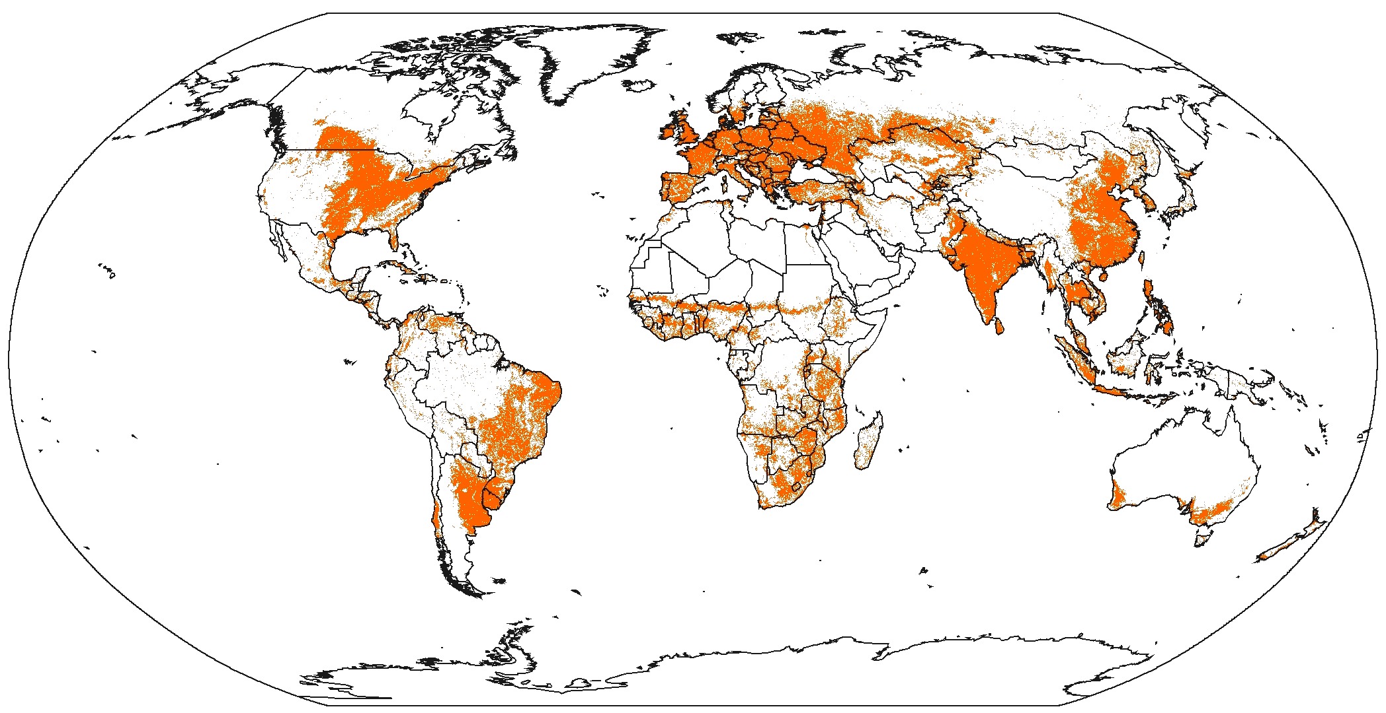

Figure 2. Areas of Rapid Land Cover Change, 1980–2000, Due to Desertification, Deforestation, and Afforestation.
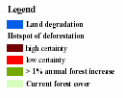
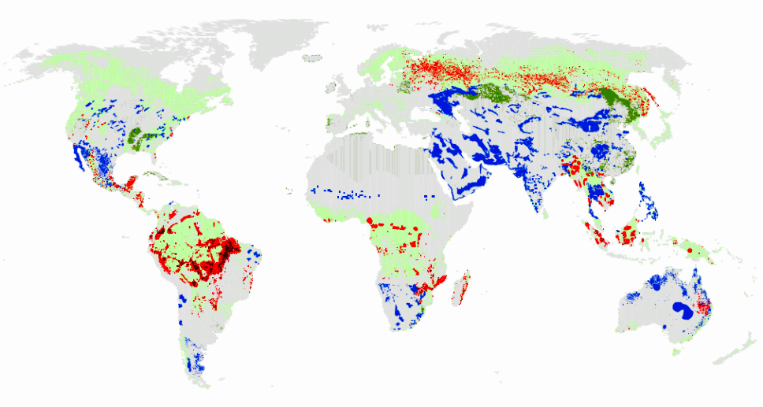

Figure 3. Conversion of Terrestrial Biomes. It is not possible to estimate accurately the extent of different biomes prior to significant human impact, but it is possible to determine the “potential” area of biomes based on soil and climatic conditions. This figure shows how much of that potential area is estimated to have been converted by 1950 (medium certainty), how much was converted between 1950 and 1990 (medium certainty), and how much would be converted under the four MA scenarios (low certainty) between 1990 and 2050.
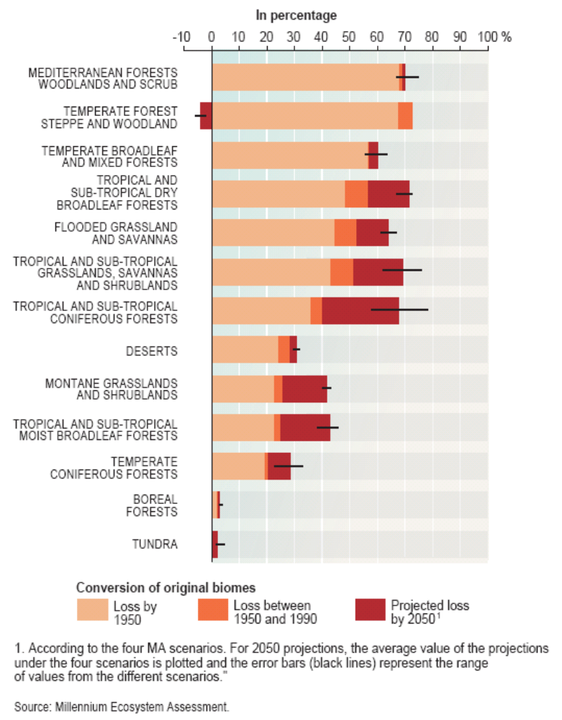

Figure 4. Species Extinction Rates. (Adapted from C4 Fig 4.22) “Fossil Record” refers to average extinction rates as estimated from the fossil record. “Past Century—Known Species” refers to extinction rates calculated from known extinctions of species (lower estimate) or known extinctions plus “possibly extinct” species (upper bound). A species is considered to be “possibly extinct” if it is believed by experts to be extinct but extensive surveys have not yet been undertaken to confirm its disappearance. “Projected” extinctions are model-derived estimates using a variety of techniques, including species-area models, rates at which species are shifting to increasingly more threatened categories, extinction probabilities associated with the IUCN categories of threat, impacts of projected habitat loss on species currently threatened with habitat loss, and correlation of species loss with energy consumption. The time frame and species groups involved differ among the “projected” estimates, but in general refer to either future loss of species based on the level of threat that exists today or current and future loss of species as a result of habitat changes taking place over the period of roughly 1970 to 2050. Estimates based on the fossil record are low certainty; lower-bound estimates for known extinctions are high certainty and upper-bound estimates are medium certainty; lower-bound estimates for projected extinctions are low certainty and upper bound estimates are speculative.

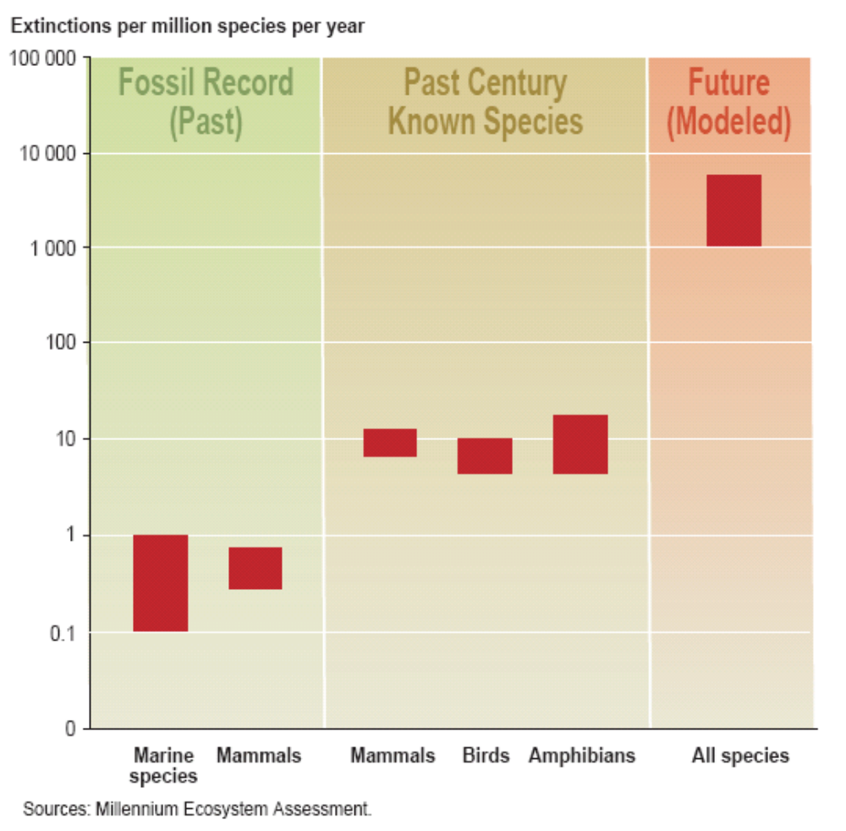

Figure 5. Estimated Global Marine Fish Catch, 1950–2001. (Fig C18.3) In this figure, the catch reported by governments is in some cases adjusted to correct for likely errors in data.

Figure 6. Decline in Trophic Level of Fisheries Catch Since 1950. (Fig C18.??) A trophic level of an organism is its position in a food chain. Levels are numbered according to how far particular organisms are along the chain from the primary producers at level 1, to herbivores (level 2), to predators (level 3), to carnivores or top carnivores (level 4 or 5). Fish at higher trophic levels are typically of higher economic value. The decline in the trophic level harvested is largely a result of the overharvest of fish at higher trophic levels.

Figure 7. Trend in Mean Depth of Catch Since 1950. Fisheries catches increasingly originate from deep areas. (Data from Fig. C18.5)

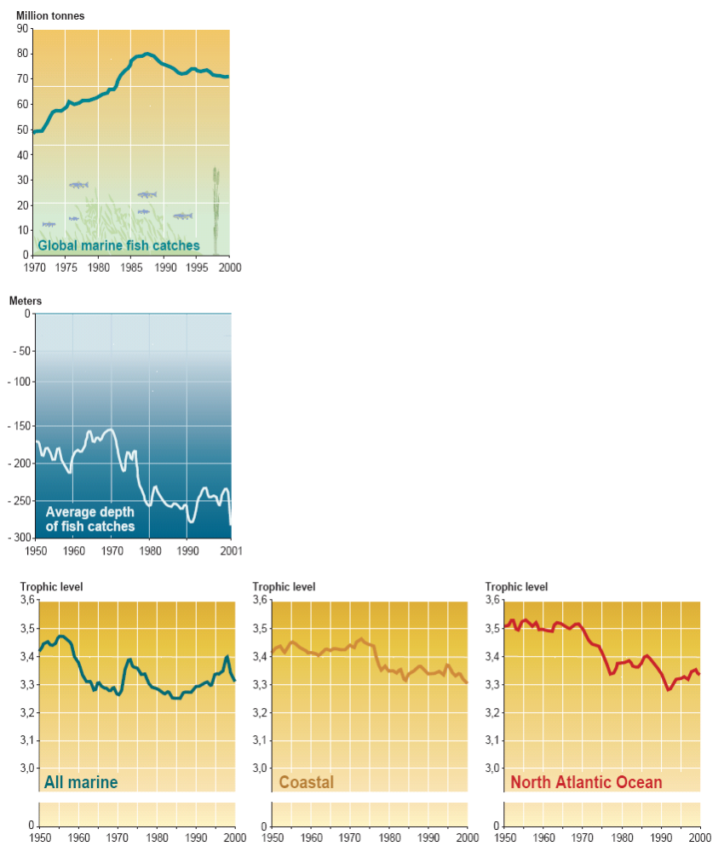
Figure 8. Annual Flow of Benefits from Forests in Selected Mediterranean Countries. In most countries, the marketed values of ecosystems associated with timber and fuelwood production are less than one third of the total economic value, including nonmarketed values such as carbon sequestration, watershed protection, and recreation.
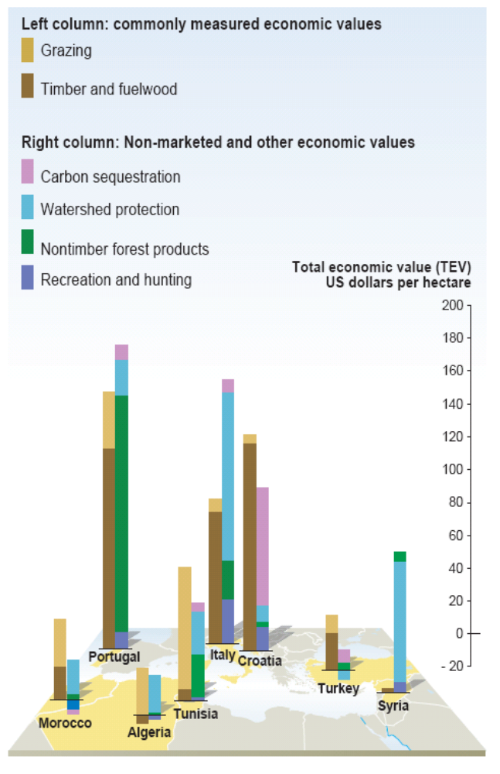

Figure 9. Economic Benefits Under Alternate Management Practices (expressed as net present value in dollars per hectare). In each case, the net benefits from the more sustainably managed ecosystem (purple bars) are greater than those from the converted ecosystem (maroon bars) even though the private (market) benefits would be greater from the converted ecosystem. (Where ranges of values are given in the original source, lower estimates are plotted here.)

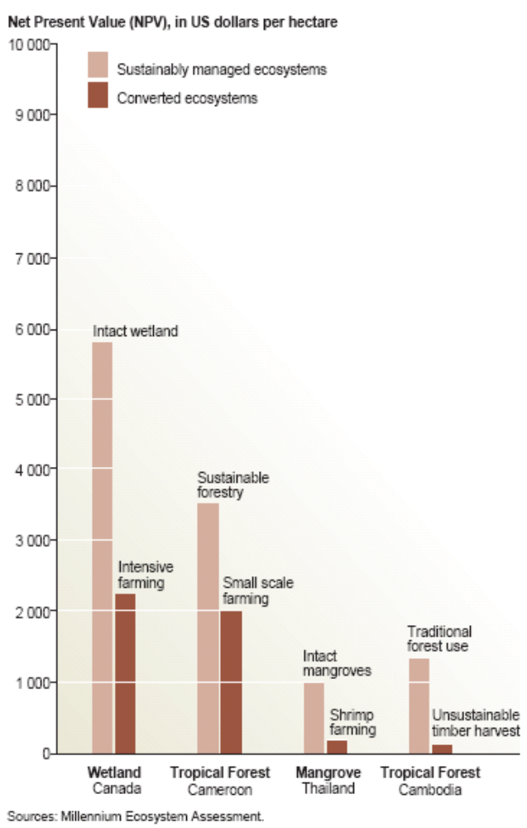
Figure 10. Collapse of Atlantic Cod Stocks Off the East Coast of Newfoundland in 1992. This collapse forced the closure of the fishery after hundreds of years of exploitation. Until the late 1950s, the fishery was exploited by migratory seasonal fleets and resident inshore small-scale fishers. From the late 1950s, offshore bottom trawlers began exploiting the deeper part of the stock, leading to a large catch increase and a strong decline in the underlying biomass. The stock collapsed to extremely low levels in the late 1980s and early 1990s, and a moratorium on commercial fishing was declared in June 1992. A small commercial inshore fishery was reintroduced in 1998, but catch rates declined and the fishery was closed indefinitely in 2003.

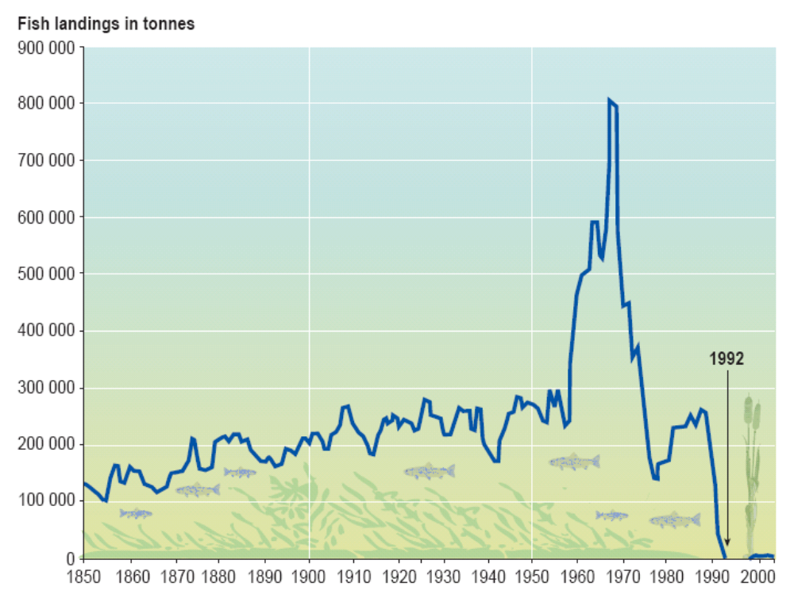
Figure 11. Human Population Growth Rates, 1990–2000, and Per Capita GDP and Biological Productivity in 2000 in MA Ecological Systems

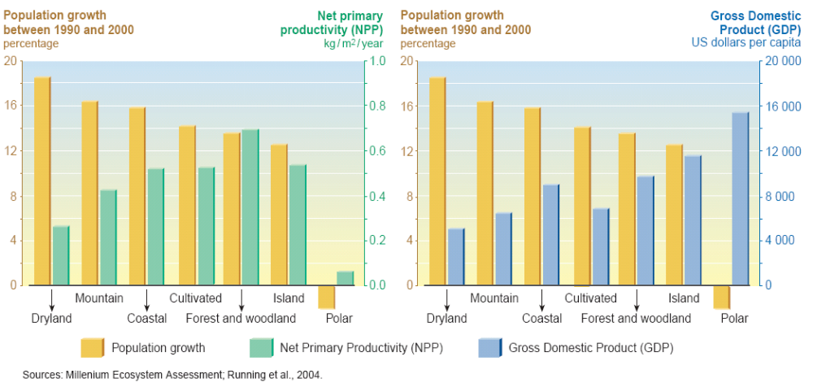
Figure 12. Dust Cloud Off the Northwest Coast of Africa, January 10, 2005. At the bottom left corner is northeastern South America. The dust clouds travel thousands of miles and fertilize the water off the west coast of Florida with iron. This has been linked to blooms of toxic algae in the region and respiratory problems in North America and has affected coral reefs in the Caribbean. Degradation of drylands exacerbates problems associated with dust storms.

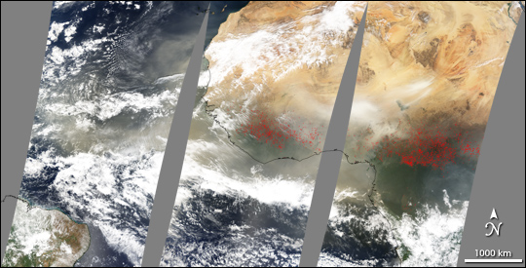
Source: NASA
Figure 13. Main Direct Drivers of Change in Biodiversity and Ecosystems. The cell color indicates impact of each driver on biodiversity in each biome over the past 50–100 years. High impact means that over the last century the particular driver has significantly altered biodiversity in that biome; low impact indicates that it has had little influence on biodiversity in the biome. The arrows indicate the trend in the driver. Horizontal arrows indicate stabilization of the impact; diagonal and vertical arrows indicate progressively stronger increasing trends in impact. Thus a vertical arrow indicates that the effect of the driver on biodiversity is currently growing stronger.

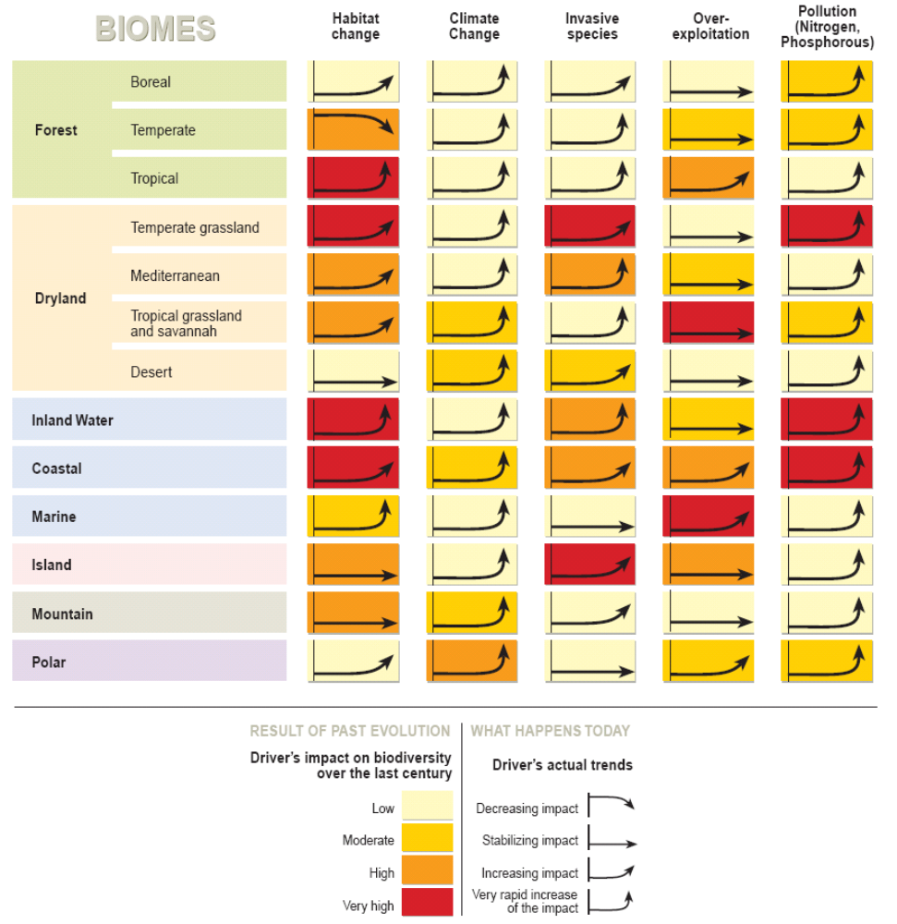
Figure 14. Estimated Total Reactive Nitrogen Deposition from the Atmosphere (Wet and Dry) in 1860, early 1990s, and Projected for 2050 (milligrams of nitrogen per square meter per year). Atmospheric deposition currently accounts for roughly 12% of the reactive nitrogen entering terrestrial and coastal marine ecosystems globally, although in some regions, atmospheric deposition accounts for a higher percentage (about 33% in the United States). (Note: projections were included in original study, not based on MA Scenarios). (R9 Figure 9.2)
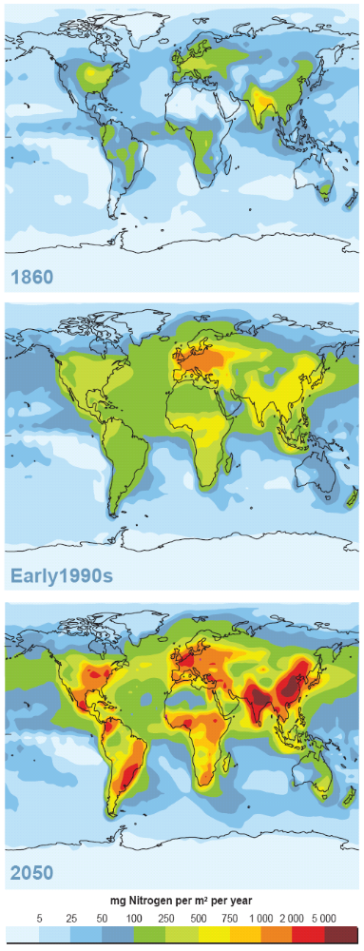
Figure 15. Changes in Availability of Ecosystem Services by 2050 in the Four MA Scenarios. Figure shows the net percent change in ecosystem services enhanced (positive) or degraded in each category of services for industrial and developing countries. The total number of services evaluated for each category was six provisioning services, nine regulating services, and five cultural services.

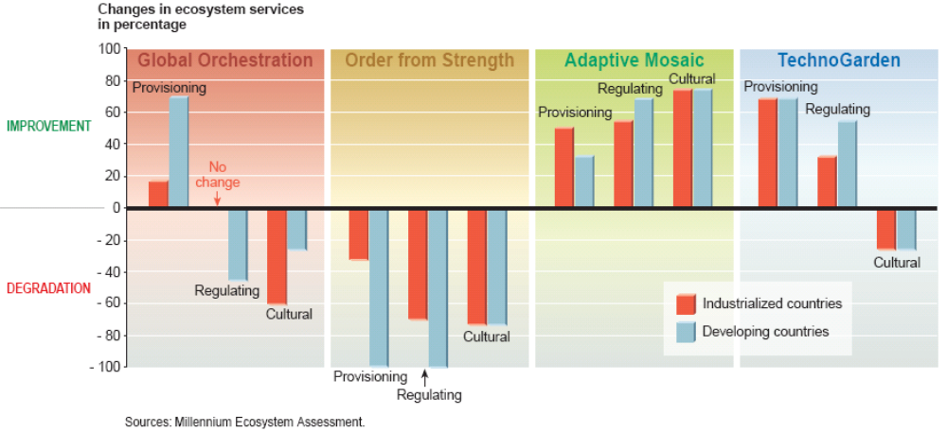

Key Questions in the Millennium Ecosystem Assessment

1. How have ecosystems changed? 49
2. How have ecosystem services and their use changed? 63
3. How have ecosystem changes affected human well-being and poverty alleviation? 76
4. What are the most critical factors causing ecosystem changes? 93
5. How might ecosystems and their services change in the future under various plausible scenarios? 100
6. What can be learned about the consequences of ecosystem change for human well-being at sub-global scales? 116
7. What is known about time scales, inertia, and the risk of non-linear changes in ecosystems? 122
8. What options exist to sustainably manage ecosystems? 128
9. What are the most important uncertainties hindering decision-making concerning ecosystems? 142

1. How have ecosystems changed?

Ecosystem Structure
The structure of the world’s ecosystems changed more rapidly in the second half of the 20th century than at any time in recorded human history, and virtually all of Earth’s ecosystems have now been significantly transformed through human actions. The most significant change in the structure of ecosystems has been the transformation of approximately one quarter (24%) of Earth’s terrestrial surface to cultivated systems (C26.1.2). (See Fig. 1; see also Box 1.1 for description of the MA “systems”.) More land was converted to cropland since 1945 than in the 18th and 19th centuries combined (C26.??). Between 1960 and 2000 reservoir storage capacity quadrupled (C7.2.4) and, as a result, the amount of water stored behind large dams is estimated to be 3 to 6 times the amount held by natural river channels (this excludes natural lakes) (C7.3.2). (See Fig. 1.1.) In countries for which sufficient multi-year data are available (encompassing more than half of the present-day mangrove area), approximately 35 percent of mangroves have been lost in the last two decades (C19.2.1). Roughly 27% of the world’s coral reefs were badly degraded or destroyed in the last several decades of the 20th century (C19.2.1). Box 1.1 and Table 1.1 summarize important characteristics and trends in different ecosystems.
Although the most rapid changes in ecosystems are now taking place in developing countries, industrialized countries historically experienced comparable rates of change. Croplands expanded rapidly in Europe after 1700 and in North America and the Former Soviet Union, particularly after 1850 (C26.1.1) Roughly 70% of the original temperate forests and grasslands and Mediterranean forests had been lost by 1950, largely through conversion to agriculture (C4.4.3). Historically, deforestation has been much more intensive in temperate regions than in the tropics, and Europe is the continent with the smallest fraction of its original forests remaining (C21.4.2). However, changes prior to the industrial era seemed to occur at much slower rates than current transformations.
Ecosystems and biomes that have been most significantly altered globally by human activity include: marine and freshwater ecosystems, temperate broadleaf forests and temperate grasslands, Mediterranean forests, and tropical dry forests. (Fig. 3 and C18, C20) Within marine systems, the world’s demand for food and animal feed over the last 50 years has resulted in fishing pressure so strong that the biomass of both targeted species, and those caught incidentally (the ‘by-catch’) has been reduced in much of the world to one tenth of the levels prior to the onset of industrial fishing (C18.ES). Globally, the degradation of fisheries is also reflected in the fact that the fish being harvested are increasingly coming from the less valuable lower trophic levels as populations of higher trophic level species are depleted. (See Fig. 6.) Freshwater ecosystems have been modified through the creation of dams and through the withdrawal of water for human use. The construction of dams and other structures along rivers has moderately or strongly affected flows in 60 percent of the large river systems in the world (C20.4.2). Water removal for human uses has reduced the flow of several major rivers, including the Nile, Yellow, and Colorado rivers, to the extent that they do not always flow to the sea. As water flows have declined, so have sediment flows which are the source of nutrients important for the maintenance of estuaries. Worldwide sediment delivery to estuaries has declined by roughly 30% (C19.ES). Within terrestrial ecosystems, more than two-thirds of the area of two of the world’s 14 major terrestrial biomes (Temperate Grasslands and Mediterranean Forests) and more than half of the area of four other biomes (Tropical Dry Forests; Temperate Broadleaf Forests; and, Tropical and Flooded Grasslands) had been converted (primarily to agriculture) by 1990 (Fig. 3). Among the major biomes, only tundra and boreal forests show negligible levels of loss and conversion, although they have begun to be affected by climate change.
Globally, the rate of conversion of ecosystems has begun to slow largely due to reductions in the rate of expansion of cultivated land, and in some regions (particularly in temperate zones) ecosystems are returning to conditions and species compositions similar to their pre-conversion states. However rates of ecosystem conversion remain high or are increasing for specific ecosystems and regions. Under the aegis of the MA, the first systematic examination of the status and trends in terrestrial and coastal land cover was carried out using global and regional datasets. The pattern of deforestation, afforestation, and dryland degradation between 1980 and 2000 is shown in Figure 2. Opportunities for further expansion of cultivation are diminishing in many regions of the world as most of the land well-suited for intensive agriculture has been converted to cultivation. (C26.ES) Increased agricultural productivity is also diminishing the need for agricultural expansion. As a result of these two factors, a greater fraction of land in cultivated systems (areas with at least 30 percent of land cultivated) is being cultivated, intensity of cultivation of land is increasing, fallow lengths are decreasing, and management practices are shifting from monocultures to polycultures. Since 1950, cropland areas have stabilized in North America and decreased in Europe and China (C26.1.1). Cropland areas in the Former Soviet Union have decreased since 1960 (C26.1.1). Within temperate and boreal zones, forest cover increased by approximately 2.9 million hectares per year in the 1990s, of which approximately 40% was forest plantations (C21.4.2). In some cases, rates of conversion of ecosystems have slowed apparently because most of the ecosystem has now been converted, as is the case with temperate broadleaf forests and Mediterranean forests. (C4.4.3)
Ecosystem Processes

Ecosystem processes, including water, nitrogen, carbon and phosphorus cycling, changed more rapidly in the second half of the 20th century than at any time in recorded human history. Human modifications of ecosystems have changed not only the structure of the systems (e.g., what habitats or species are present in a particular location), but the processes and functioning of the systems as well. The capacity of ecosystems to provide ecosystems services derives directly from the operation of natural biogeochemical cycles that in some cases have been significantly modified.
Water Cycle: Water withdrawals from rivers and lakes for irrigation or urban or industrial use doubled between 1960 and 2000 (C7.2.4). (Worldwide, 70% of water use is for agriculture (C7.2.2.) Large reservoir construction has doubled or tripled the residence time of river water; that is the average time that a drop of water takes to reach the sea (C7.3.2). Globally, humans use slightly more than 10 percent of the available renewable freshwater supply through household, agricultural, and industrial activities (C7.2.3), although in some regions such as the Middle East and North Africa, humans use 120 percent of renewable supplies (the excess is obtained through the use of groundwater supplies at rates greater than their rate of recharge) (C7.2.2).
Carbon Cycle: Since 1750, the atmospheric concentration of carbon dioxide (CO₂) has increased by about 34 percent (from about 280 ppm to 376 ppm in 2003 (S7.3.1). Approximately 60% of that increase (60ppm) has taken place since 1959. The effect of changes in terrestrial ecosystems on the carbon cycle reversed during the last fifty years. Terrestrial ecosystems were on average a net source of CO₂ during the 19th and early 20th century (primarily due to deforestation, but with contributions from degradation of agricultural, pasture, and forest lands), and became a net sink sometime around the middle of the last century (although carbon losses from land use change continue at high levels) (high certainty). Factors contributing to the growth of the role of ecosystems in carbon sequestration include: afforestation/reforestation/forest management in North America, Europe, China and other regions, changed agriculture practices, and the fertilizing effects of N deposition and increasing atmospheric CO₂ (high certainty) (C13.ES).
Nitrogen Cycle: The total amount of reactive, or biologically available, nitrogen created by human activities increased 9-fold between 1890 and 1990, with most of that increase taking place in the second half of the century in association with increased use of fertilizers (S7.3.2). (See Fig. 1.2 and Fig. 14.) More than half of all the synthetic nitrogen fertilizer (first produced in 1913) ever used on the planet has been used since 1985 (R9.2). Human activities has now roughly doubled the rate of creation of reactive N on the land surfaces of Earth (R9.2). The flux of reactive N to the oceans has increased by nearly 80% from 1860 to 1990, from roughly 27 Tg N per year in 1860 to 48 Tg N per yr in 1990 (R9.??). (This change is not uniform over the Earth, however, and while some regions such as Labrador and Hudson's Bay in Canada have seen little if any change, the fluxes from more developed regions such as the northeastern US, the watersheds of the North Sea in Europe, and the Yellow River basin in China have increased by 10- to 15-fold)
Phosphorus Cycle: The use of phosphorus fertilizers and the rate of phosphorus accumulation in agricultural soils increased nearly three-fold between 1960 and 1990, although the rate has declined somewhat since that time (S7 Fig 7.18). The current flux of phosphorus to the oceans is now triple that of background rates (approximately 22 Tg P yr⁻¹ versus the natural flux of 8 Tg P yr⁻¹) (R9.2).
Species
A change in an ecosystem necessarily affects the species comprising the system and changes in species affect ecosystem processes.
The distribution of species on Earth is becoming more homogenous. By homogenous, we mean that the differences between the set of species at one location on the planet and the set of species at another location are, on average, diminishing. The natural process of evolution, and particularly the combination of natural barriers to migration and local adaptation of species, led to significant differences in the types of species that make up ecosystems in different regions of the planet. However, these regional differences in the planet’s biota are now being diminished. Two factors are responsible for this trend. First, the extinction of species or the loss of populations results in the loss of the presence of species that had been unique to particular regions. Second, the rate of invasion or introduction of species into new ranges is already high and continues to accelerate in pace with growing trade and faster transportation. (See Fig. 1.3.) For example, a high proportion of the roughly 100 non-native species in the Baltic Sea are native to the North American Great Lakes and and 75% of the recent arrivals of the about 170 non-native species in the Great Lakes are native to the Baltic Sea (S10.5). When species decline or go extinct as a result of human activities they are replaced by a much smaller number of expanding species that thrive in human-altered environments. One effect is that in some regions where diversity has been low, the biotic diversity may actually increase – a result of invasions of non-native forms (this is true in continental areas such as the Netherlands as well as on oceanic islands).
Across a range of taxonomic groups, either the population size or range or both of the majority of species is currently declining. Studies of amphibians globally, African mammals, birds in agricultural lands, British butterflies, Caribbean corals, and fishery species show the majority of species to be declining in range or number. Exceptions include species that have been protected in reserves, have had their particular threats eliminated (such as over-exploitation), and that tend to thrive in landscapes that have been modified by human activity (C4.ES).
Between ten and thirty percent of mammal, bird and amphibian species are currently threatened with extinction (medium to high certainty), based on World Conservation Union (IUCN) criteria for threats of extinction. As of 2004, comprehensive assessments of every species within major taxonomic groups have been completed for only three groups of animals (mammals, birds and amphibians), and two plant groups (conifers and cycads, a group of evergreen palm-like plants). Specialists on these groups have categorized species as “threatened with extinction” if they meet a set of quantitative criteria involving their population size, the size of area in which they are found, and trends in population size or area. Under the widely utilized World Conservation Union (IUCN) criteria for extinction, the vast majority of species “threatened with extinction” have approximately a 10% chance of going extinct within 100 years (although some long-lived species will persist much longer even though their small population size and lack of recruitment means that they have a very high likelihood of extinction). Twelve percent of bird species, 23% of mammals and 25% of conifers are currently threatened with extinction. Thirty-two percent of amphibians are threatened with extinction but information is more limited and this may be an underestimate. Higher levels of threat have been found in the cycads, where 52% are threatened with extinction (C4.ES)
Over the past few hundred years humans have increased the species extinction rate by as much as one thousand times background rates typical over the planet’s history (medium certainty). (C4.ES, C4.4.2.) (See Figure 4.) Extinction is a natural part of the Earth’s history. Most estimates of the total number of species on Earth today lie between 5 and 30 million, although the overall total could be higher than 30 million if poorly known groups such as deep sea organisms, fungi, and micro-organisms including parasites, have more species than currently estimated. Species present today only represent between 2 and 4 percent of all species that have ever lived. The fossil record appears to be punctuated by five major mass extinctions, the most recent of which occurred 65 million years ago. The average rate of extinction found for marine and mammal fossil species fossil species (excluding extinctions that occurred in the five major mass extinctions) is approximately 0.1–1 extinctions per million species per year. There are approximately 100 documented extinctions of birds, mammal and amphibians over the past 100 years, a rate approximately 50 to 500 times higher than background rates. (See Fig. 4.) Including possibly extinct species, the rate is more than 1000 times higher than background rates. Although the data and techniques used to estimate current extinction rates have improved over the past two decades, significant uncertainty still exists in measuring current rates of extinction because: i) the extent of extinctions of undescribed taxa is unknown, ii) the status of many described species is poorly known, iii) it is difficult to document the final disappearance of very rare species; and iv) there are time lags between the impact of a threatening process and the resulting extinction.

Genes
Genetic diversity has declined globally, particularly among cultivated species. The extinction of species and loss of unique populations has resulted in the loss of unique genetic diversity contained by those species and populations. For wild species, there are few data on the actual changes in the magnitude and distribution of genetic diversity (C4.4) although studies have documented declining genetic diversity in wild species that have been heavily exploited. In cultivated systems, since 1960 there has been a fundamental shift in the pattern of intra-species diversity in farmer’s fields and farming systems as the crop varieties planted by farmers have shifted from locally adapted and developed populations (landraces) to more widely adapted varieties produced through formal breeding systems (modern varieties). Roughly 80 percent of wheat area in developing countries and three-quarters of all rice planted in Asia is planted with modern varieties. (For other crops, such as maize, sorghum and millet, the proportion of area planted to modern varieties is far smaller.) (C26.2.1) The on-farm losses of genetic diversity of crops and livestock have been partially offset by the maintenance of genetic diversity in seedbanks.

Box 1.1. Characteristics of the World’s Ecological Systems

We report assessment findings for ten categories of the land/marine surface which we refer to as “Systems”: Forest, Cultivated, Dryland, Coastal, Marine, Urban, Polar, Freshwater, Island, and Mountain. Each of these categories contains a number of ecosystems. However, ecosystems within each category share a suite of biological, climatic, and social factors that tend to be similar within categories and differ across categories. The MA reporting categories are not spatially exclusive: their areas often overlap. For example, transition zones between forest and cultivated lands are included in both the forest system and cultivated system reporting categories. These reporting categories were selected because they correspond to the regions of responsibility of different governmental ministries (e.g., agriculture ministries, water ministries, forest departments, and so forth) and because they are the categories used within the Convention on Biological Diversity.
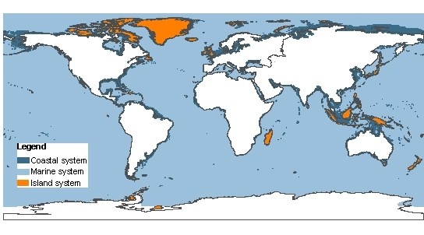
Coastal, Island and Marine Systems
- Marine systems are the world’s oceans. For mapping purposes, the map above shows ocean areas where the depth is greater than 50 meters. Global fisheries catches from marine systems peaked in the late 1980s and are now declining despite increasing fishing effort (C18.ES).
- Coastal systems refer to the interface between ocean and land, extending seawards to about the middle of the continental shelf and inland to include all areas strongly influenced by proximity to the ocean. The map above shows the area between 50 meters below mean sea level and 50 meters above the high tide level or extending landward to a distance 100 kilometers from shore. Coastal systems include coral reefs, intertidal zones, estuaries, coastal aquaculture, and seagrass communities. Nearly half of the world’s major cities (having more than 500,000) people are located within 50 kilometers of the coast and coastal population densities are 2.6 times larger than the density of inland areas. By all commonly used measures, the human well-being of coastal inhabitants is on average much higher than that of inland communities.(C19.3.1)
- Islands are lands (both continental and oceanic) isolated by surrounding water and with a high proportion of coast to hinterland. For mapping purposes, the MA uses the ESRI ArcWorld Country Boundary dataset, which contains nearly 12,000 islands. Islands smaller than 1.5 ha are not mapped (or included in the statistics). The largest island included is Greenland. The map above includes islands within 2km of the mainland (e.g, Long Island in the United States) but the statistics provided for island systems in this report exclude these islands. Island states together with their exclusive economic zones comprise 40 percent of the world’s oceans (C23.ES). Island systems are especially sensitive to disturbances, and the majority of recorded extinctions have occurred on island systems, although this pattern is changing and over the past 20 years as many extinctions have occurred on continents as on islands (C4.ES).
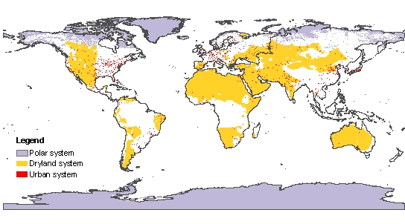
Urban, Polar and Dryland Systems

- Urban systems are built environments with a high human density. For mapping purposes, the MA uses known human settlements with a population of 5,000 or more, with boundaries delineated by observing persistent night-time lights or by inferring areal extent in the cases where such observations are absent. The world’s urban population increased from about 0.2 billion in 1900 to 2.9 billion in 2000, and the number of cities with populations in excess of 1 million increased from 17 in 1900 to 388 in 2000 (C27.ES).
- Dryland systems are lands where plant production is limited by water availability; the dominant human uses are large mammal herbivory, including livestock grazing, and cultivation. The map shows drylands as defined by the U.N. Convention to Combat Desertification, namely lands where annual precipitation is less than two thirds of potential evapotranspiration, from dry subhumid areas (ratio ranges 0.50–0.65), through semiarid, arid, and hyper-arid (ratio <0.05), but excluding polar areas. Drylands include cultivated lands, scrublands, shrublands, grasslands, savannahs, semi-deserts, and true deserts. Dryland systems cover about 41% of the Earth’s land surface and are inhabited by more than 2 billion people (about one third of the human population) (C22.ES). Croplands cover approximately 25% of drylands (C22 Table 22.2) and dryland rangelands support approximately 50% of the world’s livestock (C22.4.2). The current socio-economic condition of people in dryland systems, of which about 90% are in developing countries, is worse than in other areas. Freshwater availability in drylands is projected to be further reduced from the current average of 1300 m³/capita/year in the year 2000, which is already below the threshold of 2000 m³/capita/year required for minimum human well-being and sustainable development. (C22.ES) Approximately 10 to 20% of the world’s drylands are degraded (medium certainty) (C22.ES).
- Polar systems are high-latitude systems frozen for most of the year, including ice caps, areas underlain by permafrost, tundra, polar deserts, and polar coastal areas. Polar systems do not include high-altitude cold systems in low latitudes. Temperature in polar systems is on average warmer now than at any time in the last 400 years resulting in widespread thaw of permafrost and reduction of sea ice (C25.ES). Most changes in feedback processes that occur in polar regions magnify trace-gas-induced global warming trends and reduce the capacity of polar regions to act as a cooling system for planet Earth (C25.ES). Tundra constitutes the largest natural wetland in the world. (C25.1.1) 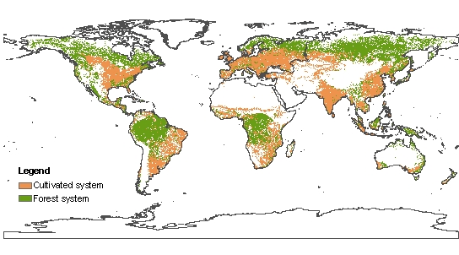Cultivated and Forest systems
- Forest systems are lands dominated by trees; often used for timber, fuelwood, and non-timber forest products. The map above shows areas with a canopy cover of at least 40 percent by woody plants taller than 5 meters. Forests include temporarily cut-over forests and plantations but exclude orchards and agroforests where the main products are food crops. The global area of forest systems has been reduced by one half over the past three centuries. Forests have effectively disappeared in 25 countries and another 29 have lost more than 90% of their forest cover (C21.ES). Forest systems are associated with the regulation of 57 percent of total water runoff. About 4.6 billion people depend for all or some of their water on supplies from forest systems (C7 Table 7.2). From 1990 to 2000, the global area of temperate forest increased by almost 3 million ha per year, while deforestation in the tropics occured at an average rate exceeding 12 million ha per year over the past two decades. (C.SDM)
- Cultivated systems are lands dominated by domesticated species, used for and substantially changed by crop, agroforestry, or aquaculture production. The map above shows areas in which at least 30 percent by area of the landscape comes under cultivation in any particular year. Cultivated systems, including croplands, shifting cultivation, confined livestock production, and freshwater aquaculture, cover approximately 24 percent of total land area (Table 1.1). In the last two decades, the major areas of cropland expansion were located in Southeast Asia, parts of South Asia, the Great Lakes region of eastern Africa, the Amazon Basin, and the U.S. Great Plains. The major decreases of cropland occurred in the southeastern United States, eastern China, and parts of Brazil and Argentina (C26.1.1). Most of the increase in food demand of the past 50 years has been met by intensification of crop, livestock, and aquaculture systems rather than expansion of production area. In developing countries over the period 1961-1999, expansion of harvested land contributed only 29 % to growth in crop production, although in Sub-Saharan Africa expansion accounted for two-thirds of growth in production (C26.1.1). Increased yields of crop production systems have reduced the pressure to convert natural ecosystems into cropland but intensification has increased pressure on inland water ecosystems, generally reduced biodiversity within agricultural landscapes, and requires higher energy inputs in the form of mechanization and the production of chemical fertilizers. Cultivated systems provide only 16 percent of global runoff, although their close proximity to humans means that about 5 billion people depend for all or some of their water on supplies from cultivated systems (C7 Table 7.2).. Such proximity is associated with nutrient and industrial water pollution.
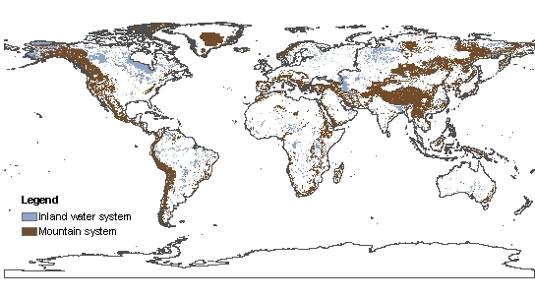
Inland water and mountain systems

- Inland water systems are permanent water bodies inland from the coastal zone, and areas whose properties and use are dominated by the permanent, seasonal, or intermittent occurrence of flooded conditions. Inland waters include rivers, lakes, floodplains, reservoirs, wetlands, and inland saline systems. (Note that the wetlands definition used by the Ramsar Convention includes both the MA inland water and coastal system categories). The biodiversity of inland waters appears to be in a worse condition than that of any other system, driven by declines in both the area of wetlands, and of the water quality in inland waters (C4 and C20). It is speculated that 50 percent of inland water area (excluding large lakes) has been lost globally (C20.ES). Dams and other infrastructure fragment 60% of the large river systems in the world (C20.4.2).
- Mountain systems are steep and high lands. The map above is based on elevation and, at lower elevations, a combination of elevation, slope, and local topography. Twenty percent (or 1.2 billion) of the world’s human population lives in mountains or at their edges and half of mankind depends, directly or indirectly, on mountain resources (largely water) (C24.ES). Ninety percent of the 1.2 billion people living in mountains live in countries with developing and transition economies. In developing and transition countries, 7 percent of the total mountain area is currently classified as cropland and people are often highly dependent on local agriculture or livestock production (C24.3.2). About 4 billion people depend for all or some of their water on supplies from mountain systems. Some 90 million mountain people – almost all of those living above 2500 m – live in poverty and are considered especially vulnerable to food insecurity (C24.1.4).

Table 1.1. Comparative table of systems as reported by the Millennium Assessment. (C.SDM) Note that as described in Box 1, these systems often overlap. Statistics for different systems can therefore be compared, but cannot be totaled across systems as this will result in partial double-counting.

System  and  subsystem | Area (million km²) | % of terrestrial surface of the globe | Population |  |  | GDP per capita¹ | Infant  Mortality Rate² | Mean NPP (Kg C/m2/yr)³ | % System covered by PA's⁴ | % Area trans-formed⁵
System  and  subsystem | Area (million km²) | % of terrestrial surface of the globe | Density  (people per square km) |  | Growth rate (% 1990-2000)
System  and  subsystem | Area (million km²) | % of terrestrial surface of the globe | Urban | Rural
Marine | 349.3 | 68.6⁶ | - | - | - | - | - | 0.15 | 0.3 | -
Coastal | 17.9 | 4.5 | 1105 | 70 | 15.9 | 8960 | 41.5 |  | 7
Terrestrial | 6.7 | 4.5 | 1105 | 70 | 15.9 | 8960 | 41.5 | 0.52 | 4 | 11
Marine | 11.2 | 2.2⁶ | - | - | - | - | - | 0.14 | 9 | -
Inland water⁷ | 10.3 | 7.0 | 817 | 26 | 17 | 7300 | 57.6 | 0.36 | 12 | 11
Forest/woodlands | 42.2 | 28.6 | 472 | 18 | 13.5 | 9580 | 57.7 | 0.68 | 10 | 42
Tropical/ subtropical | 23.5 | 15.9 | 565 | 14 | 17 | 6854 | 58.3 | 0.95 | 11 | 34
Temperate | 6.3 | 4.3 | 320 | 7 | 4.4 | 17109 | 12.5 | 0.45 | 16 | 67
Boreal | 12.4 | 8.4 | 114 | 0.1 | -3.7 | 13142 | 16.5 | 0.29 | 4 | 25
Dryland | 60.9 | 41.3 | 750 | 20 | 18.5 | 4930 | 66.6 | 0.26 | 7 | 18
Hyperarid | 9.8 | 6.6 | 1061 | 1 | 26.2 | 5930 | 41.3 | 0.01 | 11 | 1
Arid | 15.7 | 10.6 | 568 | 3 | 28.1 | 4680 | 74.2 | 0.12 | 6 | 5
Semiarid | 22.3 | 15.3 | 643 | 10 | 20.6 | 5580 | 72.4 | 0.34 | 6 | 25
Dry sub-humid | 12.9 | 8.7 | 711 | 25 | 13.6 | 4270 | 60.7 | 0.49 | 7 | 35
Island | 9.9 | 6.7 | 1020 | 37 | 12.3 | 11570 | 30.4 | 0.54 | 17 | 17
Island states | 7.0 | 4.8 | 918 | 14 | 12.5 | 11148 | 30.6 | 0.45 | 18 | 21
Mountain | 33.2 | 22.2 | 63 | 3 | 16.3 | 6470 | 57.9 | 0.42 | 14 | 12
300-1000m | 15.1 | 10.2 | 58 | 3 | 12.7 | 7815 | 48.2 | 0.47 | 11 | 13
1000-2500m | 11.9 | 8.1 | 69 | 3 | 20.0 | 5080 | 67.0 | 0.45 | 14 | 13
2500-4500m | 3.9 | 2.7 | 90 | 2 | 24.2 | 4144 | 65.0 | 0.28 | 18 | 6
> 4500m | 1.8 | 1.2 | 104 | 0 | 25.3 | 3663 | 39.4 | 0.06 | 22 | 0.3
Polar | 23.0 | 15.6 | 161 | 0.06 | -6.5 | 15401 | 12.8 | 0.06 | 42⁸ | 0.3⁸
Cultivated | 35.6 | 24.1 | 786 | 70 | 14.1 | 6810 | 54.3 | 0.52 | 6 | 47
Pasture | 0.1 | 0.1 | 419 | 10 | 28.8 | 15790 | 32.8 | 0.64 | 4 | 11
Cropland | 8.3 | 5.7 | 1014 | 118 | 15.6 | 4430 | 55.3 | 0.49 | 4 | 62
Mixed (crop & other) | 27.1 | 18.4 | 575 | 22 | 11.8 | 11060 | 46.5 | 0.6 | 6 | 43
Urban | 3.6 | 2.4 | 681 | - | 12.7 | 12057 | 36.5 | 0.47 | 0 | 100
Gobal | 510 | - | 681 | 13 | 16.7 | 7309 | 57.4 | - | 4 | 38
c – to come from CIESIN
1) Gross Domestic Product.
2) Infant Mortality Rate (deaths of <1yr old children per thousand live births).
3) Mean Net Primary Productivity.
4) Includes only natural or mixed classes of Protected Areas in IUCN categories I to VI.
5) Area Transformed - For all systems except forest/woodland, area transformed is calculated from land depicted as cultivated or urban areas by GLC2000 land cover data set. The area transformed for forest/woodland systems is calculated as the % change in area between potential vegetation (forest biomes of the WWF Ecoregions) and current forest/woodland areas in GLC2000. Note: 22 percent of the forest/woodland system falls outside forest biomes and is therefore not included in this analysis.
6) % total surface of the globe.
7) Population density, growth rate, GDP per capita and growth rate for the Inland Water system have been calculated with an area buffer of 10km
8) Excluding Antarctica

Figure 1.1. Time series of intercepted continental runoff and large reservoir storage, 1900-2000 (C7 Fig 7.8) The series is taken from a subset of large reservoirs (>0.5 km³ storage each) totaling about 65% of the global total reservoir storage for which information was available that allowed the reservoir to be georeferenced to river networks and discharge. The years 1960-2000 have shown a rapid move toward flow stabilization, which has slowed recently in some parts of the world, due to the growing social, economic, and environmental concerns surrounding large hydraulic engineering works.

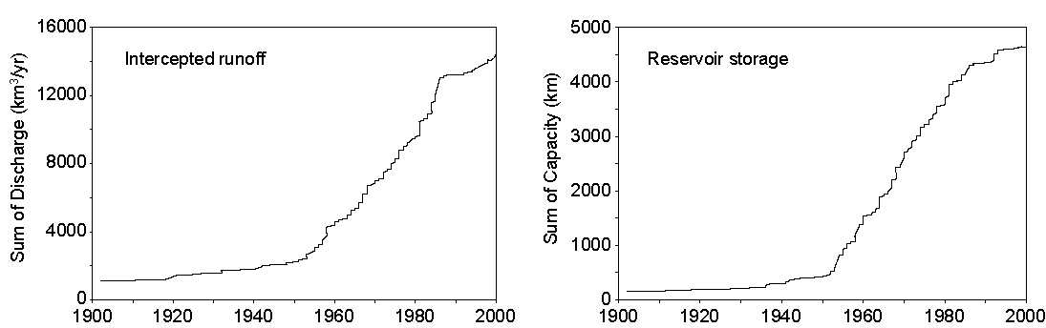
Figure 1.2. Global trends in the creation of reactive nitrogen on Earth by human activity and projection to 2050 (teragrams nitrogen per year). (1 teragram = 10¹² grams.) Most of the reactive nitrogen produced by humans comes from manufacturing of nitrogen for synthetic fertilizer and industrial use. Reactive nitrogen is also created as a by-product of fossil fuel combustion and by some (nitrogen-fixing) crops and trees in agro-ecosystems. The range of the natural rate of bacterial nitrogen fixation in natural terrestrial ecosystems (excluding fixation in agro-ecosystems) is shown for comparison. Human activity now produces approximately as much reactive nitrogen as natural processes on the continents. (Note: the 2050 projection is included in the original study and is not based on MA Scenarios.) (R9 Fig 9.1)
N fixation in agro-ecosystems

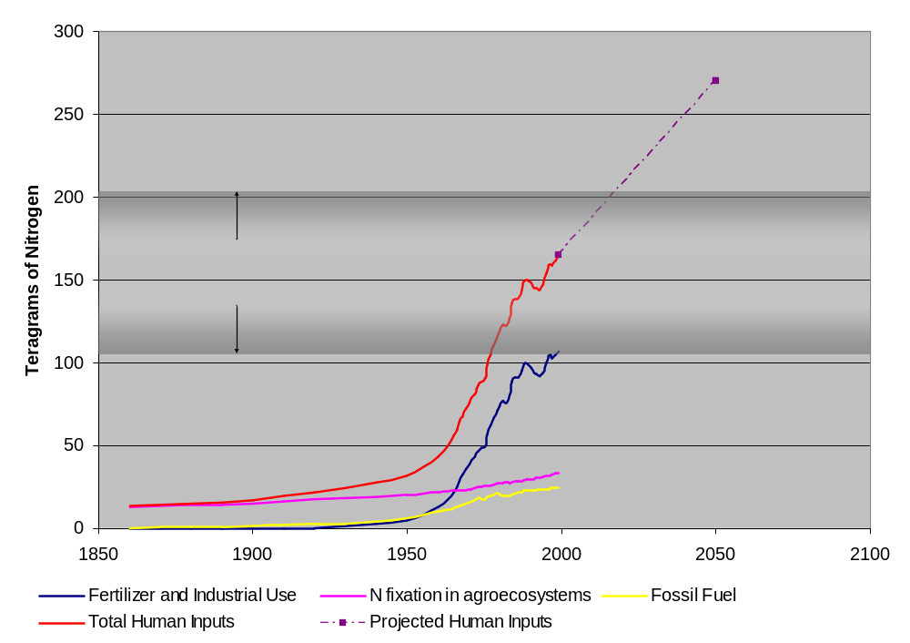

Figure 1.3. Growth in number of marine species introductions. [Note: figure and caption not yet available.]

2. How have ecosystem services and their use changed?
Ecosystem services are the benefits provided by ecosystems. These include provisioning services such as food, water, timber, fiber, and genetic resources; regulating services such as the regulation of climate, floods, disease, and water quality and waste treatment; cultural services such as recreational, aesthetic, and spiritual benefits; and supporting services such as soil formation, pollination and nutrient cycling (See Box 2.1).
Human use of all ecosystem services is growing rapidly. Approximately sixty percent (15 out of 24) of the ecosystem services evaluated in this assessment (including seventy percent of regulating and provisioning services), are being degraded or used unsustainably. (See Table 2.1.) Use of Services: Of 24 provisioning, cultural, and regulating ecosystem services for which sufficient information was available, the use of 20 continues to increase. The use of one service, capture fisheries, is now declining as a result of a decline in the quantity of fish which, in turn, is due to excessive capture of fish in past decades. Two other services (fuelwood and fiber) show mixed patterns. For fiber, the use of some types of fiber is increasing and others decreasing, and in the case of fuelwood, there is evidence of a recent peak in use. Enhancement and Degradation of Services: Humans have enhanced production of three ecosystem services – crops, livestock, and aquaculture – through expansion of the area devoted to their production or through technological inputs. Recently, the service of carbon sequestration has been enhanced globally, due in part to the re-growth of forests in temperate regions, although previously deforestation had been a net source of carbon emissions. Half (6 of 11) of provisioning services and nearly 70 percent (9 of 13) regulating and cultural services are being degraded or used unsustainably.
- Provisioning Services. The quantity of provisioning ecosystem services such as food, water, and timber used by humans increased rapidly, often more rapidly than population growth although generally more slowly than economic growth, during the second half of the 20th century, and it continues to grow. In a number of cases, provisioning services are being used at unsustainable rates. The growing human use has been made possible by a combination of substantial increases in the absolute amount of some services produced by ecosystems and by increasing the fraction used by humans. World population doubled between 1960 and 2000, from 3 billion to 6 billion people and the global economy increased more than six-fold. During this time, food production increased by roughly 2 ½ times (a 160% increase in food production between 1961 and 2003), water use doubled, wood harvests for pulp and paper tripled, and timber production increased by nearly 60 percent (C9.ES, C9.2.2, S7, C7.2.3, C8.1). (Food production increased four-fold in developing countries over this period.) The sustainability of the use of provisioning services differs in different locations. However, the use of several provisioning services is unsustainable even in the global aggregate. The current level of use of capture fisheries (marine and freshwater) is not sustainable and many fisheries have already collapsed. Currently, one quarter of important commercial fish stocks are overexploited or significantly deplete (high certainty) (C8.2.2). From 5 to possibly 25 percent of global fresh water use exceeds long-term accessible supplies and is maintained only through engineered water transfers and/or overdraft of groundwater supplies (low to medium certainty) (C7.ES). Between 15 to 35% of irrigation withdrawals exceed supply rates and are therefore unsustainable (low to medium certainty) (C7.2.2). Current agricultural practices are also unsustainable in some regions due to their reliance on unsustainable sources of water, harmful impacts caused by excessive nutrient or pesticide use, salinization, nutrient depletion, and rates of soil loss that exceed rates of soil formation.
- Regulating Services. Humans have substantially modified regulating services such as disease and climate regulation by modifying the ecosystem providing the service and, in the case of waste processing services, by exceeding the capabilities of ecosystems to provide the service. Most changes to regulating services are inadvertent results of actions taken to enhance the supply of provisioning services. Humans have substantially modified the climate regulation service of ecosystems, first by greatly increasing the emissions of carbon dioxide and other greenhouse gasses such as methane and nitrous oxide into the atmosphere and more recently by increasing the sequestration of carbon dioxide (although ecosystems remain a net source of methane and nitrous oxide). Modifications of ecosystems have altered patterns of disease by increasing or decreasing habitat for certain diseases or their vectors (e.g., dams and irrigation canals that provide habitat for schistosomiasis) or by bringing human populations into closer contact with various disease organisms. Changes to ecosystems have contributed to a significant rise in the number of floods and major wildfires on all continents since the 1940s. Ecosystems serve an important role in detoxifying wastes introduced into the environment, but there are intrinsic limits to that waste processing capability. For example, aquatic ecosystems “cleanse” on average 80% of their global incident nitrogen loading but this intrinsic self-purification capacity of aquatic ecosystems varies widely and is being reduced by the loss of wetlands. (C7.2.5).
- Cultural Services. Although the use of cultural services has continued to grow, the capability of ecosystems to provide these benefits has been significantly diminished in the past century. (C17) Human cultures are strongly influenced by ecosystems, and ecosystem change can have a significant impact on cultural identity and social stability. Human cultures, knowledge systems, religions, heritage values, social interactions, and the linked amenity services (e.g., aesthetic enjoyment, recreation, artistic and spiritual fulfillment, and intellectual development) have always been influenced and shaped by the nature of the ecosystem and ecosystem conditions. Many of these cultural service benefits are being degraded, either through changes to ecosystems (e.g., there has been a recent rapid decline in the numbers of sacred groves and other such protected areas) or through societal changes (e.g., the loss of languages or the loss of traditional knowledge) that reduce people’s recognition or appreciation of those cultural benefits. Rapid loss of culturally valued ecosystems and landscapes can contribute to social disruptions and societal marginalization. And, there has been a decline in the quantity and quality of aesthetically-pleasing natural landscapes.
Global gains in the supply of food, water, timber and other provisioning services were often achieved in the past century despite local resource depletion and local restrictions on resource use (e.g., timber harvest bans) by shifting production and harvest to new underexploited regions, sometimes considerable distances away. These options are diminishing. This trend is most distinct in the case of marine fisheries. As individual stocks have been depleted, fishing pressure has shifted to less exploited stocks ( C18.3.1). Industrial fishing fleets have also shifted to fishing further offshore and in deeper water to meet the global demand (C18.ES). (See Fig. 7.) A variety of drivers related to market demand, supply, and government policies have influenced patterns of timber harvest. For example, international trade in forest products increases when a nation’s forests no longer can meet demand (e.g., forests have disappeared in 25 countries and another 29 have lost more than 90%; C21.ES) or when policies have been established to restrict or ban timber harvest.
Although human demand for ecosystem services continues to grow in the aggregate, the demand for particular services in particular regions is declining as substitutes are developed. For example, kerosene, electricity and other energy sources are increasingly being substituted for fuelwood (still the primary source of energy for heating and cooking for some 2.6 billion people) (C9-ES). The substitution of a variety of other materials for wood (e.g., vinyl, plastics, and metal) has contributed to relatively slow growth in global timber consumption in recent years (C9.2.1). While the use of substitutes can reduce pressure on specific ecosystem services, this may not always have positive net environmental benefits. Substitution of fuelwood by fossil fuels, for example, reduces pressure on forests and reduces indoor air pollution but may result in increased net greenhouse gas emissions. Substitutes are also often costlier to provide than the original ecosystem services.
Both the supply and resilience of ecosystem services are affected by changes in biodiversity. Biodiversity is the variability among living organisms and the ecological complexes of which they are part. When a species is lost from a particular location (even if it does not go extinct globally) or introduced to a new location, the various ecosystem services associated with that species are changed. More generally, when a habitat is converted, an array of ecosystem services associated with the species present in that location is changed, often with direct and immediate impacts on people (S10). Changes in biodiversity also have numerous indirect impacts on ecosystem services over longer time periods, including: influencing the capacity of ecosystems for adjustment to changing environments (medium certainty), causing disproportionately large and sometimes irreversible changes in ecosystem processes, influencing the potential for infectious disease transmission, and, in agricultural systems, influencing the risk of crop failure in a variable environment and altering the potential impacts of pests and pathogens (high to medium certainty) (C11.ES, C14.ES).
Trade-offs and Synergies
The modification of an ecosystem to alter one ecosystem service (e.g., increase food or timber production) generally results in changes to other ecosystem services as well (CWG; SG7). Trade-offs among ecosystem services are commonplace. (See Table 2.2) For example, actions to increase food production often involve one or more of the following: increased water use, degraded water quality, reduced biodiversity, reduced forest cover, loss of forest products, and release of greenhouse gasses. Frequent cultivation, irrigated rice production, livestock production, and burning of cleared areas and crop residues now contribute about 166 MtC/year of methane and 1,600±800 MtC/year of CO2. About 70% of anthropogenic nitrous oxide gas emissions are attributable to agriculture, mostly from land conversion and nitrogen fertilizer use (C26.ES). Similarly, the conversion of forest to agriculture can significantly change flood frequency and magnitude, although the amount and direction of this impact is highly dependent on the characteristics of the local ecosystem and the nature of the land cover change (C21.5.2). Many trade-offs associated with ecosystem services are expressed in areas remote from the site of degradation. For example, conversion of forests to agriculture can affect water quality and flood frequency downstream of where the ecosystem change occurred. Increased application of nitrogen fertilizers to croplands can have negative impacts on coastal water quality. These trade-offs are rarely taken fully into account in decision-making, partly due to the sectoral nature of planning and partly because some of the effects are also displaced in time (e.g., long-term climate impacts).
The net benefits gained through actions to increase the productivity or harvest of ecosystem services have been less than initially believed after taking into account negative trade-offs. The benefits of resource management actions have traditionally been evaluated only from the standpoint of the service targeted by the management intervention. However, management interventions to increase any particular service almost always result in costs to other services. Negative trade-offs, are commonly found between individual provisioning services and between provisioning services and the combined regulating, cultural, and supporting services and biodiversity. Taking the costs of these negative trade-offs into account reduces the apparent benefits of the various management interventions. For example,
- Expansion of commercial shrimp farming has had serious impacts on ecosystems including loss of vegetation, deterioration of water quality, decline of capture fisheries, and loss of biodiversity (R6, C19).
- Expansion of livestock production around the world has often led to overgrazing and dryland degradation, rangeland fragmentation and loss of wildlife habitat, dust formation, bush encroachment, deforestation, nutrient overload through disposal of manure, and greenhouse gas emissions (R6-ES).
- Poorly designed and executed agricultural policies led to an irreversible change in the Aral Sea ecosystem. The Aral Sea has lost more than 60% of its area and approximately 80% of its volume (until 1998) and ecosystem related problems now include: excessive salt content of major rivers, contamination of agricultural products with agrochemicals, high levels of turbidity in major water sources, high levels of pesticides and phenols in surface waters, loss of soil fertility, extinctions of species, and destruction of commercial fisheries. (R6-Box 6.9).
- Forested riparian wetlands adjacent to the Mississippi river in the United States had the capacity to store about 60 days of river discharge. With the removal of the wetlands through canalization, leveeing and draining, the remaining wetlands have a storage capacity of less than 12 days discharge, an 80% reduction in flood storage capacity (C16.1.1)
However, positive synergies can also be achieved where actions to conserve or enhance a particular component of an ecosystem or its services benefit other services or other stakeholders. Agroforestry can meet human needs for food and fuel, restore soils, and contribute to biodiversity conservation. Intercropping can increase yields, increase biocontrol, reduce soil erosion, and reduce weed invasion in fields. Urban parks and other urban green spaces provide spiritual, aesthetic, educational and recreational benefits, while generating other ecosystem services such as water purification, wildlife habitat, waste management, and carbon sequestration. Protection of natural forests for biodiversity conservation can also reduce carbon emissions and protect water supplies. Protection of wetlands can contribute to flood control and also help to remove pollutants such as phosphorus and nitrogen from the water. For example, it is estimated that the nitrogen load from the heavily polluted Illinois River basin to the Mississippi River could be cut in half by converting 7% of the basin back to wetlands (R9.4.5). Positive synergies often exist among regulating, cultural and supporting services and with biodiversity conservation.
Box 2.1: Ecosystem Services
Ecosystem Services are the benefits people obtain from ecosystems. These include provisioning, regulating, and cultural services that directly affect people and supporting services needed to maintain other services (CF-2). Many of the services listed here are highly interlinked (for example, primary production, photosynthesis, nutrient cycling, and water cycling all involve different aspects of the same biological processes.)
Provisioning Services. These are the products obtained from ecosystems, including:
Food. This includes the vast range of food products derived from plants, animals, and microbes.
Fiber. Materials such as wood, jute, cotton, hemp, silk, and wool.
Fuel. Wood, dung, and other biological materials serve as sources of energy.
Genetic resources. This includes the genes and genetic information used for animal and plant breeding and biotechnology.
Biochemicals, natural medicines, and pharmaceuticals. Many medicines, biocides, food additives such as alginates, and biological materials are derived from ecosystems.
Ornamental resources. Animal and plant products, such as skins, shells and flowers are used as ornaments and whole plants are used for landscaping and ornaments.
Freshwater. People obtain freshwater from ecosystems and thus the supply of freshwater can be considered a provisioning service. Freshwater in rivers is also a source of energy. Because water is required for other life to exist, however, it could also be considered a supporting service.

Regulating Services. These are the benefits obtained from the regulation of ecosystem processes, including:
Air quality regulation. Ecosystems both contribute chemicals to and extract chemicals from the atmosphere, influencing many aspects of air quality;
Climate regulation. Ecosystems influence climate both locally and globally. For example, at a local scale, changes in land cover can affect both temperature and precipitation. At the global scale, ecosystems play an important role in climate by either sequestering or emitting greenhouse gases.
Water regulation. The timing and magnitude of runoff, flooding, and aquifer recharge can be strongly influenced by changes in land cover, including, in particular, alterations that change the water storage potential of the system, such as the conversion of wetlands or the replacement of forests with croplands or croplands with urban areas.
Erosion regulation. Vegetative cover plays an important role in soil retention and the prevention of landslides.
Water purification and waste treatment. Ecosystems can be a source of impurities (e.g., in fresh water) but also can help to filter out and decompose organic wastes introduced into inland waters and coastal and marine ecosystems and assimilate and detoxify compounds through soil and sub-soil processes.
Disease regulation. Changes in ecosystems can directly change the abundance of human pathogens, such as cholera, and can alter the abundance of disease vectors, such as mosquitoes.
Pest regulation. Ecosystem changes affect the prevalence of crop and livestock pests and diseases.
Pollination. Ecosystem changes affect the distribution, abundance, and effectiveness of pollinators.
Natural hazard regulation. The presence of coastal ecosystems such as mangroves and coral reefs can reduce the damage caused by hurricanes or large waves.

Cultural Services. These are the nonmaterial benefits people obtain from ecosystems through spiritual enrichment, cognitive development, reflection, recreation, and aesthetic experiences, including:
Cultural diversity. The diversity of ecosystems is one factor influencing the diversity of cultures.
Spiritual and religious values. Many religions attach spiritual and religious values to ecosystems or their components.
Knowledge systems (traditional and formal). Ecosystems influence the types of knowledge systems developed by different cultures.
Educational values. Ecosystems and their components and processes provide the basis for both formal and informal education in many societies.
Inspiration. Ecosystems provide a rich source of inspiration for art, folklore, national symbols, architecture, and advertising.
Aesthetic values. Many people find beauty or aesthetic value in various aspects of ecosystems, as reflected in the support for parks, scenic drives, and the selection of housing locations.
Social relations. Ecosystems influence the types of social relations that are established in particular cultures. Fishing societies, for example, differ in many respects in their social relations from nomadic herding or agricultural societies.
Sense of place. Many people value the “sense of place” that is associated with recognized features of their environment, including aspects of the ecosystem.
Cultural heritage values. Many societies place high value on the maintenance of either historically important landscapes (“cultural landscapes”) or culturally significant species.
Recreation and ecotourism. People often choose where to spend their leisure time based in part on the characteristics of the natural or cultivated landscapes in a particular area.

Supporting Services. Supporting services are those that are necessary for the production of all other ecosystem services. They differ from provisioning, regulating, and cultural services in that their impacts on people are often indirect or occur over a very long time, whereas changes in the other categories have relatively direct and short-term impacts on people. (Some services, like erosion regulation, can be categorized as both a supporting and a regulating service, depending on the time scale and immediacy of their impact on people.)
Soil Formation. Because many provisioning services depend on soil fertility, the rate of soil formation influences human well-being in many ways.
Photosynthesis. Photosynthesis produces oxygen necessary for most living organisms.
Primary Production. The assimilation or accumulation of energy and nutrients by organisms.
Nutrient cycling. Approximately 20 nutrients essential for life, including nitrogen and phosphorus, cycle through ecosystems and are maintained at different concentrations in different parts of ecosystems.
Water cycling. Water cycles through ecosystems and is essential for living organisms.

Table 2.1. Trends in the human use of ecosystem services and enhancement or degradation of the service around the year 2000.

Legend
⬆ | = Increasing (for “Human Use” column) or enhanced (for “Enhanced or Degraded” column)
⬇ | = Decreasing (for “Human Use” column) or degraded (for “Enhanced or Degraded” column)
+/- | = Mixed (trend increases and decreases over past 50 years or some components/regions increase while others decrease
* = indicates low to medium confidence. All other trends are medium to high certainty.
NA = Not assessed within the MA. In some cases, the service was not addressed at all in the MA (e.g. ornamental resources) and in other cases the service was included but the information and data available did not allow an assessment of the pattern of human use of the service or the status of the service.

Service | Sub-category | Human Use | Enhanced or Degraded | Notes | MA Chapter
Provisioning Services
Food | Crops | ⬆ | ⬆ | Significant increase in area devoted to agriculture and in production per unit area | C8.2
Food | Livestock | ⬆ | ⬆ | Significant increase in area devoted to livestock and increase in production per unit area | C8.2
Food | Capture Fisheries | ⬇ | ⬇ | Marine fish harvest increased until the late 1980’s and has been declining since that time. Currently, one quarter of marine fish stocks are overexploited or significantly depleted. Freshwater capture fisheries have also declined. Human use of capture fisheries has declined because of the reduced supply, not because of reduced demand. | C18, C8.2.2
Food | Aquaculture | ⬆ | ⬆ | Aquaculture has become a globally significant source of food in the last 50 years, and in 2000 contributed 27 percent of total fish production. | C8 Table 8.4
Food | Wild plant and animal food products | NA | ⬇ | Provision of these food sources is generally declining as natural habitats worldwide are under increasing pressure, and as wild populations are exploited for food at unsustainable levels. | C8.3.1
Fiber | Timber | ⬆ | +/- | Global timber production has increased by 60% in the last four decades. Plantations provide an increasing volume of harvested roundwood, amounting to 35% of the global harvest in 2000. Roughly 40 % of forest area has been lost during the industrial era and forests continue to be lost in many regions (thus the service is degraded in those regions), although forest is now recovering in some temperate countries and thus this service has been enhanced (from this lower baseline) in these regions in recent decades. | C9.ES, C21.1
Fiber | Cotton, hemp, silk, wool | +/- | +/- | Cotton and silk production have doubled and tripled respectively in the last four decades. Production of flax, wool, hemp, jute and sisal has declined. | C9.ES
Fiber | Wood fuel | +/- | ⬇ | Global consumption of fuelwood appears to have peaked in the 1990s and is now believed to be slowly declining. | C9.ES
Genetic resources |  | ⬆ | ⬇ | Use of genetic resources grows in both traditional industries (e.g., crop breeding) and in connection with new biotechnologies. Genetic resources have been lost through the loss of traditional cultivars of crop species and through species extinctions. | C26.2.1
Biochemicals, natural medicines, and pharmaceuticals |  | ⬆ | ⬇ | Demand for biochemicals and new pharmaceuticals is growing, but new synthetic technologies compete with natural products to meet the supply. Historically, use of natural products has been cyclical. For many other natural products (cosmetics, personal care, bioremediation, biomonitoring, ecological restoration), use is growing. | C10
Ornamental resources |  | NA | NA
Freshwater |  | ⬆ | ⬇ | Human modification to ecosystems (e.g., reservoir creation) have made more freshwater available to people but have not changed the actual quantity. The timing of availability of water has been altered by the use of infrastructure, such as dams, although vegetation changes have also had an impact on the seasonal flow of water in river systems. From 5 to possibly 25 percent of global fresh water use exceeds long-term accessible supplies and requires supplies either through engineered water transfers and/or overdraft of groundwater supplies (low to medium certainty). Water flowing in rivers provides a source of energy that is exploited through hydropower. The construction of dams has not changed the amount of energy, but it has made the energy more available to people. Humans have doubled the installed hydroelectric capacity between 1960 and 2000. The service provided by ecosystems, however has neither been enhanced or degraded. | C7
Regulating Services
Air quality regulation |  | ⬆ | ⬇ | The ability of the atmosphere to cleanse itself of pollutants has declined slightly since pre-industrial times but likely not by more than 10 percent. Ecosystems are also a sink for tropospheric ozone, ammonia, NO_{x}, SO₂, particulates, and CH₄ but changes in these sinks (apart from that for CO₂) were not assessed. | C13.ES
Climate regulation | Global | ⬆ | ⬆ | Terrestrial ecosystems were on average a net source of CO2 during the 19th and early 20th century, and became a net sink sometime around the middle of the last century. The biophysical effect of historical land cover changes (1750 to present) is net cooling on a global scale due to increased albedo, partially offsetting the warming effect of associated CO2 emissions from land cover change over much of that period. | C13.ES
Climate regulation | Regional and local | ⬆ | ⬇ | Changes in land cover have affected regional and local climates both positively and negatively, but there is a preponderance of negative impacts. For example tropical deforestation and desertification have tended to reduce local rainfall. | C13.3, C11.3
Water regulation |  | ⬆ | +/- | The effect of ecosystem change on the timing and magnitude of runoff, flooding and aquifer recharge depends on the specific change and the specific ecosystem. | C7.4.4
Erosion regulation |  | ⬆ | ⬇ | Land use and crop/soil management practices have exacerbated soil degradation and erosion, although appropriate soil conservation practices are increasingly being adopted. | C26
Water purification and waste treatment |  | ⬆ | ⬇ | Globally, water quality is declining, although in most developed countries pathogen and organic pollution of surface waters has decreased over the last 20 years. Both pesticide contamination and nitrate concentration have grown rapidly in the last 30 years. | C7.2.5
Disease regulation |  | ⬆ | +/- | Ecosystem modifications associated with development have often increased the local incidence of infectious diseases, although major changes in habitats can both increase or decrease the risk of particular infections diseases. | C14
Pest regulation |  | ⬆ | ⬇ | In many agricultural areas pest control provided by natural enemies has been replaced by the use of pesticides. Such pesticide use has itself degraded the capacity of agro-ecosystems to provide pest control. In other systems, pest control provided by natural enemies is being used and enhanced through integrated pest management. | C11.3
Pollination |  | ⬆ | ⬇* | There is established but incomplete evidence of a global decline in the abundance of pollinators. Pollinator declines have been reported in at least one region/country on every continent (except for Antarctica, which has no pollinators). Declines in abundance of pollinators have rarely resulted in complete failure of crops to produce seed or fruit, but more frequently resulted in less seeds, or fruit of reduced viability or quantity. Losses in populations of specialized pollinators have directly affected the reproductive ability of some rare plants. | C11 Box 11.2
Natural hazard regulation |  | ⬆ | ⬇ | People are increasingly occupying regions and localities that are exposed to extreme events, thereby exacerbating human vulnerability to natural hazards. This trend, along with the decline in the capacity of ecosystems to buffer from extreme events, has led to continuing high loss of life globally and rapidly rising economic losses from natural disasters. | C16
Cultural Services
Cultural diversity |  | NA | NA
Spiritual and religious values |  | ⬆ | ⬇ | There has been a decline in the numbers of sacred groves and other such protected areas. The loss of particular ecosystem attributes (sacred species or sacred forests), combined with social and economic changes, can sometimes weaken the spiritual benefits people obtain from ecosystems. On the other hand, under some circumstances (e.g., where ecosystem attributes are causing significant threats to people) the loss of some attributes may enhance spiritual appreciation for what remains. | C17.2.3
Knowledge systems |  | NA | NA
Educational values |  | NA | NA
Inspiration |  | NA | NA
Aesthetic values |  | ⬆ | ⬇ | The demand for aesthetically-pleasing natural landscapes has increased in accordance with increased urbanization. There has been a decline in quantity and quality of areas to meet this demand. A reduction in the availability of and access to natural areas for urban residents may have important detrimental effects on public health and economies. | C17.2.5
Social relations |  | NA | NA
Sense of place |  | NA | NA
Cultural heritage values |  | NA | NA
Recreation and ecotourism |  | ⬆ | +/- | The demand for recreational use of landscapes is increasing, and areas are increasingly being managed to cater for this use, to reflect changing cultural values and perceptions. However, many naturally occurring features of the landscape (e.g. coral reefs) have been degraded as resources for recreation. | C17.2.6
Supporting Services
Soil formation |  | † | †
Photosynthesis |  | † | †
Primary Production |  | † | † | Several global MA systems, including drylands, forest and cultivated systems, show a trend of NPP increase for the period 1981 to 2000. However, high seasonal and inter-annual variations associated with climate variability occur within this trend on the global scale | C22.2.1
Nutrient cycling |  | † | † | There have been large-scale changes in nutrient cycles in recent decades, mainly due to additional inputs from fertilizers, livestock waste, human wastes, and biomass burning. Inland water and coastal systems have been increasingly affected by eutrophication due to transfer of nutrients from terrestrial to aquatic systems. | C12, S7
Water Cycling |  | † | † | Humans have made major changes to water cycles through structural changes to rivers, extraction of water from rivers, and more recently by changing climate. | C7
† The categories of “Human Benefit” and “Enhanced or Degraded” do not apply for supporting services since, by definition, these services are not directly used by people. (Their costs or benefits would be double-counted if the indirect effects were included). Changes in supporting services influence the supply of provisioning, cultural or regulating services which are then used by people and may be enhanced or degraded.
Table 2.2. Indicative Ecosystem Service Trade-offs. The nature and direction of trade-offs among ecosystem services depends significantly on the specific management practices used to change the target service and on the ecosystem involved. This table summarizes common directions of trade-offs encountered across ecosystem services, although the magnitude (or even direction) of the trade-off may differ from case to case. Key: – indicates the change in the left column has a negative impact on the service above; + change in the left column has a positive impact on the service above; o indicates that the change is neutral or has no effect on the service above; NA indicates that the category is not applicable.
Effects of changes to Ecosystem Services below on ecosystem services to the right | Provisioning Services |  |  | Regulating Services |  |  | Cultural Services | Supporting Services
 | Food production | Water availability and quality | Fiber production | Carbon seques-tration | Disease reduction | Flood control | Ecotourism potential | N Regulation (Avoidance of Eutrophication) | Notes
Increased food production through intensification of agriculture | Intervention target | – | o | – | +/– | o | o | – | Agricultural ecosystems reduce exposure to certain diseases but increase the risk of other diseases
Increased food production through expansion of agriculture | Intervention target | – | – | – | +/– | – | – | –
Increased wild fish catch | Intervention target | NA | NA | NA | NA | NA | +/– | +/- | Increased fish catch can increase ecotourism opportunities (e.g., increased sport fishing opportunities) or decrease them if the levels are unsustainable or if the increased catch reduces populations of predators that attract tourists (e.g. killer whales, seals, sea lions).
Damming rivers to increase water availability | + | Intervention target | – | +/- | – | +/– | +/– | – | River modification can reduce flood frequency but increase the risk and magnitude of catastrophic floods. Reservoirs provide recreational opportunities but the recreational opportunities associated with the original river are lost.
Increased timber harvest | – | +/– | Intervention target | – | +/– | +/– | – | o | Timber harvest generally reduces availability of wild sources of food.
Draining or filling wetlands to reduce malaria risk | + | – | o | o | Intervention target | – | – | – | Filled wetlands are often used for agriculture. Loss of wetlands results in a loss of water cleansing capability and loss of a source of flood control and loss of ecotourism potential.
Establishing a strictly protected area to maintain biodiversity and provide recreation | – | + | – | + | +/– | + | + | + | Strictly protected areas may result in the loss of a local source of food supply and fiber production. The presence of the protected area protects water supplies and water quality, prevents emissions of greenhouse gases that might have resulted from habitat conversion and increases tourism potential.

3. How have ecosystem changes affected human well-being and poverty alleviation?

Relationships between Ecosystem Services and Human Well-being
Changes in ecosystem services influence all components of human well-being, including: the basic material needs for a good life, health, good social relations, security, and freedom of choice and action (CF3). (See Box 3.1) Humans are fully dependent on Earth’s ecosystems and the services that they provide, such as food, clean water, disease regulation, climate regulation, and spiritual and aesthetic benefits. The relationship between ecosystem services and human well-being is mediated by access to manufactured, human, and social capital. Human well-being depends upon ecosystem services but also on the supply and quality of social capital, technology, and institutions. These factors mediate the relationship between ecosystem services and human well-being in ways that remain contested and incompletely understood. The relationship between human well-being and ecosystem services is not linear. When an ecosystem service is abundant relative to the demand, a marginal increase in ecosystem services generally contributes only slightly to human well-being (or may even diminish well-being), but when the service is relatively scarce, a small decrease can substantially reduce human well-being. (S-SDM, SG3.4)
Ecosystem services contribute significantly to global employment and economic activity. The ecosystem service of food production contributes by far the most to economic activity and employment. In 2000, the market value of food production was $981 billion, or roughly 3 percent of global GDP, but it is a much higher share of GDP within developing countries (C8 Table 8.1). In 2000, for example, agriculture (including forestry and fishing) represented 24% of total GDP in countries with per capita GNP less than $765 (“low income developing countries” as defined by the World Bank) (C8.5.5.2). In 2000, the agricultural labor force comprised 1.3 billion people globally – approximately a fourth (22%) of the world’s population and half (46%) of the total labor force – and approximately 2.5 billion people (about 40% of the world’s population) lived in agriculturally-based households (C8.5.5). Significant differences exist between developing and industrialized countries in these patterns. For example, in the US only 2.4 percent of the labor force works in agriculture. Other ecosystem services (or commodities based on ecosystem services) that make significant contributions to national economic activity include timber (around $400 billion), marine fisheries (around $80 billion in 2000), marine aquaculture ($57 billion in 2000), recreational hunting and fishing ($50 billion, and $24-37 billion annually in the US alone), as well as edible forest products, botanical medicines, and medicinal plants, (C9.ES, C18.1, C20.ES). And many other industrial products and commodities rely on ecosystem services such as water as inputs.
The degradation of ecosystem services represents a loss of a capital asset. (C5.4.1) (See Fig 3.1.) Both renewable resources such as ecosystem services and non-renewable resources such as mineral deposits, soil nutrients and fossil fuels are capital assets. Yet traditional national accounts do not include measures of resource depletion or of the degradation of renewable resources. As a result, a country could cut its forests and deplete its fisheries, and this would show only as a positive gain to GDP despite the loss of the capital asset. Moreover, many ecosystem services are available freely to those who use them (freshwater in aquifers, the use of the atmosphere as a sink for pollutants) and so again their degradation is not reflected in standard economic measures. When estimates of the economic losses associated with the depletion of natural assets are factored into measurements of the total wealth of nations they significantly change the balance sheet of those countries with economies significantly dependent on natural resources. For example, countries such as Ecuador, Ethiopia, Kazakhstan, Republic of Congo, Trinidad and Tobago, Uzbekistan, Venezuela, that had positive growth in net savings (reflecting a growth in the net wealth of the country) in 2001 actually experienced a loss in net savings when depletion of natural resources (energy, forests) and estimated damages from CO₂ emissions (associated with its contribution to global warming) were factored into the accounts.
The degradation of ecosystem services often causes significant harm to human well-being. (C5 Box 5.1) The information available to assess the consequences of changes in ecosystem services for human well-being is relatively limited. Many ecosystem services have not been monitored and it is also difficult to estimate the relative influence of changes in ecosystem services in relation to other social, cultural, and economic factors that also affect human well-being. Nevertheless, the following types of evidence indicate that the harmful effects of the degradation of ecosystem services on livelihoods, health and local and national economies are substantial.
- Most resource management decisions are most strongly influenced by ecosystem services entering markets and, as a result, the non-marketed benefits are often lost or degraded. Many ecosystem services, such as the purification of water, regulation of floods, or provision of esthetic benefits, do not pass through markets. The benefits they provide to society, therefore, are largely unrecorded: only a portion of the total benefits provided by an ecosystem make their way into statistics, and many of these are misattributed (the water regulation benefits of wetlands, for example, do not appear as benefits of wetlands but as higher profits in water-using sectors). Moreover, for ecosystem services that do not pass through markets there is often insufficient incentive for individuals to invest in their maintenance (although in some cases common property management systems provide such incentives). Typically, even if individuals are aware of the services provided by an ecosystem they are neither compensated for providing these services nor penalized for reducing them. These non marketed benefits are often high and sometimes more valuable than the marketed benefits. For example,
- Total economic value of forests. One of the most comprehensive studies to date, examining the marketed and non-marketed economic values associated with forests in eight Mediterranean countries, found that timber and fuelwood generally accounted for less than a third of total economic value in each country (Fig 8).
- Recreational benefits of protected areas. The annual recreational value of the coral reefs of each of six Marine Management Areas in the Hawaiian Islands in 2003 ranged from US$300,000 to US$35 million.
- Water quality. The net present value in 1998 of protecting water quality in the 224 mile Catawba River in the United States for a 5-year period was estimated to be $346 million.
- Water purification service of wetlands. Approximately one half of the total economic value of the Danube River Floodplain in 1992 could be accounted for in its role as a nutrient sink.
- Native pollinators. A study in Costa Rica found that forest-based pollinators increased coffee yields by 20% within 1 km of forest (as well as increasing the quality of the coffee). During 2000–2003, pollination services from two forest fragments (of 46 ha and 111 ha) thus increased the income of a 1,100 ha farm by US$60,000 per year, a value commensurate with expected revenues from competing land uses.
- Flood control. Muthurajawela Marsh, a 3,100 ha coastal peat bog in Sri Lanka, provides an estimated $5 million in annual benefits ($1,750 per ha) through its role in local flood control.

- The total economic value associated with managing ecosystems more sustainably is often higher than the value associated with the conversion of the ecosystem through farming, logging or other intensive uses. Relatively few studies have compared the total economic value (including values of both marketed and non-marketed ecosystem services) of ecosystems under alternate management regimes but a number of studies that do exist have found that the benefit of managing the ecosystem more sustainably exceeded that of converting the ecosystem (Fig. 9) although the private benefits (that is, the actual monetary benefits captured from the services entering the market) would favor conversion or unsustainable management. These studies are consistent with the understanding that market failures associated with ecosystem services lead to greater conversion of ecosystems than is economically justified. However, this finding would not hold at all locations. For example, the value of conversion of an ecosystem in areas of prime agricultural land or in urban regions often exceeds the total economic value of the intact ecosystem (although even in dense urban areas, the TEV of maintaining some ‘greenspace’ can be greater than development of these sites).

- The economic and public health costs associated with damage to ecosystem services can be substantial.
- The early 1990s collapse of the Newfoundland cod fishery due to over-fishing resulted in the loss of tens of thousands of jobs and has cost at least US$2 billion in income support and re-training.
- The costs of UK agriculture in 1996 associated with damage to water (pollution, eutrophication), air (emissions of greenhouse gases), soil (off-site erosion damage, carbon dioxide loss), and biodiversity was $US2.6 billion or 9% of average yearly gross farm receipts for the 1990s. Similarly, the damage costs of freshwater eutrophication alone in England and Wales was estimated to be US$105-160 million per year in the 1990s, with an additional $77 million per year being spent to address those damages.
- The burning of 10 million ha of Indonesia’s forests in 1997/98 cost an estimated $9.3 billion in increased health care, lost production, and lost tourism revenues and affected some 20 million people across the region.
- The total damages for the Indian Ocean region over a 20-year time period (with a 10% discount rate) resulting from the long-term impacts of the massive 1998 coral bleaching episode in the region are estimated to be between US$608 million (under a scenario where only a slight decrease in tourism-generated income and employment results) and US$8 billion (under a scenario where tourism income and employment and fish productivity drop significantly and reefs cease to function as a protective barrier).
- The net annual loss of economic value associated with invasive species in the fynbos vegetation of the Cape Floral region of South Africa in 1997 was estimated to be US$93.5 million (R455 million), equivalent to a reduction of the potential economic value without the invasive species of more than 40%. The invasive species have caused losses of biodiversity, water, soil, and scenic beauty, although they also provide some benefits such as provision of firewood.
- The incidence of diseases of marine organisms and emergence of new pathogens is increasing and some of these such as the tropical fish disease Ciguatera, harm human health (C19.3.1). Episodes of harmful (including toxic) algal blooms in coastal waters are increasing in frequency and intensity, harming other marine resources such as fisheries, and harming human health. In a particularly severe outbreak in Italy in 1989, harmful algal blooms cost the coastal aquaculture industry $10 million and the Italian tourism industry US$11.4 million (C19.3.1).
- The number of both floods and fires has increased significantly, in part due to ecosystem changes, in the past 50 years. Examples are the increased susceptibility of coastal populations to tropical storms when mangrove forests are cleared and the increase in downstream flooding that followed land use changes in the upper Yangtze river (C.SDM) Annual economic losses from extreme events increased ten fold from the 1950’s to approximately $70 billion in 2003, of which natural catastrophes (floods, fires, storms, drought, earthquakes) accounted for 84% of insured losses.

- Significant investments are often needed to restore or maintain non-marketed ecosystem services. Examples include:
- In South Africa, invasive tree species threaten both native species and water flows by encroaching into natural habitats, with serious impacts for economic growth and human well-being. In response the South African government established the “Working for Water Programme.” Between 1995 and 2001 the program invested $US131 million (at 2001 exchange rates) (R1.59 billion) in clearing programs to control the invasive species.
- The state of Louisiana has put in place a US$14 billion wetland restoration plan to protect 10,000 km2 of marsh, swamp and barrier islands in part to reduce storm surges generated by hurricanes.

Although degradation of ecosystem services could be significantly slowed or reversed if the full economic value of the services was taken into account in decision-making, economic considerations alone would likely lead to lower levels of biodiversity (medium certainty). (CWG) Although most or all biodiversity has some economic value (e.g., the option value of any species is always greater than zero), that does not mean that the protection of all biodiversity is always economically justified. Other utilitarian benefits often ‘compete’ with the benefits of maintaining greater diversity. For example, many of the steps taken to increase the production of ecosystem services involve the simplification of natural systems (e.g., agriculture typically has involved the replacement of relatively diverse systems with more simplified production systems). And, protecting some other ecosystem services may not necessarily require the conservation of biodiversity. (For example, a forested watershed could provide clean water whether it was covered in a diverse native forest or in a single-species plantation.) Ultimately, the level of biodiversity that survives on Earth will be determined not just by utilitarian considerations but to a significant extent by ethical concerns including considerations of intrinsic values of species.
Even wealthy populations cannot be fully insulated from the degradation of ecosystem services (CWG). The degradation of ecosystem services influences human well-being in industrialized regions (and among wealthy populations in developing countries) because:
- The physical, economic, or social impacts of ecosystem service degradation may cross boundaries (See Fig. 12). Land degradation or fires in poor countries, for example, has contributed to air quality degradation (dust and smoke) in wealthy countries. Degradation of ecosystem services also exacerbates poverty in developing countries, which can affect neighboring wealthy countries by slowing regional economic growth and contributing to the outbreak of conflicts or migrations of refugees.
- Many sectors of industrialized countries are still directly dependent on ecosystem services. The collapse of fisheries, for example, has harmed many communities in industrialized countries.
- Wealthy populations are insulated from the harmful effects of some aspects of ecosystem degradation but not all (for example, substitutes are typically not available when cultural services are lost).

While traditional natural resource sectors such as agriculture, forestry, and fisheries are still important in industrialized country economies, the relative economic and political significance of other sectors has grown as a result of the ongoing transition from agricultural to industrial and service economies. (S7) Over the past two centuries, the economic structure of the world’s largest economies has shifted significantly from agricultural production to industry and, in particular, to service industries. (See Fig 3.2) These changes increase in the relative significance of the industrial and service sectors (using conventional economic measures that do not factor in non-marketed costs and benefits) in comparison to agriculture, forestry, and fisheries, although these natural resource-based sectors often still dominate in developing countries. In 2000, agriculture accounted for 5% of world GDP, industry 31% and service industries 64%. At the same time, the importance of other non-marketed ecosystem services has grown, although many of the benefits provided by these services are not captured in national economic statistics. The economic value of water from forested ecosystems near urban populations, for example, now sometimes exceeds the value of timber in those ecosystems. Economic and employment contributions from ecotourism, recreational hunting and fishing have all grown.
Increased trade has often helped to meet growing demand for ecosystem services such as grains, fish, and timber in regions where the supply of those services is limited. While this lessens pressures on ecosystem services within the importing region it increases pressures in the exporting region. Fish products are heavily traded, and approximately 50 percent of exports are from developing countries. Exports from developing countries and the Southern Hemisphere presently offset much of the shortfall of supply in European, North American, and East Asian markets (C18.ES). Trade has increased the quantity and quality of fish supplied to wealthy countries, in particular the United States, Europe and Japan, despite reductions in marine fish catch (C18.5.1). The value of international trade in forest products has increased much faster than increases in harvests (roundwood harvests grew by 60 percent between 1961 and 2000 while the value of international timber trade increased 25-fold) (C9.ES.) The United States, Germany, Japan, United Kingdom, and Italy were the destination of more than half of the imports in 2000, while Canada, United States, Sweden, Finland, and Germany account for more than half of the exports. Trade in commodities such as grain, fish, and timber is accompanied by a ‘virtual trade’ in other ecosystem services that are required to support the production of these commodities. Globally, the international virtual water trade in crops has been estimated between 500 and 900 km³ per year, and 130-150 km³ per year is traded in livestock and livestock products. For comparison, current rates of water consumption for irrigation total 1200 km³ per year (C7.3.2).
Changes in ecosystem services affect people living in urban ecosystems both directly and indirectly. Likewise, urban populations have strong impacts on ecosystem services both in the local vicinity and at considerable distances from urban centers (C27). Almost half of the world’s population now lives in urban areas and this proportion is growing. Urban development often threatens the availability of water, air and water quality, waste processing, and many other qualities of the ambient environment that contribute to human well-being, and this degradation is particularly threatening to vulnerable groups such as poor people. A wide range of ecosystem services are still important to livelihoods. For example, agriculture practiced within urban boundaries contributes to food security in urban Sub-Saharan Africa. Urban populations affect distant ecosystems through trade and consumption and are affected by changes in distant ecosystems that effect the local availability or price of commodities, air or water quality, or global climate, or that affect socioeconomic conditions in those countries in ways that influence the economy, demographic, or security situation in distant urban areas.
Spiritual and cultural values of ecosystems are as important as other services for many local communities. Human cultures, knowledge systems, religions, heritage values, social interactions have always been influenced and shaped by the nature of the ecosystem and ecosystem conditions in which culture is based. People have benefited in many ways from cultural ecosystem services including aesthetic enjoyment, recreation, artistic and spiritual fulfilment, and intellectual development (C17ES). Several of the MA sub-global assessments highlighted the importance of these cultural services and spiritual benefits to local communities (SG-SDM). For example, local villages in India preserve selected sacred groves of forest for spiritual reasons and urban parks provide important cultural and recreational services in cities around the world.

Ecosystem Services, the Millennium Development Goals, and Poverty Reduction
The degradation of ecosystem services poses a significant barrier to the achievement of the Millennium Development Goals (MDGs) and to the MDG 2015 Targets. (See Box 3.2) The regions facing the greatest challenges in achieving the MDGs overlap with the regions facing the greatest problems related to the sustainable supply of ecosystem services. Sub-Saharan Africa, Central Asia, parts of South and South-East Asia, as well as some regions in Latin America are currently not moving toward meeting the MDGs (R19.ES). Sub-Saharan Africa has experienced an increase in maternal deaths and in income poverty (those living on less than $1 a day) and the number of people living in poverty is forecasted to rise from 315 million in 1999 to 404 million by 2015 (R19.1). These regions all face problems of unsustainable use of ecosystem services or declining per capita supply of services. Per capita food production has been declining in southern Africa and relatively little gain is projected in the MA scenarios. Many of these regions include large areas of drylands, in which a combination of growing populations and land degradation are increasing the vulnerability of people to both economic and environmental change. In the past 20 years, these same regions have experienced some of the highest rates of forest and land degradation in the world.

Despite the progress achieved in increasing the production and use of some ecosystem services, levels of poverty remain high, inequities are growing, and many people still do not have a sufficient supply of ecosystem services. (C5)
- Over one billion people (1.1 billion in 2001) survive on less than $1 per day of income, most of them (roughly 70%) in rural areas where they are highly dependent on agriculture, grazing, and hunting for subsistence (R19.2.1)
- Inequality in income and other measures of human well-being has increased over the past decade (C5-SDM). A child born in sub-Saharan Africa is 20 times more likely to die before age 5 than a child born in an OECD country, and this ratio is higher than it was a decade ago. During the 1980s only four countries experienced declines in their Human Development Index (an aggregate measure of economic well-being, health and education) while during the 1990s, 21 countries experienced declines, 14 of which were in sub-Saharan Africa.
- Despite the growth in per capita food production in the past four decades, an estimated 856 million people were undernourished in 2000-2003, up 32 million from the period 1995-1997. Of these, nearly 95 percent live in developing countries (C8.ES). South Asia and Sub-Saharan Africa, the regions with the largest numbers of undernourished people, are also the regions where growth in per capita food production has been the slowest. Most notably, per capita food production has declined in sub-Saharan Africa (C28.5.1).
- 1.1 billion people still lack access to improved water supply and more than 2.6 billion lack access to improved sanitation. (See Box 3.1.) Water scarcity affects roughly 1-2 billion people worldwide. Since 1960, the ratio of water use to accessible supply has grown by 20 percent per decade (C7.ES, C7.2.3).
The degradation of ecosystem services is harming many of the world’s poorest people, and is sometimes the principle factor causing poverty. This is not to say that ecosystem changes such as increased food production have not also helped to lift hundreds of millions of people out of poverty, but these changes have harmed many other communities and their plight has been largely overlooked. Examples of these impacts include:
- Half of the urban population in Africa, Asia, Latin America and the Caribbean suffers from one or more diseases associated with inadequate water and sanitation (C-SDM). Approximately 1.8 million people die annually as a result of inadequate water, sanitation, and hygiene (C7.ES).
- The declining state of capture fisheries is reducing a cheap source of protein in developing countries. Per capita fish consumption in developing countries (excluding China) declined between 1985 and 1997 (C18.ES).

The pattern of ‘winners’ and ‘losers’ associated with ecosystem changes, and in particular the impact of ecosystem changes on poor people, women, and indigenous peoples has not been adequately taken into account in management decisions. (R17) Changes in ecosystems typically yield benefits for some people and exact costs on others who may either lose access to resources or livelihoods or who may be affected by externalities associated with the change. For several reasons, groups such as the poor, women, and indigenous communities have tended to be harmed by these changes:
- Many changes have been associated with the privatization of what were formerly common pool resources and the individuals who are dependent on those resources have thus lost rights to the resources. This has been particularly the case for indigenous peoples, forest dependent communities and other groups relatively marginalized from political and economic sources of power.
- Some of the people and places affected by changes in ecosystems and ecosystem services are highly vulnerable and poorly equipped to cope with the major changes in ecosystems that may occur (C6.ES). Highly vulnerable groups include those whose needs for ecosystem services already exceed the supply, such as people lacking adequate clean water supplies and people living in areas with declining per capita agricultural production. Vulnerability has also been increased by the growth of populations in ecosystems at risk of disasters such as floods or drought, often due to inappropriate policies that have encouraged this growth. Populations are growing in low-lying coastal areas and in dryland ecosystems. In part due to the growth in these vulnerable populations, the number of natural disasters (floods, droughts, earthquakes, etc.) requiring international assistance has quadrupled over the past four decades. Finally, vulnerability has been increased when the resilience in either the social or ecological system has been diminished, as for example through the loss of drought-resistant crop varieties.
- Significant differences between the roles and rights of men and women in developing countries lead to increased vulnerability of women to changes in ecosystem services. Rural women, in developing countries, are the main producers of staple crops like rice, wheat and maize (R6 Box 6.1). Because the gendered division of labor within many societies places responsibility for routine care of the household with women, even in situations where women may also play important roles in agriculture, degradation of ecosystem services, such as water quality or quantity, fuelwood, agricultural or rangeland productivity, often result in increased labor demands on women. These increased demands on women’s time for coping with loss of ecosystem services can affect the larger household by diverting time from food preparation, child care, education of children, and other beneficial activities (C6.3.3).Yet gender bias persists in agricultural policies in many countries and rural women involved in agriculture tend to be the last to benefit from – or in some cases negatively affect by – development policies and new technologies.
- The reliance of the rural poor on ecosystem services is rarely measured and thus typically overlooked in national statistics and in poverty assessments, resulting in inappropriate strategies that do not take into account the role of the environment in poverty reduction. For example, a recent study that synthesized data from 17 countries found that 22 percent of household income for rural communities in forested regions comes from sources typically not included in national statistics such as harvesting wild food, fuelwood, fodder, medicinal plants, and timber. These activities generated a much higher proportion of poorer families’ total income and this income was of particular significance in periods of both predictable and unpredictable shortfalls in other livelihood sources. (R17.??)
Poor people have historically lost access to ecosystem services disproportionately as demand for those services has grown. Coastal habitats are often converted to other uses, frequently for aquaculture ponds or cage culturing of high valued species such as shrimp and salmon. Despite the fact that the area is still used for food production, local residents are often displaced and the food produced is usually not for local consumption but for export (C18.5.1). Many areas where overfishing is a concern are also Low-Income Food Deficit Countries. For example, significant quantities of fish are caught by large distant water fleets in the Exclusive Economic Zones of Mauritania, Senegal, Gambia, Guinea Bissau and Sierra Leone. Much of the catch is exported or shipped directly to Europe while compensation for access is often low compared to the value of the product landed overseas. These countries do not necessarily benefit through increased fish supplies or increased government revenue when foreign distant water fleets access their waters. (C18.5.1)
Diminished human well-being tends to increase immediate dependence on ecosystem services, and the resultant additional pressure can damage the capacity of those ecosystems to deliver services. (SG2ES) As human well-being declines, the options available to people that allow them to regulate their use of natural resources at sustainable levels decline as well. This in turn increases pressure on ecosystem services and can create a downward spiral of increasing poverty and further degradation of ecosystem services.
Dryland ecosystems tend to have the lowest levels of human well-being (C5.3.3). Drylands have the lowest per capita GDP and the highest Infant Mortality Rate (IMR) of all of the MA systems (See Table 1.1.) Nearly 500 million people live in rural areas in dry and semi-arid lands, mostly in Asia and Africa but also in regions of Mexico and Northern Brazil (C5 Box 5.2). The small amount of precipitation and its high variability limit the productive potential of drylands for settled farming and nomadic pastoralism, and many ways of expanding production, such as reducing fallow periods, overgrazing pasture areas, and cutting trees for fuelwood, result in environmental degradation. The combination of high variability in environmental conditions and relatively high levels of poverty leads to situations where human populations can be extremely sensitive to changes in the ecosystem (although the presence of these conditions has led to the development of very resilient land management strategies). After rainfall in the Sahel reverted to normal low levels after 1970, following favorable rainfall from the 1950s to mid-1960s that had attracted people to the region, an estimated 250,000 people died along with nearly all their cattle, sheep and goats (C5 Box 5.1).
Whereas historically population growth has been higher in high-productivity ecosystems or urban areas, during the 1990s population growth was highest in less productive ecosystems (C5.ES, C5.3.4) Dryland systems (encompassing both rural and urban regions of drylands) experienced the highest, and mountain systems the second highest, population growth rate in 1990s of any of the systems examined in the MA. (See Figure 11.) One factor that has helped to reduce relative population growth in marginal lands has been migration of some people out of marginal lands to cities or to agriculturally productive regions; today the opportunities for such migration are limited due to a combination of factors including poor economic growth in some cities, tighter immigration restrictions in wealthy countries, and limited availability of land in more productive regions.
Box 3.1 Linkages between Ecosystem Services and Human Well-being
Human well-being has five main components; the basic material needs for a good life, health, good social relations, security, and freedom of choice and action. Freedom of choice and action is influenced by other constituents of well being (as well as other factors including, importantly, education) and is also a precondition for achieving other components of well-being, particularly with respect to equity and fairness. Human well-being is a continuum from extreme deprivation, or poverty, to a high attainment or experience of well-being. Ecosystems underpin human well-being through supporting, provisioning, regulating and cultural services. Well-being also depends upon the supply and quality of human services, technology, and institutions.

Basic Material for a Good Life
This refers to the ability to have a secure and adequate livelihood including income and assets, enough food and water at all times, shelter, ability to have energy to keep warm and cool, and access to goods. Changes in provisioning services such as food, water, and fuelwood have very strong impacts on the adequacy of material for a good life. Access to these materials is heavily mediated by socio-economic circumstances. For the wealthy, local changes in ecosystems may not cause a significant change in their access to necessary material goods since those goods can be purchased from other locations, sometimes at artificially low prices if governments provide subsidies (for example, water delivery systems). Changes in regulating services influencing water supply, pollination and food production, and climate have very strong impacts on this element of human well-being. These too can be mediated by socio-economic circumstances but to a smaller extent. Changes in cultural services have relatively weak linkages to material elements of well-being. Changes in supporting services have a strong influence by virtue of their influence on provisioning and regulating services. The following are some examples of material components of well-being affected by ecosystem change.

- Income and Employment: Increased production of crops, fisheries, and forest products has been associated with significant growth in local and national economies. Changes in the use and management of these services can either increase employment (as for example when agriculture spreads to new regions) or decrease employment through gains in productivity of labor. In regions where productivity has declined due to land degradation or overharvesting of fisheries, the impacts on local economies and employment can be devastating to the poor or to those who rely on these services for income.

- Food: The growth in food production and farm productivity has more than kept pace with global population growth, resulting in significant downward pressure on the price of foodstuffs. Following significant spikes in the 1970s caused primarily by oil crises, there have been persistent and profound reductions in the price of foodstuffs globally (C8.1) Over the last 40 years, food prices have dropped by around 40% in real terms due to increases in productivity (C26.2.3). It is well-established that past increases in food production, at progressively lower unit cost, has improved the health and well-being of billions, particularly the most needy who spend the largest share of their incomes on food (C8.1). Increased production of food and lower prices for food have not been entirely positive. Among industrialized countries, and increasingly among developing countries, diet-related risks, mainly associated with overnutrition, in combination with physical inactivity now accounts for one third of the burden of disease (R16.1.2). At present, over 1 billion adults are overweight with at least 300 million considered clinically obese, up from 200 million in 1995 (C8.5.1)

- Water Availability. The modification of rivers and lakes through the construction of dams and diversions has increased the water available for human use in many regions of the world. However, the declining per capita availability of water is having negative impacts on human well-being. Water scarcity is a globally significant and accelerating condition for roughly 1-2 billion people worldwide, leading to problems with food production, human health, and economic development. Rates of increase in a key water scarcity measure (water use relative to accessible supply) from 1960 to the present averaged nearly 20 percent per decade globally, with values of 15 to more than 30 percent/decade for individual continents (C7.ES).

Health
By health, we refer to the ability of an individual to feel well and be strong, or in other words to be adequately nourished, free from disease, have access to adequate and clean drinking water and clean air, and the ability to have energy to keep warm and cool. Human health is both a product and a determinant of well-being. Changes in provisioning services such as food, water, medicinal plants, and access to new medicines and changes in regulating services, influencing air quality, water quality, disease regulation and waste treatment also have very strong impacts on health. Changes in cultural services can have strong influences on health since they affect spiritual, inspirational, aesthetic, and recreational opportunities and these in turn affect both physical and emotional state. Changes in supporting services have a strong influence on all of the other categories of services. These benefits are moderately mediated by socio-economic circumstances. The wealthy can purchase substitutes for some health benefits of ecosystems (e.g. medicinal plants, water quality) but are more susceptible to changes affecting air quality. The following are some examples of health components of well-being affected by ecosystem change.

- Vector Borne Disease. Actions to reduce vector-borne diseases have resulted in major health gains, and helped to relieve important constraints on development in poor regions. Vector-borne diseases cause approximately 1.4 million deaths a year, mainly from malaria in Africa. These infections are both an effect and a cause of poverty. (R12-ES) Prevalence of a number of infectious diseases appears to be growing and environmental changes such as deforestation, dam construction, road building, agricultural conversion, and urbanization are contributing factors in many cases (C14.2).

<insert Table Box 1a here>

- Medicines. The use of natural products in the pharmaceutical industry has tended to fluctuate widely, with a general decline in pharmaceutical bioprospecting by major companies. Historically, most drugs were obtained from natural products. Even near the end of the 20th century, approximately 50% of prescription medicines were originally discovered in plants (C10.2). Natural products still are actively used in drug exploration . Medicinal plants continue to play an important role in health care systems in many parts of the world. One MA sub-global assessment in the Mekong wetlands identified more than 280 medically important plant species of which 150 are still in regular use (C10.2.2). Medicinal plants have generally declined in availability due to overharvesting and loss of habitats (C10.5.4).

- Nutrition. In the year 2000, among the poorest countries, about a quarter of the burden of disease was attributable to childhood and maternal under-nutrition. Worldwide, undernutrition accounted for nearly 10% of the global burden of disease (R16.1.2).

- Water and Sanitation. The burden of disease from inadequate water, sanitation, and hygiene totals 1.8 million deaths and results in the loss of >70 million healthy life years, annually. Along with sanitation, water availability and quality are well-recognised as important risk factors for infectious diarrhoea and other major diseases (see Table below). Some 1.1 billion people lack access to clean drinking water and more than 2.6 billion lack access to sanitation (C7.ES). Globally, the economic cost of pollution of coastal waters costs is estimated to be $16 billion annually, mainly due to human health impacts. (C19.3.1)

<Insert Fig Box 1b and Fig. Box 1c here>

Security
By security, we refer to safety of person and possessions; secure access to necessary resources; and security from natural and human-made disasters. Changes in regulating services such as disease regulation, climate regulation, and flood regulation have very strong influences on security. Changes in provisioning services such as food and water have strong impacts on security since degradation of these services can lead to loss of access to these essential resources. Changes in cultural services can influence security since they can contribute to the breakdown or strengthening of social networks within society. Changes in supporting services have a strong influence by virtue of their influence on all of the other categories of services. These benefits are moderately mediated by socio-economic circumstances. The wealthy have access to some safety nets that can minimize the impacts of some ecosystem changes (e.g., flood insurance, drought insurance). Nevertheless, the wealthy cannot entirely escape exposure to some of these changes occurring in areas where they live.

One example of an aspect of security affected by ecosystem change involves influences on the severity and magnitude of floods and fires. The incidence of floods and major fires has increased significantly over the past 50 years. Changes in ecosystems and changes in the management of ecosystems have contributed to these trends. The canalization of rivers, for example, tends to decrease the incidence and impact of small flood events and increase the incidence and severity of large events. On average 140 million people are affected by floods each year, more than all other natural or technological disasters put together. Between 1990 and 1999, more than 100,000 people were killed in floods which caused a total of $243 billion in damages (C7.4.4)

Good Social Relations
Good social relations refer to the presence of social cohesion, mutual respect, and the ability to help others and provide for children. Changes in provisioning and regulating ecosystem services can affect social relations, principally through their more direct impacts on material well-being, health, and security. Changes in cultural services can have a strong influence on social relations, particularly in cultures that have retained strong connections to local environments. Changes in provisioning and regulating services can be mediated by socio-economic factors, but changes in cultural services cannot. Even a wealthy country like Sweden or U.K. cannot readily purchase a substitute to a cultural landscape that is valued by the people in the community.

Changes in ecosystems have tended to increase the accessibility that people have to ecosystems for recreation and ecotourism. There are clear examples of declining ecosystem services disrupting social relations or resulting in conflicts. Indigenous societies whose cultural identities are tied closely to particular habitats or wildlife suffer if habitats are destroyed or wildlife populations decline. Such impacts have been observed in coastal fishing communities, in Arctic populations, traditional forest societies, and pastoral nomads (C5.4.4)

Freedom of Choice and Action
Freedom and choice refers to the ability for individuals to control what happens to them and to be able to achieve what a person values doing or being. Freedom and choice cannot exist without the presence of the other elements of well-being so there is an indirect influence of changes in all categories of ecosystem services on the attainment of this constituent of well-being. The influence of ecosystem change on freedom and choice is heavily mediated by socio-economic circumstances. The wealthy and people living in countries with efficient governments and strong civil society can maintain freedom and choice even in the face of significant ecosystem change, while this would be impossible for the poor if, for example, the ecosystem change resulted in a loss of livelihood.

In the aggregate, the state of our knowledge about the impact that changing ecosystem conditions have on freedom and choice is severely limited. Declining provision of fuel wood and drinking water have been shown to increase the amount of time needed to collect such basic necessities, which in turn reduces the amount of time available for education ,employment and care of family members. Such impacts are typically thought to be disproportionately experienced by women (although the empirical foundation for this understanding is relatively limited) (C5.4.2).

Tables and Figures for Box 1:
Fig Box 1a: Include Fig P-1 (links between ES and HWB)
Table Box 1a: Selected water related diseases. Approximate yearly number of cases, mortality, and disability adjusted life years (DALYs). The DALY is a summary measure of population health, calculated, on a population scale, as the sum of years lost due to premature mortality, and the healthy years lost due to disability for incident cases of the ill-health condition. (C7 Table 7.10)

Disease | Number Of Cases | Disability Adjusted Life Years (1000 Dalys) | Estimated Mortality  (1000s) | Relationship To Freshwater Services
Diarrhea | 4 billion | 62,000 | 1,800 | Water contaminated by human faeces
Malaria | 300-500 million | 46,500 | 1,300 | Transmitted by Anopheles mosquitoes
Schistosomiasis | 200 million | 1,700 | 15 | Transmitted by aquatic mollusks
Dengue and dengue hemorrhagic fever | 50 to 100 million dengue & 500,000 DHF | 616 | 19 | Transmitted by Aedes mosquitoes
Onchocerciasis (River Blindness) | 18 million | 484 | 0 | Transmitted by black fly
Typhoid and paratyphoid fevers | 17 million |  |  | Contaminated water, food, flooding
Trachoma | 150 million with 6 million blind | 2,300 | 0 | Lack of basic hygiene
Cholera | 140,000 to 184,000ª |  | 5 to 28ª | Water and food contaminated by human faeces
Dracunculiasis (Guinea Worm Disease) | 96,000 |  |  | Contaminated water
ª The upper part of the range refers specifically to 2001.

Fig Box 1b. Proportion of population with improved drinking water supply in 2002. (C7 Fig 7.13) Access to improved drinking water is estimated by the percentage of the population using the following drinking water sources: household connection, public standpipe, borehole, protected dug well, protected spring, and rainwater collection.
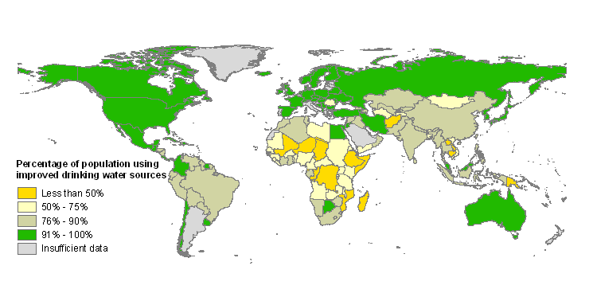
Fig Box 1c. Proportion of population with improved sanitation coverage in 2002. (C7 Fig 7.14) Access to improved sanitation is estimated by the percentage of the population using the following sanitation facilities: connection to a public sewer, connection to a septic system, pour-flush latrine, simple pit latrine (a portion of pit latrines are also considered unimproved sanitation), and ventilated improved pit latrine.
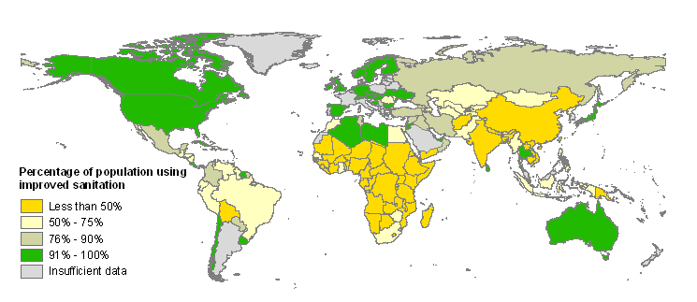

Box 3.2: Ecosystems and the Millennium Development Goals

The eight Millennium Development Goals (MDGs) were endorsed by governments at the United Nations in September 2000. The MDGs aim to improve human well-being by reducing poverty, hunger, child and maternal mortality, ensuring education for all, controlling and managing diseases, tackling gender disparity, ensuring sustainable development and pursuing global partnerships. Under each of the MDGs, governments have agreed to between one and 8 targets (a total of 15 targets) that are to be achieved by 2015. Slowing or reversing the degradation of ecosystem services will contribute significantly to the achievement of many of the MDGs:
Poverty Eradication. Ecosystem services are a dominant influence on livelihoods of most poor people. Most of the world’s poorest people live in rural areas and are thus highly dependent, directly or indirectly, on the ecosystem service of food production, including agriculture, livestock and hunting (R19.2.1). Mismanagement of ecosystems threatens the livelihood of poor people and may threaten their survival (C5.ES). Poor people are highly vulnerable to changes in watershed services that affect the quality or availability of water, loss of ecosystems such as wetlands, mangroves or coral reefs that affect the likelihood of flood or storm damage, or changes in climate regulating services that might alter regional climate. Ecosystem degradation is often one of the factors trapping people in cycles of poverty.
Hunger Eradication (R19.2.2). Although economic and social factors are often the primary determinants of hunger, food production remains an important factor, particularly among the rural poor. Food production is an ecosystem service in its own right and also depends on watershed services, pollination, pest regulation, and soil formation. Food production needs to increase to meet the needs of the growing human population, and at the same time the efficiency of food production (the amount produced per unit of land, water and other inputs) needs to increase in order to reduce harm to other key ecosystem services.
Combating Disease (R19.2.7). Human health is strongly influenced by ecosystem services related to food production, water quality, water quantity, and natural hazard regulation, and the role of ecosystem management is central to addressing some of the most pressing global diseases such as malaria. Changes in ecosystems influence the abundance of human pathogens such as malaria and cholera as well as the risk of emergence of new diseases. Malaria is responsible for 11 percent of the disease burden in Africa and it is estimated that Africa’s GDP could have been $100 billion larger (roughly a 25% increase) in 2000 if malaria had been eliminated 35 years ago (R16.1).
Environmental Sustainability. Achievement of this goal will require, at a minimum, an end to the current unsustainable uses of ecosystem services such as fisheries and freshwater and an end to the degradation of other services such as water purification, natural hazard regulation, disease regulation, climate regulation, and cultural services.
Figure 3.1. Net national savings adjusted to take into account investments in human capital, depletion of natural resources and damage caused by pollution as compared to standard measurements of net national savings. (C5) Positive values for national savings reflect a gain in wealth for a nation. Standard measures do not incorporate investments in human capital (in standard national accounting these expenditures are treated as consumption), depletion of a variety of natural resources, or pollution damages. The World Bank provides estimates of adjusted net national savings, taking into account education expenses (which are added to standard measures), unsustainable forest harvest, depletion of non-renewable resources (minerals and energy), and damage from carbon emissions (all of which are subtracted from the standard measure). The adjusted measure still overestimates actual net national savings since it does not include potential degradation of many ecosystem services including depletion of fisheries, atmospheric pollution, degradation of sources of fresh water, and loss of noncommercial forests and the ecosystem services they provide. Here we show the change in net national savings for countries in which there was at least a decline of at least 5% in net national savings due to the incorporation of resource depletion or damage from carbon emissions. The numbers in brackets after the country name refer to the net decrease in national savings due to resource depletion and atmospheric pollution.

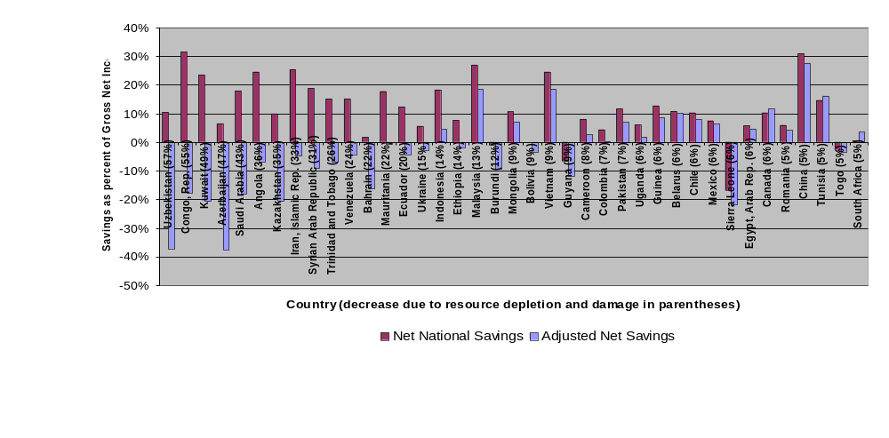

Figure 3.2. Changes in economic structure for selected countries. Share of national GDP for different sectors between 1820 and 1992. (S7 Fig 7.3)

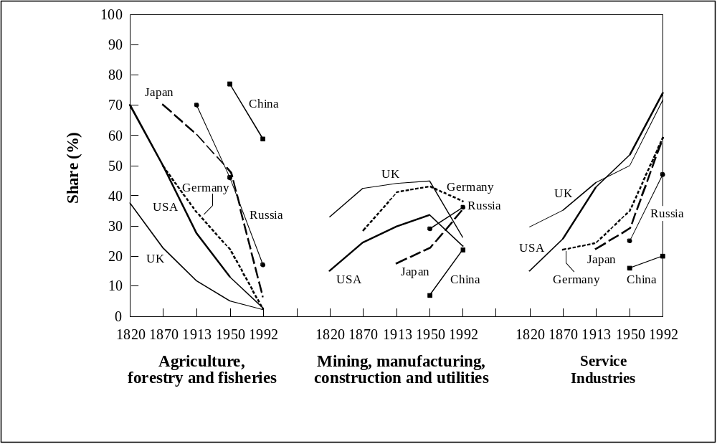

4. What are the most critical factors causing ecosystem changes?
Natural or human-induced factors that directly or indirectly cause a change in an ecosystem are referred to as “drivers”. A direct driver unequivocally influences ecosystem processes. An indirect driver operates more diffusely, by altering one or more direct drivers.
Drivers affect ecosystem services and human well-being at different spatial and temporal scales, which makes both their assessment and management complex (SG7). Climate change may operate on a global or large regional spatial scale; political change may operate at the scale of a nation or a municipal district. Social-cultural change typically occurs slowly, on a time scale of decades (although sometimes abrupt changes can occur as in the case of wars or political regime changes), while economic changes tend to occur more rapidly. As a result of this spatial and temporal dependence of drivers, the forces that appear to be most significant at a particular location and time may not be the most significant over larger (or smaller) regions or time scales.

Indirect Drivers
In the aggregate and at a global scale, there are five indirect drivers of changes in ecosystems and their services: population change, change in economic activity, socio-political factors, cultural factors, and technological change. Collectively these factors influence the level of production and consumption of ecosystem services and the sustainability of the production. Both economic growth and population growth lead to increased consumption of ecosystem services although the harmful environmental impacts of any particular level of consumption depend on the efficiency of the technologies used in the production of the service. These factors interact in complex ways in different locations to change pressures on ecosystems and uses of ecosystem services. Driving forces are almost always multiple and interactive, so that a one-to-one linkage between particular driving forces and particular changes in ecosystems rarely exists. Even so, changes in any one of these indirect drivers generally result in changes in ecosystems. The causal linkage is almost always highly mediated by other factors, thereby complicating statements of causality or attempts to establish the proportionality of various contributors to changes. Major indirect drivers include:
Demographic. Global population doubled in the past forty years and increased by 2 billion people in the last twenty-five years, reaching 6 billion in 2000 (S7.2.1). Developing countries have accounted for most recent population growth in the past quarter century, but there is now an unprecedented diversity of demographic patterns across regions and countries. Some high income countries such as the United States are still experiencing high rates of population growth, while some developing countries such as China, Thailand, and North and South Korea have very low rates of population growth. In the case of the United States, high population growth is due primarily to high levels of immigration. About half of the world’s population now lives in urban areas (although urban areas cover less than 3 percent of the terrestrial surface) up from less than 15% at the start of the twentieth century (C27.1). High-income countries typically have populations that are 70-80 percent urban. Some developing country regions, such as parts of Asia, are still largely rural, while Latin America, at 75 percent urban, is indistinguishable from high-income countries in this regard. (S7.2.1)
Economic. Global economic activity increased nearly 7-fold between 1950 and 2000 (S7.SDM). With rising per capita income the demand for many ecosystem services grows. At the same time, the structure of consumption changes. In the case of food, for example, as income grows, the share of additional income spent on food declines, the importance of starchy staples (e.g. rice, wheat, potatoes) declines and diets include more fat, meat and fish, and fruits and vegetables, and the proportionate consumption of industrial goods and services rises (S7.2.2). In the late twentieth century, income was distributed unevenly, both within countries and around the world. The level of per capita income was highest in North America, Western Europe, Australasia, and Northeast Asia, but growth rates were highest in South Asia, China, and parts of South America. (See Fig 4.1) (S7.2.2) Growth in international trade flows has exceeded growth in global production for many years, and the differential may be growing. In 2001, international trade in goods was equal to 40 percent of world gross domestic product (GDP) (S7.2.2). Inappropriate taxes and subsidies are important indirect drivers of ecosystem change. Fertilizer taxes or taxes on excess nutrients, for example, provide an incentive to increase the efficiency of the use of fertilizer applied to crops and thereby reduce negative externalities. Currently, many subsidies are having the effect of substantially increasing rates of resource consumption and increasing negative externalities. Annual subsidies to conventional energy, which encourage greater use of fossil fuels and consequently emissions of greenhouse gases are estimated to have been $250–300 billion in the mid-1990s (S7.ES). The 2001-03 average subsidies paid to the agricultural sectors of OECD countries were over US$324 billion annually (S7.ES), encouraging greater food production and associated water consumption, and nutrient and pesticide release. At the same time, many developing countries also have significant agricultural production subsidies.
Sociopolitical. Sociopolitical drivers encompass the forces influencing decision-making and include the quantity of public participation in decision-making, the makeup of participants in public decision-making, the mechanisms of dispute resolution, the role of the state relative to the private sector, and levels of education and knowledge (S7.2.3). These factors in turn influence the institutional arrangements for ecosystem management, as well as property rights over ecosystem services. Over the past fifty years, there have been significant changes in sociopolitical drivers. There is a declining trend in centralized authoritarian governments and a rise in elected democracies. The role of women is changing in many countries, average levels of formal education are increasing, and there has been a rise in civil society (such as increased involvement of NGOs and grassroots organizations in decision-making processes). The trend toward democratic institutions has helped to empower local communities, especially women and resource-poor households (S7.2.3). There has been an increase in multilateral environmental agreements. The importance of the state relative to the private sector – as a supplier of goods and services, as a source of employment, and as a source of innovation – is declining.
Cultural and Religious. To understand culture as a driver of ecosystem change, it is most useful to think of culture as the values, beliefs, and norms that a group of people share. In this sense, culture conditions individuals’ perceptions of the world, influences what they consider important, and suggests courses of action that are appropriate and inappropriate (S7.2.4). Broad comparisons of whole cultures have not proven useful because they ignore vast variations in values, beliefs and norms within cultures. Nevertheless, cultural differences clearly have important impacts on direct drivers. Cultural factors, for example, can influence consumption behavior (what and how much people consume) and values related to environmental stewardship, and may be particularly important drivers of environmental change.
Science and Technology. The development and diffusion of scientific knowledge and technologies that exploit that knowledge has profound implications for ecological systems and human well-being. The twentieth century saw tremendous advances in the understanding of how the world works physically, chemically, biologically, and socially and in the applications of that knowledge to human endeavors. Science and technology are estimated to have accounted for more than one-third of total GDP growth in the U.S. from 1929 to the early 1980s, and for 16 percent to 47 percent of GDP growth in selected OECD countries for the period 1960 to 1995. (S7.2.5) The impact of science and technology on ecosystem services is most evident in the case of food production. Much of the increase in agricultural output over the past 40 years has come from an increase in yields per hectare rather than an expansion of area under cultivation. For instance, wheat yields rose 208 percent, rice yields rose109 percent, and maize yields rose 157 percent in the past 40 years in developing countries. (S7.2.5) At the same time, technological advances can also lead to the degradation of ecosystem services. Advances in fishing technologies, for example, have contributed significantly to the depletion of marine fish stocks.
Consumption of ecosystem services is slowly being decoupled from economic growth. Growth in the use of ecosystem services over the past five decades was generally much less than the growth in GDP. This change reflects structural changes in economies but also results from new technologies and new management practices and policies that have increased the efficiency of use of ecosystem services and provided substitutes for some services. Even with this progress, though, the absolute level of consumption of ecosystem services continues to grow, which is consistent with the pattern for the consumption of energy and materials such as metals: in the 200 years for which we have reliable data, growth of consumption of energy and materials has outpaced increases in materials and energy efficiency leading to absolute increases of materials and energy use. (S7.ES)
Global trade magnifies the effect of governance, regulations, and management practices on ecosystems and their services, enhancing good practices but worsening the damage caused by poor practices. (R8, S7) Increased trade can accelerate degradation of ecosystem services in exporting countries if their policy, regulatory, and management systems are inadequate. At the same time, international trade enables comparative advantage to be exploited and accelerates the diffusion of more efficient technologies and practices. For example, the increased demand for forest products in many countries stimulated by growth in forest products trade can lead to more rapid degradation of forests in countries with poor systems of regulation and management, but can stimulate a “virtuous cycle” if the regulatory framework is sufficiently robust to prevent resource degradation while trade, and profits, increase. While historically most trade related to ecosystems has involved provisioning services such as food, timber, fiber, genetic resources and biochemicals, one regulating service (climate regulation or more specifically carbon sequestration) is now also traded internationally.
Urban demographic and economic growth has been increasing pressures on ecosystems globally, but affluent rural and suburban living often places even more pressure on ecosystems (C27-ES). Dense urban settlement is considered to be less environmentally burdensome than is urban and suburban sprawl. And, the movement of people into urban areas has significantly lessened pressure on some ecosystems and, for example, has led to the reforestation of some parts of industrialized countries that had been deforested in previous centuries. At the same time, urban centers facilitate human access to and management of ecosystem services through, for example, the scale and proximity economies of piped water systems.

Direct Drivers
Important direct drivers include: habitat change (land use change and physical modifications of rivers or water withdrawal from rivers), climate change, invasive alien species, overexploitation, and pollution. Most of the direct drivers of degradation in ecosystem services are currently remaining constant or growing in intensity in most ecosystems. (See Figure SDM-8). The most important direct drivers of change in ecosystem services are habitat change (land use change and physical modification of rivers or water withdrawal from rivers), overexploitation, invasive alien species, pollution, and climate change.

For terrestrial ecosystems, the most important direct drivers of change in ecosystem services in the past fifty years, in the aggregate, have been land cover change (in particular, conversion to cropland) and the application of new technologies (which have contributed significantly to the increased supply of services such as food, timber, and fiber). (CWG, S7.2.5, SG8.ES) Within nine of the fourteen biomes examined in the MA, between one-half and one-fifth of the area has been transformed, largely to croplands (C4.ES). Only biomes relatively unsuited to crop plants, such as deserts, boreal forests, and tundra have remained largely untransformed by human action. Both land cover changes and the management practices and technologies used on lands may cause major changes in ecosystem services. New technologies have resulted in significant increases in the supply of some ecosystem services such as through increases in agricultural yield. For example, in the case of cereals, from the mid 1980s to the late 1990s the global area under cereals fell by around 0.3% per year, while yields increased by about 1.2% per year (C26.4.1)
For marine ecosystems and their services, the most important direct driver of change in the past fifty years, in the aggregate, has been fishing. (C18) At the beginning of the 21st century, the biological capability of commercially exploited fish stocks was probably at an historical low. FAO estimates that about half of the wild marine fish stocks for which information is available are fully exploited and offer no scope for increased catches (C8.2.2). Fishing pressure is so strong in some marine systems that the biomass of some targeted species, especially larger fishes, and those caught incidentally (the ‘by-catch’) has been reduced to one tenth of levels prior to the onset of industrial fishing (C18.ES). The impact of fishing has been particularly significant in coastal areas but is now also affecting the open oceans.
For freshwater ecosystems and their services, depending on the region, the most important direct drivers of change in the past fifty years include modification of water regimes, invasive species, and pollution, particularly high levels of nutrient loading. It is speculated that 50% of inland water ecosystems (excluding large lakes and closed seas) were converted during the 20th Century (C20.ES). Massive changes have been made in water regimes: In Asia, 78 per cent of the total reservoir volume was constructed in the last decade, and in South America almost 60 percent of all reservoirs have been built since the 1980s (C20.4.2). The introduction of non-native invasive species is one of the major causes of species extinction in freshwater systems. While the presence of nutrients such as phosphorus and nitrogen is necessary for biological systems, high levels of nutrient loading cause significant eutrophication of water bodies and contributes to high levels of nitrate in drinking water in some locations. (The nutrient load refers to the total amount of nitrogen or phosphorus entering the water during a given time) Non-point pollution sources such as storm water run-off in urban areas, poor or non-existent sanitation facilities in rural area, the flushing of livestock manure by rainfall and snow melt are also cause of contamination (C20.4.5). Pollution from point sources such as mining has also had devastating local and regional impacts on the biota of inland waters.
Coastal ecosystems are affected by multiple direct drivers. Fishing pressures in coastal ecosystems are compounded by a wide array of other drivers including land, river and ocean-based pollution, habitat loss, invasive species, and nutrient loading. Upstream freshwater diversion has meant a 30% decrease worldwide of water and sediment delivery to estuaries, which are key nursery areas and fishing grounds (C19.ES). Approximately 17% of the world human population lives within the boundaries of the MA coastal system (up to an elevation of 50m above sea level and no further than 100km from the coast) and approximately 40% live in the full area within 50km of the coast, and the absolute number is increasing, through a combination of in-migration, high reproduction rates, and tourism (C-SDM). Demand on coastal space for shipping, waste disposal, military and security uses, recreation, and aquaculture is increasing. The greatest threat to coastal systems is the development-related conversion of coastal habitats such as forests, wetlands and coral reefs, through coastal urban sprawl, resort and port development, aquaculture, and industrialization. Dredging, reclamation and destructive fishing also account for widespread, effectively irreversible destruction. Shore protection structures and engineering works (beach armoring, causeways, bridges, etc.), by changing coastal dynamics, have impacts extending beyond their direct footprints. Nitrogen loading to the coastal zone has increased by about 80% worldwide, and has driven coral reef community shifts (R9).
Over the past four decades, excessive nutrient loading has emerged as one of the most important direct drivers of ecosystem change in terrestrial, freshwater, and marine ecosystems. (Table 4.1) While the introduction of nutrients into ecosystems can have both beneficial effects (such as increased crop productivity) and adverse effects (such as eutrophication of inland and coastal waters), as greater quantities of nutrients are introduced the adverse effects predominate. Synthetic production of nitrogen fertilizer has been an important driver for the remarkable increase in food production that has occurred during the past 50 years (S7.3.2). As much as 50 percent of the nitrogen fertilizer applied may be lost to the environment depending on how well the application is managed. Since excessive nutrient loading is largely the result of applying more nutrients than crops can use, it harms both farm incomes and the environment. Excessive nitrogen loading can cause algal blooms, decreased drinking water quality, eutrophication of freshwater ecosystems (a process whereby excessive plant growth depletes oxygen in the water), hypoxia in coastal marine ecosystems (substantial depletion of oxygen resulting in die-offs of support fish and other aquatic animals), nitrous oxide emissions contributing to global climate change, and air pollution by NO_{x} in urban areas (S7.3.2). Phosphorus application has increased three-fold since 1960, with a steady increase until 1990, followed by leveling off at a level approximately equal to 1980’s applications. While phosphorus use has increasingly concentrated on phosphorus deficient soils, the growing phosphorus accumulation in soils contributes to high levels of phosphorus runoff that can cause eutrophication of freshwaters and coastal waters. Potential consequences include eutrophication of freshwater ecosystems and hypoxia in coastal marine ecosystems. Many ecosystem services are reduced when inland waters and coastal ecosystems become eutrophic. Water from lakes that experience algal blooms is more expensive to purify for drinking or other industrial uses. Eutrophication can reduce or eliminate fish populations. Possibly the most striking loss in services is the loss of many of the cultural services provided by lakes. Foul odors of rotting algae, slime-covered lakes, and toxic chemicals produced by some blue-green algae during blooms keep people from swimming, boating, and otherwise enjoying the aesthetic value of lakes (S7.3.2).
Climate change in the past century has already had a measurable impact on ecosystems. The Earth's climate system has changed since the pre-industrial era, in part due to human activities, and is projected to continue to change throughout the 21st century. During the last 100 years, the global mean surface temperature has increased by about 0.6C, precipitation patterns have changed spatially and temporally, and global average sea level rose between 0.1 and 0.2 meters (S7.ES). Observed changes in climate, especially warmer regional temperatures, have already affected biological systems in many parts of the world. There have been changes in species distributions, population sizes, the timing of reproduction or migration events, and an increase in the frequency of pest and disease outbreaks, especially in forested systems. The growing season in Europe has lengthened over the last 30 years (R13.1.3). Although it is not possible to determine whether the extreme temperatures were a result of human-induced climate change, many coral reefs have undergone major, although often partially reversible, bleaching episodes, when sea surface temperatures have increased by 1ºC during a single season. Extensive coral mortality has occurred with observed local increases in temperature of 3ºC (R13.1.3).
Table 4.1. Increase in nitrogen fluxes in rivers to coastal oceans due to human activities relative to fluxes prior to the industrial and agricultural revolutions. (R9 Table 9.1)
Labrador & Hudson’s Bay no change
Southwestern Europe 3.7-fold
Great Lakes/St. Lawrence basin 4.1-fold
Baltic Sea watersheds 5.0-fold
Mississippi River basin 5.7-fold
Yellow River basin 10-fold
Northeastern US 11-fold
North Sea watersheds 15-fold
Republic of Korea 17-fold

Figure 4.1. GDP average annual growth, 1990-2000 (S7 Fig 7.6). (Note: Dollar figures for GDP are converted from domestic currencies using 1995 official exchange rates.)

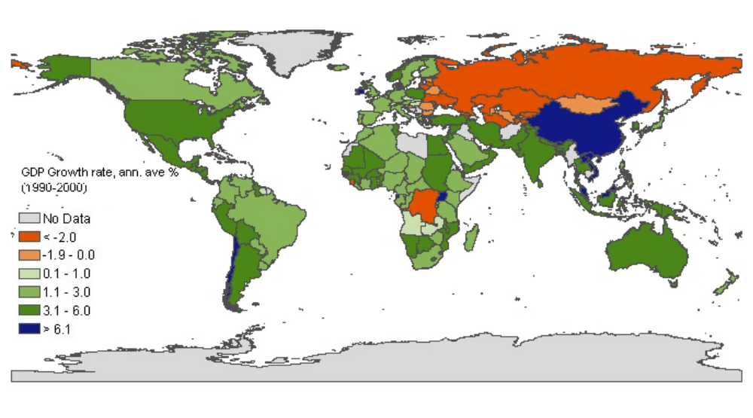

5. How might ecosystems and their services change in the future under various plausible scenarios?
The MA developed four scenarios (in addition to other scenarios at sub-global scales) to explore plausible futures for ecosystems and human well-being (see Box 5.1). The scenarios were developed with a focus on conditions in 2050, although they include some information through the end of the century. The scenarios explored two global development paths, one in which the world becomes increasingly globalized and one in which it becomes increasingly regionalized, and two different approaches to ecosystem management, one in which actions are reactive and most problems are addressed only after they become obvious and one in which ecosystem management is proactive and policies deliberately seek to maintain ecosystem services for the long term. Framed in terms of these contrasts, the scenarios are:
- Global Orchestration - This scenario depicts a globally-connected society that focuses on global trade and economic liberalization and takes a reactive approach to ecosystem problems but which also takes strong steps to reduce poverty and inequality and to invest in public goods such as infrastructure and education.
- Order from Strength – This scenario represents a regionalized and fragmented world, concerned with security and protection, emphasizing primarily regional markets, paying little attention to public goods, and taking a reactive approach to ecosystem problems;
- Adapting Mosaic – In this scenario, regional watershed-scale ecosystems are the focus of political and economic activity. Local institutions are strengthened and local ecosystem management strategies are common, and societies develop a strongly proactive approach to the management of ecosystems.
- TechnoGarden – This scenario depicts a globally connected world relying strongly on environmentally sound technology, using highly managed, often engineered, ecosystems to deliver ecosystem services, and taking a proactive approach to the management of ecosystems in an effort to avoid problems.
The scenarios are not predictions; instead they were developed to explore the unpredictable and uncontrollable features of change in ecosystem services and a number of socio-economic factors. No scenario represents business as usual though all begin from current conditions and trends. The future will represent a mix of approaches and consequences described in the scenarios, as well as events and innovations that have not yet been imagined. No scenario will match the future as it actually occurs. These four scenarios were not designed to explore the entire range of possible futures for ecosystem services – other scenarios could be developed with either more optimistic or more pessimistic outcomes for ecosystems, their services, and human well-being.
The scenarios were developed using both quantitative models and qualitative analysis. For some drivers (e.g., economic growth, land use change, carbon emissions), and ecosystem services (water withdrawals, food production), quantitative projections were calculated using established, peer reviewed global models. Other drivers (such as rates of technological change), ecosystem services (particularly supporting and cultural services such as soil formation and recreational opportunities), and human well-being indicators (such as human health and social relations), for which there are no appropriate global models, were estimated qualitatively. In general, the quantitative models used for these scenarios addressed incremental changes but failed to address thresholds, risk of extreme events, or impacts of large, extremely costly, or irreversible changes in ecosystem services. These phenomena were addressed qualitatively, by considering the risks and impacts of large but unpredictable ecosystem changes in each scenario.
Projected Changes in Indirect and Direct Drivers under MA Scenarios
In the four MA scenarios, during the first half of the 21st century the array of both indirect and direct drivers affecting ecosystems and their services is projected to remain largely the same as over the past half century, but the relative importance of different drivers will begin to change with some factors (e.g., global population growth) beginning to decline in importance and other factors (distribution of people, climate change, changes to nutrient cycles) growing in importance. (See Table 5.1 to 5.3.) In the four MA scenarios, between 2000 and 2050:
- Population is projected to grow to between approximately 8.1 and 9.6 billion in 2050 (medium to high certainty) and to between 6.8 and 10.5 billion in 2100 depending on the scenario (S7.2.1). (See Fig. 5.1) The rate of global population growth has already peaked, at 2.1% per year in the late 1960s, and has fallen to 1.35% per year in 2000 when global population reached 6 billion (S7.ES). Population growth over the next several decades is expected to be concentrated in the poorest, urban communities in sub-Saharan Africa, South Asia, and the Middle East (S7.ES).
- Per capita income is projected to increase two- to four-fold depending on the scenario (low to medium certainty) (S7.2.2.). Increasing income leads to increasing per capita consumption in most parts of the world for most resources and changes the structure of consumption. For example, diets tend to become higher in animal protein as income rises.
- Land use change (primarily the continuing expansion of agriculture) is projected to continue to be a major direct driver of change in terrestrial and freshwater ecosystems (medium to high certainty) (S9.ES). At the global level and across all scenarios, land-use change is projected to remain the dominant driver of biodiversity change in terrestrial ecosystems, consistent with the pattern over the past 50 years, followed by changes in climate and nitrogen deposition. (S10.ES) However, other direct drivers may be more important than land use change in particular biomes. For example, climate change is likely to be the dominant driver of biodiversity change in tundra and deserts. Species invasions and water extraction are important drivers for freshwater ecosystems.
- Nutrient loading is projected to become an increasingly severe problem, particularly in developing countries. Nutrient loading already has major adverse effects on freshwater ecosystems and coastal regions in both industrialized and developing countries. These impacts include toxic algae blooms, other human health problems, fish kills, and damage to habitats such as coral reefs. The MA scenarios project that the global flux of nitrogen to coastal ecosystems will increase by 10-20% by 2030 (medium certainty) (S9.3.7.2). (See Fig. 5.2) River nitrogen will not change in most industrialized countries, while a 20-30% increase is projected for developing countries, particularly in Asia. The MA scenarios did not attempt to quantify the overall changes in global nitrogen flows. One recent study of global human contributions to reactive nitrogen flows for the year 2050 projected that flows will increase from approximately 165 Tg of reactive Nitrogen in 1999 to 270 Tg in 2050, an increase of 64% (See Fig. 1.2) (R9.??).
- Climate change and its impacts (e.g. sea level rise) are projected to have an increasing effect on biodiversity and ecosystem services (medium certainty) (S9.ES). Under the four MA scenarios, global temperature is expected to increase significantly (1.5-2.0 ºC above pre-industrial in 2050, and 2.0 to 3.5º C in 2100, depending on the scenario and using median estimates for climate change variables. ) (medium certainty). This range is in the low to middle range of the scenarios developed for the IPCC Third Assessment Report (2.0 to 6.4 ºC) largely due to the fact that the MA scenarios with high population and economic growth are also scenarios in which significant action is taken to address the problem of climate change by mid-century. The scenarios project an increase in global average precipitation (medium certainty) but some areas will become more arid while other will become more moist. Climate change will directly alter ecosystem services, for example, by causing changes in the productivity and growing zones of cultivated and non-cultivated vegetation. Climate change is also projected to change the frequency of extreme events, with associated risks to ecosystem services. Finally, it is projected to indirectly affect ecosystem services in many ways, such as by causing sea level to rise which threatens mangroves and other vegetation that now protect shorelines.
Climate change is projected to further adversely affect key development challenges including the provisioning of clean water, energy services and food, maintaining a healthy environment and conserving ecological systems, their biodiversity and associated ecological goods and services. Specifically (R13.1.3),
- climate change is projected to exacerbate the loss of biodiversity and increase the risk of extinction for many species, especially those that are already at risk due to factors such as low population numbers, restricted or patchy habitats and limited climatic ranges (medium to high certainty).
- water availability and quality is projected to decrease in many arid and semi-arid regions (high certainty);
- the risk of floods and droughts is projected to increase (high certainty);
- the reliability of hydropower and biomass production is projected to decrease in many regions;
- the incidence of vector-borne (e.g., malaria and dengue) and water-borne (e.g., cholera) diseases is projected to increase in many regions (medium to high certainty), and so too is heat/cold stress mortality and threats of decreased nutrition in others, along with severe weather traumatic injury and death (high certainty);
- agricultural productivity is projected to decrease in the tropics and sub-tropics for almost any amount of warming (low to medium certainty), and there are projected adverse effects on fisheries;
- projected changes in climate during the 21st century will occur faster than in at least the past 10,000 years and combined with land use change and exotic/alien species spread, are likely to limit both the capability of species to migrate and the ability of species to persist in fragmented habitats.

- By the end of the century, climate change and its impacts may be the dominant direct drivers of biodiversity loss and change of ecosystem services globally (R13). Harm to biodiversity will grow with both increasing rates in change in climate and increasing absolute amounts of change. For ecosystem services, some services in some regions may initially benefit from increases in temperature or precipitation expected under climate scenarios, but the balance of evidence suggests that there will be a significant net harmful impact on ecosystem services worldwide if global mean surface temperature increase more than 2ºC above pre-industrial levels or at rates greater than 0.2ºC per decade (medium certainty). This judgment is based on the evidence that an increase of about 2ºC above pre-industrial levels in global mean surface temperature would: (i) represent a transition between the negative effects of climate change being in only some regions of the world to being negative in most regions of the world (for example, below about 2ºC, agricultural productivity is projected to be adversely impacted in the tropics and sub-tropics, but beneficially impacted in most temperate and high latitude regions, whereas a warming of greater than 2ºC is projected to adversely impact agricultural productivity not only in the tropics and sub-tropics, but also in many temperate regions); (ii) result in both positive and negative economic impacts, but with the majority of people being adversely affected, that is, predominantly negative economic effects in developing countries; (iii) pose a risk to many unique and threatened ecological systems and lead to the extinction of numerous species; and, (iv) lead to a significant increase in extreme climatic events and adversely impact agriculture in the tropics and sub-tropics, water resources in countries that are already water scarce or stressed, and human health and property.
Changes in Ecosystems
Rapid conversion of ecosystems is projected to continue under all MA scenarios in the first half of the 21st century. Roughly 10 to 20% (low to medium certainty) of current grassland and forest land is projected to be converted to other uses between now and 2050, mainly due to the expansion of agriculture and secondarily, because of the expansion of cities and infrastructure (S9.ES). The biomes projected to lose habitat and local species at the fastest rate in the next 50 years are warm mixed forests, savannahs, scrub, tropical forests, and tropical woodlands (S10ES). Rates of conversion of ecosystems are highly dependent upon future development scenarios and in particular on changes in population, wealth, and technology.
Habitat loss in terrestrial environments is projected to accelerate decline in local diversity of native species in all four scenarios by 2050 (high certainty) (S-SDM). Loss of habitat results in the immediate extirpation of local populations and the loss of the services that these populations provided.

The habitat losses projected in the MA scenarios will lead (high certainty) to global extinctions as numbers of species approach equilibrium with the remnant habitat. (S-SDM, S10.ES) The equilibrium number of plant species is projected to be reduced by roughly 10-15% as a result of habitat loss over the period of 1970 to 2050 in the MA scenarios (low certainty). Other terrestrial taxonomic groups are likely to be affected to a similar extent. The pattern of extinction through time cannot be estimated with any precision, because some species will be lost immediately when their habitat is modified but others may persist for decades or centuries. Time lags between habitat reduction and extinction provide an opportunity for humans to deploy restoration practices that may rescue those species that otherwise may be in a trajectory towards extinction. Significant declines in freshwater fish species diversity are also projected due to the combined effects of climate change, water withdrawals, eutrophication, acidification, and increased invasions by non-indigenous species (low certainty). Rivers that are expected to lose fish species are concentrated in poor tropical and subtropical countries
Changes in Ecosystem Services and Human Well-being
In three of the four MA scenarios, ecosystem services show net improvements in at least one of the three categories of provisioning, regulating, and cultural services (S-SDM). Provisioning, regulating, and cultural ecosystem services are all in worse condition in 2050 than they are today in only one of the four MA scenarios (Order from Strength). Between one and three of the categories of services are in better condition in 2050 than in 2000 in the other three scenarios. (See Figure 15.) However, even in scenarios showing improvement in one or more categories of ecosystem services, biodiversity loss continues at high rates.
The following changes to ecosystem services and human well-being were common to all the MA scenarios, and thus may be likely under a wide range of plausible futures (S-SDM):
- Human use of ecosystem services increases substantially under all MA scenarios during the next 50 years. In many cases this is accompanied by degradation in the quality of the service and sometimes, in cases where the service is being used unsustainably, a reduction in the quantity of the service available. (See Part II Ecosystem Service Reports.) The combination of growing populations and growing per capita consumption increases the demand for ecosystem services, including water and food. For example, demand for food crops (measured in tons) is projected to grow by 70 to 85 percent between 2000 and 2050 (S9.4.1) and global water withdrawals increase by between 30 and 85 percent across the MA scenarios (S9 Fig. 9.34). Water withdrawals in developing countries are projected to increase significantly under the scenarios, although water withdrawals are projected to decline in the OECD countries (medium certainty) (S-SDM). In some cases, this growth in demand will be met by unsustainable uses of the services, such as through continued depletion of marine fisheries. Demand is dampened somewhat by increasing efficiency in use of resources. The quantity and quality of ecosystem services will change dramatically in the next 50 years as productivity of some services is increased to meet demand, as humans use a greater fraction of some services, and as some services are diminished or degraded. Ecosystem services that are projected to be further impaired by ecosystem change include fisheries, food production in drylands, quality of fresh waters, and cultural services.
- Food security is likely to remain out of reach for many people and child malnutrition will be difficult to eradicate even by 2050 (with low to medium certainty), and is projected to increase in some regions in some MA scenarios, despite increasing food supply under all four scenarios (medium to high certainty) and more diversified diets in poor countries (with low to medium certainty) (S-SDM). This is due to a combination of factors related to food supply systems (inadequate investments in food production and its supporting infrastructure resulting in low productivity increases, varying trade regimes) and food demand and accessibility (continuing poverty in combination with high population growth rates, lack of food infrastructure investments).

- Vast, complex changes with great geographic variability are projected to occur in world freshwater resources and hence in their provisioning of ecosystem services in all scenarios (S-SDM). Climate change will lead to increased precipitation over more than half of the Earth’s surface and this will make more water available to society and ecosystems (medium certainty). However, increased precipitation is also likely to increase the frequency of flooding in many areas (high certainty). Increases in precipitation will not be universal, and climate change will also cause a substantial decrease in precipitation in some areas with an accompanying decrease in water availability (medium certainty). These areas could include highly populated arid regions such as the Middle East and Southern Europe (low to medium certainty). While water withdrawals decrease in most developed countries, water withdrawals and wastewater discharges are expected to increase substantially in Africa and some other developing regions, overshadowing the possible benefits of increased water availability (medium certainty).

- A deterioration of the services provided by freshwater resources (such as aquatic habitat; fish production; water supply for households, industry, and agriculture) is expected in developing countries under the scenarios that are reactive to environmental problems (S9.ES). Less severe but still important declines are expected in the scenarios that are more proactive about environmental problems (medium certainty).

- Growing demand for fish and fish products leads to an increasing risk of a major and long-lasting collapses of regional marine fisheries (low to medium certainty) (S-SDM). Aquaculture may relieve some of this pressure by providing for an increasing fraction of fish demand. However, this would require aquaculture to reduce its current reliance on marine fish as a feed source.
The future contribution of terrestrial ecosystems to the regulation of climate is uncertain (S9.ES). Carbon release or uptake by ecosystems affects the CO₂ and CH₄ content of the atmosphere at the global scale and thereby affects global climate. Currently, the biosphere is a net sink of carbon, absorbing about 1 to 2 Gt C/yr, or approximately 20% of fossil fuel emissions. It is very likely that the future of this service will be greatly affected by expected land use change. In addition, a higher atmospheric CO₂ concentration is expected to enhance net productivity, but this does not necessarily lead to an increase in the carbon sink. The limited understanding of soil respiration processes generates uncertainty about the future of the carbon sink. There is a medium certainty that climate change will increase terrestrial fluxes of CO₂ and CH₄ in some regions (e.g., in Arctic tundra).
Dryland ecosystems are particularly vulnerable to changes in over the next 50 years. The combination of low current levels of human well-being (high rates of poverty, low per capita GDP, high infant mortality rates), the large and growing population, the high variability of environmental conditions in dryland regions, and the high sensitivity of populations to changes in ecosystem services, means that continuing land degradation could have profoundly negative impacts on the well-being of a large number of people (S-SDM). Subsidies of food and water to people in vulnerable drylands can have the unintended effect of increasing the risk of even larger breakdowns of ecosystem services in future years. Local adaptation and conservation practices can mitigate some losses of dryland ecosystem services, although it will be difficult to reverse trends toward loss of food production capacity, water supplies, and biodiversity in drylands.

While human health improves under most MA scenarios, under one plausible future health and social conditions for the North and South could diverge, health in developing countries becoming worse, causing a negative spiral of poverty, declining health, and degraded ecosystems (S11). In the more promising scenarios related to health, the number of undernourished children is reduced, the burden of disease of epidemic diseases such as HIV/AIDS, malaria and tuberculosis should be reduced, improved vaccine development and distribution could allow populations to cope comparatively well with the next influenza pandemic and the impact of other new diseases, such as SARS, should also be limited, by well-coordinated public health measures. However, under the Order from Strength scenario, it is plausible that the health and social conditions for the North and South could diverge as inequality increases, and commerce and scientific exchanges between industrialized and developing countries decrease., Under this scenario, health in developing countries could become worse, causing a negative spiral of poverty, declining health, and degraded ecosystems. The increased population in the South, combined with static or deteriorating nutrition could force increased contact between humans and non-agricultural ecosystems, especially to obtain bushmeat and other forest goods. This could lead to more outbreaks of hemorrhagic fever and zoonoses. It is possible, though with low probability, that a more chronic disease could cross from a non-domesticated animal species into humans, slowly and then more rapidly colonize human populations, as HIV is thought to have done.
Each scenario yields a different package of gains, losses, and vulnerabilities to components of human well-being in different regions and populations (Table 5.4). (S-SDM) Actions which focus on improving the lives of the poor by reducing barriers to international flows of goods, services, and capital, tend to lead to the most improvement in health and social relations for the currently most disadvantaged people. However, human vulnerability to ecological surprises is high. Globally-integrated approaches that focus on technology and property rights for ecosystem services generally improve human well-being in terms of health, security, social relations, and material needs. However, if the same technologies are used globally, local culture can be lost or undervalued. High levels of trade lead to more rapid spread of emergent diseases, somewhat reducing the gains in health in all areas. Locally-focused, learning-based approaches lead to the largest improvements in social relations. Order from Strength, which focuses on reactive policies in a regionalized world, has the least favorable outcomes for human well-being, as the global distribution of ecosystem services and human resources that underpin human well-being are increasingly skewed. Wealthy populations generally meet most material needs, but experience psychological unease. Anxiety, depression, obesity, and diabetes have a greater impact on otherwise privileged populations in this scenario. Disease creates a heavy burden for disadvantaged populations.
Proactive or anticipatory management of ecosystems is generally advantageous in the MA scenarios, but is particularly beneficial under conditions of changing or novel conditions (S-SDM). (See Table 5.2.). Ecological surprises are inevitable because of the complexity of the interactions and because of limitations in current understanding of the dynamical properties of ecosystems. Currently well-understood phenomena that were surprises of the past century include the ability of pests to evolve resistance to biocides, the contribution to desertification of certain types of land use, biomagnification of toxins, and the increase in vulnerability of ecosystem to eutrophication and unwanted species due to removal of predators. While we do not know which surprises will come in the next 50 years, we can be certain that there will be some. In general, proactive action to manage systems sustainably and to build resilience into systems will be advantageous, particularly when conditions are changing rapidly, when surprise events are likely, or uncertainty is high. This approach is beneficial largely because the restoration of ecosystems or ecosystem services following their degradation or collapse is generally more costly and time consuming than preventing degradation, if it is possible at all. Nevertheless, there are costs and benefits to both proactive and reactive approaches as shown in Table 5.1.
Box 5.1 MA Scenarios

The MA developed four global scenarios exploring plausible future changes in drivers, ecosystems, ecosystem services, and human well-being.


The Global Orchestration scenario depicts a globally-connected society in which policy reforms that focus on global trade and economic liberalization are used to reshape economies and governance, emphasizing the creation of markets that allow equal participation and provide equal access to goods and services. These policies, in combination with large investments in global public health and the improvement of education worldwide, generally succeed in promoting economic expansion and lifting many people out of poverty into an expanding global middle class. Supra national institutions in this globalized scenario are well-placed to deal with global environmental problems such as climate change and fisheries. However, the reactive approach to ecosystem management favored in this scenario makes people vulnerable to surprises arising from delayed action. While the focus is on improving human well-being of all people, environmental problems that threaten human well-being are only considered after they become apparent.

Growing economies, expansion of education, and growth of the middle class leads to demand for cleaner cities, less pollution, and a more beautiful environment. Rising income levels bring about changes in global consumption patterns, boosting demand for ecosystem services, including agricultural products such as meat, fish, and vegetables. Growing demand for these services leads to declines in other services, as forests are converted into cropped area and pasture, and the services formerly provided by forests decline. The problems related to increasing food production, such as loss of wildlands, are not apparent to most people who live in urban areas. These problems therefore receive only limited attention. Global economic expansion expropriates or degrades many of the ecosystem services poor people once depended upon for their survival. While economic growth more than compensates for these losses in some regions by increasing our ability to find substitutes for particular ecosystem services, in many other places, it does not. An increasing number of people are impacted by the loss of basic ecosystem services essential for human life. While risks seem manageable in some places, in other places there are sudden, unexpected losses as ecosystems cross thresholds and degrade irreversibly. Loss of potable water supplies, crop failures, floods, species invasions, and outbreaks of environmental pathogens increase in frequency. The expansion of abrupt, unpredictable changes in ecosystems, many with harmful effects on increasingly large numbers of people, is the key challenge facing managers of ecosystem services.


The Order from Strength scenario represents a regionalized and fragmented world, concerned with security and protection, emphasizing primarily regional markets, and paying little attention to common goods. Nations see looking after their own interests as the best defense against economic insecurity, and the movement of goods, people, and information is strongly regulated and policed. The role of government expands as oil companies, water systems, and other strategic businesses are either nationalized or subjected to more state oversight. Trade is restricted, large amounts of money are invested in security systems, and technological change slows due to restrictions on the flow of goods and information. Regionalization exacerbates global inequality. Global climate change treaties, international fisheries, and the trade in endangered species are only weakly and haphazardly implemented, resulting in degradation of the global commons. Local problems often go unresolved, but major problems are sometimes handled by rapid disaster relief to at least temporarily resolve the immediate crisis. Many powerful countries cope with local problems by shifting burdens to other, less powerful countries, increasing the gap between rich and poor. In particular, natural resource-intensive industries are moved from wealthier nations to poorer and less powerful ones. Inequality increases considerably within countries as well.
Ecosystem services become more vulnerable, fragile, and variable in Order from Strength. For example, parks and reserves exist within fixed boundaries, but climate changes around them, leading to the unintended extirpation of many species. Conditions for crops are often suboptimal, and the ability of societies to import alternative foods is diminished by trade barriers. As a result, there are frequent shortages of food and water, particularly in poor regions. Low levels of trade tend to restrict the number of invasions by exotic species; however, ecosystems are less resilient and invaders are therefore more often successful when they arrive.


In the Adapting Mosaic scenario, regional watershed-scale ecosystems are the focus of political and economic activity. This scenario sees the rise of local ecosystem management strategies, and the strengthening of local institutions. Investments in human and social capital are geared towards improving knowledge about ecosystem functioning and management, which results in a better understanding of resilience, fragility, and local flexibility of ecosystems. There is optimism that we can learn, but humility about preparing for surprises and about our ability to know everything about managing ecosystems. There is also great variation among nations and regions in styles of governance, including management of ecosystem services. Some regions explore actively adaptive management, investigating alternatives through experimentation. Others employ bureaucratically rigid methods to optimize ecosystem performance. Great diversity exists in the outcome of these approaches: some areas thrive, while others develop severe inequality or experience ecological degradation. Initially, trade barriers for goods and products are increased, but barriers for information nearly disappear (for those who are motivated to use them) due to improving communication technologies and rapidly decreasing costs of access to information.

Eventually, the focus on local governance leads to failures in managing the global commons. Problems like climate change, marine fisheries, and pollution grow worse and global environmental problems intensify. Communities slowly realize that they cannot manage their local areas because global and regional problems are infringing, and they begin to develop networks among communities, regions, and even nations, to better manage the global commons. Solutions that were effective locally are adopted among networks. These networks of regional successes are especially common in situations where there are mutually beneficial opportunities for coordination, such as along river valleys. Sharing good solutions and discarding poor ones eventually improves approaches to a variety of social and environmental problems, ranging from urban poverty to agricultural water pollution. As more knowledge is collected from successes and failures, provision of many services improves.

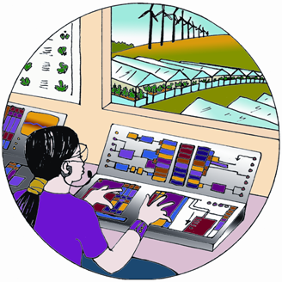
The TechnoGarden scenario depicts a globally connected world relying strongly on technology and highly managed, often engineered ecosystems, to deliver ecosystem services. Overall efficiency of ecosystem service provision improves, but is shadowed by the risks inherent in large-scale human-made solutions and rigid control of ecosystems. Technology and market-oriented institutional reform are used to achieve solutions to environmental problems. These solutions are designed to benefit both the economy and the environment. These changes co-develop with the expansion of property rights to ecosystem services, such as requiring people to pay for pollution they create or paying people for providing key ecosystem services through actions such as preservation of key watersheds. Interest in maintaining, and even increasing, the economic value of these property rights, combined with an interest in learning and information, leads to a flowering of ecological engineering approaches for managing ecosystem services. Investment in green technology is accompanied by a significant focus on economic development and education, improving people’s lives and helping them understand how ecosystems make their livelihoods possible. A variety of problems in global agriculture are addressed by focusing on the multifunctional aspects of agriculture and a global reduction of agricultural subsidies and trade barriers. Recognition of the role of agricultural diversification encourages farms to produce a variety of ecological services, rather than simply maximizing food production. The combination of these movements stimulates the growth of new markets for ecosystem services, such as tradable nutrient runoff permits, and the development of technology for increasingly sophisticated ecosystem management. Gradually, environmental entrepreneurship expands as new property rights and technologies co-evolve to stimulate the growth of companies and cooperatives providing reliable ecosystem services to cities, towns, and individual property owners.

Innovative capacity expands quickly in developing nations. The reliable provision of ecosystem services, as a component of economic growth, together with enhanced uptake of technology due to rising income levels, lifts many of the world’s poor into a global middle class. Elements of human well-being associated with social relations decline in this scenario due to great loss of local culture, customs, and traditional knowledge that occurs and due to the weakening of civil society institutions as an increasing share of interactions take place over the Internet. While the provision of basic ecosystem services improves the well-being of the world’s poor, the reliability of the services, especially in urban areas, is increasingly critical and increasingly difficult to ensure. Not every problem has succumbed to technological innovation. Reliance on technological solutions sometimes creates new problems and vulnerabilities. In some cases, we seem to be barely ahead of the next threat to ecosystem services. In such cases new problems often seem to emerge from the last solution, and the costs of managing the environment are continually rising. Environmental breakdowns that impact large numbers of people become more common. Sometimes new problems seem to emerge faster than solutions. The challenge for the future will be to learn how to organize social-ecological systems so that ecosystem services are maintained without taxing society’s ability to implement solutions to novel, emergent problems.
Table 5.1. Main assumptions concerning indirect and direct driving forces used in the MA Scenarios, and outcomes of for ecosystem services and human well-being:
Indirect and Direct Drivers (S-SDM) (“Industrialized” and “developing” nations refer to the countries at the beginning of the scenario, and some may actually change categories during the course of the 50 years.)
 | Global Orchestration | Order from Strength |  | Adapting Mosaic | TechnoGarden
 | Global Orchestration | Industrialized Nations | Developing Nations | Adapting Mosaic | TechnoGarden
Indirect Drivers
Demographics  low fertility growth rates; | high migration; low mortality 2050 population: 8.1 billion | high fertility growth rates (esp. in developing countries); | low migration, high mortality 2050 population: 9.6 billion | high fertility growth rates;  low migration, high mortality until 2010 then to medium by 2050  2050 population: 9.5 billion | medium fertility growth rates, medium migration, medium mortality  2050 population: 8.8 billion
Average income growth | high | medium | low | similar to Order from Strength but with increasing growth rates towards 2050 | lower than Global Orchestration, but catching up towards 2050
GDP growth rates/capita per year until 2050 | Global: 1995-2020: 2.4 %/y  2020-2050: 3.0%/y | 1995-2020: 1.4 %/y  2020-2050: 1.0 %/y |  | 1995-2020:  1.5 %/y  2020-2050:  1.9 %/y | 1995-2020:  1.9 %/y  2020-2050:  2.5 %/y
GDP growth rates/capita per year until 2050 | industrialized c.: 1995-2020: 3.2%/y  2020-2050:  2.1%/y  developing c.:  1995-2020: 4.8%/y  2020-2050:  4.8%/y | 1995-2020: 2.6%/y  2020-2050: 1.4%/y | 1995-2020: 3.0%/y  2020-2050:  2.3%/y | industrialized c.: 1995-2020:  2.6%/y  2020-2050:  1.7%/y  developing c.:  1995-2020: 3.5%/y  2020-2050:  3.5%/y | industrialized c.: 1995-2020: 2.9%/y  2020-2050:  1.9%/y  developing c.:  1995-2020: 4.0%/y  2020-2050:  4.3%/y
Income distribution | becomes more equal | similar to today |  | similar to today, then becomes more equal | becomes more equal
Investments into new produced assets | high | medium | low | begins like Order from Strength, then increases in tempo | high
Investments into human capital | high | medium | low | begins like Order from Strength, then increases in tempo | medium
International relationships (stimulating technology transfer) | high | low (medium among cultural groups) |  | low-medium | high
Overall trend in technology advances | high | low |  | medium-low | medium in general; high for environmental technology
International cooperation | strong | weak - international competition |  | weak - focus on local environment | strong
Attitude toward environmental policies | reactive | reactive |  | proactive - learning | proactive
Energy demand and lifestyle | based on current North American values | regionalized assumptions |  | regionalized assumptions | based on current Japan and West European values
Energy supply | market liberalization; selects least-cost options; rapid technology change | focus on domestic energy resources |  | some preference for clean energy resources | preference for renewable energy resources and rapid technology change
Climate policy | no | no |  | no | yes, aims at stabilization of CO₂-equivalent concentration at 550 ppmv
Approach to achieving sustainability | Sustainable development; economic growth; public goods | Reserves, parks; national-level policies; conservation |  | Local-regional co-management; common-property institutions | Green-technology; eco-efficiency; tradable ecological property rights
Direct Drivers
Land use change
Greenhouse gas emissions by 2050 | CO₂: 20.1 GtC-eq  CH₄: 3.7 GtC-eq  N₂O: 1.1 GtC-eq  Other GHG:  0.7 GtC-eq | CO₂: 15.4 GtC-eq  CH₄: 3.3 GtC-eq  N₂O: 1.1 GtC-eq  Other GHG:  0.5 GtC-eq |  | CO₂: 13.3 GtC-eq  CH₄: 3.2 GtC-eq  N₂O: 0.9 GtC-eq  Other GHG:  0.6 GtC-eq | CO₂: 4.7 GtC-eq  CH₄: 1.6 GtC-eq  N₂O: 0.6 GtC-eq  Other GHG:  0.2 GtC-eq
Air pollution emissions | SO₂ emissions stabilize, NO_{x} emissions increase from 2000 to 2050 | SO₂ emissions decline slightly, significant decline in NO_{x} emissions in OECD, major increase elsewhere |  | SO₂ emissions declines in all regions except Asia, NO_{x} trends similar to Global Orchestration | strong reductions in SO₂ and NO_{x} emissions
Climate change | Gradual rise to around 0.35 by 2050 (declining to 0.20 by 2100) | Fluctuating but reaching around 0.26 by 2050 (increase to 0.30 by 2100) |  | Gradual increase to around 0.28 by 2050 (declining to 0.16 by 2100) | Initial rise to around 0.23 by 2020, then decline to 0.15 by 2050 (and to 0.06 by 2100).
Nutrient loading | increase in N transport in rivers | increase in N transport in rivers |  | increase in N transport in rivers | decrease in N transport in rivers

Table 5.2. Main assumptions concerning indirect and direct driving forces used in the MA Scenarios and outcomes of for ecosystem services and human well-being:
Ecosystem Services in 2050 (compared to 2000) (S-SDM). Legend: ⬆ = increase, ⬄ = remains the same as in 2000, ⬇ = decrease,

 | Global Orchestration |  |  | Order from Strength |  |  |  | Adapting Mosaic |  |  | TechnoGarden
Provisioning Services | Indus-trialized |  | Devel-oping |  | Indus-trialized | Devel-oping |  | Indus-trialized | Devel-oping |  | Indus-trialized |  | Devel-oping
Food (extent to which demand is met) | ⬆ |  | ⬆ |  | ⬄ | ⬇ |  | ⬄ |  | ⬆ | ⬆ | ⬆
Fuel | ⬆ |  | ⬆ |  | ⬄ | ⬇ |  | ⬄ |  | ⬄ | ⬆ | ⬆
Genetic resources | ⬄ |  | ⬄ |  | ⬇ | ⬇ |  | ⬆ |  | ⬆ | ⬄ | ⬆
Biochemicals/Pharmaceuticals discoveries | ⬇ |  | ⬆ |  | ⬇ | ⬇ |  | ⬄ |  | ⬄ | ⬆ | ⬆
Ornamental resources | ⬄ |  | ⬄ |  | ⬄ | ⬇ |  | ⬆ |  | ⬆ | ⬄ | ⬄
Freshwater | ⬄ |  | ⬆ |  | ⬄ | ⬇ |  | ⬆ |  | ⬇ | ⬆ | ⬄
Regulating Services
Air quality regulation | ⬄ | ⬄ |  |  | ⬄ |  | ⬇ | ⬄ |  | ⬄ | ⬆ | ⬆
Climate regulation | ⬆ | ⬆ |  |  | ⬇ |  | ⬇ | ⬄ |  | ⬄ | ⬆ | ⬆
Water regulation | ⬄ | ⬇ |  |  | ⬇ |  | ⬇ | ⬆ |  | ⬆ | ⬄ | ⬆
Erosion control | ⬄ | ⬇ |  |  | ⬇ |  | ⬇ | ⬆ |  | ⬆ | ⬄ | ⬆
Water purification | ⬄ | ⬇ |  |  | ⬇ |  | ⬇ | ⬆ |  | ⬆ | ⬄ | ⬆
Disease control: Human | ⬄ | ⬆ |  |  | ⬄ |  | ⬇ | ⬄ |  | ⬆ | ⬆ | ⬆
Disease control: Pests | ⬄ | ⬇ |  |  | ⬇ |  | ⬇ | ⬆ |  | ⬆ | ⬄ | ⬄
Pollination | ⬇ | ⬇ |  |  | ⬇ |  | ⬇ | ⬄ |  | ⬄ | ⬇ | ⬇
Storm protection | ⬄ | ⬇ |  |  | ⬄ |  | ⬇ | ⬆ |  | ⬆ | ⬆ | ⬄
Cultural Services
Spiritual /religious values | ⬄ | ⬄ |  |  | ⬄ |  | ⬇ | ⬆ |  | ⬆ | ⬇ | ⬇
Aesthetic values | ⬄ | ⬄ |  |  | ⬄ |  | ⬇ | ⬆ |  | ⬆ | ⬄ | ⬄
Recreation and ecotourism | ⬇ | ⬆ |  |  | ⬇ |  | ⬆ | ⬇ |  | ⬇ | ⬆ | ⬆
Cultural diversity | ⬇ | ⬇ |  |  | ⬇ |  | ⬇ | ⬆ |  | ⬆ | ⬇ | ⬇
Knowledge systems (diversity and memory) | ⬄ | ⬇ |  |  | ⬇ |  | ⬇ | ⬆ |  | ⬆ | ⬄ | ⬄

Table 5.3. Main assumptions concerning indirect and direct driving forces used in the MA Scenarios and outcomes of for ecosystem services and human well-being:
Human Well-being in 2050 (compared to 2000) (S-SDM). Legend: ⬆ = increase, ⬄ = remains the same as in 2000, ⬇ = decrease.

 | Global Orchestration |  | Order from Strength |  | Adapting Mosaic |  | TechnoGarden
Material well-being | ⬆ | ⬆ | ⬆ | ⬇ | ⬄ | ⬆ | ⬆ | ⬆
Health | ⬆ | ⬆ | ⬆ | ⬇ | ⬆ | ⬆ | ⬆ | ⬆
Security | ⬆ | ⬆ | ⬇ | ⬇ | ⬆ | ⬆ | ⬆ | ⬆
Social Relations | ⬄ | ⬆ | ⬇ | ⬇ | ⬆ | ⬆ | ⬇ | ⬇
Freedom and Choice | ⬄ | ⬆ | ⬇ | ⬇ | ⬆ | ⬆ | ⬆ | ⬆

Figure 5.1: MA world population scenarios. (S7.Fig 7.2)
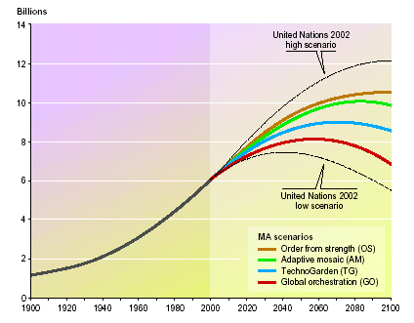

Figure 5.2. Comparison of global river nitrogen export stemming from natural ecosystems, agricultural systems and sewage effluents for the years 1975 and 1990 with projections for the year 2030 made by FAO (FAO: Agriculture towards 2015/2030) and model results for the MA scenarios (GO-Global Orchestration, TG-TechnoGarden, OS-Order from Strength, AM-Adapting Mosaic; AT-FAO Agriculture towards 2015/2030 projections) (S9 Fig. 9.21)

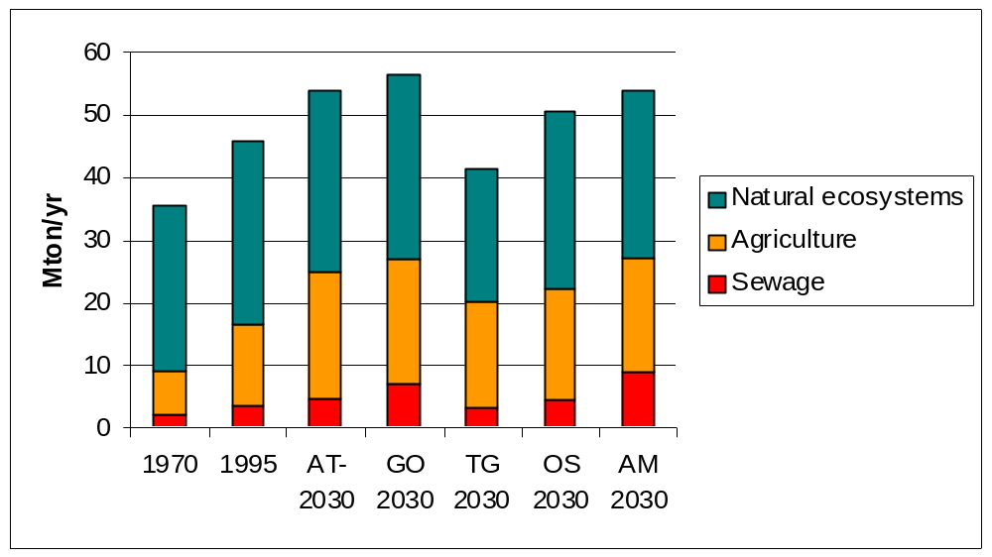
Table 5.4 Costs and benefits of proactive as contrasted with reactive ecosystem management as revealed in the MA Scenarios (S-SDM).

 | Proactive Ecosystem Management | Reactive Ecosystem Management
Payoffs | Benefit from lower risk of unexpected losses of ecosystem services, achieved through investment in (1) More efficient use of resources (water, energy, fertilizer etc.); (2) More innovation of green technology; (3) Capacity to absorb unexpected fluctuations in ecosystem services; (4) Adaptable management systems; (5) Ecosystems that are resilient and self-maintaining  Do well under changing or novel conditions  Build natural, social and human capital | Defer costs of unexpected losses of ecosystem services until after the losses occur  Do well under smoothly or incrementally changing conditions  Build manufactured, social and human capital
Costs | Technological solutions can create new problems  Costs of unsuccessful experiments  Costs of monitoring  Some short-term benefits are traded for long-term benefits | Expensive unexpected events  Persistent ignorance (repeating the same mistakes)  Lost option values  Inertia of less flexible and adaptable management of infrastructure and ecosystems  Loss of natural capital

6. What can be learned about the consequences of ecosystem change for human well-being at sub-global scales?
The Millennium Ecosystem Assessment (MA) included a sub-global assessment component to assess differences in the importance of ecosystem services for human well-being around the world. (SG.SDM) The sub-global working group included a total of 33 sub-global assessments around the world. These were designed to assess the importance of ecosystem services for human well-being at local, national and regional scales. The areas covered in these assessments range from small villages in India, to cities like Stockholm (Sweden) and Sao Paulo (Brazil), to whole countries like Portugal, and large regions like southern Africa. In a few cases, the sub-global assessments were designed to cover multiple nested scales. For example, the Southern Africa sub-global assessment (SAfMA) included assessments of the entire region of Africa south of the equator, of the Gariep and Zambezi river basins in that region, and of local communities within those basins. This nested design was included as part of the overall design of the MA to analyze the importance of scale on ecosystem services and human well-being, and to study cross-scale interactions. However, most assessments were conducted with a focus on the needs of users at a single spatial scale (e.g., a particular community, watershed, or region).
The scale at which an assessment is undertaken significantly influences the problem definition and the assessment results. (SG.SDM) Findings of assessments conducted at different scales differed due to differences in the questions posed and/or the information analyzed. Local communities are influenced by global, regional and local factors. Global factors include commodity prices (e.g. global trade asymmetries that influence local production patterns) and global climate change (e.g. sea level rise). Regional factors include water supply regimes (safe piped water in rural areas), regional climate (desertification) and geomorphological processes (soil erosion and degradation). Local factors include market access (distance to market), disease prevalence (e.g., malaria), or localized climate variability (patchy thunder storms). Assessments conducted at different scales tended to focus on drivers and impacts most relevant at each scale, yielding different but complementary findings. This provides some of the benefit of a multiscale assessment process, since each component assessment provides a different perspective on the issues addressed.
Although there is overall congruence in the results from global and sub-global assessments for services like water and biodiversity, there are examples where local assessments showed the condition was either better or worse than expected from the global assessment. (SG.SDM) For example, the condition of water resources was significantly worse than expected in places like Sao Paulo (Brazil) and the Laguna Lake Basin (Philippines). There were more mismatches for biodiversity than for water provisioning because the concepts and measures of biodiversity were more diverse in the sub-global assessments.
Drivers of change act in very distinct ways in different regions (SG7.ES). Though similar drivers might be present in different assessments, their interactions, and thus the processes leading to ecosystem change, differed significantly from assessment to assessment. For example, although the three regions of the Amazon, Central Africa, and Southeast Asia in the Tropical Forest Margins assessment have the same set of individual drivers of land-use change (deforestation, road construction and pasture creation), the interactions among these drivers leading to change differ. Deforestation driven by swidden agriculture is more widespread in upland and foothill zones of Southeast Asia than in other regions. Road construction by the state followed by colonizing migrant settlers, who in turn practice slash-and-burn agriculture, is most frequent in lowland areas of Latin America, and especially in the Amazon Basin. Pasture creation for cattle ranching is causing deforestation almost exclusively in the humid lowland regions of mainland South America. The spontaneous expansion of smallholder agriculture and fuel-wood extraction for domestic uses are important causes of deforestation in Africa.
The assessments identified inequities in the distribution of the costs and benefits of ecosystem change, which are often displaced to other places or future generations. (SG.SDM) For example, the increase in urbanization in countries like Portugal is generating pressures on ecosystems and services in rural areas. The increase in international trade is also generating additional pressures on ecosystem services around the world, illustrated in the cases of the mining industries in Chile and Papua New Guinea. In some cases, the costs of transforming ecosystems are simply deferred to future generations. An example reported widely across sub-global assessments in different parts of the world is tropical deforestation, which caters to current needs, but leads to a reduced capacity to supply services in the future.
Declining ecosystem trends have been mitigated by innovative local responses. The “threats” observed at an aggregated, global level may be both overestimated and underestimated from a sub-global perspective. (SG.SDM) Assessments at an aggregated level often fail to take into account the adaptive capacity of sub-global actors. Through collaboration in social networks, actors can develop new institutions and reorganize to mitigate declining conditions. On the other hand, sub-global actors tend to neglect drivers that are beyond their reach of immediate influence when they craft responses. Hence, it is crucial for decision-makers to develop institutions at the global, regional, and national levels that strengthen the adaptive capacity of actors at the sub-national and local levels to develop context-specific responses that do address the full range of relevant drivers. The Biodiversity Management Committees in India are a good example of a national institution that enables local actors to respond to biodiversity loss. This means neither centralization nor decentralization but institutions at multiple levels that enhance the adaptive capacity and effectiveness of sub-national and local responses (Ch. 9).
Multiscale assessments offer insights and results that would otherwise be missed. (SG.SDM) The variability among sub-global assessments in problem definition, objectives, scale criteria, and systems of explanation increased at finer scales of assessment (e.g. the visibility of social equity issues increased from coarser to finer scales of assessment). The role of biodiversity as a risk avoidance mechanism for local communities is frequently hidden until local assessments are conducted (e.g. India local, Sinai, SAfMA livelihoods).
There is evidence that including multiple knowledge systems increases the relevance, credibility and legitimacy of the assessment results for some users. (SG.SDM) For example, in Bajo Chirripó in Costa Rica, the involvement of non-scientists added legitimacy and relevance to assessment results for a number of potential assessment users at the local level. However, in many of the sub-global assessments, local resource users were one among many groups of decision-makers, so the question of legitimacy needs to be taken together with that of empowerment.
Integrated assessments of ecosystems and human well-being need to be adapted to the specific needs and characteristics of the groups undertaking the assessment. (SG-SDM, SG11.ES) Assessments are most useful to decision-makers if they respond to the needs of the decision-makers. The MA sub-global assessments differed significantly in the issues that they addressed as a result. At the same time, given the diversity of assessments involved in the MA, the basic assessment approach had to be adapted by different assessments to ensure its relevance to different user groups. (See Box 6.1.) Several community-based assessments adapted the MA framework to allow for more dynamic interplays between variables, capture fine-grained patterns and processes in complex systems, and leave room for a more spiritual worldview. In Peru and Costa Rica, for example, other conceptual frameworks were used that incorporated both the MA principles and local cosmologies. In southern Africa, various frameworks were used in parallel to offset the shortcomings of the MA framework for community assessments. These modifications and adaptations of the framework are an important outcome of the MA.
Figure 6.1. MA Sub-Global Assessments. Eighteen assessments were approved as components of the MA. Any institution or country was able to undertake an assessment as part of the MA if it agreed to: a) use the MA conceptual framework; b) centrally involve the intended users as stakeholders and partners; and, c) meet a set of procedural requirements related to: peer review, metadata, transparency, and intellectual property rights. The MA assessments were largely self-funded, although planning grants and some core grants were provided to support some assessments. The MA also drew on information from fifteen other sub-global assessments affiliated with the MA which met a sub-set of these criteria or were at earlier stages in development.
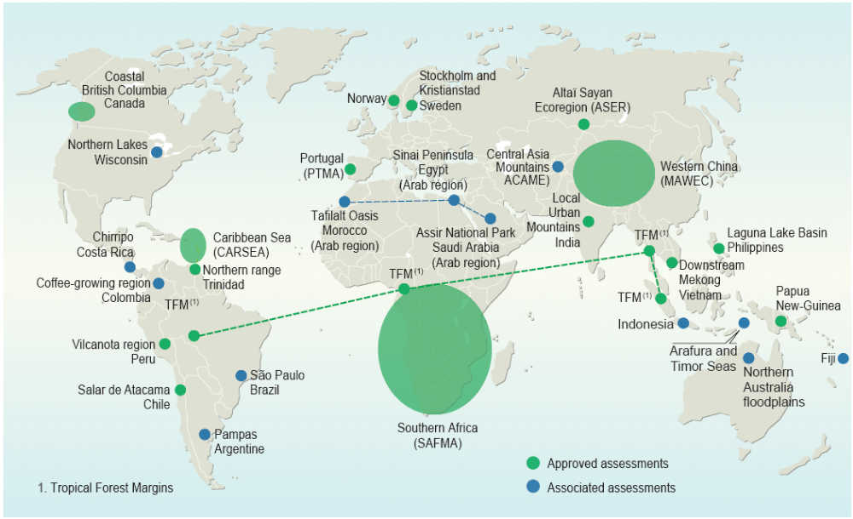

Box 6.1 Local Adaptations of MA Conceptual Framework (SG-SDM)
The MA Framework was applied in a wide range of assessments at multiple scales. Particularly for the more local assessments, the framework needed to be adapted to better reflect the needs and concerns of local communities. In the case of one assessment conducted by and for indigenous communities in the Vilcanota Region of Peru, the MA framework had to be recreated from a base in the Quechua understanding of ecological and social relationships was needed. Within the Quechua vision of the cosmos, concepts such as reciprocity (Ayni), the inseparability of space and time and the cyclical nature of all processes (Pachakuti), are important components of the Inca definition of ecosystems. Love (Munay) and working (Llankay) bring humans to a higher state of knowledge (Yachay) about their surroundings, and are therefore key concepts linking Quechua communities to the natural world. Ayllu represents the governing institutions that regulate interactions between all living beings.
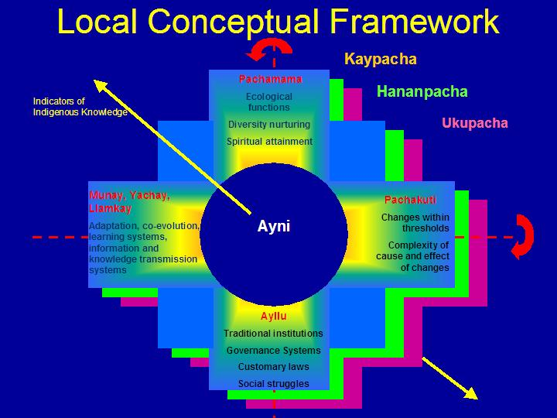
The resulting framework has similarities with the MA Conceptual Framework, but the divergent features are considered to be important to the Quechua people conducting the assessment. The Vilcanota Conceptual Framework also includes multiple scales (Kaypacha, Hananpacha, Ukupacha), however these scales represent both spatial scales and the cyclical relationship between the past, present and future. Inherent in this concept of space and time is the adaptive capacity of the Quechua people who welcome change and have become resilient to it through an adaptive learning process (it is recognized that current rates of change may prove challenging to the adaptive capacities of the communities). The cross shape of the CF diagram represents the “Chakana”, the most recognized and sacred shape to Quechua people and orders the world through deliberative and collective decision-making that emphasizes reciprocity (Ayni). Pachamama is similar to a combination of the “ecosystem goods and services” and “human well-being” components of the MA Framework. Pachakuti is similar to the MA ‘drivers’ (both direct and indirect). Ayllu (and Munay, Yachay and Llankay) may be seen as responses, and are more organically integrated into the cyclic process of change and adaptation.
The Quechua communities will direct their work process to assess the conditions and trends of certain aspects of the Pachamama (focusing on water, soil and agrobiodiversity), how these goods and services are changing, the reasons behind the changes, the effects on the other elements of the Pachamama, how the communities have adapted and are adapting to the changes, and the state of resilience of the Quechua principles and institutions for dealing with these changes into the future.
Developing the local conceptual framework from a base of local concepts and principles (as opposed to simply translating the MA framework into local terms) has allowed the local communities to take ownership of their assessment process and empowers them to both assess the local environment and human populations using their own knowledge and principles of well-being, and seek responses to problems within their own cultural and spiritual institutions.

7. What is known about time scales, inertia, and the risk of non-linear changes in ecosystems?
Time scale of change refers to the time required for the effects of a perturbation of a process to be expressed. Time scales relevant to ecosystems and their services are shown in Table 7.1. Inertia refers to the delay or slowness in the response of a system to factors altering their rate of change, including continuation of change in the system after the cause of that change has been removed. Resilience refers to as the amount of disturbance or stress that a system can absorb and still remain capable of returning to its pre-disturbance state.
Time Scales and Inertia
Many impacts of humans on ecosystems (both harmful and beneficial) are slow to become apparent; this can result in the costs associated with ecosystem changes being deferred to future generations. For example, excessive phosphorus is accumulating in many agricultural soils, threatening rivers, lakes, and coastal oceans with increased eutrophication, however it may take years or decades for the full impact of the phosphorus to become apparent through erosion and other processes (S7.3.2). Similarly, the use of groundwater supplies can exceed the recharge rate for some time before costs of extraction begin to grow significantly. In general, people manage ecosystems in a manner to increase short term benefits and may not be aware of, or may ignore, costs that are not readily and immediately apparent. This has the inequitable result of increasing current benefits at costs to future generations.
Different categories of ecosystem services tend to change over different time scales making it difficult for managers to fully evaluate trade-offs. For example, supporting services such as soil formation and primary production and regulating services such as water and disease regulation tend to change over much longer time scales than provisioning services. As a consequence impacts on more slowly changing supporting and regulating services are often overlooked by managers in pursuit of increased use of provisioning services (S12.ES).
The inertia of different direct and indirect drivers differs considerably and this strongly influences the time frame for solving ecosystem related problems once they are identified (RWG, S7). For some drivers, such as the overharvest of particular species, lag times are rather short and the impact of the driver can be minimized or halted within short time frames. For others such as nutrient loading and, especially, climate change, lag times are much longer and the impact of the driver cannot be lessened for years or decades.
Significant inertia exists in the process of species extinctions that result from habitat loss; even if habitat loss were to end today, it would take hundreds of years for species numbers to reach a new and lower equilibrium resulting from the habitat changes that have taken place in the last centuries (S10). Most species that will go extinct in the next several centuries will be driven to extinction as a result of loss or degradation of their habitat (either through land cover changes or increasingly through climate changes). While habitat loss can lead to rapid extinction of some species (such as species with extremely limited ranges), for many species extinction will only occur after many generations and long-lived species such as some trees could persist for centuries before ultimately going extinct. This “extinction debt” has important implications. First, while reductions in the rate of habitat loss will protect certain species and have significant long-term benefits for species survival in the aggregate, the impact on rates of extinction over time scales of the next 10 to 50 years are likely to be small (medium certainty). Second, until a species does go extinct, opportunities do exist for it to be recovered to a viable population size.
Non-linear Changes in Ecosystems

Non-linear (stepped or abrupt) changes have been commonly encountered in ecosystems and their services. Most of the time, change in ecosystems and their services is gradual and incremental. Most of these gradual changes are detectable and predictable, at least in principle (high certainty) (S.SDM). However, many examples exist of non-linear and sometimes abrupt changes in ecosystems. In theses cases, the ecosystem may change gradually until a particular pressure on the ecosystem reaches a threshold, at which point changes occur relatively rapidly as the system shifts to a new state. Some of these non-linear changes can be very large in magnitude and have substantial impacts on human well-being. Capabilities for predicting some non-linear changes are improving, but for most ecosystems and for most potential non-linear changes, science cannot predict the thresholds where the non-linear change will be encountered (C6.2, S13.4). Examples of non-linear and relatively abrupt changes in ecosystems include:

Disease emergence (S13.4). Infectious diseases regularly exhibit non-linear behavior. If on average each infected person infects at least one other person then an epidemic spreads, while if the infection is transferred on average to less than one person the epidemic dies out. High human population densities in close contact with animal reservoirs of infectious disease facilitate rapid exchange of pathogens, and if the threshold rate of infection is achieved (that is, each infected person on average transmits the infection to at least one other person) the resulting infectious agents can spread quickly through a worldwide contiguous, highly mobile, human population with few barriers to transmission. The almost instantaneous outbreak of SARS in different parts of the world is an example of such potential, although rapid and effective action contained its spread. An event similar to the 1918 Spanish Flu pandemic, which is thought to have killed 20-40 million people worldwide, could now result in over 100 million deaths within a single year. Such a catastrophic event, the possibility of which is being seriously considered by the epidemiological community, would probably lead to severe economic disruption and possibly even rapid collapse in a world economy dependent on fast global exchange of goods and services.
Algal blooms and fish kills (S13.4). Excessive nutrient loading causes fertilizes freshwater and coastal ecosystems. While small increases in nutrient loading often cause little change in many ecosystems, once a threshold of nutrient loading is achieved, the changes can be abrupt and extensive, creating harmful algal blooms (including blooms of toxic species) and often leading to the domination of the ecosystem by one or a few species. Severe nutrient overloading can lead to the formation of oxygen-depleted zones, killing all animal life.
Fisheries collapses (C18). Fish population collapses have been commonly encountered in both freshwater and marine fisheries. Fish populations are generally able to withstand some level of catch with a relatively small impact on their overall population size. As the catch increases, however, a threshold is reached after which there are too few adults remain to produce enough offspring to support that level of harvest and the population may drop abruptly to a much smaller size. For example, the Atlantic cod stocks of the east coast of Newfoundland collapsed in 1992, forcing the closure of the fishery after hundreds of years of exploitation (CF2 Box 2.4). Most importantly, the stocks may not recover, even if harvesting is significantly reduced or eliminated entirely.
Species introductions and losses. Introductions (or removal) of species can cause non-linear changes in ecosystems and their services. For example, the introduction of the zebra mussel into aquatic systems in the United States resulted in the extirpation of native clams in Lake St. Clair, large changes in energy flow and ecosystem function, and annual costs of US$100 million to the power industry and other users (S12.4.8). The introduction of the comb jelly fish (Mnemiopsis leidyi) in the Black Sea caused the loss of 26 major fisheries species, and has been implicated (along with other factors) in subsequent growth of the anoxic “dead zone” (C28.5). The loss of the sea otters from many coastal ecosystems on the Pacific Coast of North America due to hunting led to the booming populations of sea urchins (a prey species for otters) which in turn led to the loss of kelp forests (which are eaten by urchins).
Changes in dominant species in coral ecosystems. Some coral reef ecosystems have undergone sudden shifts from coral-dominated to algal–dominated reefs. The trigger for such phase shifts, which are essentially irreversible, is usually multi-faceted and includes increased nutrient input leading to eutrophic conditions, and removal of herbivorous fishes that maintain the balance between corals and algae. Once a threshold is reached, the change in the ecosystem takes place within months and the resulting ecosystem, although stable, is less productive and less diverse. One well-studied example is the sudden switch in 1983 from coral to algal domination of Jamaican reef systems. This followed several centuries of overfishing of herbivores, which left the control of algal cover almost entirely dependent on a single species of sea urchin, whose populations collapsed when exposed to a species-specific pathogen. As a result, Jamaica’s reefs shifted (apparently irreversibly) to a new low diversity, algal-dominated state with very limited capacity to support fisheries. (C4.6).
Regional climate change. (C13.3) The vegetation in a region influences climate through albedo (reflectance of radiation from the surface), transpiration (flux of water from the ground to the atmosphere through plants), and the aerodynamic properties of the surface. In the Sahel region of North Africa, vegetation cover is almost completely controlled by rainfall. When vegetation is present, rainfall is quickly recycled generally increasing precipitation and, in turn, leading to a denser vegetation canopy. Model results suggest that land degradation leads to a substantial reduction in water recycling, and may have contributed to the observed trend in rainfall reduction in the region over the last 30 years. In tropical regions, deforestation generally leads to decreased rainfall. Since forest existence crucially depends on rainfall, the relationship between tropical forests and precipitation forms a positive feedback, which, under certain conditions, theoretically leads to the existence of two steady states: rainforest and savanna. Some models suggest only one stable climate-vegetation state in the Amazon.
There is established but incomplete evidence that changes being made in ecosystems are increasing the likelihood of non-linear and potentially high-impact, abrupt changes in physical and biological systems that have important consequences for human well-being (C6, S3, S13.4, S-SDM,). The increased likelihood of these events stems from the following factors:

- On balance, changes humans are making to ecosystems are reducing the resilience of the ecological components of the systems (established but incomplete). (C6, S3, S12) Genetic and species diversity, as well as spatial patterns of landscapes, environmental fluctuations, and temporal cycles with which species evolved, generate the resilience of ecosystems. Functional groups of species contribute to ecosystem processes and services in similar ways. Diversity among functional groups increases the flux of ecosystem processes and services (established but incomplete). Within functional groups, species respond differently to environmental fluctuations. This response diversity derives from variation in species' response to environmental drivers, heterogeneity in species distributions, differences in ways that species use seasonal cycles or disturbance patterns, or other mechanisms. Response diversity enables ecosystems to adjust in changing environments, altering biotic structure in ways that maintain processes and services (high certainty) (S.SDM). The loss of biodiversity that is now taking place thus tends to reduce the resilience of ecosystems.

- Growing pressures from various drivers (S7, SG7.5). Threshold changes in ecosystems are not uncommon but they are rarely encountered in the absence of human-caused pressures on ecosystems. Many of these pressures are now growing. Increased fish harvests increase the likelihood of fisheries collapses; higher rates of climate change increase the potential for species extinctions; increased introductions of nitrogen and phosphorus into the environment increase the likelihood of the eutrophication of aquatic ecosystems; as human populations become more mobile, more and more species are being introduced into new habitats and this increases the likelihood of harmful pests to emerge in those regions.
The growing bushmeat trade poses particularly significant threats associated with non-linear changes. (C8.3, S.SDM, C14) Growth in the use and trade of bushmeat is placing increasing pressure on many species, particularly in Africa and Asia. Once this pressure exceeds levels of sustainable harvest, the populations of the harvested species are likely to decline extremely rapidly, and could be at risk of extinction. Because of the growing dependence of some populations on bushmeat as a source of protein, however, the collapse of the supply of these resources could result in sudden and significant harm to the food supply of these populations. Finally, the bushmeat trade involves relatively high levels of interaction between humans and some relatively closely related wild animals that are eaten, and this increases the risk of emergence of new and serious pathogens such as took place in the case of HIV/AIDs. Given the speed and magnitude of international travel today, new pathogens could spread rapidly around the world.
A potential non-linear response, currently the subject of intensive scientific research, is the atmospheric capacity to cleanse itself of air pollution (in particular, hydrocarbons and reactive nitrogen compounds) (C-SDM). This capacity depends on chemical reactions involving the hydroxyl radical (OH-), the atmospheric concentration of which has declined by about 10% (medium certainty) since pre-industrial times. An abrupt decrease in the atmospheric self-cleansing capacity would result in a severe air quality decline in many urban and industrialized regions.

Once an ecosystem has undergone a non-linear change, recovery to the original state may take decades or centuries and may sometimes be impossible. For example, the recovery of over-exploited fisheries that have been closed to fishing is quite variable. Although the cod fishery in Newfoundland has been closed for nearly 10 years, there have been few signs of a recovery and many scientists are not optimistic about the cod fishery in the foreseeable future (C18.3.6). On the other hand, the North Sea Herring fishery collapsed due to overharvest in the late 1970s, but recovered after a four-year closure (C18.??)
Table 7.1. Characteristic Time and Space Scales Related to Ecosystems and their Services. Time scale is defined here as the time needed for at least half the process to be expressed. The characteristic spatial scale is the spatial area over which the process takes place. (Note: For comparison, this table includes references to time and space scales cited in the Synthesis Report of the IPCC Third Assessment Report, noted as IPCC TAR.)

Process | Spatial Scale (km²) | Time Scale (years) | Ref
Atmosphere
Greenhouse Gasses to mix in global atmosphere | Global | 2-4 | IPCC TAR
50% of a C02 pulse to disappear | Global | 50-200 | IPCC TAR
Air temperature to respond to C02 rise | Global | Up to 120-150 | IPCC TAR
Sea level to respond to temperature change | Global | up to 10,000 | IPCC TAR
Ecosystem Structure
Range size of vertebrate species | 0.1 to 100 million |  | C4 Fig 4.15
Range of species “lifetimes” in marine fossil record |  | 1 million to 10 million | C4.4.2
Species numbers to reach a new equilibrium through extinction after habitat loss | 100 to 10,000 | 10-100 | S10.1
Species composition in a region to reach a new equilibrium following a lasting change in climate | 10 to 10,000 | 10,000 to 1 million | CF7
Secondary Succession (re-establishment of original community of species following disturbance) | 1 to 10 | 50-1000 | CF7
Ecosystem Functioning and Service Changes
Physiological acclimation of plants to an increase in CO₂ | Local | 1 to 100 | IPCC TAR
Life cycle of plants | Local | 1 to 1000 | IPCC TAR
Phosphorus concentrations to return to natural levels after applications halted | 1 to 10 | 10-200 | S7

8. What options exist to sustainably manage ecosystems?
It is a major challenge to reverse the degradation of ecosystems while meeting increasing demands for their services. But this challenge can be met. Three of the four MA scenarios show that changes in policy can mitigate many of the negative consequences of growing pressures on ecosystems, although the changes required are large and not currently underway (S-SDM). As noted in Chapter 5, in three of the four MA Scenarios, at least one of the three categories of provisioning, regulating, and cultural services are in better condition in 2050 than in 2000, although biodiversity loss continues at high rates in all scenarios (Figure 15). The scale of interventions that result in these positive outcomes, however, are very significant. These include major investments in environmentally sound technology, active adaptive management, proactive action to address environmental problems before their full consequences are experienced, major investments in public goods (education, infrastructure), and strong action to reduce economic disparities and eliminate poverty.
Past actions to slow or reverse the degradation of ecosystems have yielded significant benefits, but these improvements have generally not kept pace with growing pressures and demands. Although most ecosystem services assessed in the MA are being degraded, the extent of that degradation would have been much greater without responses implemented in past decades. For example, more than 100,000 protected areas (including strictly protected areas such as national parks as well as areas managed for the sustainable use of natural ecosystems including timber harvest or wildlife harvest), covering about 11.7 percent of the terrestrial surface have now been established (R5.2.1) and these play an important role in the conservation of biodiversity and ecosystem services (although important gaps in the distribution of protected areas remain, particularly in marine and freshwater systems). Technological advances have also helped to lessen the pressure on ecosystems per unit increase in demand for ecosystem services. For example, for all developing countries, yields of wheat, rice, and maize rose between 109 and 208 percent in the past 40 years. Without this increase, far more habitat would have been converted to agriculture over this period of time.
An effective set of responses to ensure the sustainable management of ecosystems must address the drivers presented in Chapter 4 and overcome barriers related to (RWG):
- Inappropriate institutional and governance arrangements, including the presence of corruption and weak systems of regulation and accountability.
- Market failures and the misalignment of economic incentives
- Social and behavioral factors including lack of political and economic power of some groups (e.g., poor people, women, indigenous groups) particularly dependent on ecosystem services or harmed by their degradation
- Underinvestment in the development and diffusion of technologies that could increase the efficiency of use of ecosystem services and reduce the harmful impacts of various drivers of ecosystem change.
- Insufficient knowledge (as well as the poor use of existing knowledge) concerning ecosystem services and management, policy, technological, behavioral and institutional responses that could enhance benefits from these services while conserving resources.

All of these barriers are further compounded by weak human and institutional capacity related to the assessment and management of ecosystem services, underinvestment in the regulation and management of their use, lack of public awareness, and lack of awareness among decision-makers of both the threats posed by the degradation of ecosystem services and the opportunities that more sustainable management of ecosystems could provide.

The MA assessed 74 response options for eight ecosystem services and additional responses related to integrated ecosystem management and the driver climate change. (See Appendix 2.) Many of these options hold significant promise for conserving or sustainably enhancing the supply of ecosystem services. Examples of promising responses that address the barriers listed above are presented below (RWG, R2):
Institutions and Governance
Changes in institutional and environmental governance frameworks are often required to create the enabling conditions for effective management of ecosystems. Today’s institutions were not designed to take into account the threats associated with the degradation of ecosystem services, nor were they well designed to deal with the management of open access resources, a feature of many ecosystem services. Issues of ownership and access to resources, rights to participation in decision-making, and regulation of particular types of resource use or discharge of wastes, can strongly influence the sustainability of ecosystem management and are fundamental determinants of who wins and loses from changes in ecosystems. Corruption, a major obstacle to effective management of ecosystems, also stems from weak systems of regulation and accountability.
Promising interventions include:
- Integration of ecosystem management goals within other sectors and within broader development planning frameworks (G). The most important public policy decisions affecting ecosystems are often made by agencies and in policy arenas other than those charged with protecting ecosystems. Ecosystem management goals are more likely to be achieved if they are reflected in decisions in other sectors and in national development strategies. For example, the Poverty Reduction Strategy Papers (PRSP) prepared by developing country governments in collaboration with the World Bank and other institutions strongly shape national development priorities, but these have not taken into account the importance of ecosystems to improving the basic human capabilities of the poorest (R17.ES).
- Increased coordination among multilateral environmental agreements and between environmental agreements and other international economic and social institutions (G). International agreements are indispensable for addressing ecosystem related concerns that span national boundaries but numerous obstacles weaken their current effectiveness (R17.2). The limited and focused nature of the goals and mechanisms included in most bilateral and multilateral environmental treaties do not address the broader issue of ecosystem services and human well-being. Steps are now being taken to increase the coordination among these treaties and this could help to broaden the focus of the array of instruments. However, coordination is also needed between the multilateral environmental agreements and the more politically powerful international legal institutions, such as economic and trade agreements to ensure that they are not acting at cross-purposes (RSDM)..
- Increased transparency and accountability of government and private sector performance in decisions that impact ecosystems, including through greater involvement of concerned stakeholders in decision-making (G, B, N). (RWG; SG9) Laws, policies, institutions, and markets that have been shaped through public participation in decision-making are more likely to be effective and perceived as just. For example, degradation of freshwater and other ecosystem services generally have a disproportionate impact on those who are, in various ways, excluded from participation in the decision-making process (R7.2.3). Stakeholder participation also contributes to the decision-making process because it allows for a better understanding of impacts and vulnerability, the distribution of costs and benefits associated with trade-offs, and the identification of a broader range of response options that are available in a specific context. And stakeholder involvement and transparency of decision-making can increase accountability and reduce corruption.
- Development of institutions that devolve (or centralize) decision-making to meet management needs while ensuring effective coordination across scales (G, B, N). (RWG) Problems of ecosystem management have been exacerbated by both overly centralized and overly decentralized decision-making. For example, highly centralized forest management has proven ineffective in many countries and efforts are now being made to devolve responsibility to lower levels of decision-making either within the natural resources sector alone or as part of broader decentralization of governmental responsibilities. At the same time, one of the most intractable problems of ecosystem management has been the lack of alignment between political boundaries and units appropriate for the management of ecosystem goods and services. Downstream communities may not have access to the institutions through which upstream actions can be influenced or alternatively downstream communities or countries may be stronger politically than upstream regions and may dominate control of upstream areas without addressing upstream needs. A number of countries, however, are now strengthening regional institutions for the management of transboundary ecosystems (e.g., Danube River, Mekong River Commission, East African cooperation on Lake Victoria and the Amazon Cooperation Treaty Organization).
- Development of institutions to regulate interactions between markets and ecosystems (G). (RWG) The potential of policy and market reforms to improve ecosystem management are often constrained by weak or absent institutions. For example, the potential of the Clean Development Mechanism, established under the United Nations Framework Convention on Climate Change to provide financial support to developing countries in return for greenhouse gas reductions, to realize climate and biodiversity benefits through payments for carbon sequestration in forests is constrained by unclear property rights, concerns over the permanence of reductions and lack of mechanisms for resolving conflicts. Moreover, existing regulatory institutions often do not have ecosystem protection as a clear mandate. For example, independent regulators of privatized water systems and power systems do not necessarily promote resource use efficiency and renewable supply. There is a continuing importance of the role of the state to set and enforce rules even in the context of privatization and market-led growth.
- Development of institutional frameworks that promote a shift from highly sectoral approaches to resource management to more integrated approaches (G, B). (R15.ES, R12.ES, R11.ES) In most countries, separate ministries are in charge of different aspects of ecosystems (e.g., ministries of environment, agriculture, water, and forests) and different drivers of change in ecosystems (e.g., ministries of energy, transportation, development, trade). Each of these ministries has control over different aspects of management of ecosystems. As a result there is seldom the political will to develop effective ecosystem management strategies and often competition among the ministries that results in policy choices that are detrimental to ecosystems. Integrated responses are those which intentionally and actively address ecosystem services and human well-being simultaneously such as integrated coastal zone management, integrated river basin management, and national sustainable development strategies. Although the potential for integrated responses is high, numerous barriers have limited their effectiveness: a) they are resource intensive, but the potential benefits can exceed the costs; b) they require multiple instruments for their implementation; c) they require new institutional and governance structures, skills, knowledge and capacity. make ambitious claims about their likely benefits, in practice the results of implementation have been mixed in terms of ecological, social and economic impacts.
Economics and Incentives
Economic and financial interventions provide powerful instruments to regulate the use of ecosystem goods and services (C5 Box 5.1). Because many ecosystem services are not traded in markets, markets fail to provide appropriate signals that might otherwise contribute to the efficient allocation and sustainable use of the services. Even if an individual is aware of the services provided by an ecosystem they are neither compensated for providing these services nor penalized for reducing them. In addition, the people harmed by the degradation of ecosystem services are often not the ones who benefit from the actions leading to their degradation, and so those costs are not factored into management decisions. A wide range of opportunities exists to influence human behavior to address this challenge in the form of economic and financial instruments. Some of them establish markets; others work through the monetary and financial interests of the targeted social actors; and yet others affect relative prices.
Market mechanisms can only work if supporting institutions are in place and thus there is a need to build institutional capacity to enable more widespread use of these mechanisms (R17).The adoption of economic instruments usually requires a legal framework and, in many cases, the choice of a viable and effective economic intervention mechanism is determined by the socioeconomic context. For example, resource taxes can be a powerful instrument to guard against the overexploitation of an ecosystem service but an effective tax scheme requires well-established and reliable monitoring and tax-collection systems. Similarly, subsidies can be effective to introduce and implement certain technologies or management procedures but they are inappropriate in settings that lack the transparency and accountability needed to prevent corruption. The establishment of market mechanisms also often involves explicit decisions about wealth distribution and resource allocation, when, for example, decisions are made to establish private property rights for resources that were formerly considered common pool resources. For that reason, the inappropriate use of market mechanisms can further exacerbate problems of poverty.
Promising interventions include:
Elimination of subsidies that promote excessive use of ecosystem services (and, where possible, transfer these subsidies to payments for non-marketed ecosystem services). (G) (S7.ES) Subsidies paid to the agricultural sectors of OECD countries between 2001 and 2003 averaged over US$324 billion annually, or one third the global value of agricultural products in 2000. And, many countries outside the OECD, also have inappropriate subsidies. A significant proportion of this total involves production subsidies that lead to over-production, reduce the profitability of agriculture in developing countries, and promote overuse of fertilizers and pesticides. Furthermore, they distort the terms of trade sometimes reducing the profitability of agricultural production in developing countries. They also increase land values (increasing land owners’ resistance to subsidy reductions). Finally, they promote overuse of certain inputs such as fertilizers and pesticides. On the social side, they make farmers overly dependent on taxpayers for their livelihood, change wealth distribution and social composition by benefiting large corporate farms to the detriment of smaller family farms and contribute to the dependency of large segments of the developing world on aid. On the environmental side, these policies encourage the use of environmentally damaging agricultural practices such as excessive use of water, fertilizers and pesticides. Finally, it is not clear that these policies achieve one of their primary targets, which is to support farmers’ income. Only about a quarter of the total expenses in price supports translate into additional income for farm households.
Similar problems are created by fishery subsidies, which for the OECD countries are estimated at $6.2 billion in 2002, or about 20 percent of the gross value of production in the same year (C8.4.1). Subsidies on fisheries, apart from their distributional impacts, affect the management of resources and their sustainable use by encouraging over-exploitation of the resource, thereby worsening the common property problem present in fisheries. Although some indirect subsidies, such as payments for the withdrawal of Individual Transferable harvest quotas (ITQs), could have a positive impact on fisheries management, the majority of subsidies have a negative effect. Inappropriate subsidies are also common in sectors such as water and forestry.
Although removal of production subsidies would produce net benefits, it would not occur without costs. Those farmers and fishers benefiting directly from the subsidies would suffer the most immediate losses, but there would also be indirect effects on ecosystems both locally and globally. In some cases it may be possible to transfer production subsides to other activities that promote ecosystem stewardship, for example payment for the provision or enhancement of regulatory or supporting services. Compensatory mechanisms may be needed for the poor who are adversely affected by the immediate removal of subsidies (R17.5). Reduced subsidies within the OECD may lessen pressures on some ecosystems in OECD countries, but could lead to more rapid conversion and intensification of land for agriculture in developing countries and would thus need to be accompanied by policies to minimize the adverse impacts on ecosystems in developing countries.
- Greater use of economic instruments and market-based approaches in the management of ecosystem services (G, B, N). (RWG) Economic instruments and market mechanisms with the potential to enhance the management of ecosystem services include:
- Taxes or user fees for activities with ‘external’ costs (trade-offs not accounted for in the market). These instruments create an incentive that lessens the external costs and provides revenues that can help to protect the damaged ecosystem services. Examples include taxes on excessive application of nutrients or ecotourism user fees.
- Creation of markets, including through cap and trade systems. Ecosystem services that have been treated as “free” resources, as is often the case for water, tend to be used wastefully. The establishment of markets for the services can both increase the incentives for their conservation and increase the economic efficiency of their allocation if supporting legal and economic institutions are in place. However, as noted above, while markets will increase the efficiency of the use of the resource, they can have harmful effects on particular groups of users who may inequitably affected by the change (R17). The combination of regulated emission caps, coupled with market-mechanisms for trading pollution rights, often provides an efficient means of reducing emissions harmful to ecosystems. For example, nutrient trading systems may be a low-cost way to reduce water pollution in the United States (R7.Box 7.3) One of the most rapidly growing markets related to ecosystem services is the carbon market. (See Fig 8.1.) Approximately 64 million metric tonnes of carbon dioxide equivalent were exchanged through projects from January to May 2004, nearly as much as during the whole year 2003 (78 million) (C5 Box 5.1). The value of carbon dioxide trades in 2003 was approximately US$300 million. Approximately 25 percent of the trades (by volume of carbon dioxide equivalents) involve investment in ecosystem services (hydropower or biomass). The World Bank has established a fund with a capital of $33.3 million (as of January 2005) to invest in afforestation and reforestation projects that sequester or conserve carbon in forest and agro-ecosystems while promoting biodiversity conservation and poverty alleviation. It is speculated that the value of the global carbon emissions trading markets could reach $44 billion in 2010 (and involve trades totaling 4.5 billion metric tonnes of carbon dioxide or equivalent).
- Payment for ecosystem services. Mechanisms can be established to enable individuals, firms, or the public sector to pay resource owners to provide particular services. For example, in New South Wales, Australia, associations of farmers purchase salinity credits from the State Forests Agency, which in turn contracts with upstream landholders to plant trees, which reduce water tables and store carbon. Similarly, in 1996 Costa Rica established a nation-wide system of conservation payments to induce landowners to provide ecosystem services. Under this program, Costa Rica brokers contracts between international and domestic “buyers” and local “sellers” of sequestered carbon, biodiversity, watershed services, and scenic beauty. By 2001, over 280,000 ha of forests had been incorporated into the PSA at a cost of about US$ 30 million, with pending applications covering an additional 800,000 ha. (C5 Box 5.1). Another innovative conservation financing mechanisms include “biodiversity offsets” (whereby developers pay for conservation activities as compensation for unavoidable harm that a project causes to biodiversity). An on-line news site, the Ecosystem Marketplace, has now been established by a consortium of institutions to provide information on the development of markets for ecosystem services and payments for ecosystem services (http://www.ecosystemmarketplace.com).
- Mechanisms to enable consumer preferences to be expressed through markets. Consumer pressure may provide an alternative way to influence producers toward more sustainable production practices in the absence of effective government regulation. For example, certification schemes that exist for sustainable fisheries and forest practices provide people with the opportunity to promote sustainability through their consumer choices. Within the forest sector, forest certification has become widespread in many countries and forest conditions, however, most certified forests are in temperate regions, managed by large companies that export to Northern retailers (R8).
Social and Behavioral Responses

Social and behavioral responses including population policy, public education, empowerment of communities, women and youth, and civil society actions can be instrumental in responding to ecosystem degradation. These are generally interventions that stakeholders initiate and execute through exercising their procedural or democratic rights in efforts to improve ecosystems and human well-being.
Promising interventions include:
- Changes in consumption (G, B, N). (RWG) The choices about what individuals consume and how much they consume are influenced not just by considerations of price but also by behavioral factors related to culture, ethics and values. Behavioral changes that could reduce demand for threatened ecosystem services can be encouraged through actions by governments (e.g., education and public awareness programs; promotion of demand-side management), industry (e.g., commitments to use raw materials that are from sources certified as being sustainable; improved product labeling), and civil society (e.g., public awareness).
- Communication and education (G, B, N. (RWG, R5). Improved communication and education are essential to achieve the objectives of the environmental Conventions, the Johannesburg Plan of Implementation, and the sustainable management of natural resources more generally. Both the public and decision-makers can benefit from education concerning ecosystems and human well-being, but education more generally provides tremendous social benefits that can help to address many indirect drivers of ecosystem degradation. Barriers to the effective use of communication and education include a failure to use research and apply modern theories of learning and change. While the importance of communication and education is well recognized, providing the human and financial resources to undertake effective work is a continuing barrier.
- Empowerment of groups particularly dependent on ecosystem services or affected by their degradation including women, indigenous people, and youth (G, B, N) (RWG). Despite their knowledge about the environment and the potential they possess, the participation of women in decision-making has often been restricted by social and cultural structures. Youth are key stakeholders in that they will experience the longer-term consequences of decisions made today concerning ecosystem services. Indigenous control of traditional homelands is often presented as having environmental benefits by indigenous peoples and their supporters, although the justification continues to be based on human and cultural rights.
Technological Responses

Given the growing demands for ecosystem services and other increased pressures on ecosystems, the development and diffusion of technologies designed to increase the efficiency of resource use or reduce the impacts of drivers such as climate change and nutrient loading are essential. Technological change has been essential for meeting growing demands for some ecosystem services and technology holds considerable promise to help meet future growth in demand. Technologies already exist for reduction of nutrient pollution at reasonable costs, for example, but new policies are needed for these tools to be applied on a sufficient scale to slow and ultimately reverse the increase in nutrient loading (recognizing that this global goal must be achieved even while increasing nutrient application in relatively poor regions such as Sub-Saharan Africa). However, many negative impacts on ecosystems and human well-being have resulted from these technological changes (R17.ES). The cost of ‘retrofitting’ technologies once their negative consequences become apparent can be extremely high thus careful assessment is needed prior to the introduction of new technologies.
Promising interventions include:
  - Promotion of technologies that enable increased crop yields without harmful impacts related to water, nutrient, and pesticide use (G, B, N) (R6). Agricultural expansion will continue to be one of the major drivers of biodiversity loss well into the 21st century. Development, assessment and diffusion of technologies that could sustainably increase the production of food per unit area without harmful trade-offs related to excessive consumption of water or use of nutrients or pesticides would significantly lessen pressure on other ecosystem services. Without the intensification that has taken place since 1950, a further 20 million km² of land would have had to be brought into production to achieve today’s crop production (C.SDM). The challenge for the future is to similarly reduce the pressure for expansion of agriculture without simultaneously increasing pressures on ecosystem services due to water use, excessive nutrient loading, and pesticide use.
  - Restoration of ecosystem services (G, B, N) (RWG, R7.4). Ecosystem restoration activities are now common in many countries and include actions to restore almost all types of ecosystems including wetlands, forests, grasslands, estuaries, coral reefs, and mangroves. Ecosystems similar to the ones that were present before conversion can often be established and can provide some of the original ecosystem services (e.g., pollution filtration in wetlands, timber production from forests, etc.). The restored systems seldom fully replace the original systems but still help meet needs for particular services. Moreover, the cost of restoration is generally extremely high in relation to the cost of preventing the degradation of the ecosystem.
Knowledge and Cognitive Responses

Effective management of ecosystems is constrained both by the lack of knowledge and information concerning different aspects of ecosystems and by the failure to adequately use information that does exist in support of management decisions. Although sufficient information exists to take many actions that could help to conserve ecosystems and enhance human well-being, major information gaps exist. For example, in most regions, relatively limited information exists about the status and economic value of most ecosystem services and their depletion is rarely tracked in national economic accounts. Limited information exists about the likelihood of non-linear changes in ecosystems or the location of thresholds where such changes may be encountered. Basic global data on the extent and trend in different types of ecosystems and land use are surprisingly scarce. Models used to project future environmental and economic conditions have limited capability of incorporating ecological ‘feedbacks’ including non-linear changes in ecosystems. At the same time, decision-makers do not use all of the relevant information that is available. This is due in part to institutional failures that prevent existing policy-relevant scientific information from being made available to decision-makers but also due to the failure to incorporate other forms of knowledge and information such as traditional knowledge and practitioner’s knowledge that are often of considerable value for ecosystem management.
Promising interventions include:
- Incorporate both the market and non-market values of ecosystems in resource management decisions (G, B) (RWG). Most resource management decisions are strongly influenced by considerations of the monetary costs and benefits of alternative policy choices. In the case of ecosystem management, however, this often leads to outcomes that are not in the interest of society since the non-marketed values of ecosystems may exceed the marketed values. As a result, many existing resource management policies favor sectors such as agriculture, forestry, and fisheries at the expense of the use of these same ecosystems for water supply, recreation, and cultural services that may be of greater economic value. Decisions can be improved if they are informed by the total economic value of alternative management options and involve deliberative mechanisms that bring to bear non-economic considerations as well.
- Use of all relevant forms of knowledge and information in assessments and decision-making, including traditional and practitioner’s knowledge (G, B, N) (RWG, C17-ES). Effective management of ecosystems typically requires “place based” knowledge, that is, information about the specific characteristics and history of an ecosystem. Formal scientific information is often one source of such information but, particularly at local scales, traditional knowledge or practitioner's knowledge held by local resource mangers can be of equal or greater value. While that knowledge is used in the decisions taken by the holders of the knowledge, it is too rarely incorporated into other decision-making processes and often inappropriately dismissed.
- Enhancement of human and institutional capacity for assessing the consequences of ecosystem change for human well-being and acting on such assessments (G, B, N) (RWG). Greater technical capacity is needed for agriculture, forest, and fisheries management. But the capacity that exists for these sectors, as limited as it is in many countries, is still vastly greater than the capacity for effective management of other ecosystem services. Because awareness of the importance of these other services has only recently grown, there is only limited experience with fully assessing ecosystem services and serious limits in all countries, but especially in developing countries, of the expertise needed in such areas as monitoring of changes in ecosystem services, economic valuation or health assessment of ecosystem changes, and policy analysis related to ecosystem services. Even when such assessment information is available, however, the traditional highly sectoral nature of decision-making and resource management makes the implementation of recommendations difficult. This constraint too can be overcome in part through increased training of individuals in existing institutions and through institutional reforms to build capacity for more integrated responses.

Design of effective decision-making processes
Decisions affecting ecosystems and their services can be improved by changing the processes used to reach those decisions. The context of decision-making about ecosystems is changing rapidly. The new challenge to decision-making is to make effective use of information and tools in this changing context in order to improve the decisions. At the same time, some old challenges must still be addressed. The decision making process and the actors involved influence the intervention chosen. Decision-making processes vary across jurisdictions, institutions, and cultures. However, this assessment has identified the following elements of decision-making processes related to ecosystems and their services that tend to improve the decisions reached and their outcomes for ecosystems and human well-being (R18ES):
- Use the best available information, including considerations of the value of both marketed and non-marketed ecosystem services.
- Ensure transparency and the effective and informed participation of important stakeholders. .
- Recognize that not all values at stake can be quantified and thus quantification can provide a false objectivity in decision-processes that have significant subjective elements.
- Strive for efficiency, but not at the expense of effectiveness.
- Consider equity and vulnerability in terms of the distribution of costs and benefits.
- Ensure accountability and provide for regular monitoring and evaluation.
- Consider cumulative and cross-scale effects and, in particular, assess trade-offs across different ecosystem services.

A wide range of deliberative tools, which facilitate transparency and stakeholder participation, information gathering tools, which are primarily focused on collecting data and opinions, and planning tools, which are typically employed for the evaluation of potential policy options can assist decision-making concerning ecosystems and their services. (R3 Tables 3.6 to 3.8) Deliberative tools include: neighborhood forums, citizen’s juries, community issues groups, consensus conferences, electronic democracy, focus groups, issue forums, and ecosystem service user forums. Information gathering tools include: citizen’s research panels, deliberative opinion polls, environmental impact assessments, participatory rural appraisal, and rapid rural appraisal. Planning tools include: consensus participation, cost-benefit analysis, multi-criteria analysis, participatory learning and action, stakeholder decision analysis, trade-off analysis, and visioning exercises. The use of decision-making methods that adopt a pluralistic perspective is particularly pertinent, since these techniques do not privilege any particular viewpoint. These tools can be employed at a variety of scales, including global, sub-global and local.
A variety of frameworks and methods can be used to make better decisions in the face of uncertainties in data, prediction, context and scale (R4.5). Commonly used methods include: Cost Benefit Analysis; Risk Assessment; Multi-criteria Analysis; Precautionary Principle; and, Vulnerability Analysis. (See Table 8.1) All of these methods have been able to support optimization exercises, but few of them have much to say about equity. Cost-benefit analysis can for example, be modified to weight the interests of some people more than others. The discount rate can be viewed, in long-term analyses, as a means of weighing the welfare of future generations; and the precautionary principal can be expressed in terms of reducing the exposure of certain populations or systems whose preferential status may be the result of equity considerations. Only multi-criteria analysis (MCA) was designed primarily to accommodate optimization across multiple objectives with complex interactions, but MCA can also be adapted to consider equity and threshold issues at national and sub-national scales. Finally, the existence and significance of various thresholds for change can be explored by several tools, but only the precautionary principal was designed explicitly to address such issues.
Scenarios provide one means to cope with many aspects of uncertainty, but our limited understanding of ecological and human response process shrouds any individual scenario in it own characteristic uncertainty (R4ES). Scenarios can be used to highlight the implications of alternative assumptions about critical uncertainties related to the behaviour of human and ecological systems. In this way, they provide one means to cope with many aspects of uncertainty in assessing responses. The relevance, significance, and influence of scenarios ultimately depend on who is involved in their development (SG9.ES). At the same time, though, there are a number of reasons to be cautious in the use of scenarios. First, individual scenarios represent conditional projections based upon these specific assumptions. Thus, to the extent that our understanding and representation of the ecological and human systems represented in the scenarios is limited, specific scenarios are characterized by their own uncertainty. Second, there is uncertainty in translating the lessons derived from scenarios developed at one scale, say, global, to the assessment of responses at other scales, say, sub-national. Third, scenarios often have hidden and hard to articulate assumptions. Fourth, environmental scenarios have tended to more effectively incorporate state of the art natural science modelling than social science modelling.
Historically, most responses addressing ecosystem services have concentrated on the short term benefits from increasing the productivity of provisioning services. (RWG). Far less emphasis has been placed on: a) managing regulating, cultural and supporting ecosystem services; b) management goals related to poverty alleviation and equitable distribution of benefits from ecosystem services; and, c) the long term consequences of ecosystem change on the provision of services. As a result, the current management regime falls far short of the potential for meeting human needs and conserving ecosystems.
Effective management of the ecosystems requires coordinated responses as multiple scales. (SG9; R17.ES) Responses that are successful at a small-scale are often less successful at higher levels due to constraints in legal frameworks and government institutions that prevent their success. In addition, there appear to be limits to scaling up, not only because of these higher-level constraints, but also because interventions at a local level often address only direct, rather than indirect or underlying drivers of change. For example, a local project to improve livelihoods of communities surrounding a protected area in order to reduce pressure on the protected area, if successful, may increase migration into buffer zones, thereby increasing pressure on the protected area. Cross-scale responses may be more effective at addressing both the higher-level constraints and leakage problems, and simultaneously tackle regional and national as well as local level drivers of change. Examples of successful cross-scale responses include some co-management approaches to natural resource management in fisheries and forestry, and multi-stakeholder policy processes (R15-ES).
Failure to acknowledge that stakeholders at different scales perceive different values in various ecosystem services can lead to unworkable and inequitable policies or programs at all scales. (SGWG) Ecosystem services that are of considerable importance at global scales, such as carbon sequestration or waste regulation, are not necessarily seen to be of value locally. Similarly, services of local importance, such as the importance of cultural benefits from ecosystems, the availability of manure for fuel and fertilizer, or the presence of non-timber forest products, are often not seen as important globally. Responses designed to achieve goals related to global or regional concerns are likely to fail unless they take into account the different values and concerns motivating local communities.
Active adaptive management can be a particularly valuable tool for reducing uncertainty about ecosystem management decisions. (R17.4.5) We refer to “active” adaptive management to emphasize the key characteristic of the original concept (which is frequently and inappropriately used to mean “learning by doing”): the design of management programs to test hypotheses about how components of an ecosystem function and interact and thereby reduce uncertainty about the system more rapidly than would otherwise occur. Under an adaptive management approach, for example, a fisheries manager might intentionally set harvest levels either lower or higher than the ‘best estimate’ in order to more rapidly gain information about the shape of the yield curve for the fishery. Given the high levels of uncertainty surrounding coupled social-ecological systems, the use of active adaptive management is often warranted.

Table 8.1. Applicability of decision support methods and frameworks (R4 Table 4.1) Legend: ++ = direct application of the method by design; + = possible application with modification or (in the case of uncertainty) the method has already been modified to handle uncertainty; – = weak but not impossible applicability with significant effort.
 |  |  |  |  | Scale of Application
Method | Optimization | Equity | Thresholds | Uncertainty | Micro | National | Regional and Global
Cost Benefit Analysis | + | + | – | +
Risk Assessment | + | + | ++ | ++
Multi-criteria Analysis | ++ | + | + | +
Precautionary Principle* | + | + | ++ | ++
Vulnerability Analysis | + | + | ++ | +

* The precautionary principle is not strictly analogous to the other analytical and assessment methods but still can be considered a method for decision support. The precautionary principle prescribes how to bring scientific uncertainty into the decision-making process by explicitly formalizing precaution and bringing it to the forefront of the deliberations. It posits that significant actions (ranging from doing nothing to banning a potentially harmful substance or activity, for instance) may be justified when the degree of possible harm is large and irreversible.
Figure 8.1. Total carbon market value per year in $US million (nominal). (2004 figures are for the first five months of the year only.) (C5 Box 5.1).
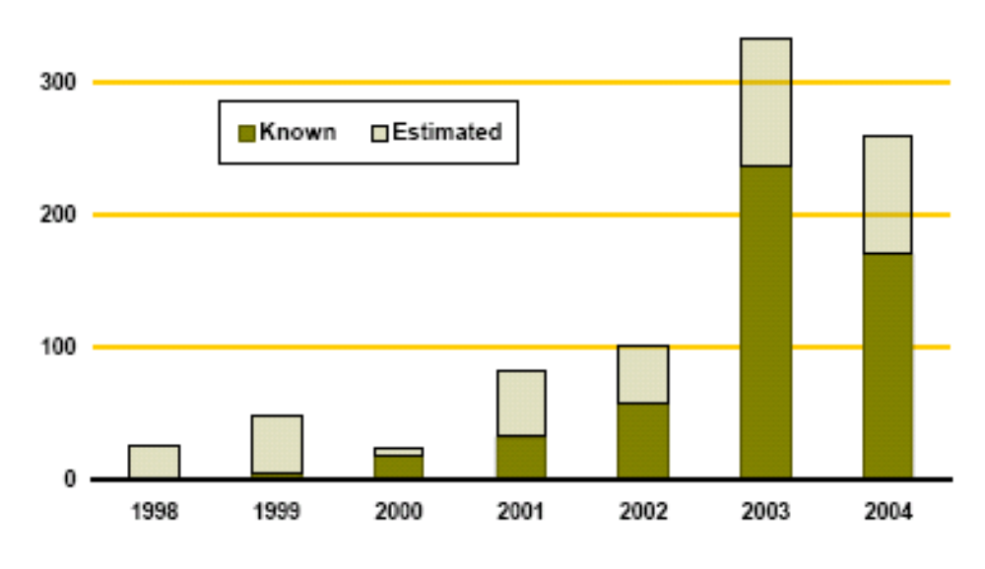

9. What are the most important uncertainties hindering decision-making concerning ecosystems?
The MA was unable to provide adequate scientific information to inform a number of important policy questions related to ecosystem services and human well-being. In some cases, the scientific information may well exist already but the process used and time-frame available was unable to access or assess the information. But in many cases, it is clear that either the data needed to answer the questions were unavailable or the knowledge of the ecological or social systems was inadequate. We identify the following key uncertainties that, if reduced, could significantly enhance the ability of a process like the MA to answer policy-relevant questions posed by decision-makers.

Conditions and Trends
- There are major gaps in global and national monitoring systems that result in the absence of well-documented, comparable, and time-series information for many ecosystem features and that pose significant barriers in assessment conditions and trends in ecosystem services. Moreover, in a number of cases, including hydrological systems, the monitoring systems that exist are declining in condition. These gaps include:
  - Although remote sensing information is now regularly being gathered that could enable rigorous global monitoring of habitat change, the financial resources are not available to process this information and thus accurate measurements of land cover change are only available on a case study basis.
  - Information on land degradation in drylands is extremely poor. Major shortcomings in the currently available assessments point to the need for a systematic global monitoring program, leading to the development of a scientifically credible, consistent baseline of the state of land degradation and desertification (UNCCD Synthesis Report).
  - There is little replicable data on global forest extent that can be tracked over time (C28.7);
  - There is no reasonably accurate global map of wetlands (C28.7).

- There are major gaps in information on non-marketed ecosystem services, particularly regulating, cultural, and supporting services. (CWG)
- There is no complete inventory of species, and limited information on the actual distributions of many important plant and animal species.
- Research in the following areas could significantly improve information available for decision-makers:
  - the nature of interactions among drivers in particular regions and across scales;
  - the responses of ecosystems to changes in the availability of important nutrients and carbon dioxide;
  - non-linear changes in ecosystems, predictability of thresholds, and structural and dynamic characteristics of systems that lead to threshold and irreversible changes (C28.7);
  - quantification and prediction of the relationships between biodiversity changes and changes in ecosystem services for particular places and times (C28.7);
- There is limited information on the economic consequences of changes in ecosystem services at any scale and, more generally, limited information on the details of linkages between human well-being and the provision of ecosystem services, except in the case of food and water.
- General lack of models for the relationship between ecosystem services and human well-being (S13.5).
- Research agenda: what to do about water and N; monitoring system needs; add more on need for ecology-society modeling tools; proactive scenarios have major implications for research; long term monitoring
Scenarios
- There is a lack of analytical and methodological approaches to explicitly nest or link scenarios developed at different geographic scales. This innovation would provide decision makers with information that directly links local, national, regional and global futures of ecosystem services, in considerable detail.
- There is limited modeling capability related to effects of changes in ecosystems on flows of ecosystem services and effects of changes in ecosystem services on changes in human well-being. Absence of quantitative models linking ecosystem change to many ecosystem services (S13.5)
- Significant advances are needed in models that link ecological and social processes and models don’t yet exist for many cultural and supporting ecosystem services.
- There is limited capability of incorporating adaptive responses and changes in human attitudes and behaviors in models and limited capability of incorporating critical feedbacks in quantitative models. For example, as food supply changes, so will patterns of land use, which will then feedback on ecosystem services and climate alteration and future food supplies (S4).
- There is a lack of theories and models that anticipate thresholds, which, once passed, yield fundamental system changes or even system collapse (S4).
- There is limited capability of communicating the complexity associated with holistic models and scenarios involving ecosystem services to non-specialists, in particular in relation to the abundance of non-linearities, feedbacks, and time lags in most global ecosystems (S4).
Response Options
- There is limited information on the marginal costs and benefits of alternative policy options in terms of Total Economic Value (including non-marketed ecosystem services.)
- Substantial uncertainty exists with respect to who benefits from watershed services and how changes in particular watersheds influence those services; information in both of these areas is needed in order to determine whether markets for watershed services can be a fruitful response option.
- There has been little social science analysis of the effectiveness of responses on biodiversity conservation (R5.4).
- There is considerable uncertainty with regards to the importance people in different cultures place on cultural services, how this changes over time and how it influences the net costs and benefits of trade-off and decisions.

Appendix A. Ecosystem Service Reports
This Appendix presents some of the main findings from the Condition and Trends Working Group and the Scenarios Working Group for a selected set of ecosystem services addressed in the Millennium Ecosystem Assessment.

Food Provisioning Service
People obtain food from highly managed systems such as crops, livestock, and aquaculture and also from wild sources, including freshwater and marine capture fisheries and the harvesting of wild plants and animals (bushmeat, for example).

Condition and Trends
- Food production more than doubled (an increase of over 160%) from 1961 to 2003. (C8.1) (See Appendix Figure A.1.) Over this period, production of cereals—the major energy component of human diets—has increased almost two and a half times, beef and sheep production increased by 40%, pork production by nearly 60%, and poultry production doubled. (C8.ES)
- Over the past 40 years, globally, intensification of cultivated systems has been the primary source (almost 80%) of increased output. But some countries, predominantly found in Sub-Saharan Africa, have had persistently low levels of productivity, and continue to rely on expansion of cultivated area. For all developing countries over the period 1961–99, expansion of harvested land contributed only 29% to growth in crop production versus the contribution of increases in yields, which amounted to 71%; in sub-Saharan Africa, however, yield increases accounted for only 34% of growth in production. (C26.ES, C26.1.1)
- Both total and per capita fish consumption have grown over the past four decades. Total fish consumption has declined somewhat in industrial countries, while it has nearly doubled in the developing world since 1973 (C8.ES).
- Demand for fish has risen more rapidly than production, leading to increases in the real prices of most fresh and frozen fish products (C8.ES).
- Freshwater aquaculture is the fastest-growing food production sector. Worldwide, it has increased at an average compounded rate of 9.2% per year since 1970, compared with only 1.4% for capture fisheries and 2.8% for terrestrial farmed meat production systems (C26.3.1). Aquaculture systems now account for roughly 30% of total fish production (C8.ES).
- The level of global output of cereals has stagnated since 1996, so grain stocks have been in decline. Although there is concern about these trends, they may reflect only a normal cycle of market adjustment (C8.2.2).
- Though there has been some cereal price recovery since 2001, prices are still some 30–40% lower than their peak in the mid-1990s. (C8.2.2.1)
- Current patterns of use of capture fisheries are unsustainable. Humans increased the capture of marine fish up until the 1980s by harvesting an ever-growing fraction of the available resource. Marine fish landings are now declining as a result of the overexploitation of this resource (C18.ES). Inland water fisheries, which are particularly important in providing high-quality diets for poor people, have also declined due to habitat modification, overfishing, and water withdrawals (C8.ES).
- While traditional aquaculture is generally sustainable, an increasing share of aquaculture uses carnivorous species, and this puts increased pressure on other fisheries to provide fishmeal as feed and also exacerbates waste problems. Shrimp farming often results in severe damage to mangrove ecosystems, although some countries have taken steps to reduce these harmful impacts.

Scenarios
- All four MA scenarios project increased total and per capita global food production by 2050 (S9). On a per capita basis, however, basic staple production stagnates or declines in the Middle East and North Africa and increases very little in sub-Saharan Africa for all four scenarios. Production shortfalls are expected to be covered through increased food imports in these regions. Agricultural land area continues to increase in developing countries under the MA scenarios, but declines in industrial countries. (See Appendix Figure A.2.)
- Global demand for food crops (measured in tons) is projected to grow by 70–85% between 2000 and 2050 (S9.4.1).
- Demand for both freshwater and marine fish will expand because of increasing human population and changing food preferences, and the result will be an increasing risk of a major and long-lasting decline of regional marine fisheries (medium to high certainty) (S9.ES).
Appendix Figure A.1. Trends in Key Indicators of Food Provision: 1961–2003 (C8 Figure 8.3)

a) Global Production, Prices and Undernourishment
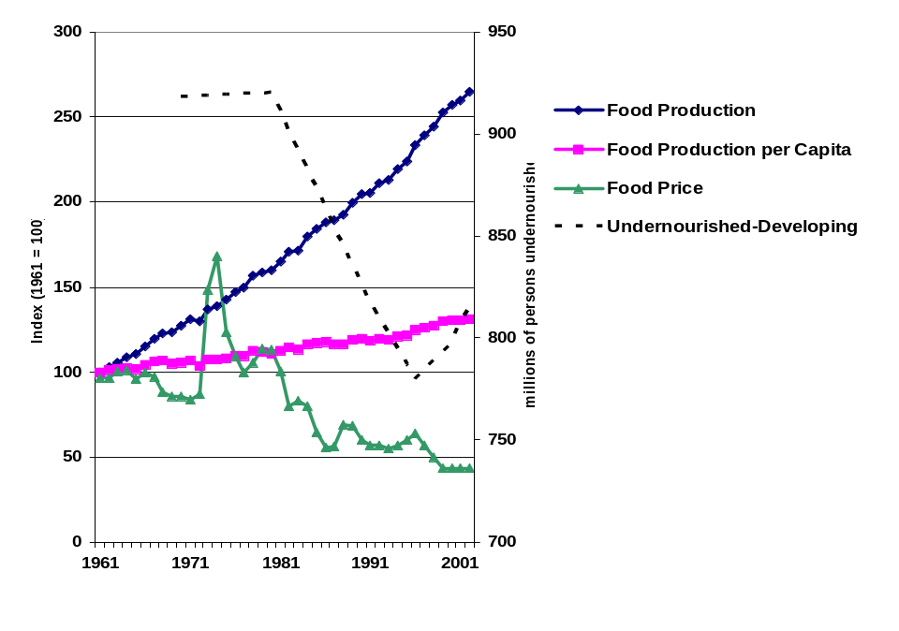

b) Relative Changes in Food Supply (Crops and Livestock): Industrial and Developing.
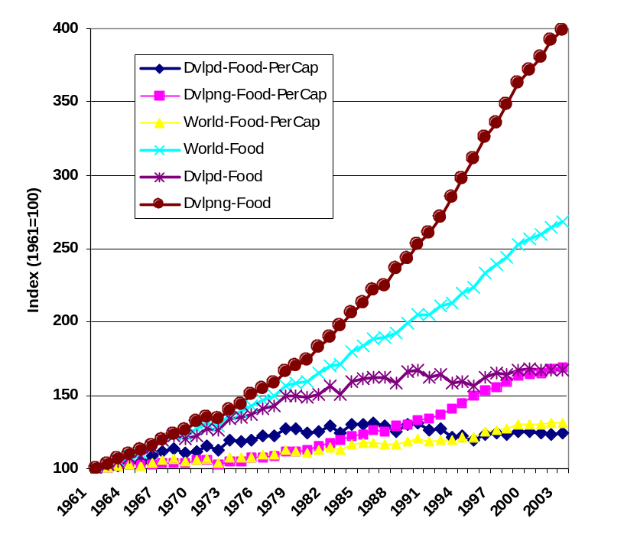

Appendix Figure A.2. Changes in Agricultural Land (Pasture and Cropland) under MA Scenarios (S9 Fig 9.15)

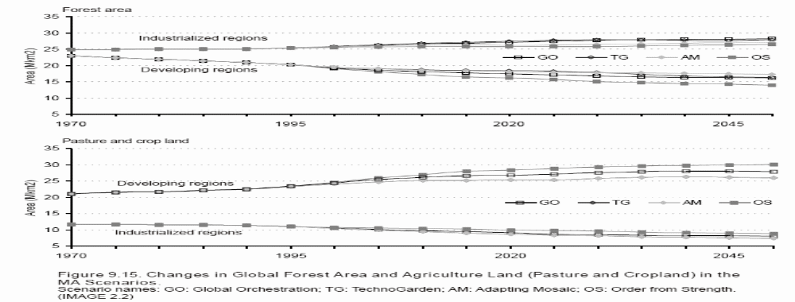

Water Provisioning and Supporting Service
Water is both a provisioning service, since ecosystems are the source of water used by people, and a supporting service, since water is required for life on Earth and thus supports all other ecosystem processes. Forest and mountain ecosystems are associated with the largest amounts of fresh water—57% and 28% of the total runoff, respectively. These systems each provide renewable water supplies to at least 4 billion people, or two thirds of the global population. Cultivated and urban systems generate only 16% and 0.2%, respectively, of global runoff, but due to their close proximity to humans they serve from 4.5–5 billion people. Such proximity is associated with nutrient and industrial water pollution (C7.ES).

Condition and Trends
- Recent changes to ecosystems have not significantly reduced the net amount of renewable freshwater runoff on Earth, but the fraction of that runoff used by humans has grown dramatically. Global freshwater use expanded at a mean rate of 20% per decade between 1960 and 2000, doubling over this time period (C7.ES).
- Contemporary water withdrawal is approximately 10% of global continental runoff, although this amounts to between 40% and 50% of the continental runoff to which the majority of the global population has access during the year (C7.ES,, (C7.2.3).
- Inorganic nitrogen pollution of inland waterways has increased more than twofold globally since 1960 and more than tenfold for many industrialized parts of the world (C7.ES).
- Current patterns of human use of water are unsustainable. From 5% to possibly 25% of global freshwater use exceeds long-term accessible supplies and is met through engineered water transfers or the overdraft of groundwater supplies (low to medium certainty). More than 1 billion people live in areas without appreciable supplies of renewable fresh water and meet their water needs in this way (C7.ES). In North Africa and the Middle East, unsustainable use represents about a third of all water use (low certainty) (C7.ES).
- Globally, 15–35% of irrigation withdrawals are estimated to be unsustainable (low to medium certainty) (C7.2.2). (See Appendix Figure A.3.)

Scenarios
- Use of water is expected to grow by approximately 10% between 2000 and 2010, compared with rates of 20% per decade over the past 40 years (C7.ES).
- Water withdrawals began to decline in many parts of the OECD at the end of the twentieth century, and with medium certainty will continue to decline throughout OECD during the twenty-first century because of saturation of per capita demands, efficiency improvements, and stabilizing populations (S9.ES).
- Water withdrawals are expected to increase greatly outside the OECD as a result of economic development and population growth. The extent of these increases is very scenario-dependent. In sub-Saharan Africa, domestic water use greatly increases and this implies (low to medium certainty) an increased access to fresh water. However, the technical and economic feasibility of increasing domestic water withdrawals is very uncertain (S9.ES).
- Across all the MA scenarios, global water withdrawals increase between 30% and 85% between 2000 and 2050. (S9 Fig 9.35) (See Appendix Figure A.4.)
- Global water availability increases under all MA scenarios. By 2050, global water availability increases by 5–7% (depending on the scenario), with Latin America having the smallest increase (around 2%, depending on the scenario), and the Former Soviet Union the largest (16–22%) (S9.4.5). Increasing precipitation tends to increase runoff, while warmer temperatures intensify evaporation and transpiration, which tends to decrease runoff.
Appendix Figure A.3. Unsustainable Water Withdrawals for Irrigation. (C7 Fig 7.3) Globally, roughly 15–35% of irrigation withdrawals are estimated to be unsustainable (low to medium certainty) (C7.2.2). The map indicates where there is insufficient fresh water to fully satisfy irrigated crop demands. The imbalance in long-term water budgets necessitates diversion of surface water or the tapping of groundwater resources. The areas shown with moderate-to-high levels of unsustainable use occur over each continent and are known to be areas of aquifer mining or major water transfer schemes.

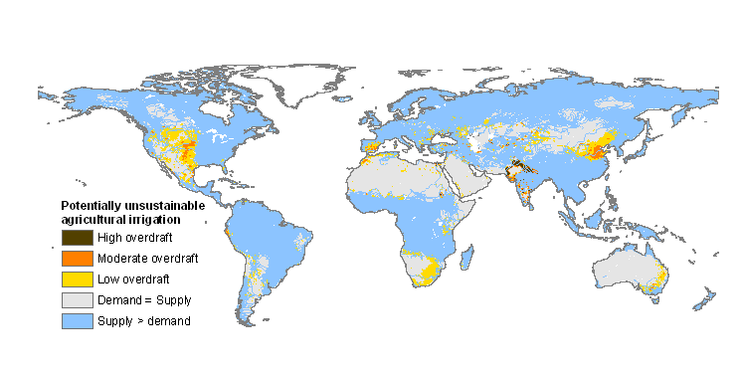
Key: High overdraft, > 1km³ yr⁻¹; Moderate, 0.1 to 1 km³ yr⁻¹; Low, 0 to 0.1 km³ yr⁻¹. All estimates made on ca. 50 km resolution. Though difficult to generalize, the imbalances translate into water table drawdowns >1.6 m yr⁻¹ or more for the high overdraft case and <0.1 m yr⁻¹ for low, assuming water deficits are met by pumping unconfined aquifers with typical dewatering potentials (specific yield = 0.2).

Appendix Figure A.4. Water Withdrawals in 2050 under MA Scenarios (S9 Fig 9.35)

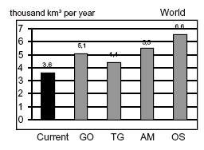

Timber, Fiber, Fuel Provisioning Services
Timber is harvested from forests and plantations and used for a variety of building, manufacturing, fuel, and other needs. Forests (providing fuelwood and charcoal), agricultural crops, and manure all serve as sources of biomass energy. A wide variety of crops and livestock are used for fiber production. Cotton, flax, hemp, and jute are generally produced from agricultural systems, while sisal is produced from the leaves of Agave cactus. Silk is produced by silkworms fed the leaves of the mulberry tree, grown in an orchard-like culture, and wool is produced by sheep, goats, alpaca, and other animals.

Condition and Trends
- Global timber harvests increased by 60% since 1960, and wood pulp production increased slightly less than threefold over this same time (C9.ES C9 Table 9.5). Rates of growth in harvests have slowed in recent years.
- Fuelwood is the primary source of energy for heating and cooking for some 2.6 billion people, and 55% of global wood consumption is for fuelwood (C9.ES). Although they account for less than 7% of world energy use, fuelwood and charcoal provide 40% of energy use in Africa and 10% in Latin America (C9.4).
- Global consumption of fuelwood appears to have peaked in the 1990s and is now believed to be slowly declining as a result of switching to alternate fuels and, to a lesser degree, more-efficient biomass energy technologies. In contrast, global consumption of charcoal appears to have doubled between 1975 and 2000, largely as a result of continuing population shifts toward urban areas (C9.4.1).
- Localized fuelwood shortages in Africa impose burdens on people who depend on fuelwood for home heating and cooking (SG3.4). The impact on people may be high prices in urban areas or lengthy and arduous travel to collect wood in rural areas.
- Among agricultural fibers, global cotton production has doubled and silk production has tripled since 1961 (C9.ES). Despite this doubling of production, the land area on which cotton is harvested has stayed virtually the same. Production of flax, wool, hemp, jute, and sisal has declined. For example, competition from synthetic fabrics has contributed to a reduction in the demand for wool in recent decades; wool production declined 16% between 1980 and 2000 (C9.5.3).

Scenarios
- Plantations are likely to provide an increasing proportion of timber products in the future (C9.ES). In 2000, plantations were 5% of the global forest cover, but they provided some 35% of harvested roundwood, an amount anticipated to increase to 44% by 2020. The most rapid expansion will occur in the mid-latitudes, where yields are higher and production costs lower.
- Under the MA scenarios, forest area increases in industrialized regions and decreases in developing ones between 1970 and 2050. In one scenario (Order from Strength), the rate of forest loss increases from the historic rate (of about 0.4% annually between 1970 and 2000) to 0.6%. In the other scenarios, the rate of loss continues at the historic rate (Global Orchestration and Adapting Mosaic) or slightly below (TechnoGarden). (See Figure Appendix A.5.)

Appendix Figure A.5. Changes in Forest Area under MA Scenarios (S9 Fig 9.15)

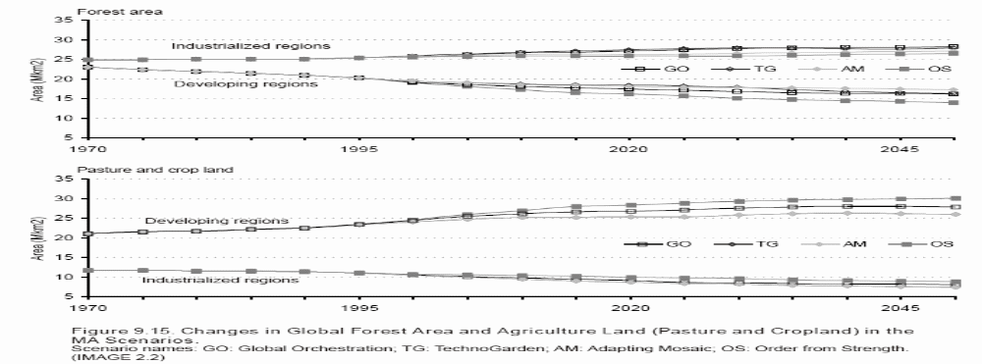

Biochemicals and Genetic Resources Provisioning Services
A wide variety of species—microbial, plant, and animal—and their genes contribute to commercial products in such industries as pharmaceuticals, botanical medicines, crop protection, cosmetics, horticulture, agricultural seeds, environmental monitoring and a variety of manufacturing and construction sectors.

Condition and Trends
- Biodiversity is in increasing demand as a source of commercial material. An overview of the industries involved, trends in the use of biodiversity, and the types of social and commercial benefits is provided in Appendix Table A.1. Appendix Table A.2 is a partial list compounds approved for marketing within the pharmaceutical industry in the 1990s.

Scenarios
- Market trends vary widely according to the industry and country involved, but many bioprospecting activities and revenues are expected to increase over the next decades. Several major new industries, such as bioremediation and biomimetics are well established and appear set to increase, while others have a less certain future. The current economic climate suggests that pharmaceutical bioprospecting will increase, especially as new methods that use evolutionary and ecological knowledge enhance productivity (C10.ES).
Appendix Table A.1. A summary of status and trends in major bioprospecting industries (C10 Table 10.8). (+++ = $billions, ++ = $millions, + profitable but amounts vary; P= plants, A = animals, M= microorganisms)
Industry | Current involvement in bioprospecting | Expected trend in bioprospecting | Social benefits | Commercial benefits | Biodiversity resources
Pharmaceutical | tends to be cyclical | cyclical, possible increase | human health,  employment | +++ | P,A,M
Botanical Medicines | high | increase | human health,  employment | +++ | mostly P
Cosmetics and Natural Personal Care | high | increase | human health & well-being | +++ | P,A,M
Bioremediation | variable | increase | environmental health | ++ | mostly M
Crop Protection & Biological Control | high | increase | food supply,  environmental health | +++ | P,A.M
Biomimetics | variable | variable, increasing? | various | ++ | P,A,M
Biomonitoring | variable | Increase | environmental health | + | P,A,M
Horticulture & Seed Industry | low | Steady | human well-being, food supply | +++ | P
Ecological Restoration | medium | Increase | environmental health | ++ | P,A, M

Appendix Table A.2. Some compounds from natural sources (pure natural products, semi-synthetic modifications, or the pharmacophore is from a natural product) approved for marketing in the 1990s, in the USA and elsewhere (C10 Table 10.2).

Generic | Brand name | Manufacturer
In the USA and elsewhere
Cladribine | Leustatin | Johnson & Johnson (Ortho Biotech)
Docetaxel | Taxotere | Rhône-Poulenc Rorer
Fludarabine | Fludara | Berlex
Idarubicin | Idamycin | Pharmacia & Upjohn
Irinotecan | Camptosar | Yakult Haisha
Paclitaxel | Taxol | Bristol-Myers Squibb
Pegaspargase | Oncospar | Rhône-Poulenc
Pentostatin | Nipent | Parke-Davis
Topotecan | Hycamtin | SmithKline Beecham
Vinorelbine | Navelbine | Lilly
Only outside the USA
Bisantrene |  | Wyeth Ayerst
Cytarabine ocfosfate |  | Yamasa
Formestane |  | Ciba-Geigy
Interferon, gamma-la |  | Siu Valy
Miltefosine |  | Acta Medica
Porfimer sodium |  | Quadra Logic
Sorbuzoxane |  | Zeuyaku Kogyo
Zinostatin |  | Yamamouchi

Climate Regulation Regulating Services
Ecosystems, both natural and managed, exert a strong influence on climate and air quality as sources and sinks of pollutants, reactive gases, greenhouse gases, and aerosols and due to physical properties that affect heat fluxes and water fluxes (precipitation). Ecosystems can affect climate in the following ways: warming (as sources of greenhouse gases, for instance, or forests with lower albedo than bare snow); cooling (as sinks of greenhouse gas, sources of some aerosol that reflect solar radiation, and evapotranspiration, for example); and water redistribution/recycling and regional rainfall patterns (through evapotranspiration, for instance, or cloud condensation nuclei).

Condition and Trends

Ecosystems have made a large contribution to historical changes in radiative forcing from 1750 to the present mainly due to deforestation, fertilizer use, and agricultural practices (C13.ES). (See Figure Appendix A.6.) Ecosystem changes account for about 10–30% of the radiative forcing of CO₂ since 1750 and a large proportion of the radiative forcing due to CH₄ and N₂O. Ecosystems are currently a net sink for CO₂ and tropospheric ozone, while they remain a net source of CH₄ and N₂O. Future management of ecosystems has the potential to modify concentrations of a number of greenhouse gases, although this potential is likely to be small in comparison to IPCC scenarios of fossil fuel emissions over the next century (high certainty). Ecosystems influence the main anthropogenic greenhouse gases as follows:

• Carbon dioxide: About 40% of the historical emissions (over the last two centuries), and about 20% of current CO₂ emissions (in the 1990s), originated from changes in land use and land management, primarily deforestation. Terrestrial ecosystems were a sink for about a third of cumulative historical emissions and a third of total emissions in the 1990s (energy plus land use). The sink may be explained partially by afforestation, reforestation, and forest management in North America, Europe, China, and other regions and partially by the fertilizing effects of N deposition and increasing atmospheric CO₂. Ecosystems were on average a net source of CO2 during the nineteenth and early twentieth centuries and became a net sink sometime around the middle of the last century (high certainty).

• Methane: Natural processes in wetland ecosystems account for about 25–30% of current methane emissions, and about 30% of emissions are due to agriculture (ruminant animals and rice paddies).

• Nitrous oxide: Ecosystem sources account for about 90% of current N₂O emissions, with 35% of emissions from agricultural systems, primarily driven by fertilizer use.

• Tropospheric ozone: Dry deposition in ecosystems accounts for about half the tropospheric ozone sink. Several gases emitted by ecosystems, primarily due to biomass burning, act as precursors for tropospheric ozone formation (NO_{x}, volatile organic compounds, CO, CH₄). The net global effect of ecosystems is as a sink for tropospheric O₃.

During much of the past century, most cropping systems have undergone a steady net loss of soil organic matter. However, with the steady increase in crop yields, which increases crop biomass and the amount of residue returned to the soil, and with the adoption of conservation tillage and no-till cropping systems, net carbon sequestration is estimated to occur in the maize-soybean systems of North America and in some continuous irrigated lowland rice systems. Agriculture accounts for 44% of anthropogenic methane emissions and about 70% of anthropogenic nitrous oxide gases, mainly from the conversion of new land to agriculture and nitrogen fertilizer use (C26.2.6).

Marine plants fix CO₂ in the ocean and return it via respiration. Some of the carbon sinks in the form of dead organisms, particles, and dissolved organic carbon, a small amount of which remains in sediments; the rest is respired at depth and eventually recirculated to the surface (the “biological pump”). The biological pump acts as a net sink for CO₂ by increasing the its concentration at depth, where it is isolated from the atmosphere for decades to centuries, causing the concentration of CO₂ in the atmosphere to be about 200 parts per million lower than it would be in the absence of life (C13.2.1).

The biophysical effect of historical land cover changes since 1750 is net cooling on a global scale due to increased albedo (medium certainty), partially offsetting the warming effect of associated CO₂ emissions (C13.ES). Deforestation and desertification in the tropics and sub-tropics leads to a reduction in regional rainfall (high certainty). Biophysical effects need to be accounted for in the assessment of options for climate change mitigation. For example, the warming effect of reforestation in seasonally snow-covered regions due to albedo decrease is likely to exceed the cooling effect of additional carbon storage in biomass. Biophysical effects of ecosystem changes on regional climate patterns depend on geographical location and season. With high certainty:

• Deforestation in seasonally snow-covered regions leads to regional cooling of the land surface during the snow season due to increase in surface albedo, and it leads to warming during the summer due to reduction in evapotranspiration. These effects propagate to the global scale through positive feedbacks involving sea-surface temperatures and sea ice.

• Large-scale tropical deforestation (hundreds of square kilometers) reduces regional rainfall, primarily due to decreased evapotranspiration.

• Desertification in the tropics and sub-tropics leads to decrease in regional precipitation due to reduced evapotranspiration and increased surface albedo.

Scenarios

The future contribution of terrestrial ecosystems to the regulation of climate is uncertain. Currently, the biosphere is a net sink of carbon, absorbing about 1–2 gigatons of carbon per year, or approx. 20% of fossil fuel emissions. It is very likely that the future of this service will be greatly affected by expected land use change. In addition, a higher atmospheric CO₂ concentration is expected to enhance net productivity, but this does not necessarily lead to an increase in the carbon sink. The limited understanding of soil respiration processes generates uncertainty about the future of the carbon sink. There is medium certainty that climate change will increase terrestrial fluxes of CO₂ and CH₄ in some regions (such as in Arctic tundras).(S9.ES)

Appendix Figure A.6. Contribution of Ecosystems to Historical Radiative Forcing and Current Greenhouse Gas Emissions (C13 Fig 13.3). Figure (A) is the radiative forcing caused by changes in atmospheric composition, alteration in land surface reflectance (albedo), and variation in the output of the sun for the year 2000 relative to conditions in 1750. The height of the bar represents a best estimate, and the accompanying vertical line a likely range of values. Factors with a significant ecosystem influence are separated from those without one. The indirect effect of aerosols shown is their effect on cloud droplet size and number, not cloud lifetime.
Figure (B) is the relative contribution of ecosystems to sources, sinks, and net changes in three main greenhouse gases. These can be compared with each other by conversion into CO₂-equivalent values, based on the global warming potential (radiative impact times atmospheric lifetime) of the different gases. For CH₄ and N₂O, a 100-year time scale was assumed; a short time scale would increase the relative value compared with CO₂ and a longer time scale would reduce it. Ecosystems are also a net sink for tropospheric ozone, but it is difficult to calculate emissions in CO₂-equivalent values.

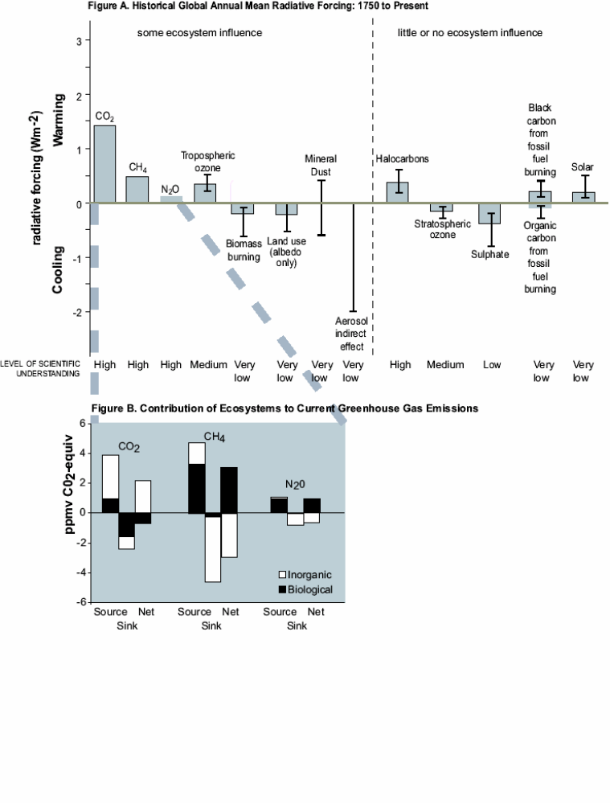

Disease Regulation Regulating Service
The availability of many ecosystem services, such as food, water, and fuel, can profoundly influence human health. Here, we consider a much narrower service provided by ecosystems related to human health: the role of ecosystems in regulating infectious disease. Ecosystem changes have played an important role in the emergence or resurgence of infectious diseases. (See Appendix Table A.3.) Ecosystem modifications associated with developments such as dam building and the expansion of agricultural irrigation, for example, have sometimes increased the local incidence of infectious diseases such as malaria, schistosomiasis, and arbovirus infections, especially in the tropics. Other modifications to ecosystems have served to reduce the incidence of infectious disease.

Condition and Trends
- Infectious diseases still account for close to one quarter of the global burden of disease. Major tropical diseases, particularly malaria, meningitis, leishmaniasis, dengue, Japanese encephalitis, African trypanosomiasis, Chagas disease, schistosomiasis, filariasis, and diarrheal diseases still infect millions of people throughout the world (very certain) (C14.ES).
- The following diseases are ranked as high priority for their large global burden of disease, in combination with their high sensitivity to ecological change: malaria across most ecological systems; schistosomiasis, lymphatic filariasis, and Japanese encephalitis in cultivated and inland water systems in the tropics; dengue fever in tropical urban centers; leishmaniasis and Chagas disease in forest and dryland systems; meningitis in the Sahel; cholera in coastal, freshwater, and urban systems; and West Nile virus and Lyme disease in urban and suburban systems of Europe and North America (high certainty) (C14.ES).
- Various changes to ecosystems can affect disease incidence through a variety of mechanisms. Disease/ecosystem relationships that best exemplify these biological mechanisms include the following examples (C14.ES):
- Dams and irrigation canals provide ideal habitat for snails that serve as the intermediate reservoir host species for schistosomiasis; irrigated rice fields increase in the extent of mosquito-breeding surface, increasing the chance of transmission of mosquito-borne malaria, lymphatic filariasis, Japanese encephalitis, and Rift Valley fever.
- Deforestation has increased the risk of malaria in Africa and South America by increasing habitat suitable for malaria-transmitting mosquitoes.
- Natural systems with preserved structure and characteristics generally resist the introduction of invasive human and animal pathogens brought by human migration and settlement. This seems to be the case of cholera, kala-azar, and schistosomiasis, which did not become established in the Amazonian forest ecosystem (medium certainty).
- Uncontrolled urbanization in the forest ecosystem has been associated with mosquito-borne viruses (arboviruses) in the Amazon and with lymphatic filariasis in Africa. Tropical urban areas with poor water supply systems and lack of shelter promote transmission of dengue fever.
- There is evidence that habitat fragmentation, with subsequent biodiversity loss, increases the prevalence in ticks of the bacteria that causes Lyme disease in North America (medium certainty).
- Zoonotic pathogens (defined by their natural life cycle in animals) are a significant cause of both historical (such as HIV and tuberculosis) and newly emerging infectious diseases affecting humans (such as SARS, West Nile virus, and Hendra virus). In addition, zoonotic pathogens can cause high case-fatality rates and are difficult to vaccinate against, since the primary reservoir hosts are nonhumans.
- Intensive livestock agriculture that uses subtherapeutic doses of antibiotics has led to the emergence of antibiotic-resistant strains of Salmonella, Campylobacter, and Escherichia coli bacteria. Overcrowded and mixed livestock practices, as well as the trade in bushmeat, can facilitate interspecies host transfer of disease agents, leading to dangerous novel pathogens such as SARS and new strains of influenza.

Scenarios
- Tropical developing countries are more likely to be affected in the future due to the greater exposure of people in these countries to vectors of infectious disease transmission. Such populations have a scarcity of resources to respond to disease and to plan environmental modifications associated with economic activities (high certainty). However, international trade and transport leave no country entirely unaffected (S11).
- The health consequences under the MA scenarios related to changes in the disease regulation service of ecosystems vary widely, with some scenarios showing improving conditions and others declining conditions (S11).
Appendix Table A.3. Importance of Infectious Diseases as Related to Ecosystem Changes (C14, Table 14.4)
DISEASE | CASES PER YEAR* | DALYs**  (000) | (Proximate) Emergence mechanism | (Ultimate) Emergence driver | Geographical Distribution | Expected Variation From Ecological Change | Confidence Level
Marlaria | 350 m | 46,486 | Niche invasion; vector expansion | Deforestation, water projects | Tropical (America, Asia & Africa ) | + + + + |  | +++
Dengue fever | 80 m | 616 | Vector expansion | Urbanization, poor housing conditions | Tropical | ++ + |  | + +
HIV | 42 m | 84,458 | Host transfer | Forest encroachment; bushmeat hunting,  Human behavior | Global | + |  | ++
Leishmaniasis | 12 m | 2090 | Host transfer, habitat alteration | Deforestation, agricultural development | Tropical Americas; Europe and Middle East | + + + + |  | + + +
Lyme disease | 23,763  (US 2002) |  | Depletion of predators; Biodiversity loss; reservoir expansion | Habitat fragmentation | N. America and Europe | + + |  | + +
Chagas disease | 16-18 m | 667 | Habitat alteration | Deforestation, urban sprawl and encroachment | Americas | ++ |  | + + +
Japanese encephalitis | 30-50,000 | 709 | Vector expansion | irrigated rice fields | SE Asia | +++ |  | +++
West Nile virus and other encephalitides | - | - |  |  | Americas, Eurasia | ++ |  | +
Guanarito; Junin, Machupo | - | - | Biodiversity loss; reservoir expansion | Monoculture in agriculture after deforestation | S. America | + + |  | + + +
Oropouche / Mayaro virus in Brazil | - | - | Vector expansion | Forest encroachment; urbanization | S. America | +++ |  | +++
Hantavirus | - | - | Variations in population density of natural food sources | Climate variability |  | ++ |  | ++
Rabies | - | - | Biodiversity loss, altered host selection | Deforestation and mining | Tropical | + + |  | + +
Schistosomiasis | 120 m | 1702 | Intermediate host expansion | Dam building, irrigation | America; Africa; Asia | ++++ |  | ++++
Leptospirosis | - | - |  |  | Global (Tropical) | + + |  | + + +
Cholera | † | ¥ | Sea surface temperature rising | Climate variability and change | Global (Tropical) | ++ + |  | ++
Cryptosporidiosis | † | ¥ | Contamination by oocystes | Poor watershed management where livestock exist | Global | + + + |  | + + + +
Meningitis |  | 6,192 | Dust Storms | Desertification | Saharan Africa | ++ |  | ++
Coccidioidomycosis | - | - | Disturbing soils | Climate Variability | Global | + + |  | + + +
Lymphatic Filariasis | 120 m | 5,777 |  |  | Tropical America and Africa | + |  | + + +
Trypanosomiasis | 30-500,000 | 1,525 |  |  | Africa
Onchocerciasis | 18 m | 484 |  |  | Africa; Tropical America | + + |  | + + +
Rift Valley Fever |  |  | Heavy rains | Climate variability and change | Africa
Nipah/Hendra viruses |  |  | Niche invasion | Industrial food production; deforestation; climate abnormalities | Australia, SE Asia | +++ |  | +
Salmonellosis |  |  | Niche invasion | Antibiotic resistance from using antibiotics in animal feed
Ebola |  |  | Forest encroachment; bushmeat hunting
BSE |  |  | Host transfer | Intensive livestock farming
SARS |  |  | Host transfer | Intensive livestock operations mixing wild and domestic animals
* m = millions
**Disability Adjusted Life Year: Years of healthy life lost, a measure of disease burden for the gap between actual health of a population compared to an ideal situation where everyone lives in full health into old age. Source: The World Health Report, 2004.
† and ¥ Diarrheal Diseases (aggregated) deaths and DALYs respectively: 1798 X 1000 cases and 61,966 X1000 DALYs
LEGEND: + low
++ moderate
+++ high
++++ very high

Waste Treatment Regulating Services
Because the characteristics of both wastes and receiving ecosystems vary, environments vary in their ability to absorb wastes and to detoxify, process, and sequester them. Some contaminants (such as metals and salts) cannot be converted to harmless materials, but others (organic chemicals and pathogens, for example) can be degraded to harmless components. Nevertheless, these materials may be released to the environment fast enough to modify ecosystem functioning significantly. Some materials (such as nutrient fertilizers and organic matter) are normal components of organism metabolism and ecosystem processes. Nevertheless, loading rates of these materials may occur fast enough to modify and impair ecosystem function significantly.

Condition and Trends
- The problems associated with wastes and contaminants are in general growing. Some wastes—sewage, for instance—are produced in nearly direct proportion to population size. Other types of wastes and contaminants reflect the affluence of society. An affluent society uses and generates a larger volume of waste-producing materials such as domestic trash and home-use chemicals (C15.ES).
- Where there is significant economic development, loadings of certain wastes are expected to increase faster than population growth. The generation of some wastes (industrial waste, for example) does not necessarily increase with population or development state. These wastes may often be reduced through regulation aimed to encourage producers to clean discharges or to seek alternate manufacturing processes C15.ES).
- In developing countries, 90–95% of all sewage and 70% of industrial wastes are dumped untreated into surface water (C7.4.5). Regional patterns of processing nitrogen loads in freshwater ecosystems provide a clear example of the overloading of the waste processing service of ecosystems.
- Aquatic ecosystems “cleanse” on average 80% of their global incident nitrogen loading but this intrinsic self-purification capacity of these ecosystems varies widely and is not unlimited (C7.2.5).
- Severe deterioration in the quality of fresh water is magnified in cultivated and urban systems (high use, high pollution sources) and in dryland systems (high demand for flow regulation, absence of dilution potential) (C7.ES).

Scenarios
- It is neither possible nor appropriate to attempt to state whether the intrinsic waste detoxification capabilities of the planet as a whole will increase or decrease with a changing environment. The detoxification capabilities of individual locations may change with changing conditions (such as changes in soil moisture levels). At high waste-loading rates, however, the intrinsic capability of environments is overwhelmed, such that wastes will build up in the environment to the detriment of human well-being and a loss of biodiversity (C15.ES).
- The service of water purification could be either enhanced or degraded in both developing and industrial countries under the MA Scenarios (S9.5.4). Within industrial countries, the dilution capacity of most rivers increases because higher precipitation leads to increases in runoff in most river basins. Wetland areas decrease because of the expansion of population and agricultural land. Wastewater flows increase, but in some scenarios the wealth of the North enables it to repair breakdowns in water purification as they occur. Within developing countries, the pace of ecosystem degradation, the overtaxing of ecosystems by high waste loads, and the decline of wetland area because of the expansion of population and agricultural land tend to drive a deterioration of water purification in two scenarios. The Adapting Mosaic scenario, however, could lead to some gains in water purification even in developing countries, and the TechnoGarden scenario would also result in gains.

Natural Hazard Regulation Regulating Service
Ecosystems play important roles in modulating the effects of extreme events on human systems. Ecosystems affect both the probability and severity of events, and they modulate the effects of extreme events. Soils store large amounts of water, facilitate transfer of surface water to groundwater, and prevent or reduce flooding. Barrier beaches, wetlands, and lakes attenuate floods by absorbing runoff peaks.

Condition and Trends
- Humans are increasingly occupying regions and localities that are exposed to extreme events, (such as on coasts and floodplains or close to fuelwood plantations). These actions are exacerbating human vulnerability to extreme events, such as the December 2004 tsunami in the Indian Ocean. Many measures of human vulnerability show a general increase due to growing poverty, mainly in developing countries (C16.ES).
- Roughly 17% of all the urban land in the United States is located in the 100-year flood zone. Likewise, in Japan about 50% of the population lives on floodplains, which cover only 10% of the land area. In Bangladesh, the percentage of flood-prone areas is much higher and inundation of more than half of the country is not uncommon. For example, about two thirds of the country was inundated in the 1998 flood (C16.2.2).
- Many of the available datasets on extreme events show that impacts are increasing in many regions around the world. From 1992 to 2001, floods were the most frequent natural disaster (43% of 2,257 disasters), and they killed 96,507 people and affected more than 1.2 billion people over the decade. Annual economic losses from extreme events increased tenfold from the 1950s to the 1990s (C16.ES).
- The loss of ecosystems such as wetlands and mangroves has significantly reduced natural mechanisms of protection from natural hazards. For example, forested riparian wetlands adjacent to the Mississippi River in the United States during presettlement times had the capacity to store about 60 days of river discharge. With the removal of wetlands through canalization, leveeing, and draining, the remaining wetlands have a storage capacity of less than 12 days discharge—an 80% reduction of flood storage capacity (C16.1.1).
- The number of floods and fires increased significantly on all continents over the past 60 years. (See Appendix Figures A.7 and A.8.)
- Within industrial countries, the area burned by fires is declining but the number of major fires is increasing. In the United States, for example, the area burned has declined by more than 90% since 1930, while in Sweden the area burned annually fell from about 12,000 hectares in 1876 to about 400 hectares in 1989. In North America, however, the number of fire “disasters”—10 or more people reportedly killed, 100 people reportedly affected, a declared state of emergency, and a call for international assistance—increased from about 10 in the 1980s to about 45 during the 1990s (C16.2.2.

Appendix Figure A.7. Number of Flood Events by Continent and Decade Since 1900s
(C16, Fig 16.6)
Appendix Figure A.8. Number of Major Wild fires by Continent and Decade Since 1900s
(C16, Fig 16.9)
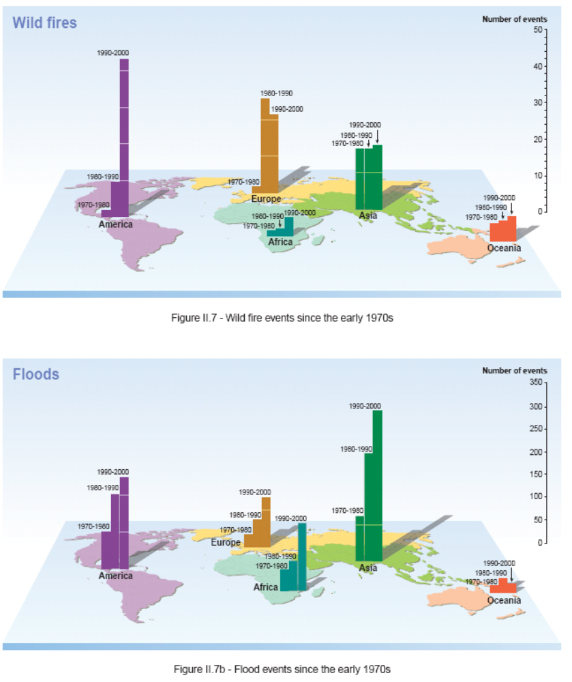

Cultural Services Cultural Services
Human cultures, knowledge systems, religions, social interactions, and amenity services have been influenced and shaped by the nature of an ecosystem. At the same time, humankind has influenced and shaped its environment to enhance the availability of certain valued services. Recognizing that it is not possible to fully separate the different spiritual, intellectual, and physical links between human cultures and ecosystems, the MA assessed six main types of cultural and amenity services provided by ecosystems: cultural diversity and identity; cultural landscapes and heritage values; spiritual services; inspiration (such as for arts and folklore); aesthetics; and recreation and tourism. Because global aggregated information on the condition of cultural services was limited (with the partial exception of recreational and tourism benefits), the section below draws significantly on information in the MA sub-global assessments.

Condition and Trends
- Transformation of once diverse ecosystems into relatively more similar cultivated landscapes, combined with social and economic changes including rapid urbanization, breakdown of extended families, loss of traditional institutions, easier and cheaper transportation, and growing economic and social “globalization,” has significantly weakened the linkages between ecosystems and cultural diversity and cultural identity (C17.2.1). Throughout human evolution, human societies have developed in close interaction with the natural environment, which has shaped their cultural identity, value systems, and language.
- The loss of particular ecosystem attributes (sacred species or sacred forests), combined with social and economic changes, can sometimes weaken the spiritual benefits people obtain from ecosystems in many parts of the world (C17.2.3). On the other hand, under some circumstances (such as where ecosystem attributes are causing significant threats to people) the loss of some attributes may enhance spiritual appreciation for what remains.
- People across cultures and regions express, in general, an aesthetic preference for natural environments over urban or built ones; the conversion and degradation of relatively natural environments has diminished these benefits. Ecosystems continue to inspire arts, songs, drama, dance, design, and fashion, although the stories told through such media are different from those told historically (C17.2.5).
- Recreation and tourism uses of ecosystems are growing, due to growing populations, greater leisure time available among wealthy populations, and greater infrastructure development to support recreational activities and tourism. Nature travel increased at an estimated rate of 10–30% annually in the early 1990s, and in 1997 nature tourism accounted for approximately 20% of total international travel (C17.2.6). Tourism is now the primary economic development strategy for a number of developing countries.
- Tourism is an important component of the economies of many of the MA sub-global assessment study areas, and at all scales most stakeholders of assessments requested its inclusion. In contrast, spiritual, religious, recreational, and educational services tended to be assessed only at a fine scale in small local studies, typically because the data required for these assessments are not available at a broad scale as well as because of the culture-specific, intangible, and sometimes sensitive nature of these services (SG8.3).
- Within the MA sub-global assessments, cultural services of tourism and recreation were generally in a good condition and growing, although some assessments expressed concerns about tourist activities potentially reducing the capacity of ecosystems to provide this cultural service (SG8.3).
- In contrast, within the MA sub-global assessments local-scale services of a spiritual nature are of a variable condition, typically either collapsing or being revived, depending on policies, interventions, and context-specific factors such as changes in leadership (SG8.3). Spiritual values were found to act as strong incentives for ecosystem conservation in sub-global assessments in Peru, Costa Rica, India, and some parts of Southern Africa. Educational services of ecosystems assessed in Sweden, São Paulo, and Portugal are all increasing due to growing levels of awareness of the value and benefits of, and thus the demand for, environmental education.
- While provisioning services such as water, medicinal plants, fuelwood, and food are very important, spiritual and sacred elements in the local landscape also have a very specific and important value to local people across all the assessments. In several cases, spiritual values coincided with other values, such as biodiversity, water supply, biomedicines, and fuel (SG11.3).

Scenarios
- The MA Scenarios project changes in cultural services based only on a qualitative analyses due to the absence of suitable quantitative models. Cultural services increase in some scenarios and decline in others, indicating that our path into the future could have considerable impact on the provision of cultural services. Generally, cultural services decline moderately in Global Orchestration and strongly in Order from Strength, driven in both cases by lack of personal experience with nature and lower cultural diversity. Lower cultural diversity also drives a decline in cultural services in the TechnoGarden scenario. On the other hand, cultural services increase in Adapting Mosaic, which can be seen in the marked increase in knowledge systems and cultural diversity (S9.7).

Nutrient Regulation Supporting Services
An adequate and balanced supply of elements necessary for life, provided through the ecological processes of nutrient cycling, underpins all other ecosystem services. The cycles of several key nutrients have been substantially altered by human activities over the past two centuries, with important positive and negative consequences for a range of other ecosystem services and for human well-being. Nutrients are mineral elements such as nitrogen, phosphorus, and potassium that are essential as raw materials for organism growth and development. Ecosystems regulate the flows and concentrations of nutrients through a number of complex processes that allow these elements to be extracted from their mineral sources (atmosphere, hydrosphere, or lithosphere) or recycled from dead organisms. This service is supported by a diversity of different species.

Condition and Trends

- The capacity of terrestrial ecosystems to absorb and retain the nutrients supplied to them either as fertilizers or from the deposition of airborne nitrogen and sulfur has been undermined by the radical simplification of ecosystems into large-scale, low-diversity agricultural landscapes. Excess nutrients leak into the groundwater, rivers, and lakes and are transported to the coast. Treated and untreated sewage released from urban areas adds to the load. (C.SDM)
- In preindustrial times, the annual flux of nitrogen from the atmosphere to the land and aquatic ecosystems was roughly 110–210 teragrams of nitrogen a year. Human activity contributes an additional 165 teragams or so of nitrogen per year, roughly doubling the rate of creation of reactive N on the land surfaces of Earth (R9.2). (See Appendix Figure A.9.)
- The N accumulation on land and in waters has permitted a large increase in food production in some countries, but at the cost of increased emissions of greenhouse gases and frequent deterioration in freshwater and coastal ecosystem services, such as water quality, fisheries, and amenity values (C12.ES).
- Phosphorus is also accumulating in ecosystems at a rate of 10.5–15.5 tergrams per year, compared with a preindustrial rate of 1–6 teragrams per year, mainly as a result of the use of phosphorus (obtained through mining) in agriculture. Most of this accumulation is in soils. If these soils erode into freshwater systems, deterioration of ecosystem services can result. This tendency is likely to spread and worsen over the next decades, since large amounts of P have been accumulated on land and their transport to water systems is slow and difficult to prevent (C12.ES).
- Sulfur emissions have been progressively reduced in Europe and North America but not yet in the emerging industrial areas of the world: China, India, South Africa, and the southern parts of South America. A global assessment of acid deposition threats suggests that tropical ecosystems are at high risk (C12.ES).
- Human actions at all scales required to feed the current world population have increased the “leakiness” of ecosystems with respect to nutrients. Tillage often damages soil structure, and the loss of biodiversity may increase nutrient leaching. Simplification of the landscape and destruction of riparian forests, wetlands, and estuaries allow unbuffered flows of nutrients between terrestrial and water ecosystems. Specific forms of biodiversity are critical to performing the buffering mechanisms that ensure the efficient use and cycling of nutrients in ecosystems (C12.ES).
- In contrast to these issues associated with nutrient oversupply, there remain large parts of Earth, notably in Africa and Latin America, where harvesting without nutrient replacement has led to a depletion of soil fertility, with serious consequences for human nutrition and the environment (C12.ES).

Scenarios
- Recent scenario studies that include projections of nitrogen fertilizer use indicate an increase of between 10% and 80% (or more) by 2020 (S9.3.7).

- The MA scenarios project the global flux of nitrogen to coastal ecosystems to increase by 10–20% by 2030. River nitrogen will not change in most industrial countries, while a 20–30% increase is projected for developing countries. This is a consequence of increasing nitrogen inputs to surface water associated with urbanization, sanitation, development of sewerage systems, and lagging wastewater treatment, as well as increasing food production and associated inputs of nitrogen fertilizer, animal manure, atmospheric nitrogen deposition, and biological nitrogen fixation in agricultural systems. Growing river nitrogen loads will lead to increased incidence of problems associated with eutrophication in coastal seas. (S9.3.7)

Appendix Figure A.9. Contrast between Contemporary and Pre-disturbance Transports of Total Nitrogen through Inland Aquatic Systems Resulting from Anthropogenic Acceleration of This Nutrient Cycle. (C7 Fig 7.5) While the peculiarities of individual pollutants, rivers, and governance define the specific character of water pollution, the general patterns observed for nitrogen are representative of anthropogenic changes to the transport of waterborne constituents. Elevated contemporary loadings to one part of the system (such as croplands) often reverberate to other parts of the system (to coastal zones, for example), exceeding the capacity of natural systems to assimilate additional constituents.
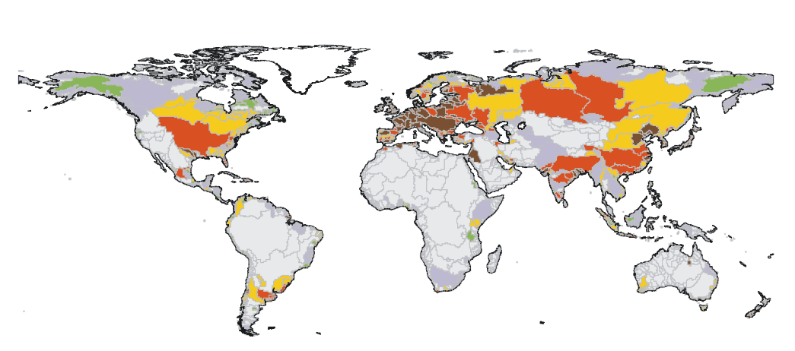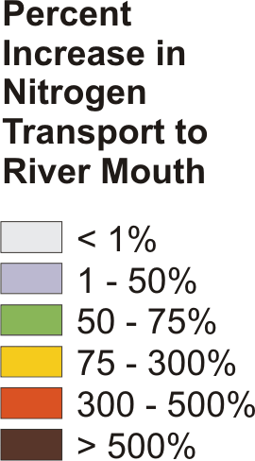

Appendix B. Effectiveness of Assessed Responses
A response is considered to be effective when its assessment indicates that it has enhanced the particular ecosystem service (or, in the case of biodiversity, its conservation and sustainable use) without significant harm to other ecosystem services. A response is considered promising either if it does not have a long track record to assess but appears likely to succeed or if there are known means of modifying the response so that it can become effective. A response is considered problematic if its historical use indicates either that it has not met the goals related to service enhancement (or conservation and sustainable use of biodiversity) or that it has caused significant harm to other ecosystem services. Labeling a response as effective does not mean that the historical assessment has not identified problems or harmful trade-offs. Such trade-offs almost always exist, but they are not considered significant enough as to negate the effectiveness of the response. Similarly, labeling a response as problematic does not mean that there are no promising opportunities to reform the response in a way that can meet its policy goals without undue harm to ecosystem services.
The typology of response presented in the Table in this Appendix is defined by the nature of intervention, classified as following: institutional and legal (I), economic and incentives (E), social and behavioral (S), technological (T), and knowledge and cognitive (K). Note that the dominant class is given in the Table. The actors who make decisions to implement a response are governments at different levels, such as international (GI) (mainly through multilateral agreements or international conventions), national (GN), and local (GL); the business/industry sector (B); and civil society, which includes nongovernmental organizations (NGO), community-based and indigenous peoples organizations (C), and research institutions (R). The actors are not necessarily equally important.
The table includes responses assessed for a range of ecosystem services—food, fresh water, wood, nutrient management, flood and storm control, disease regulation, and cultural services. It also assesses responses for biodiversity conservation, integrated responses, and responses addressing one specific driver: climate change.
Response | Effective-ness |  |  | Notes | Type of Response | Required actors
Response | Effective | Promising | Problematic | Notes | Type of Response | Required actors
Biodiversity conservation and sustainable use
Protected areas (PA) |  |  |  | PAs are an extremely important in biodiversity and ecosystem conservation programs, especially in sensitive environments that contain valuable biodiversity components. At global and regional scale, existing PAs are essential but not sufficient to conserve the full range of biodiversity. PAs need to be better located, designed, and managed to ensure representativeness and to deal with the impacts of human settlement within PAs, illegal harvesting, unsustainable tourism, invasive species and climate change. They also need a landscape approach that includes protection outside of PAs (R5) | I | GI  GN  GL  NGO  C  R
Helping Local People to Capture Biodiversity Benefits |  |  |  | Providing incentives for biodiversity conservation in the form of benefits for local people (e.g. through products from single species or from ecotourism) has proved to be very difficult. Programs have been more successful when local communities have been in a position to make management decisions consistent with overall biodiversity conservation. “Win-win” opportunities for biodiversity conservation and benefits for local communities exist, but local communities can often achieve greater benefits from actions that lead to biodiversity loss. (R5) | E | GN  GL  B  NGO  C
Promoting better management of wild species as a conservation tool, including ex situ conservation |  |  |  | More effective management of individual species should enhance biodiversity conservation and sustainable use. “Habitat-based” approaches are critical, but they can not replace “species-based” approaches. Zoos, botanical gardens and other ex situ programs build support for conservation, support valuable research, and provide cultural benefits of biodiversity. (R5) | T  S | GN  S  NGO  R
Integrating biodiversity into regional planning |  |  |  | Integrated regional planning can provide a balance among land uses that promotes effective trade-offs among biodiversity, ecosystem services, and other needs of society. Great uncertainty remains as to what components of biodiversity persist under different management regimes, limiting the current effectiveness of this approach. (R5) | I | GN  GL  NGO
Encouraging private sector involvement in biodiversity conservation |  |  |  | Many companies are preparing their own biodiversity action plans, managing their landholdings in ways that are more compatible with biodiversity conservation, supporting certification schemes that promote more sustainable use, and accepting their responsibility for addressing biodiversity issues. The business case that has been made for larger companies needs to be extended to other companies as well. (R5) | I | NG  B  NGO  R
Including biodiversity issues in agriculture, forestry and fisheries |  |  |  | More diverse production systems can be as effective as low-diversity systems, or even more effective. And strategies based on more intensive production rather than on the expansion of the area allow for better conservation. (R5) | T | NG  B
Designing governance approaches to support biodiversity |  |  |  | Decentralization of biodiversity management in may parts of the world has had variable results. The key to success is strong institutions at all levels, with secure tenure and authority at local levels essential to providing incentives for sustainable management. (R5) | I | GI  GN  GL  R
Promoting international cooperation through Multilateral Environmental Agreements (MEAs) |  |  |  | MEAs should serve as an effective means for international cooperation in the areas of biodiversity conservation and sustainable use. They cover the most pressing drivers and issues related to biodiversity loss. Additional MEAs are not required, but better coordination between conventions would increase their usefulness. (R5,15) | I | GI  GN
Environmental education and communication |  |  |  | Education and communication programs have both informed and changed preferences for biodiversity conservation and have improved implementation of biodiversity responses. Providing the human and financial resources to undertake effective work in this area is a continuing barrier. (R5) | S | GN  GL  NGO  C
Globalization, trade, and domestic and International policies on food |  |  |  | Government policies related to food production (price supports and various types of payments, or taxes) can have adverse economic, social and environmental effects. (R6) | E | GI  GN  B
Knowledge and education |  |  |  | Further research can make food production socially, economically and environmentally sustainable. Public education should enable consumers to make informed choices about nutritious, safe and affordable food. (R6) | S  K | GN  GL  NGO  C
Technological responses, including biotechnology, precision agriculture and organic farming |  |  |  | New agricultural sciences and effective natural resource management could support a new agricultural revolution to meet world-wide food needs. This would help environmental, economic and social sustainability. (R6) | T | GN  B  R
Water management |  |  |  | Emerging water pricing schemes and water markets indicate that water pricing can be a means for efficient allocation and responsible use. (R6) | E | GN  GL  B  NGO
Fisheries management |  |  |  | Strict regulation of marine fisheries, especially in the area of fishing quotas and fishing capacity reduction, is urgently needed. Given the potential detrimental environmental impacts of aquaculture, appropriate regulatory mechanisms need to supplement existing polices. (R6) | I  E | GN  GL  B  NGO
Livestock management |  |  |  | Livestock polices need to be reoriented in view of problems concerning overgrazing and dry land degradation, rangeland fragmentation and loss of wildlife habitat, dust formation, bush encroachment, deforestation, nutrient overload through disposal of manure, and greenhouse gas emissions. Policies also need to focus on human health issues related to diseases such as bird flu and BSE. (R6) | T | GN  B
Recognition of gender issues |  |  |  | Response polices need to be gender sensitive and designed to empower women by providing knowledge and ensuring access to and control of resources necessary for food security. This needs to be based on a systematic analysis of gender dynamics and explicit consideration of relationships between gender and food and water security. (R6) | S | GN  NGO  C
Determining ecosystem water requirements |  |  |  | In order to balance competing demands, it is critical that society explicitly agrees on ecosystem water requirements (environmental flows). (R7) | I T | GN  GL  NGO  R
Rights to freshwater services and responsibilities for their provision |  |  |  | Both public and private ownership systems of fresh water, and of the land resources associated with its provision, have largely failed to create incentives for provision of water services. As a result, upland communities have generally been excluded from access to benefits, particularly when they lack tenure security, and have resisted regulations regarded as unfair. Effective property rights systems with clear and transparent rules can increase stakeholders’ confidence that they will have access to the benefits of freshwater services and, therefore, willingness to pay for them. (R7) | I | GN  B  C
Increasing the effectiveness of public participation in decision-making |  |  |  | Degradation of freshwater and other ecosystem services have a disproportionate impact on those excluded from participation in decision-making. Key for improving participatory processes are to increase the transparency of information, improve the representation of marginalized stakeholders, engage them in the establishment of policy objectives and priorities for the allocation of freshwater services, and create space for deliberation and learning that accommodates multiple perspectives. (R7) | I | GN  GL  NGO  C  R
River Basin Organizations (RBOs) |  |  |  | RBOs can play an important role in facilitating cooperation and reducing transaction costs of large-scale responses. RBOs are constrained or enabled primarily by the degree of stakeholder participation, their agreement on objectives and management plans, and their cooperation on implementation. (R7) | I | GI  GN  NGO
Regulatory responses |  |  |  | Regulatory approaches based on market-based incentives (e.g. damages for exceeding pollution standards) are suitable for point-source pollutants. Regulatory approaches that simply outlaw particular types of behavior can be unwieldy and burdensome, and may fail to provide incentives for protecting freshwater services. (R7) | I | GN  GL
Water markets |  |  |  | Economic incentives can potentially unlock significant supply- and demand-side efficiencies while providing cost-effective reallocation between old (largely irrigation) and new (largely municipal and instream) uses. (R7) | E | GI  GN  B
Payments for watershed services |  |  |  | Payments for ecosystem services provided by watersheds have narrowly focused on the role of forests in the hydrological regime. They should be based on the entire flow regime, including consideration of the relative values of other land cover and land uses, such as wetlands, riparian areas, steep slopes, roads, and management practices. Key challenges for payment schemes are capacity building for place-based monitoring and assessment, identifying services in the context of the entire flow regime, considering trade-offs and conflicts among multiple uses, and making uncertainty explicit. (R7) | E | GN  B  C
Partnerships and financing |  |  |  | There is a clear mismatch between the high social value of freshwater services and the resources allocated to manage water. Insufficient funding for water infrastructure is one manifestation of this. Focusing only on large-scale privatization to improve efficiency and cost-recovery has proven a double-edged strategy – price hikes or control over resources have created controversy and, in some cases, failure and withdrawal. Development of water infrastructure and technologies must observe best practices to avoid problems and inequities. The re-examination and retrofitting/refurbishment of existing infrastructure is the best option in the short and medium term. (R7) | I E | GI  GN  GN  B  NGO  C
Large dams |  |  |  | The impact of large dams on freshwater ecosystems is widely recognized as being more negative than positive. In addition, the benefits of their construction have rarely been shared equitably – the poor and vulnerable and future generations often fail to receive the social and economic benefits from dams. Pre-construction studies are typically overly optimistic about the benefits of projects and underestimate costs. (R7) | T | GN
Wetland restoration |  |  |  | Challenges exist in relation to when is necessary to create and restore wetlands: what combination of processes leads to a desired combination of wetland structure and function. It is unlikely that created wetlands can structurally and functionally replace natural wetlands. (R7) | T | GN  GL  NGO  B
International forest policy processes and development assistance |  |  |  | International forest policy processes have made some gains within the forest sector. Attention should be paid to integration of agreed forest management practices in financial institutions, trade rules, global environment programs and global security decision-making. (R8) | I | GI  GN  B
Trade liberalization |  |  |  | Forest product trade tends to concentrate decision making power (and benefits from) forest management, rather than spreading it to include poorer and less powerful players. It “magnifies” the effect of governance, making good governance better and bad governance worse. Trade liberalization can stimulate a “virtuous cycle” if the regulatory framework is robust and externalities are addressed. (R8) | E | GI  GN
National forest governance initiatives and national forest programs |  |  |  | Forest governance initiatives and country-led national forest programs show promise for integrating ecosystem health and human well-being where they are negotiated by stakeholders and strategically focused. (R8) | I | GN  GL
Direct management of forests by indigenous peoples |  |  |  | Indigenous control of traditional homelands is often presented as having environmental benefits, although the main justification continues to be based on human and cultural rights. Little systematic data exist, but preliminary findings on vegetation cover and forest fragmentation from the Brazilian Amazon, suggests that an indigenous control area is at least as effective as a strict-use protected area. (R8) | I | GL  C
Collaborative forest management and local movements for access and use of forest products |  |  |  | Government-community collaborative forest management can be highly beneficial but has had mixed results. Programs have generated improved resource management and access of the rural poor to forest resources, but have fallen short in their potential to benefit the poor. Local responses to problems of access and use of forest products have proliferated in recent years. They are collectively more significant than efforts led by governments or international processes but require their support to spread. (R8) | I | GN  GL  B  NGO  C
Small-scale private and public-private ownership and management of forests |  |  |  | Small private ownership of forests can deliver more local economic benefits and better forest management than ownership by larger corporate bodies where information, tenure and capacity are strong. (R8) | I | GL  B  C
Company-community forestry partnerships |  |  |  | Company–community partnerships can be better than solely corporate forestry, or solely community or small-scale farm forestry, in delivering benefits to the partners and the public at large. (R8) | I | GL  B  C
Public and consumer action |  |  |  | Public and consumer action has resulted in important forest and trade policy initiatives and improved practices in large forest corporations. This has had an impact in “timber consuming countries” and in international institutions. The operating standards of some large corporations and institutions, as well as of those whose non-forest activities have an impact on forests, have been improved. (R8) | S | NGO  B  C
Third-party voluntary forest certification |  |  |  | Forest certification has become widespread; however, most certified forests are in the North, managed by large companies and exporting to Northern retailers. The early drivers of certification hoped it would be an effective response to tropical deforestation. (R8) | I E | B
Wood technology and biotechnology |  |  |  | Wood technology responses have focused on industrial plantation species with properties suited for manufactured products. (R8) | T | NG  R  B
Commercialization of non-timber forest products (NTFP) |  |  |  | Commercialization of NTFP has had modest impacts on local livelihoods and had not always created incentives for conservation. An increased value of NTFPs is not always an incentive for conservation and can have the opposite effect. Incentives for sustainable management of NTFPs should be reconsidered, including exploration of joint-production of timber and NTFP. (R8) | E | NGO  B  R
Natural forest management in the tropics |  |  |  | To be economic, sustainable natural forest management in the tropics must focus on a range of forest goods and services, not just timber. The “best practices” of global corporations should be assessed, exploring at the same time “what works” in traditional forest management and the work of local (small) enterprises. Considerable interest has developed in the application of reduced impact logging, especially in tropical forests, which lowers environmental impacts and can also be more efficient and cost-effective. (R8) | T | GI  GN  GL  B  NGO  C
Forest plantation management |  |  |  | Farm woodlots and large-scale plantations are becoming a response to growing wood demand and declining natural forest areas. Without adequate planning and management, forest plantations can be in established in the wrong sites, with the wrong species and provenances. In degraded lands, afforestation may deliver economic, environmental, and social benefits to communities and help in reducing poverty and enhancing food security. (R8) | T | GN  GL  B  NGO  R
Fuelwood management |  |  |  | Fuelwood remains one of the main products of the forest sector in the South. If technology development continues, the industrial-scale forest product fuels could become a major sustainable energy source. (R8) | T | GL  B  C
Afforestation and reforestation for carbon management |  |  |  | Although many early initiatives were based on forest conservation or management, afforestation activities now predominate, perhaps reflecting the international decisions in 2001 to allow only afforestation and reforestation activities into the Clean Development Mechanism (CDM) for the first commitment period. (R8) | T E | GI  GN  B
Regulations |  |  |  | Mandatory policies, including regulatory control and tax or fee systems, place the costs and burden of pollution control on the polluter. Technology-based standards are easy to implement but may discourage innovation and are generally not seen as cost-effective. (R9) | I | GI  GN
Market based instruments |  |  |  | Market-based instruments, such as financial incentives, subsidies and taxes, hold potential for better nutrient management, but may not be relevant in all countries and circumstances. Relatively little is known empirically about the impact of these instruments on technological change. (R9) | E | GN  B  R
Hybrid approaches |  |  |  | Combinations of regulatory, incentive, and market-based mechanisms are possible for both national and watershed-based approaches and may be the most cost-effective and politically acceptable (R9) | I E | GI  GN  GL  NGO  C, R
Physical structures |  |  |  | Historically, emphasis was on physical structures/measures over natural environment and social institutions. This choice often creates a false sense of security, encouraging people to accept high risks. Evidence indicates that more emphasis needs to be given to the natural environment and nonstructural measures. (R11) | T | GN  B
Use of natural environment |  |  |  | Flood and storm impacts can be lessened through maintenance and management of vegetation and through natural or manmade geomorphological features (natural river channels, dune systems, terrace farming). (R11) | T | GN  GL  NGO  C
Information, institutions and education |  |  |  | These approaches emphasize disaster preparedness, disaster management, flood and storm forecasting, early warning, evacuation. These programs are vital for reducing losses. (R11) | S I | GN  GL  B  C
Financial services |  |  |  | These responses emphasize insurance, disaster relief and aid. Both social programs and private insurance are important coping mechanisms for flood disaster recovery. They can, however, inadvertently contribute towards community vulnerability by encouraging development within floodplains or by creating cultures of entitlement. (R11) | E | GN  B
Land-use planning |  |  |  | Land-use planning a process of determining the most desirable type of land-use. It can help to mitigate disasters and reduce risks by avoiding development in hazard prone areas. (R11) | I | GN
Integrated vector management (IVM) |  |  |  | Reducing the transmission of infectious diseases often has effects on other ecosystems services. IVM enable a coordinated response to health and the environment. IVM use targeted interventions to remove or control vector-breeding sites, disrupt vector lifecycles, and minimize vector-human contact, while minimizing effects on other ecosystem services. IVM is most effective when integrated with socioeconomic development. (R12) | I | GN  NGO
Environmental management/modification to reduce vector and reservoir host abundance |  |  |  | Environmental management and biological and chemical interventions can be highly cost-effective and entail very low environmental impacts. Crucially, well-targeted environmental management techniques can be highly cost-effective. (R12) | I | GN  B  C  R
Biological control/natural predators |  |  |  | Environmental management and biological and chemical interventions can be highly cost-effective and entail very low environmental impacts. Biological control may be effective if breeding sites are well known and limited in number but less feasible where these are numerous. (R12) | T | GN  B  R
Chemical control |  |  |  | Environmental management and biological and chemical interventions can be highly cost-effective and entail very low environmental impacts. Insecticides remain an important tool and their selective use is likely to continue within IVM. However, there are concerns regarding the impacts of insecticides, especially persistent organic pollutants, on the environment and on human populations, particularly insecticide sprayers. (R12) | T | GN  B  R
Human settlement patterns |  |  |  | The most basic management of human-vector contact is through improvements in the placement and construction of housing. (R12) | T | GN  NGO  C
Health awareness and behavior |  |  |  | Social and behavioral responses can help control vector-borne disease while also improving other ecosystem services. (R12) | S | C
Genetic modification of vector species to limit disease transmission |  |  |  | New “cutting-edge” interventions, such as transgenic techniques, could be available within the next 5-10 years. However, consensus is lacking in the scientific community on the technical feasibility and public acceptability of such an approach. (R12) | T | GN  B  NGO  R
Awareness of the global environment and linking local and global institutions |  |  |  | Awareness of the globe working as a system has led to an integrated approach to ecosystems. This process has emphasized the “human environment” concept and the discussion of environmental problems at a global scale. Local organizations also take advantage of emerging global institutions and conventions to bring their case to wider political arenas. (R14) | S I | GI  GN  GL
From restoring landscapes to valuing cultural landscapes |  |  |  | Landscapes are subject to and influenced by cultural perceptions and political and economic interests. This influences decisions on landscape conservation. (R14) | S K | GL  NGO  C
Recognizing sacred areas |  |  |  | While linking sacred areas and conservation is not new, there has been an increase in translating “the sacred” into legislation or legal institutions granting land rights. This requires extensive knowledge about the link between the sacred, nature, and society in a specific locale. (R14) | S | GL  NGO  C
International agreements and conservation of biological, and agro-pastoral diversity |  |  |  | Increased exploitation and awareness concerning the disappearance of local resources and knowledge has highlighted the need to protect local and indigenous knowledge. Some countries have adopted specific laws, policies and administrative arrangements emphasizing the concept of prior informed consent of knowledge-holders. (R14) | I | GI  GN
Integrating local and indigenous knowledge |  |  |  | Local and indigenous knowledge evolves in specific contexts and good care should be taken to not de-contextualize it. Conventional “best-practices” methods focusing on content may not be appropriate to deal with local/indigenous knowledge. (R14) | K I | GN  B  NGO
Compensating for knowledge |  |  |  | Compensation for the use of local and indigenous knowledge by third parties is an important, yet complicated response. The popular idea that local and indigenous knowledge can be promoted by strengthening “traditional” authorities may not be valid in many cases. (R14) | E K | GN  B  C
Property right changes |  |  |  | Communities do need control over natural resources. Traditional leadership may not always be the solution. Local government institutions that are democratically elected and have real authority over resources may be in some cases a better option. There is a tendency to shift responsibilities back and forth between “traditional” authorities and local government bodies, without giving any of them real decision-making powers. (R14) | I | GN  GL  C
Certification programs |  |  |  | This is a promising response, but many communities do not have access to it or are not aware of their existence. In addition, the financial costs involved reduce the chances for local communities to participate independently. (R14) | I S | GI  GN  B
Fair trade |  |  |  | Fair trade is a movement initiated to help disadvantaged or politically marginalized communities, by paying better prices and providing better trading conditions, along with raising consumers’ awareness of their potential role as buyers. Fair trade overlaps in some cases with initiatives focusing on the environmental performance of trade. (R14) | E S | GI  GN  GL  NGO  C
Eco-tourism and cultural tourism |  |  |  | Eco-tourism can provide economic alternatives to value eco-systems services. There may be potential conflicts in resource use and the aesthetics of certain ecosystems. Different ecosystems are subjected to different types and scales of impact from tourism infrastructures. Furthermore, some ecosystems are easier to market to tourists than others. The market value of ecosystems may vary according to public perceptions of nature. Freezing of landscapes, conversion of landscapes, dispossession, and removing of human influences may result, depending on views of what eco-tourism should represent. Yet, when conservation receives no budgetary subsidy, tourism can provide revenues for conservation. (R14) | E | GL  B  C
International environmental governance |  |  |  | Environmental policy integration at the international level is almost exclusively dependent on governments’ commitment to binding compromises on given issues. Major challenges include reform of the international environmental governance structure and coherence between international trade and environment mechanisms. (R15) | I E K T B | GI  GN
National action plans and strategies aiming to integrate environmental issues into national policies |  |  |  | Examples include National Conservation Strategies (NCS), National Environmental Action Plans (NEAP) and National Strategies for Sustainable Development (NSSD). Success depends on enabling conditions such as ownership by governments and civil society, broad participation, both across sectors within the government and with the private sector, and at the sub-national and local scales. The national integrated responses may be a good starting point for cross-departmental linkages in governments. They may initiate a consultation process and the development of skills and capacity for further integrated responses. (R15) | I E K T B | GN  GL  B  NGO  C
Sub-National, local scale integrated approaches |  |  |  | Many integrated responses are implemented at the sub-national level, and examples include Sustainable Forest Management (SFM), Integrated Coastal Zone Management (ICZM), Integrated Conservation and Development Programs (ICDP) and Integrated River Basin Management (IRBM). Results so far have been varied, and a major constraint experienced by sub-national and multi-scale responses is the lack of implementation capacity. (R15) | I E K T B | GN  GL  NGO  C
Climate change
UN Framework Convention on Climate Change (UNFCC) and Kyoto Protocol |  |  |  | The ultimate goal of UNFCCC is stabilization of greenhouse gas concentrations in the atmosphere at a level that would prevent dangerous anthropogenic interference with the climate system. The Kyoto Protocol contains binding limits on greenhouse gas emissions on industrialized countries who agreed to reduce their emissions by an average of about 5% between 2008-2012 relative to the levels emitted in 1990. (R13) | I | GI  GN
Reductions in net greenhouse gas emissions |  |  |  | Significant reductions in net greenhouse gas emissions are technically feasible, in many cases at little or no cost to society. (R13) | T | GN  B  C
Land use and land cover change |  |  |  | Afforestation, reforestation, improved forest, cropland and rangeland management, and agroforestry provide opportunities to increase carbon uptake, and slowing deforestation reduces emissions. (R13) | T | GN  GL  B  NGO  C
Market mechanisms and incentives |  |  |  | The Kyoto Protocol mechanisms, in combination with national and regional ones, can reduce the costs of mitigation for developed countries. In addition, countries can reduce net costs of emissions abatement by taxing emissions (or auctioning permits) and using the revenues to cut distortion taxes on labor and capital. In the near term, project-based trading can facilitate the transfer of climate-friendly technologies to developing countries. (R13) | E | GI  GN  B
Adaptation |  |  |  | Some climate change is inevitable and ecosystems and human societies will need to adapt to new conditions. Human populations will face the risk of damage from climate change, some of which may be countered with current coping systems; others may need radically new behaviors. Climate change needs to be factored into current development plans. (R13) | I | GN  GL  NGO  C  R

Appendix C. Authors and Review Editors
Core Writing Team

Walter V. Reid
Harold A. Mooney
Angela Cropper
Doris Capistrano
Stephen R. Carpenter
Kanchan Chopra
Partha Dasgupta
Thomas Dietz
Anantha Kumar Duraiappah
Roger Kasperson
Rik Leemans
Robert M. May
Tony (A.J.) McMichael
Prabhu Pingali
Rashid Hassan
Cristian Samper
Robert Scholes
Zhao Shidong
Robert T. Watson
A.H. Zakri
Neville J. Ash
Pushpam Kumar
Marcus J. Lee
Ciara Raudsepp-Hearne
Jillian Thonell
Monika B. Zurek

Extended Writing Team (Coordinating Lead Authors and Sub-Global Assessment Coordinators)

Nimbe Adedipe
Adel Abdel-Kader
Zafar Adeel
John Agard
Tundi Agardy
Heidi Albers
Joseph Alcamo
Jacqueline Alder
Mourad Amil
Alejandro Argumedo
Dolors Armenteras
Bruce Aylward
Suresh Chandra Babu
Jayanta Bandyopadhyay
Allan Batchelor
Thomas Beard
Andrew Beattie
Juan Carlos Belausteguigoitia
Elena Bennett
D.K. Bhattacharya
Oonsie Biggs
Hernan Blanco
Delmar Blasco
Cecilia Blasco
Lelys Bravo de Guenni
Eduardo Brondizio
Victor Brovkin
Katrina Brown
Colin Butler
J. Baird Callicott
Esther Camac-Ramirez
Diarmid Campbell-Lendrum
Kenneth Cassman
Juan Carlos Castilla
Robert Chambers
W. Bradnee Chambers
Terry Chapin
Poh Sze Choo
Lina Cimarrusti
Flavio Comim
Ulisses Confalonieri
Steve Cork
Carlos Corvalan
Wolfgang Cramer
Graeme Cumming
Gretchen Daily
Rebecca D'Cruz
Rudolf de Groot
Ruth DeFries
Sandra Diaz
Richard Dugdale
Simeon Ehui
Polly Ericksen
Christo Fabricius
Dan Faith
Colin Filer
Max Finlayson
Dana Fisher
Jon Foley
Carl Folke
Miguel Fortes
Madhav Gadgil
Gilberto Gallopin
Habiba Gitay
Yogesh Gokhale
Thomas Hahn
Kirk Hamilton
Daming He
Kenneth Hinga
Ankila Hiremath
Joanna House
Bob Howarth
Tariq Ismail
Tony Janetos
Peter Kareiva
Kishan Khoday
Christian Koerner
Kasper Kok
Eric Lambin
Paulo Lana
Rodel Lasco
Patrick Lavelle
Louis Lebel
Christian Leveque
Marc Levy
Jiyuan Liu
Shiming Ma
Georgina Mace
Jens Mackensen
Trong Thong Mai
Ben Malayang
Jean Paul Malingreau
Peter Marcotullio
Eduardo Marone
Hillary Masundire
Mampiti Matete
James Mayers
Alex McCalla
Jacqueline McGlade
Gordon McGranahan
Jeffrey McNeely
Monirul Mirza
Bedrich Moldan
David Molyneux
Richard Moss
Sanzhar Mustafin
Constancia Musvoto
Shahid Naeem
Nebojsa Nakicenovic
Gerald Nelson
Laurie Neville
Wenyuan Niu
Ian Noble
Signe Nybo
Masahiko Ohsawa
Willis Oluoch-Kosura
Zhiyun Ouyang
Ankur Patwardhan
Stefano Pagiola
Jyoti Parikh
Jonathan Patz
Daniel Pauly
Daniel Pauly
Steve Percy
Henrique Pereira
Garry Peterson
Gerhard Petschel-Held
Sarah Porter
Ina Binari Pranoto
Robert Prescott-Allen
Kilaparti Ramakrishna
P Ramakrishnan
Paul Raskin
Carmen Revenga
Belinda Reyers
Taylor H. Ricketts
Janet Riley
Jon Paul Rodriguez
Jeffrey Romm
Mark Rosegrant
Uriel Safriel
Osvaldo Sala
Neil Sampson
Stephen Schneider
Mahendra Shah
Alexander S. Shestakov
Anatoly Shvidenko
Henk Simons
David Simpson
Nigel Sizer
Marja Spierenburg
Mohamed Tawfic Ahmed
Pongmanee Thongbai
David Tilman
Tom Tomich
Ferenc Toth
Jane Turpie
Albert van Jaarsveld
Detlef van Vuuren
Joeli Veitayaki
Rodrigo Victor
Ernesto Viglizzo
Bhaskar Vira
K. Kuperan Viswanathan
Charles Vorosmarty
Merrilyn Wasson
Masataka Watanabe
Thomas Wilbanks
Meryl Williams
Poh Poh Wong
Stanley Wood
Ellen Woodley
Alistair Woodward
Anastasios Xepapadeas
Gary Yohe
Tianxiang Yue
Maria Fernanda Zermoglio
and many MA Lead and Contributing Authors

Review Editors: [check against final lists of CREs on Board review drafts of chapters ]

Antonio Alonso Concheiro
Miguel Altieri
Joe Baker
Arsenio Balisacan
Fikret Berkes
Julia Carabias
Gerardo Ceballos
Bob Costanza
Marian de los Angeles
Navroz Dubash
Jeremy Eades
Mohamed El-Kassas
Paul Epstein
Jorge Etchevers
Exequiel Ezcurra
Naser Faruqui
Christopher Field
Blair Fitzharris
Erik Framstad
Peter Gardiner
Mario Giampietro
Andrew Githeko
Allen Hammond
Marc Hershman
Brian Huntley
Rolf Ims
Pedro Jacobi
Pavel Kabat
Robert Kates
Tony La Viña
Sarah Laird
Sandra Lavorel
Neil Leary
Kai Lee
Ariel Lugo
Pim Martens
Yuzuru Matsuoka
Kenton Miller
Richard Moles
Fran Monks
Patricia Moreno Casasola
Keto Elitabu Mshigeni
Mohan Munasinghe
Gerald Nelson
Valery Neronov
Shuzo Nishioka
Richard Norgaard
León Olivé
Bernadette O'Regan
Gordon Orians
Stephen Pacala
Christine Padoch
Jan Plesnik
Ravi Prabhu
Jorge Rabinovich
Victor Ramos
David Rapport
Sulejman Redzic
Robin Reid
Ortwin Renn
Frank Rijsberman
Agnes Rola
Wang Rusong
José Sarukhán
Cherla Sastry
Marten Scheffer
Kedar Lal Shrestha
Bach Tan Sinh
Otton Solis
Nils Stenseth
Avelino Suárez Rodríguez
Jatna Supriatna
Lingzis DanLing Tang
Holm Tiessen
Hebe Vessuri
Angela Wagener
Philip Weinstein
Liao Wengen
Anne Whyte
Thomas Wilbanks
Jianchu Xu
Michael Young
Linxiu Zhang

Appendix D. Abbreviations and Acronyms
AVHRR - Advanced Very High Resolution Radiometer
CBD – Convention on Biological Diversity
CCAMLR – Commission for the Conservation of Antarctic Marine Living Resources
CCD – Convention to Combat Desertification (= UNCCD)
CEA – Cost-effectiveness analysis
CITES – Convention on International Trade in Endangered Species of Wild Fauna and Flora
CMS – Convention on the Conservation of Migratory Species of Wild Animals
CV – Contingent valuation
DAF – Decision analytical framework
DALY - Disability Adjusted Life Year
DES – Dietary Energy Supply
DHS – Demographic and health surveys
DPSEEA - Driving forces-Pressure-State-Exposure-Effect-Action
DPSIR – Driver-pressure-state-impact-response
EAP – East Asia and Pacific
ECA – Europe and Central Asia
EEA – European Environment Agency
EGS – Ecosystem global scenario
EHI - Environmental Health Indicator
EIA – Environmental Impact Assessment
EKC - Environmental Kuznets Curve
FAO - Food and Agriculture Organization of the United Nations
FSU – Countries of the Former Soviet Union
GCM – General circulation model
GDI - Gender-related Development Index
GDP - Gross domestic product
GEF – The Global Environment Facility
GEO – Global Environmental Outlook
GIS - Geographic Information System
GIWA – Global International Waters Assessment
GNI - Gross national income
GNP – Gross National Product
GPS - Global Positioning System
GSG – Global Scenarios Group
HDI – Human Development Index
HPI - Human Poverty Index
IBI - Index of Biotic Integrity
ICSU – International Council for Science
IEK - Indigenous ecological knowledge
IFPRI - International Food Policy Research Institute
IIASA - International Institute for Applied Systems Analysis
IK – Indigenous Knowledge
IMR – Infant Mortality Rate
IPCC - Intergovernmental Panel on Climate Change
IPM – Integrated Pest Management
IRBM – Integrated river basin management
ISEH – International Society for Ecosystem Health
ITQs – Individual Transferable Quotas
IUCN – The World Conservation Union
LAC – Latin America and the Caribbean
LAI - Leaf Area Index
LARD – Livelihood Approaches to Rural Development
LEK - Local ecological knowledge
LSMS - Living Standards Measurement Study
MA - Millennium Ecosystem Assessment
MBI - Market-based instruments
MCA – Multi-criteria analysis
MDGs – Millennium Development Goals
MEA - Multilateral environmental agreement
MENA – Middle East and North Africa
MER - Market exchange rate
MICS – Multiple indicator cluster surveys
MPA – Marine Protected Area
NEP - New Ecological Paradigm
NEPAD – New Partnership for African Development
NGO – Non-governmental organisation
NOAA - National Oceanographic and Atmospheric Administration
NPP – Net Primary Productivity
NUE - Nitrogen use efficiency
ODA – Oversees development aid
OECD - Organisation for Economic Co-operation and Development
PA – Protected Area
PAH - Polycyclic Aromatic Hydrocarbons
PCBs - Poly Chlorinated Bi-phenyls
PEM – protein energy malnutrition
POPs – Persistent organic pollutants
PPP - purchasing power parity. Also public-private partnership
PQLI - Physical Quality of Life Index
PRA - Participatory Rural Appraisal
PRSP – Poverty Reduction Strategy Paper
PVA - Population Viability Analysis
RUE – Rain use efficiency
RRA - Rapid Rural Appraisal
SA – South Asia
SAP – Structural Adjustment Programme
SES – Social-ecological system
SMS – Safe minimum standard
SRES - Special Report on Emissions Scenarios (of the IPCC)
SSA – Sub–Saharan Africa
TC - Travel Cost
TEK – Traditional ecological knowledge
TEV – Total economic value
TFP – Total factor productivity
TFR - Total fertility rate
UNCCD – United Nations Convention to Combat Desertification (=CCD)
UNDP – United Nations Development Programme
UNEP – United Nations Environment Programme
UNESCO – United Nations Educational, Scientific and Cultural Organisation
WBCSD – World Business Council on Sustainable Development
WCD – World Commission on Dams
WCED – World Commission on Environment and Development
WHO - World Health Organization
WISP - Weighted Index of Social Progress
WTA – Willingness to accept compensation
WTP – Willingness to pay
WWAP – World Water Assessment Programme
WWF – World Wide Fund for Nature
WWV – World Water Vision

Appendix E. Assessment Report Tables of Contents
Note that text references to CF, CWG, SWG, RWG, or SGWG refer to the entire working group report.

Conceptual Framework – Ecosystems and Human Well-being: A Framework for Assessment
CF.1 Introduction and Conceptual Framework
CF.2 Ecosystems and Their Services
CF.3 Ecosystems and Human Well-being
CF.4 Drivers of Change in Ecosystems and Their Services
CF.5 Dealing with Scale
CF.6 Concepts of Ecosystem Value and Valuation Approaches
CF.7 Analytical Approaches
CF.8 Strategic Interventions, Response Options, and Decision-making

Condition and Trends Working Group Report
SDM Summary
C.01 MA Conceptual Framework
C.02 Analytical Approaches for Assessing Ecosystems and Human Well-being
C.03 Drivers of Change (note: this is a synopsis of Scenarios Chapter 7)
C.04 Biodiversity
C.05 Ecosystem Change and Human Well-being
C.06 Vulnerable People and Places
C.07 Freshwater Ecosystem Services
C.08 Food Ecosystem Services
C.09 Timber, Fuel, and Fiber
C.10 Novel Products and Industries from Biodiversity
C.11 Biological Regulation of Ecosystem Services
C.12 Nutrient Cycling
C.13 Air Quality and Climate
C.14 Human Infectious Disease Agents
C.15 Waste Processing and Detoxification
C.16 Regulation of Natural Hazards
C.17 Cultural and Amenity Services
C.18 Marine Systems
C.19 Coastal Systems
C.20 Inland Water Systems
C.21 Forest Systems
C.22 Dryland Systems
C.23 Island Systems
C.24 Mountain Systems
C.25 Polar Systems
C.26 Cultivated Systems
C.27 Urban Systems
C.28 Synthesis

Scenarios Working Group Report
SDM Summary
S.01 MA Conceptual Framework
S.02 Global Scenarios in Historic Perspective
S.03 Why is it Important to Include Ecology in Global Scenarios?
S.04 State of Art in Describing Future Changes in Ecosystem Services
S.05 Scenarios for Ecosystem Services: Rationale and Overview
S.06 Methodology for Developing the MA Scenarios
S.07 Drivers of Change in Ecosystem Conditions and Services
S.08 Four Scenarios
S.09 Changes in Ecosystem Services and Their Drivers across the Scenarios
S.10 Biodiversity across Scenarios
S.11 Human Well-being across Scenarios
S.12 Synergies and Trade-offs Among Ecosystem Services
S.13 Lessons Learned for Assessments
S.14 Synthesis: Policy Implications

Responses Working Group Report
SDM Summary
R.01 MA Conceptual Framework
R.02 Typology of Responses
R.03 Assessing Responses
R.04 Recognizing Uncertainties in Evaluating Responses
R.05 Biodiversity
R.06 Food and Cultivated Ecosystems
R.07 Water
R.08 Wood, Fuelwood, and Non-Wood Forest Products
R.09 Nutrient Management
R.10 Waste Management, Processing, and Detoxification
R.11 Flood and Storm Control
R.12 Ecosystems and Vector-borne Disease Control
R.13 Responses to Climate Change
R.14 Cultural Services
R.15 Integrated Responses
R.16 Consequences and Options for Human Health
R.17 Consequences of Responses for Poverty Reduction, Ecosystem Services, and Human Well-being
R.18 Choosing Responses
R.19 Implications for Achieving the MDGs

Sub-Global Working Group Report
SDM Summary
SG.01 MA Conceptual Framework
SG.02 Overview
SG.03 Linking Ecosystem Services and Human Well-being
SG.04 Multi-Scale Approach
SG.05 Knowledge Systems
SG.06 Assessment Process
SG.07 Drivers of Ecosystem Change
SG.08 Condition and Trends
SG.09 Responses
SG.10 Scenarios
SG.11 Community Assessments
SG.12 Synthesis

Specifically, elevation >2,500 meters, elevation 1,500–2,500 meters and slope >2 degrees, elevation 1,000–1,500 meters and slope >5 degrees or local elevation range (7 kilometers radius) >300 meters, elevation 300–1,000 meters and local elevation range (7 kilometers radius) >300 meters, isolated inner basins and plateaus less than 25 square kilometers extent that are surrounded by mountains.
For provisioning services, human use increases if the human consumption of the service increases (e.g., greater food consumption); for regulating and cultural services, human use increases if the number of people affected by the service increases.
For provisioning services, we define enhancement to mean increased production of the service through changes in area over which the service is provided (e.g., spread of agriculture) or increased production per unit area. We judge the production to be degraded if the current use exceeds sustainable levels. For regulating and supporting services, enhancement refers to a change in the service that leads to greater benefits for people (e.g., the service of disease regulation could be improved by eradication of a vector known to transmit a disease to people). Degradation of a regulating and supporting services means a reduction in the benefits obtained from the service, either through a change in the service (e.g., mangrove loss reducing the storm protection benefits of an ecosystem), or human pressures on the service exceed its limits (e.g., excessive pollution exceeding the capability of ecosystems to maintain water quality). For cultural services, enhancement refers to a change in the ecosystem features that increase the cultural (recreational, aesthetic, spiritual, etc.) benefits provided by the ecosystem.
Goal 1: Eradicate extreme Poverty and Hunger Goal 2: Achieve universal primary education Goal 3: Promote gender equality and empower women Goal 4: Reduce Child Mortality Goal 5: Improve maternal health Goal 6: Combat HIV/AIDS, malaria and other disease Goal 7: Ensure environmental sustainability Goal 8: Develop a Global partnership for Development
Statements of certainty associated with findings related to the MA scenarios are conditional statements; that is they refer to level of certainty or uncertainty in the particular projection should that scenario and its associated changes in drivers unfold. They do not indicate the likelihood that any particular scenario and its associated projection will come to pass.
The stakeholder groups that would need to take decisions to implement each response are shown as: G = Government; B = Business/Industry; N = Non-governmental Organizations and other civil society organizations such as Community Based Organizations, Indigenous Peoples Organizations, etc.)

